NON-COMPLIANCE REPORT # 31787-27
PART NAME: | ALUMINUM SHIELD A | DATE: | 5/22/15
PF/SA NO.: | PF-391-850-60 R0 | INSPECTOR: | K. CABAN
WORK ORDER NO.: | 31787-27 | ENGINEER: | S. GUILLET | EXT.: | 4771
VENDOR | BT LASER | ROUTE TO:
Reason for Non-Compliance: | Disposition (UAI, Rework, Scrap, Other):

- 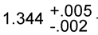 is undersized measuring 1.3371 – 1.3382.
- 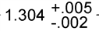 is oversized measuring 1.3132 – 1.3142.
- 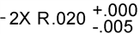is undersized measuring 0.0125.

