NON-COMPLIANCE REPORT # 31734-74
PART NAME: | SHAFT END BRACKET | DATE: | 7/1/15
PF/SA NO.: | PF-391-738-25 R0 | INSPECTOR: | K. CABAN
WORK ORDER NO.: | 31734-74 | ENGINEER: | JC | EXT.: | 5109
VENDOR | KLY MACH SHOP | PLANNER: | D. SHELLEY
Reason for Non-Compliance: | Disposition (UAI, Rework, Scrap, Other):

1 rejected , 2 accepted

- 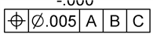 of 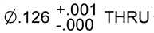 is out of true position measuring 0.0094 on SN 104 only.
  - 2.864 measured 2.8593
- 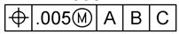 of 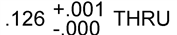is out of true position measuring 0.0081 on SN 104 only.
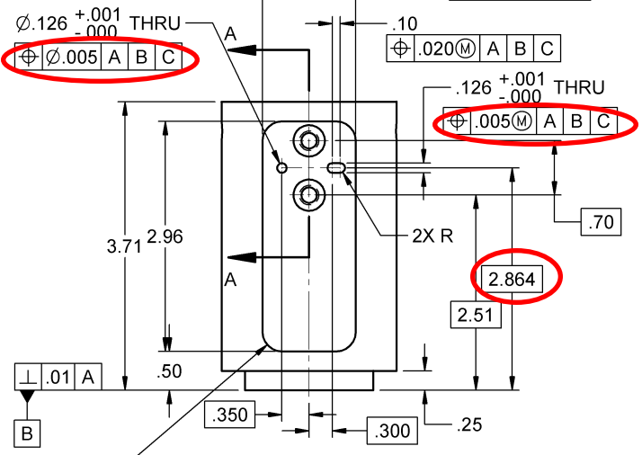
  - 2.864 measured 2.8600

