LCLS2 Bend Magnet 0.788D11.50

Alignment Engineering Group
L204548
SN 02
January 24, 2018

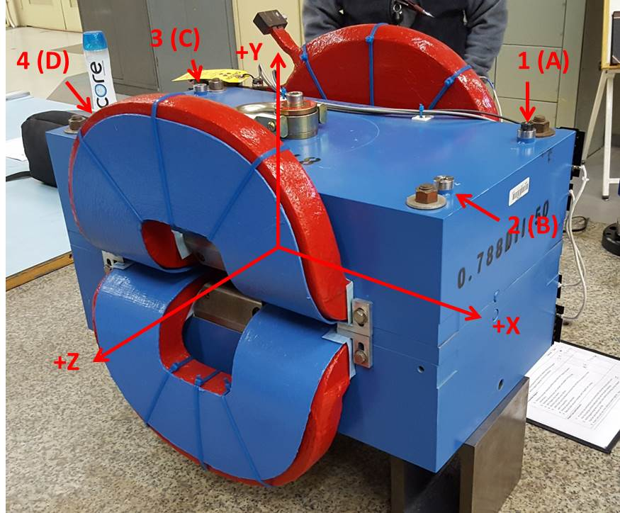

Numbered tooling balls are 1 inch offset lettered tooling balls are a 0.3125 inch offset. All units are inches. Coordinates and are to the Mechanical Center of the Poles.
Tooling Ball | Z (in) | X (in) | Y (in)
TBA | -3.463 | 9.501 | 6.221
TBB | 3.461 | 9.499 | 6.222
TBC | -3.461 | -9.511 | 6.222
TBD | 3.463 | -9.501 | 6.224
TB1 | -3.462 | 9.505 | 6.909
TB2 | 3.463 | 9.498 | 6.911
TB3 | -3.462 | -9.510 | 6.910
TB4 | 3.465 | -9.500 | 6.912

Pole gap = 0.796 inches at origin (0,0,0).

