LCLS2 Bend Magnet 0.788D11.50

Alignment Engineering Group
L204547
SN 03
January 24, 2018

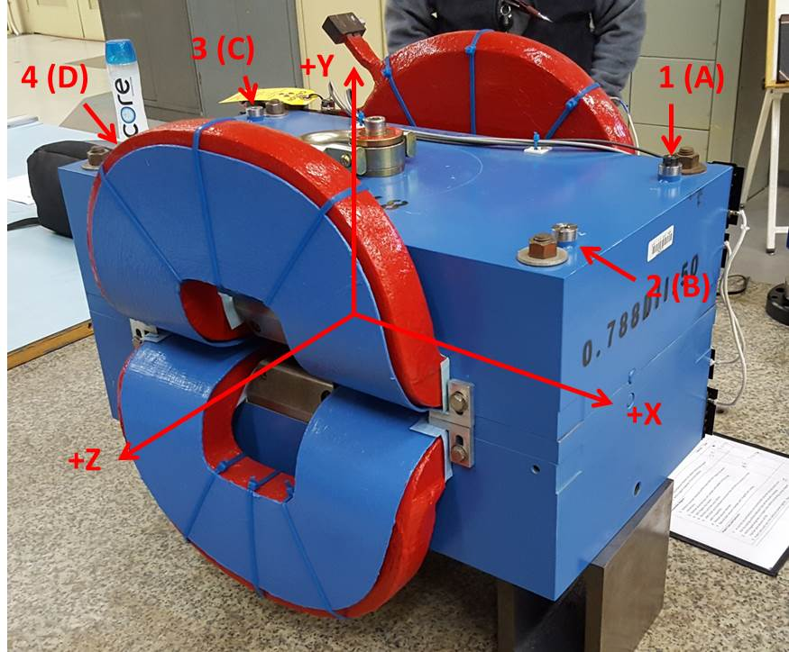

Numbered tooling balls are 1 inch offset lettered tooling balls are a 0.3125 inch offset. All units are inches. Coordinates and are to the Mechanical Center of the Poles.
Tooling Ball | Z (in) | X (in) | Y (in)
TBA | -3.430 | 9.522 | 6.222
TBB | 3.456 | 9.483 | 6.224
TBC | -3.444 | -9.476 | 6.217
TBD | 3.441 | -9.483 | 6.219
TB1 | -3.430 | 9.519 | 6.910
TB2 | 3.458 | 9.482 | 6.912
TB3 | -3.442 | -9.480 | 6.907
TB4 | 3.439 | -9.484 | 6.907

Pole gap = 0.797 inches at origin (0,0,0).

