LCLS2 Bend Magnet 0.788D11.50

Alignment Engineering Group
L204546
SN 38
January 22, 2018

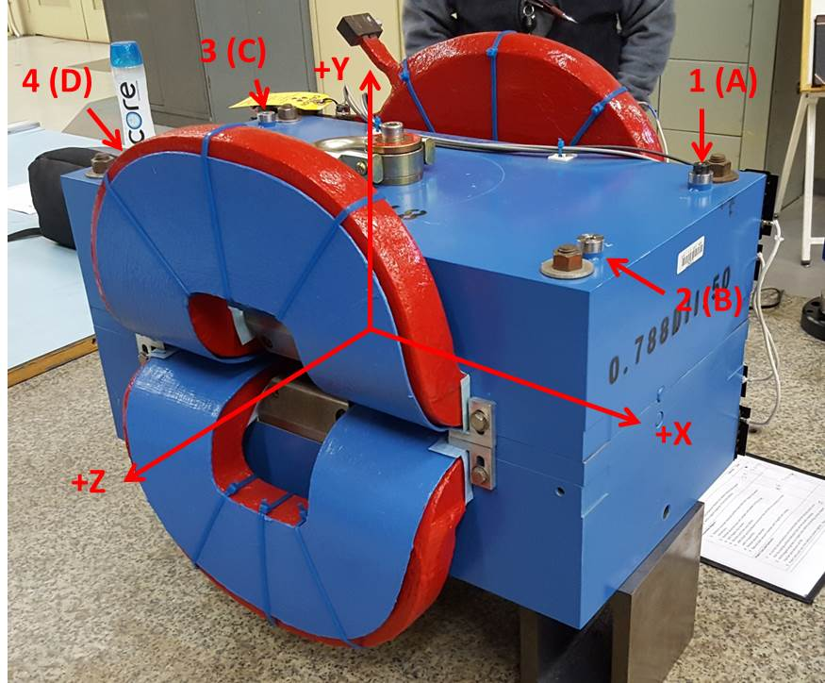

Numbered tooling balls are a 1 inch offset, lettered tooling balls are a 0.3125 inch offset. All units are inches. Coordinates are to the Mechanical Center of the Poles.
Tooling Ball | Z (in) | X (in) | Y (in)
TBA | -3.464 | 9.472 | 6.218
TBB | 3.464 | 9.479 | 6.218
TBC | -3.446 | -9.522 | 6.230
TBD | 3.461 | -9.510 | 6.230
TB1 | -3.464 | 9.471 | 6.906
TB2 | 3.464 | 9.479 | 6.906
TB3 | -3.448 | -9.521 | 6.917
TB4 | 3.461 | -9.506 | 6.917

Pole gap = 0.799 inches at origin (0,0,0).

