LCLS2 Bend Magnet 0.788D11.50

Alignment Engineering Group
L204545
SN 09
January 11, 2018

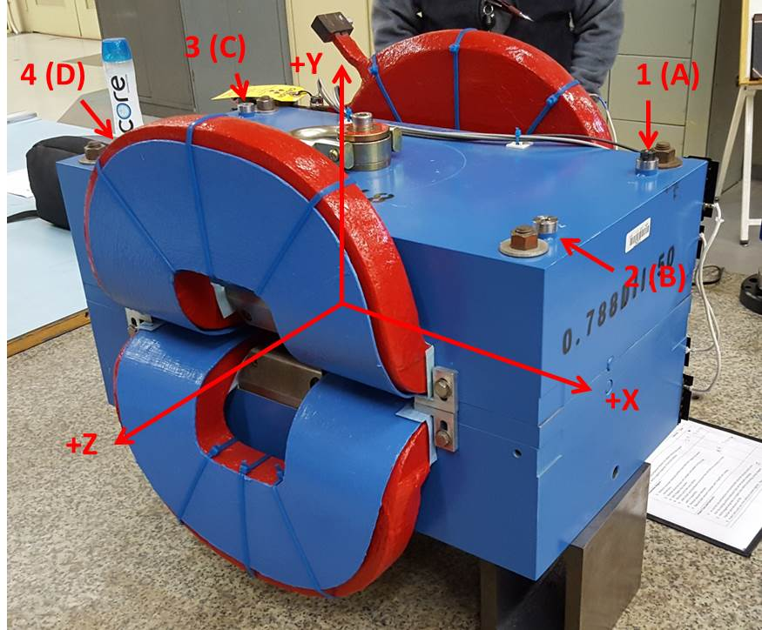

Numbered tooling balls are a 1 inch offset, lettered tooling balls are a 0.3125 inch offset. All units are inches. Coordinates are to the Mechanical Center of the Poles.
Tooling Ball | Z (in) | X (in) | Y (in)
TBA | -3.437 | 9.503 | 6.223
TBB | 3.451 | 9.495 | 6.220
TBC | -3.455 | -9.513 | 6.228
TBD | 3.462 | -9.508 | 6.226
TB1 | -3.434 | 9.503 | 6.911
TB2 | 3.455 | 9.496 | 6.908
TB3 | -3.456 | -9.513 | 6.916
TB4 | 3.465 | -9.509 | 6.914

Pole gap = 0.805 inches at origin (0,0,0).

