LCLS2 Bend Magnet 0.788D11.50

Alignment Engineering Group
L204544
SN 15
January 11, 2018

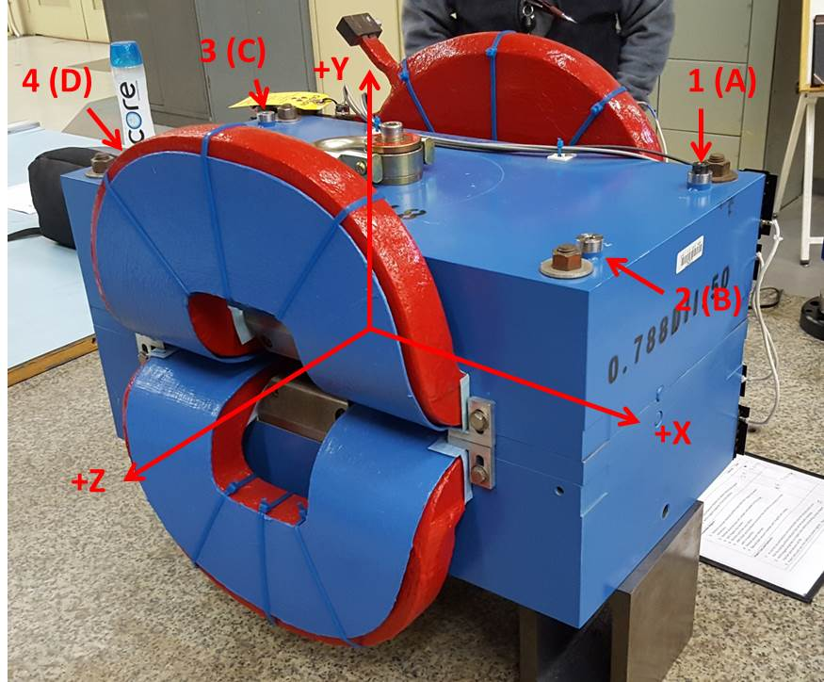

Numbered tooling balls are a 1 inch offset, lettered tooling balls are a 0.3125 inch offset. All units are inches. Coordinates are to the Mechanical Center of the Poles.
Tooling Ball | Z (in) | X (in) | Y (in)
TBA | -3.466 | 9.514 | 6.223
TBB | 3.447 | 9.502 | 6.224
TBC | -3.420 | -9.478 | 6.224
TBD | 3.468 | -9.482 | 6.224
TB1 | -3.465 | 9.513 | 6.909
TB2 | 3.446 | 9.503 | 6.911
TB3 | -3.417 | -9.471 | 6.911
TB4 | 3.467 | -9.482 | 6.911

Pole gap = 0.794 inches at origin (0,0,0).

