LCLS2 Bend Magnet 0.788D11.50

Alignment Engineering Group
L204541
SN 22
January 12, 2018

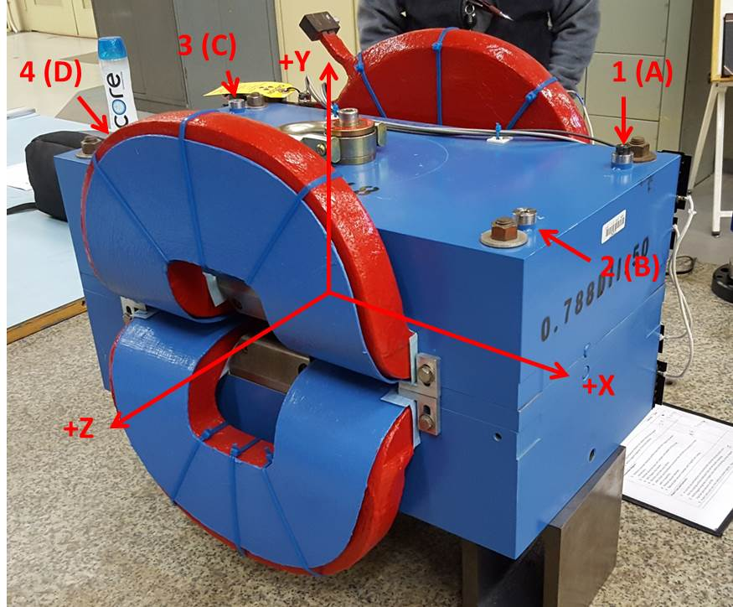

Numbered tooling balls are a 1 inch offset, lettered tooling balls are a 0.3125 inch offset. All units are inches. Coordinates are to the Mechanical Center of the Poles.
Tooling Ball | Z (in) | X (in) | Y (in)
TBA | -3.428 | 9.497 | 6.230
TBB | 3.470 | 9.479 | 6.227
TBC | -3.462 | -9.485 | 6.226
TBD | 3.444 | -9.502 | 6.225
TB1 | -3.425 | 9.501 | 6.917
TB2 | 3.471 | 9.478 | 6.914
TB3 | -3.463 | -9.486 | 6.913
TB4 | 3.445 | -9.503 | 6.912

Pole gap = 0.797 inches at origin (0,0,0).

