LCLS2 Bend Magnet 0.788D11.50

Alignment Engineering Group
L204539
SN 16
January 12, 2018

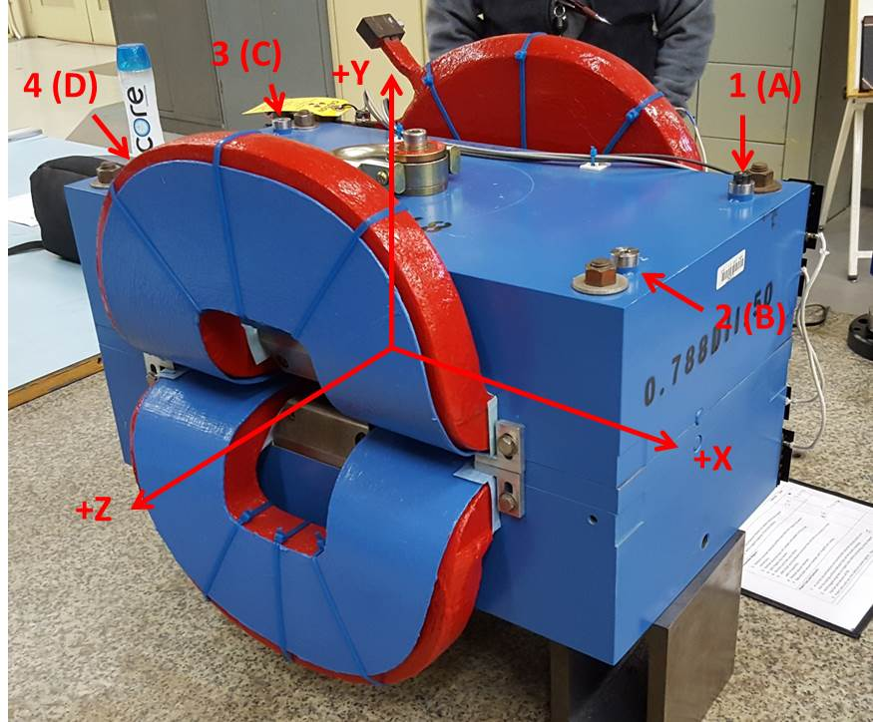

Numbered tooling balls are a 1 inch offset, lettered tooling balls are a 0.3125 inch offset. All units are inches. Coordinates are to the Mechanical Center of the Poles.
Tooling Ball | Z (in) | X (in) | Y (in)
TBA | -3.429 | 9.503 | 6.225
TBB | 3.466 | 9.483 | 6.224
TBC | -3.461 | -9.482 | 6.223
TBD | 3.436 | -9.496 | 6.220
TB1 | -3.430 | 9.502 | 6.913
TB2 | 3.468 | 9.486 | 6.912
TB3 | -3.460 | -9.482 | 6.910
TB4 | 3.438 | -9.496 | 6.907

Pole gap = 0.794 inches at origin (0,0,0).

