LCLS2 Bend Magnet 0.788D11.50

Alignment Engineering Group
L204537
SN 18
December 18, 2017

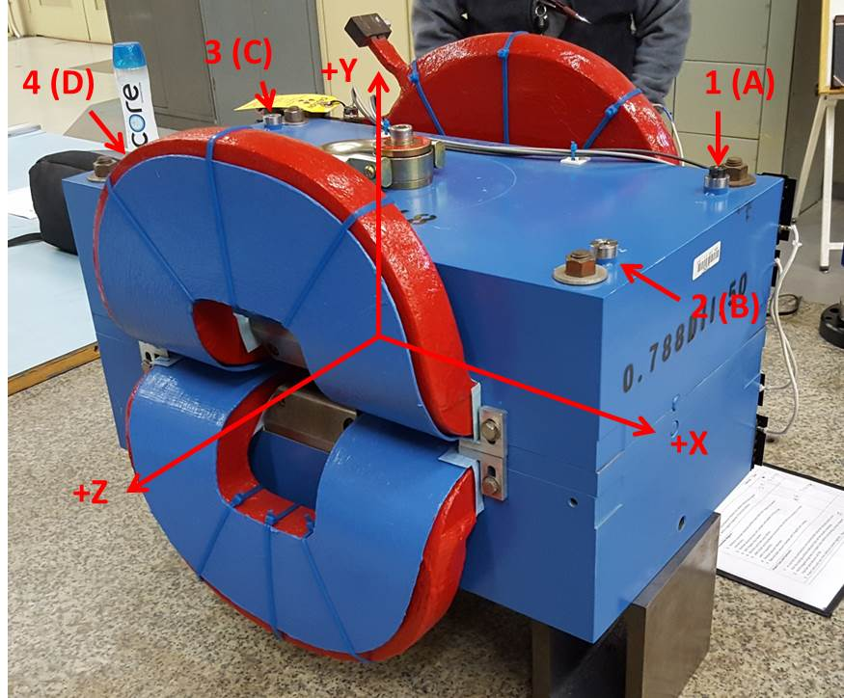

Numbered tooling balls are a 1 inch offset, lettered tooling balls are a 0.3125 inch offset. All units are inches. Coordinates are to the Mechanical Center of the Poles.
Tooling Ball | Z (in) | X (in) | Y (in)
TBA | -3.449 | 9.500 | 6.225
TBB | 3.460 | 9.514 | 6.224
TBC | -3.439 | -9.512 | 6.226
TBD | 3.457 | -9.487 | 6.228
TB1 | -3.448 | 9.499 | 6.912
TB2 | 3.461 | 9.515 | 6.911
TB3 | -3.439 | -9.511 | 6.914
TB4 | 3.458 | -9.488 | 6.915

Pole gap = 0.797 inches at origin (0,0,0).

