LCLS2 Bend Magnet 0.788D11.50

Alignment Engineering Group
L204536
SN 19
December 18, 2017

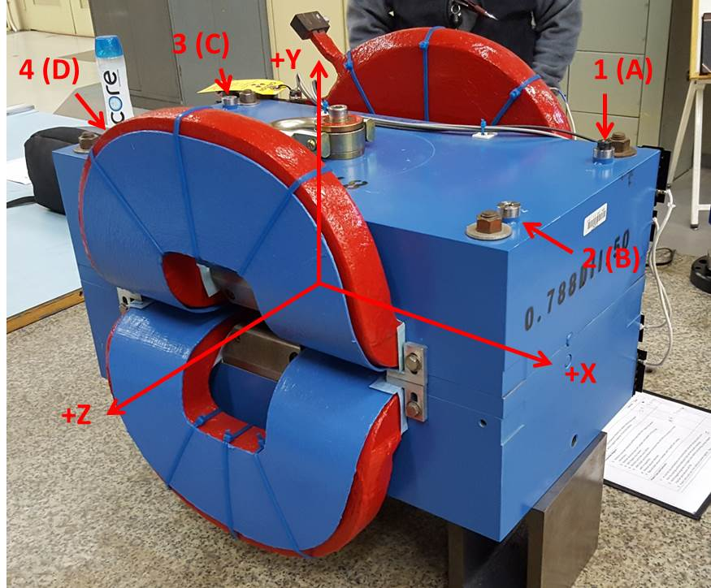

Numbered tooling balls are a 1 inch offset, lettered tooling balls are a 0.3125 inch offset. All units are inches. Coordinates are to the Mechanical Center of the Poles.
Tooling Ball | Z (in) | X (in) | Y (in)
TBA | -3.430 | 9.502 | 6.226
TBB | 3.471 | 9.493 | 6.219
TBC | -3.462 | -9.493 | 6.236
TBD | 3.453 | -9.470 | 6.227
TB1 | -3.429 | 9.503 | 6.914
TB2 | 3.472 | 9.494 | 6.907
TB3 | -3.469 | -9.494 | 6.923
TB4 | 3.455 | -9.469 | 6.914

Pole gap = 0.800 inches at origin (0,0,0).

