LCLS2 Bend Magnet 0.788D11.50

Alignment Engineering Group
L204535
SN 24
December 20, 2017

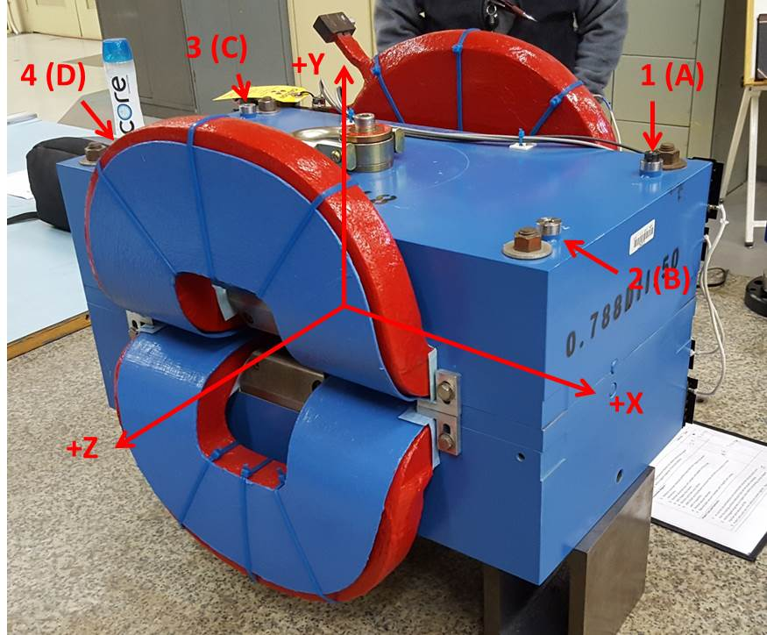

Numbered tooling balls are a 1 inch offset, lettered tooling balls are a 0.3125 inch offset. All units are inches. Coordinates are to the Mechanical Center of the Poles.
Tooling Ball | Z (in) | X (in) | Y (in)
TBA | -3.462 | 9.496 | 6.213
TBB | 3.481 | 9.491 | 6.212
TBC | -3.470 | -9.504 | 6.213
TBD | 3.471 | -9.472 | 6.213
TB1 | -3.461 | 9.497 | 6.901
TB2 | 3.482 | 9.492 | 6.900
TB3 | -3.471 | -9.504 | 6.900
TB4 | 3.472 | -9.471 | 6.901

Pole gap = 0.799 inches at origin (0,0,0).

