LCLS2 Bend Magnet 0.788D11.50

Alignment Engineering Group
L204534
SN 37
December 18, 2017

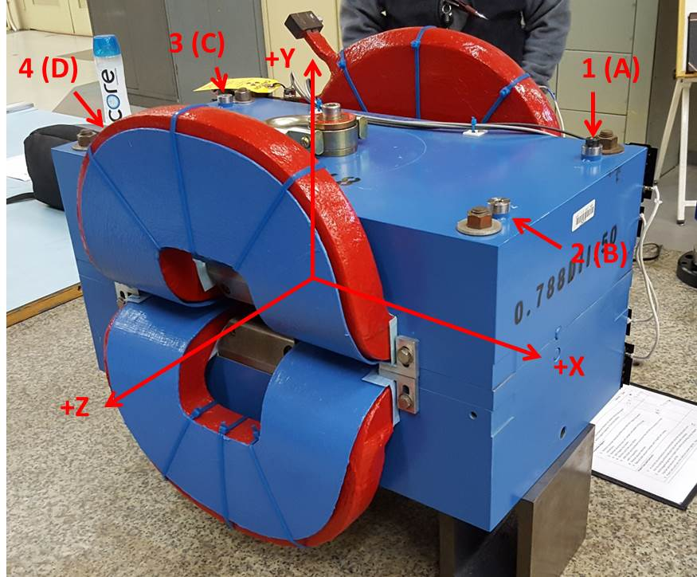

Numbered tooling balls are a 1 inch offset, lettered tooling balls are a 0.3125 inch offset. All units are inches. Coordinates are to the Mechanical Center of the Poles.
Tooling Ball | Z (in) | X (in) | Y (in)
TBA | -3.449 | 9.499 | 6.226
TBB | 3.461 | 9.521 | 6.220
TBC | -3.444 | -9.505 | 6.229
TBD | 3.465 | -9.479 | 6.223
TB1 | -3.451 | 9.499 | 6.914
TB2 | 3.463 | 9.521 | 6.907
TB3 | -3.447 | -9.506 | 6.917
TB4 | 3.469 | -9.479 | 6.911

Pole gap = 0.799 inches at origin (0,0,0).

