LCLS2 Bend Magnet 0.788D11.50

Alignment Engineering Group
L204533
SN 30
December 18, 2017

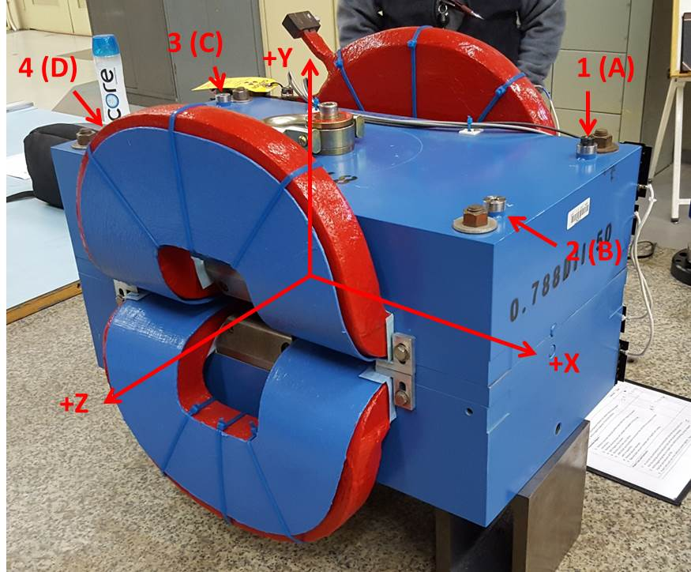

Numbered tooling balls are a 1 inch offset, lettered tooling balls are a 0.3125 inch offset. All units are inches. Coordinates are to the Mechanical Center of the Poles.
Tooling Ball | Z (in) | X (in) | Y (in)
TBA | -3.448 | 9.481 | 6.226
TBB | 3.483 | 9.484 | 6.221
TBC | -3.430 | -9.522 | 6.229
TBD | 3.497 | -9.514 | 6.223
TB1 | -3.446 | 9.480 | 6.914
TB2 | 3.487 | 9.485 | 6.909
TB3 | -3.429 | -9.523 | 6.916
TB4 | 3.499 | -9.514 | 6.910

Pole gap = 0.799 inches at origin (0,0,0).

