LCLS2 Bend Magnet 0.788D11.50

Alignment Engineering Group
L204532
SN 11
December 19, 2017

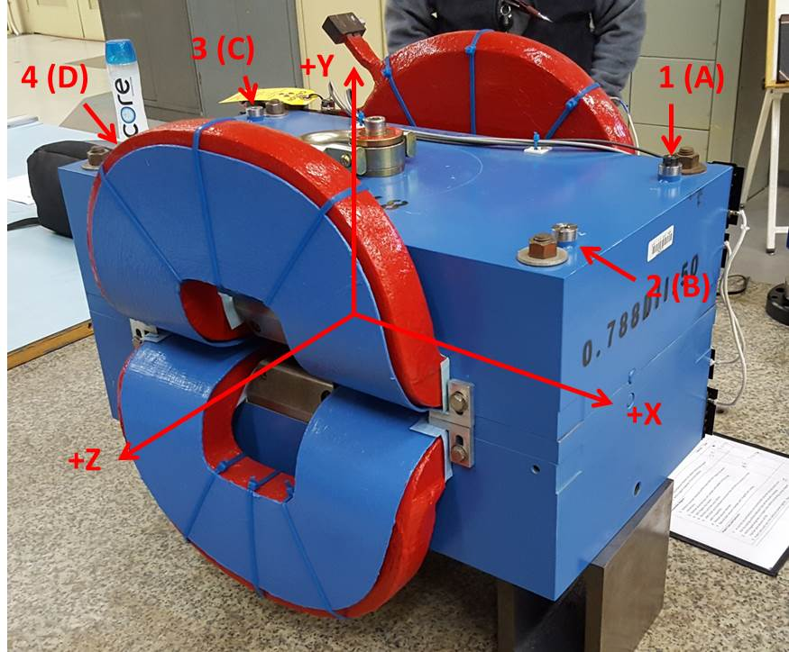

Numbered tooling balls are a 1 inch offset, lettered tooling balls are a 0.3125 inch offset. All units are inches. Coordinates are to the Mechanical Center of the Poles.
Tooling Ball | Z (in) | X (in) | Y (in)
TBA | -3.482 | 9.513 | 6.228
TBB | 3.497 | 9.496 | 6.229
TBC | -3.484 | -9.496 | 6.220
TBD | 3.484 | -9.480 | 6.223
TB1 | -3.481 | 9.512 | 6.916
TB2 | 3.498 | 9.499 | 6.917
TB3 | -3.483 | -9.498 | 6.909
TB4 | 3.487 | -9.482 | 6.911

Pole gap = 0.798 inches at origin (0,0,0).

