LCLS2 Bend Magnet 0.788D11.50

Alignment Engineering Group
L204530
SN 06
December 12, 2017

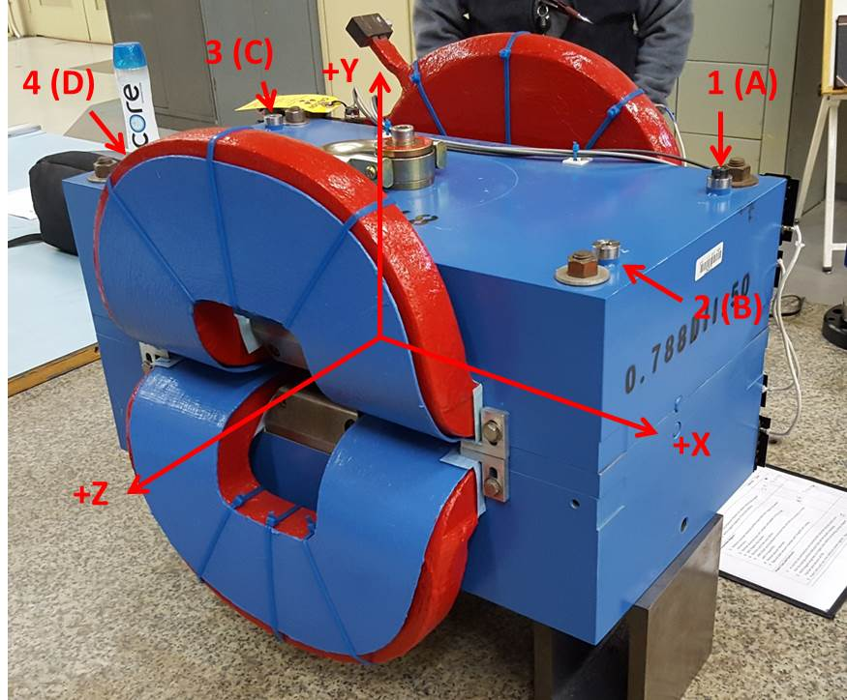

Numbered tooling balls are a 1 inch offset, lettered tooling balls are a 0.3125 inch offset. All units are inches. Coordinates are to the Mechanical Center of the Poles.
Tooling Ball | Z (in) | X (in) | Y (in)
TBA | -3.496 | 9.493 | 6.221
TBB | 3.511 | 9.478 | 6.220
TBC | -3.486 | -9.502 | 6.220
TBD | 3.526 | -9.508 | 6.221
TB1 | -3.497 | 9.492 | 6.909
TB2 | 3.512 | 9.476 | 6.908
TB3 | -3.486 | -9.503 | 6.908
TB4 | 3.524 | -9.503 | 6.908

Pole gap = 0.800 inches at origin (0,0,0).

