LCLS2 Bend Magnet 0.788D11.50

Alignment Engineering Group
L204529
SN 10
January 10, 2018

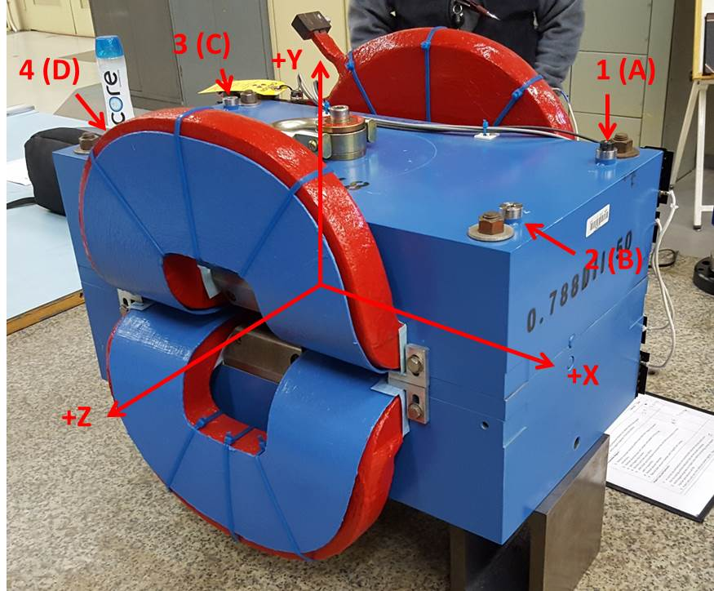

Numbered tooling balls are a 1 inch offset, lettered tooling balls are a 0.3125 inch offset. All units are inches. Coordinates are to the Mechanical Center of the Poles.
Tooling Ball | Z (in) | X (in) | Y (in)
TBA | -3.513 | 9.505 | 6.228
TBB | 3.504 | 9.499 | 6.227
TBC | -3.523 | -9.493 | 6.225
TBD | 3.488 | -9.503 | 6.225
TB1 | -3.512 | 9.507 | 6.916
TB2 | 3.501 | 9.501 | 6.914
TB3 | -3.522 | -9.499 | 6.912
TB4 | 3.495 | -9.511 | 6.912

Pole gap = 0.801 inches at origin (0,0,0).

