LCLS2 Bend Magnet 0.788D11.50

Alignment Engineering Group
L204528
SN 31
January 11, 2018

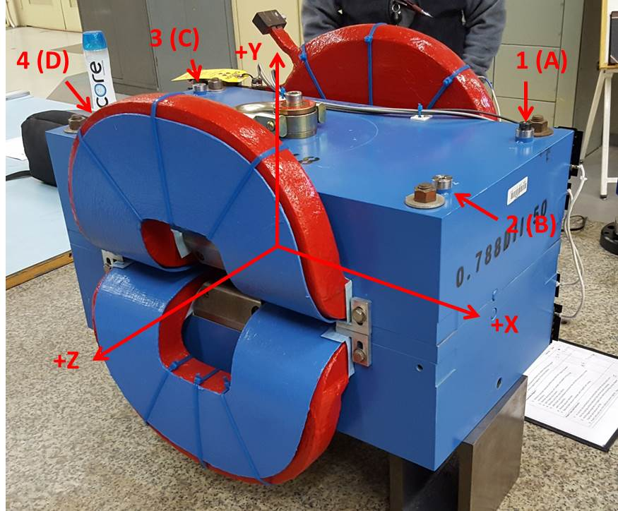

Numbered tooling balls are a 1 inch offset, lettered tooling balls are a 0.3125 inch offset. All units are inches. Coordinates are to the Mechanical Center of the Poles.
Tooling Ball | Z (in) | X (in) | Y (in)
TBA | -3.476 | 9.483 | 6.223
TBB | 3.526 | 9.476 | 6.222
TBC | -3.511 | -9.508 | 6.224
TBD | 3.514 | -9.529 | 6.224
TB1 | -3.473 | 9.482 | 6.910
TB2 | 3.525 | 9.478 | 6.910
TB3 | -3.511 | -9.509 | 6.911
TB4 | 3.514 | -9.528 | 6.912

Pole gap = 0.804 inches at origin (0,0,0).

