LCLS2 Bend Magnet 0.788D11.50

Alignment Engineering Group
L204527
SN 32
January 11, 2018

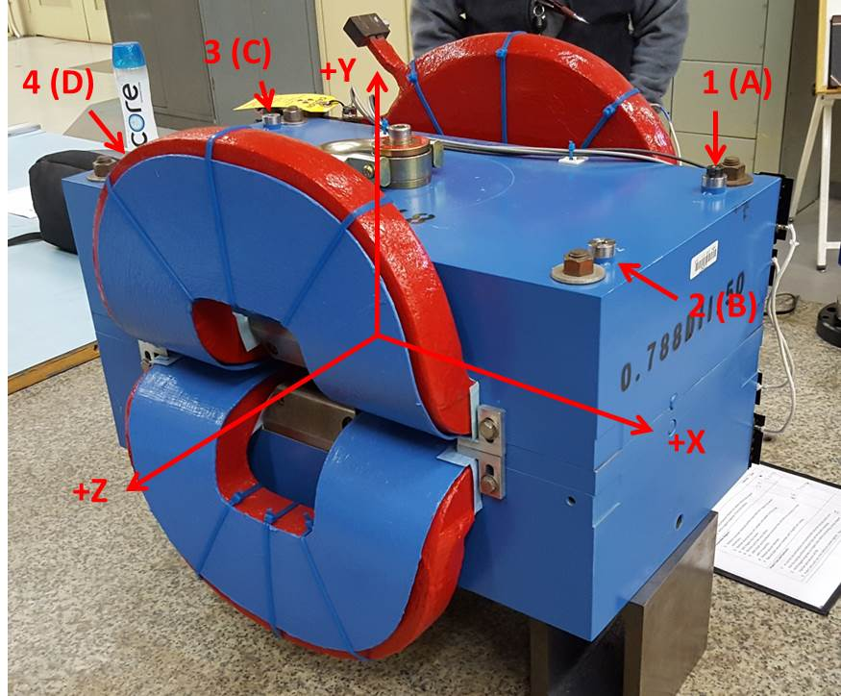

Numbered tooling balls are a 1 inch offset, lettered tooling balls are a 0.3125 inch offset. All units are inches. Coordinates are to the Mechanical Center of the Poles.
Tooling Ball | Z (in) | X (in) | Y (in)
TBA | -3.531 | 9.499 | 6.219
TBB | 3.475 | 9.570 | 6.219
TBC | -3.501 | -9.524 | 6.219
TBD | 3.524 | -9.497 | 6.218
TB1 | -3.532 | 9.499 | 6.907
TB2 | 3.474 | 9.569 | 6.907
TB3 | -3.503 | -9.525 | 6.907
TB4 | 3.521 | -9.500 | 6.931

Pole gap = 0.799 inches at origin (0,0,0).

