LCLS2 Bend Magnet 0.788D11.50

Alignment Engineering Group
L204526
SN 39
January 10, 2018

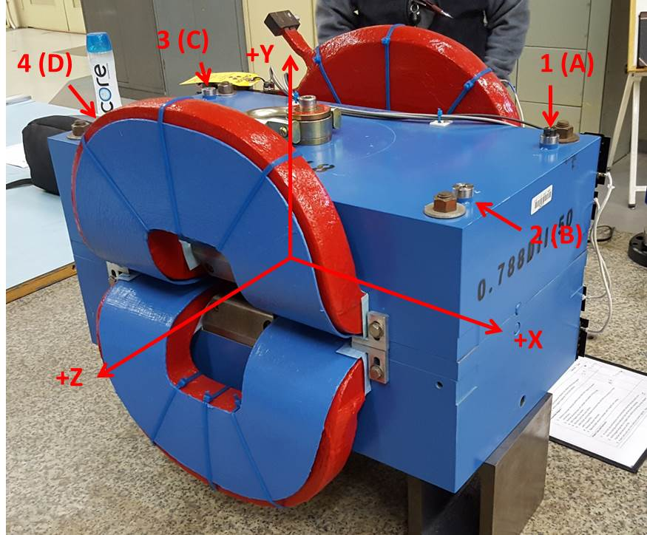

Numbered tooling balls are a 1 inch offset, lettered tooling balls are a 0.3125 inch offset. All units are inches. Coordinates are to the Mechanical Center of the Poles.
Tooling Ball | Z (in) | X (in) | Y (in)
TBA | -3.470 | 9.470 | 6.223
TBB | 3.543 | 9.459 | 6.224
TBC | -3.525 | -9.540 | 6.221
TBD | 3.500 | -9.539 | 6.222
TB1 | -3.470 | 9.472 | 6.911
TB2 | 3.543 | 9.461 | 6.911
TB3 | -3.527 | -9.537 | 6.908
TB4 | 3.500 | -9.537 | 6.910

Pole gap = 0.801 inches at origin (0,0,0).

