SLAC Test Plan for LCLS-II 0.68D102.36 Dipole Magnets: BX31, BX32, BX35, and BX36
(August 29, 2019)

This traveler is intended to cover reception, preparation, mechanical fiducialization, and magnetic measurements of the LTUH BX31, BX32, BX35, and BX36 dipole magnets. These magnets are modified versions of the original LCLS LTU dipoles (4D102.36T). The gap for these magnet has been reduced from 1.382 inches to 0.68 inches. The top-level assembly drawing for these modified magnets is LCL0350-008597.

Receiving:
The following information is to be noted upon receipt of the magnets by the SLAC MM group:
Received by (initials): | SDA
Date placed on test stand (dd-mmm-yyyy): | 9/24/2019
SLAC barcode number: | 4580
Vendor serial number from magnet label: | 5
SLAC approved electrical safety covers? (Y or N): | N
SLAC drawing number (enter number): | LCL0350-008597

Preparation:
A beam direction arrow, with text “beam direction”, is to be applied to the top and/or connector side of the magnet with a sticker supplied by LCLS-II. The terminals shall be oriented down beam.
Beam-direction arrow in place (initials): | SDA

Fiducialization:
Fiducialization may be done before or after magnetic measurements. The magnet is to be fiducialized by the CMM group. This will require the installation of removable tooling balls, location of the geometric axis of the poles of the magnet, and location of tooling balls with respect to the center of this geometric axis when the poles are aligned precisely horizontal.

CMM technician (initials): | FG, KA

URL of on-line CMM fiducialization data (please modify or correct if necessary):
https://www-group.slac.stanford.edu/met/MagMeas/MAGDATA/LCLS-II/Dipole/4580/

Magnetic Measurements:
- Verify that the magnets are complete and undamaged, including wiring connections.
Incoming inspection OK (initials): | SDA
Date of arrival to mag. meas.(mmm-dd-yyyy): | 9/24/2019

Enter URL of on-line magnetic measurements data (please modify or correct if necessary):
http://www-group.slac.stanford.edu/met/MagMeas/MAGDATA/LCLS-II/Dipole/4580

- Mark each magnet as BX31, BX32, BX35, or BX36. BX35 and BX36 are “positive” polarity (bending electrons to the left) and BX31, BX32 are “negative” polarity (bending electrons to the right).
Magnet marked as (BX31, BX32, BX35, or BX36): | BX31

- Determine the main-coil connection polarity (with main supply outputting positive current) which produces a “positive” field polarity for BX35 and BX36 (below left) and “negative” field polarity for BX31 and BX32 (below right):
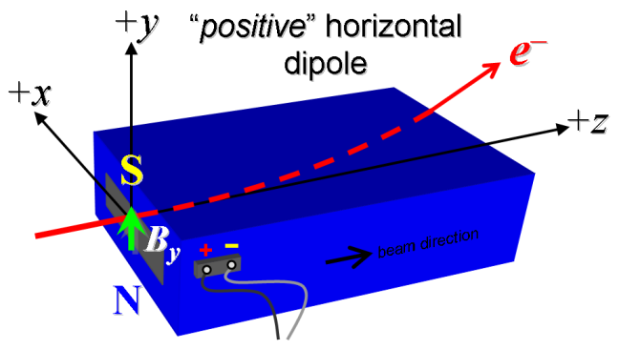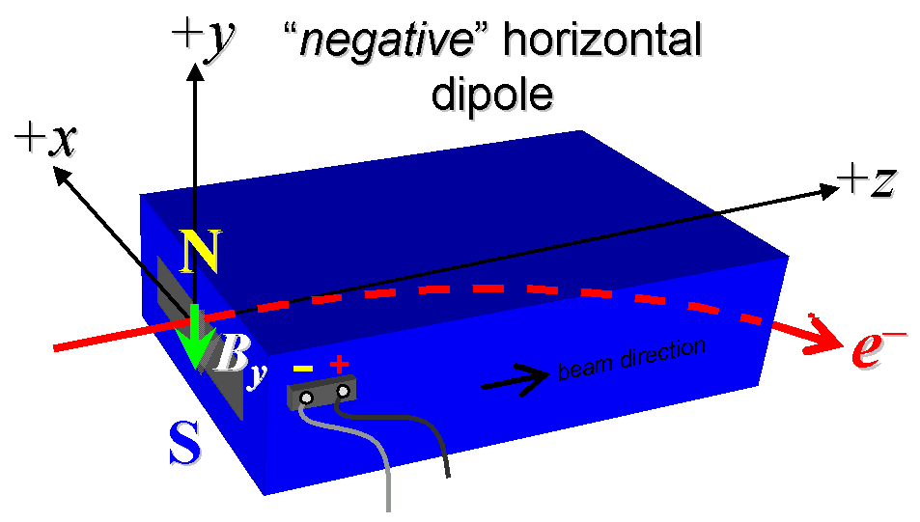

Figure 1. BX35, BX36 are “positive” polarity (bending electrons to the left) and BX31, BX32 are “negative” polarity (bending electrons to the right).

- Mark the polarity near the main magnet leads with clear “+” and “−” labels as shown above.
Polarity is marked according to Fig. 1 (initials): | SDA
- Also mark the trim leads with clear “+” and “−” labels such that, with the trim supply outputting positive current, the trim coil increases the absolute value of the magnetic field established by the main coil. This will set the trim polarity as “positive” for BX35 and BX36, and “negative” for BX31 and BX32, as described in LCLS-II-2.4-PR-0064 (https://docs.slac.stanford.edu/sites/pub/Publications/Polarity.pdf).
Trim coil polarity chosen from Fig. 1 is (P or N): | SDA

- Connect the main magnet terminals (not the trims), in the correct polarity as established above, to a unipolar (or bipolar) power supply with maximum current I ≥ 300 A (assuming this current produces at least 4.95 kG-m as the maximum required integrated field). Leave the trim coil disconnected for now.

- Connect magnet to LCW supply. At a supply pressure delta P of ~115 psi the flow rate should be ~1.6 gpm. Run the magnet up to 300 A for ~1 hour to warm it up (record, delta P, flow rate, and magnet coil and steel temperature).
LCW delta P (psi) | 116 psi
LCW flow rate (gpm) | 1.55 gpm
LCW delta T (°C) | 5.3 °C
Ambient temperature (°C): | 30.8 °C
Final magnet steel temperature (°C): | 29.6 °C

- Standardize the magnet, starting from zero to 300 A and back to zero, through three full cycles, finally ending at zero, with a flat-top pause time (at both 0 and 300 A) of 10 seconds. Use a linear ramp rate of 10 A/sec, if possible, and record the ramp rate used.
Standardization complete (initials): | SDA
Ramp rate used (A/sec): | 10 A/sec

- Maintaining this cycle history, measure the length-integrated horizontal dipole field, ∫B_{y}dl, from 0 to 300 A in 10-A steps. Also include 216.88 A, which is the nominal current at the maximum beam energy of 17 GeV for these magnets because they are on the BYD string (32 ‘up’ measurements). Then, still maintaining the cycle history, measure ∫B_{y}dl back down from 300 A to 0 in 20-A steps, including zero (14 ‘down’ measurements).
Filename & run number of ∫B_{y}dl up & down data: | Wiredat.ru1, wireplt.ru1

- With the main coils still hooked up, connect the trim coil to a bipolar 6 A (MCOR6) supply with proper trim polarity as determined above.
- Still maintaining the cycle history, run the main coil up to 216.88 A, pause at least 10 seconds, and measure ∫B_{y}dl as a function of trim coil current from 0 to -6 A in 0.5 A steps, including zero (13 ‘down’ measurements), and again from -6 to +6 A in 0.5-A steps (25 ‘up’ measurements). Set the trim current back to 0.
Filename & run # of ∫B_{y}dl trim data at I_{main} = 216.88 A: | Wiredat.ru2, wireplt.ru2

- Set the main coil to 0 current by ramping first up to 300 A, then down to zero at the same ramp rate used in the standardization cycle. Measure ∫B_{y}dl as a function of trim coil current from 0 to −6 in 0.5-A steps, including zero (13 ‘down’ measurements), and again from −6 to +6 A in 0.5-A steps (25 ‘up’ measurements). Set the trim current to 0.
Filename & run # of ∫B_{y}dl trim data at I_{main} = 0: | Wiredat.ru3, wireplt.ru3

- For all magnets, with main coil at 216.88 A, use a stretched wire to measure the length-integrated vertical field at multiple positions in x. With the wire located at the vertical mid-plane (y = 0), measure the vertical length-integrated field at each 3-mm step of horizontal wire position, from x = −36 mm to +36 mm, with x = 0 centered at the magnet’s horizontal center. Record data file name:
Filename: | Wirevsx.ru1, wirepltvsx.ru1

- For one magnet only, and at a main current of 216.88 A with trim at zero, measure the vertical magnetic field component, B_{y}, at x = y = 0, as a function of the longitudinal beam-direction coordinate, z (from −10 cm to +30 cm in 1-cm steps, where z = 0 is defined at the iron edge), at the upstream end of this one magnet. Please also measure the background field at z = +30 cm with magnet switched off (separate file).
Filename of B_{y} vs. z data for exit edge: | N/A
Background filename of B_{y}(z = 30 cm), magnet OFF: | N/A

- Measure the inductance and resistance of the main and trim magnet coils:
Inductance of main coil (mH): | 0.214 mH
Resistance of main coil (Ohms): | 0.0215 Ohm
Inductance of trim coil (mH): | 0.774 mH
Resistance of trim coil (Ohms): | 1.192 Ohm

- Measure pole tip field of the main at 300 A, then trim at 6 A with main at 0 A.
Main Pole Tip Field and Current | 0.254 T @ 300.08299 Amps
Trim Pole Tip Field and Current | 0.00958 T @ 6.00422 Amps

- Upon completion of tests, send data link to Mark Woodley who will produce a data analysis file. Place data analysis file in magnetic measurements data directory
Magnet data accepted and data analysis file produced | SDA

Enter URL of on-line magnetic measurements analysis data :
http://www-group.slac.stanford.edu/met/MagMeas/MAGDATA/LCLS-II/Dipole/4580/BX31

