## Proposed change to installation assignments for LCLS-II CuSXR (CLTS) 3D8.8MK3, SA-375-552-70 Dipole Magnets

**(July 18, 2019)**

The table below gives the MAD names, model drawing numbers, polarities, and original installation directions of the 3D8.8MK3 dipoles in the Copper Linac to Soft Xray Undulator (CLTS) beamline. This was the information given to SLAC Magnetic measurements, and reflects the measurements that were made on the magnets.

|  |  |  |  |  |  |  |
| --- | --- | --- | --- | --- | --- | --- |
| **MAD Name** | **Eng. Name** | **Drawing#/ Coil drawing#** | **Barcode** | **Color** | **Polarity** | **Terminals** |
| BRCUSDC1 | 3D8.8MK3 | SA-375-552-70 / PF-236-406-03 | 4576 | yellow | P Vertical | upstream |
| BRCUSDC2 | 3D8.8MK3 | SA-375-552-70 / PF-236-406-03 | 4575 | yellow | P Vertical | upstream |
| BYCUS1 | 3D8.8MK3 | SA-375-552-70* / PF-236-406-51 | 4574 | orange | P Vertical | upstream |
| BYCUS2 | 3D8.8MK3 | SA-375-552-70* / PF-236-406-51 | 4573 | orange | N Vertical | upstream |

*incorrect drawing number, should be SA-236-406-30

The orange dipoles (barcodes 4574 and 4573) are stronger than the yellow dipoles by ~60%, and would be better placed in the BRCUS1DC and BRCUS2DC locations where stronger field is required. The yellow dipoles would be assigned to the BYCUS1 and BYCUS2 locations.

To make this exchange, the polarity of 4573 must be swapped from N to P, and the polarity of 4575 must be swapped from P to N. This can be done by rotating the dipoles such that their terminals are now downstream instead of upstream.

We propose assigning the magnets to MAD device locations as follows:

|  |  |  |  |  |  |  |
| --- | --- | --- | --- | --- | --- | --- |
| **MAD Name** | **Eng. Name** | **Drawing# / coil drawing#** | **Barcode** | **color** | **Polarity** | **Terminals** |
| BRCUSDC1 | 3D8.8MK3 | SA-236-406-30 / PF-236-406-51 | 4574 | orange | P Vertical | upstream |
| BRCUSDC2 | 3D8.8MK3 | SA-236-406-30 / PF-236-406-51 | 4573 | orange | P Vertical | downstream |
| BYCUS1 | 3D8.8MK3 | SA-375-552-70 / PF-236-406-03 | 4576 | yellow | P Vertical | upstream |
| BYCUS2 | 3D8.8MK3 | SA-375-552-70 / PF-236-406-03 | 4575 | yellow | N Vertical | downstream |

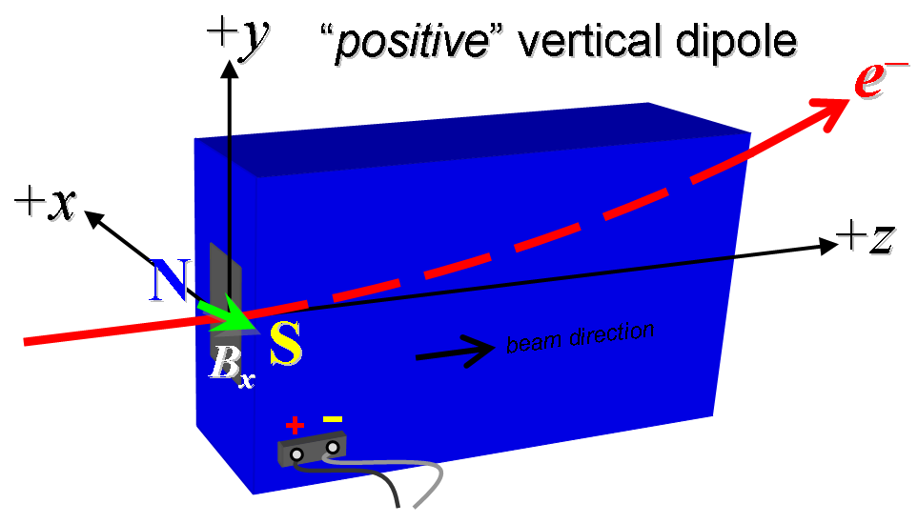

**Figure 1. “Positive” polarity (bending electrons up) . “Negative” polarity (bending electrons down).**

The magnetic measurement data for these four dipoles are summarized in the following four documents:

|  |
| --- |
| <http://www-group.slac.stanford.edu/met/MagMeas/MAGDATA/LCLS-II/Dipole/4576/3D8.8_4576.pptx> |
| <http://www-group.slac.stanford.edu/met/MagMeas/MAGDATA/LCLS-II/Dipole/4575/3D8.8_4575.pptx> |
| <http://www-group.slac.stanford.edu/met/MagMeas/MAGDATA/LCLS-II/Dipole/4574/3D8.8_4574.pptx> |
| <http://www-group.slac.stanford.edu/met/MagMeas/MAGDATA/LCLS-II/Dipole/4573/3D8.8_4573.pptx> |