SLAC Traveler for LCLS-II 1.69VD55.1 Dipole Magnets
(July 27, 2017, approved by P. Emma)

This traveler is intended to cover reception, preparation, mechanical fiducialization, and magnetic measurements of the three BYD dipole magnets used in the LCLS-II DUMPS.
Receiving:
The following information is to be noted upon receipt of the magnets by the SLAC MFD group:
Received by (initials): | SDA
Date received (dd-mmm-yyyy): | 9/29/2017
SLAC barcode number: | 4520
Vendor serial number from magnet label: | 3
SLAC approved electrical safety covers? (Y or N): | N
SLAC approved lifting eyes? (Y or N): | N
Shipping Damage? (Y or N): | N
Vendor tests passed on magnet label? (Y or N): | N
SLAC drawing number (enter number): | SA-380-328-01

Preparation:
A beam direction arrow, with text “beam direction”, is to be applied to the top and/or tunnel aisle side of the magnet with a sticker supplied by LCLS. The beam direction should point toward the end without the terminals.
Beam-direction arrow in place (initials): | SDA

Fiducialization:
Fiducialization may be done before or after magnetic measurements. The magnet is to be fiducialized by the CMM group. This will require the installation of removable tooling balls, location of the geometric axis of the poles of the magnet, and location of tooling balls with respect to the center of this geometric axis when the poles are aligned precisely horizontal.

CMM technician (initials): | FG and BR

URL of on-line CMM fiducialization data (please modify or correct if necessary):
http://www-group.slac.stanford.edu/met/MagMeas/MAGDATA/LCLS-II/Dipole/4520/LCLS%20II%201.69VD55.1%204520%20Fiducial%20Report.pdf

Magnetic Measurements:
- Verify that the magnets are complete and undamaged, including wiring connections.
Incoming inspection OK (initials): | SDA
Date of arrival to mag. meas.(mmm-dd-yyyy): | 9/29/2017

Enter URL of on-line magnetic measurements data (please modify or correct if necessary):
http://www-group.slac.stanford.edu/met/MagMeas/MAGDATA/LCLS-II/Dipole/4520
- Mark each magnet as BYD1B, BYD2B, or BYD3B.
Magnet marked as (BYD1B, BYD2B, or BYD3B): | BYD2B

- Determine the coil connection polarity (with main supply outputting positive current) which produces a “negative” field polarity for all 3 magnets, as shown below:

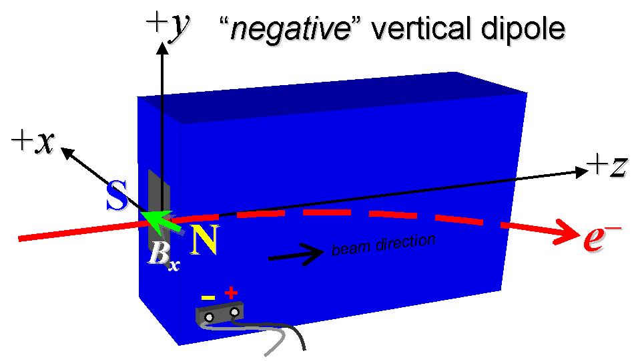
Figure 1. BYD1B, BYD2B, or BYD3B are all “negative” vertical dipoles, although rolled by 10 degrees in their final installation.

- Mark the polarity near the magnet leads with clear “+” and “−” labels as shown above.
Polarity is marked as in Fig. 1 (initials): | SDA

- Connect the magnet terminals in the correct polarity as established above to a unipolar power supply with maximum current I ≥ 200 A.
- Connect magnet to LCW supply. Adjust supply pressure to a delta P of ~60 psi to achieve a flow rate of 2.9 gpm. Run the magnet up to 150 A for ~1 hour to warm it up (record, delta P, flow rate, and magnet coil and steel temperature).
LCW delta P (psi) | psi
LCW flow rate (gpm) | 2.9 gpm
LCW delta T (°C) | 1.28 °C
Ambient temperature (°C): | 23.5°C
Final magnet steel temperature (°C): | 27.5°C

- Standardize the magnet, starting from zero to 200 A and back to zero, through three full cycles, finally ending at zero, with a flat-top pause time (at both 0 and 200 A) of 10 seconds. Use a ramp rate of 5 A/sec, if possible, and record the ramp rate used.
Standardization complete (initials): | SDA
Ramp rate used (A/sec): | Three Linear @ 5 A/sec

(Note that this is a vertical dipole, but we refer to it in this document as if it were a horizontal dipole with vertically oriented field. If it is oriented with horizontal field during the measurements, please swap the x and y coordinate references used in the text below.)

- Maintaining this cycle history, measure the length-integrated dipole field, ∫B_{y}dl, from 0 to 200 A in 20-A steps, including zero (11 ‘up’ measurements). Please record (below) the current necessary to achieve 8.2 kG-m and call P. Emma at 4189 if it is more than 10-A different than 150 A. After this check (and after calling if necessary) then, still maintaining the cycle history, measure ∫B_{y}dl back down from 200 A to 0 in 20-A steps, including zero (11 ‘down’ measurements).
Excitation current at 8.2 kG-m: | 138.8744 Amps
Filename & run number of ∫B_{y}dl up & down data: | Wiredat.ru2

- For the BYD1B magnet only, with a stretched wire, and after re-standardization, measure the length-integrated field component over a horizontal span of ±40 mm (±1.57 inches), at each 4-mm interval, at a 150-A current setting.
Filename & run # of ∫B_{y}dl vs. x data at 150 A: | N/A

- For the BYD1B magnet only, and at a current of 150 A, measure the vertical magnetic field component, B_{y}, at x = y = 0, as a function of the longitudinal beam-direction coordinate, z (from −10 cm to +30 cm in 1-cm steps, where z = 0 is defined at the iron edge), at the downstream end of this one magnet. Please also measure the background field at z = +30 cm with magnet switched off.
Filename of B vs. z data for BYD1B exit edge: | N/A
Background filename of B_{y} (z = 30 cm), magnet OFF: | N/A

- For the BYD1B magnet only, perform a final thermal test. Run the current up to 200 A and measure the magnet coil temperature after it stabilizes (2-4 hours?). Record the temperature below.
Ambient temperature (°C): | N/A °C
Final BYD1B temperature at 200 A (°C): | N/A °C

- Measure the inductance and resistance of the magnet coils:
Inductance of coil (mH): | 19.97 mH
Resistance of coil (Ohms): | 0.086 Ohm

- Upon completion of tests, email Mark Woodley that measurements are complete.

This section is to be completed by M. Woodley.
Magnet accepted (signed): | Via email
Assigned beamline location (MAD-deck name): | BYD2B

