SLAC Traveler for LCLS-II Laser-Heater Dipole Magnets – 5D3.9
(Sept. 21, 2017 – updated by P. Emma)

This traveler is intended to cover reception, preparation, mechanical fiducialization, and especially magnetic measurements of the four laser heater chicane dipole magnets. These magnets are about 8 cm wide with 30.5-mm full pole gap, 80-mm pole length, and have MAD designations of: BCXH1, BCXH2, BCXH3, and BCXH4. Each magnet has a main coil (40 turns), and a separate trim coil (14 turns).

Receiving:
The following information is to be noted upon receipt of the magnets by the SLAC MFD group:
Received by (initials): | SDA
Date received (dd-mmm-yyyy): | 12/6/2017
SLAC magnet barcode number: | 4518
Vendor serial number from magnet label: | 16082-4
SLAC approved electrical safety covers? (Y or N): | Y
SLAC approved lifting eyes? (Y or N): | N
Shipping Damage? (Y or N): | N
Vendor tests passed on magnet label? (Y or N): | Y
SLAC drawing number (enter number): | SA-380-331-12

Preparation:
A beam direction arrow, with text “beam direction”, is to be applied to the top and/or tunnel aisle side of the magnet with a sticker supplied by LCLS-II (see Fig. 1 below).
Beam-direction arrow applied (initials): | SDA

Fiducialization:
Fiducialization may be done before or after magnetic measurements. The magnet is to be fiducialized by the CMM group. This will require the installation of removable tooling balls, location of the geometric axis of the poles of the magnet, and location of tooling balls with respect to the center of this geometric axis when the poles are aligned precisely horizontal.

CMM technician (initials): | KC

URL of on-line CMM fiducialization data (please correct URL as needed):
http://www-group.slac.stanford.edu/met/MagMeas/MAGDATA/LCLS-II/Fiducial%20Reports/4518_Fiducial_Report.pdf

Magnetic Measurements:

- Verify that the magnets are complete and undamaged, including wiring connections.
Incoming inspection OK (initials): | SDA
Date of arrival to magnetic meas. (mmm-dd-yyyy): | 12/6/2017

Enter URL of on-line magnetic measurements data (please correct URL as needed):
http://www-group.slac.stanford.edu/met/MagMeas/MAGDATA/LCLS-II/Dipole/4518/

- Mark each magnet as BCXH1, BCXH2, BCXH3, or BCXH4. By choosing the magnet location initially, they will be tested in their proper polarities, since two are to be positive and two negative.
Magnet marked as (BCXH1, BCXH2, BCXH3, or BCXH4): | BCXH4

- Determine the main-coil connection polarity (with main supply outputting positive current) for these horizontal bends, which produces a “positive” field polarity for BCXH2 and BCXH3 (see Fig. 1, left side), but a “negative” field polarity for BCXH1 and BCXH4 (right side), as shown below:

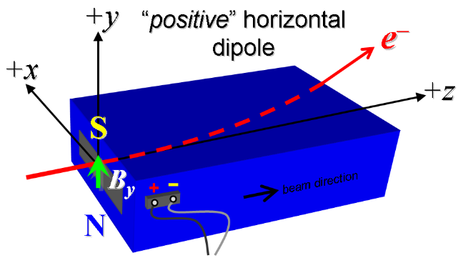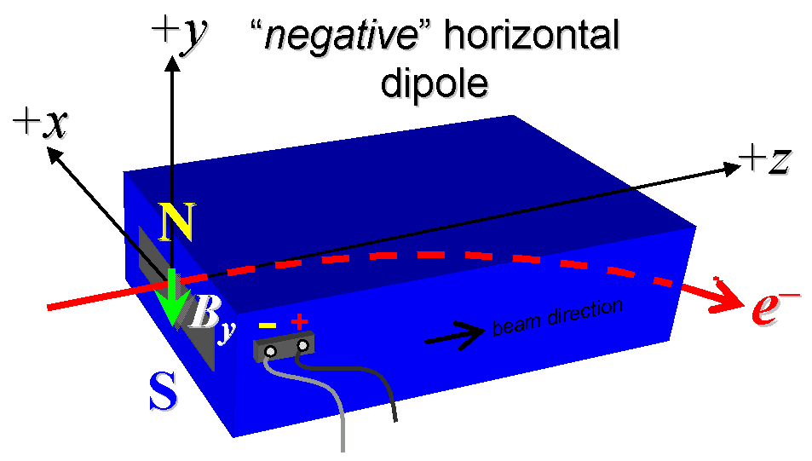
Figure 1. BCXH2 and BCXH3 are “positive” (left), while BCXH1 and BCXH4 are “negative” (right).

- Mark the polarity near the main magnet leads with clear “+” and “−” labels as shown above.
Main coil polarity chosen from Fig. 1 is (“P” or “N”): | N

- Also mark the trim-coil leads with clear “+” and “−” labels such that, with the trim supply outputting positive current, the trim coil increases the absolute value of the magnetic field established by the main coil. This will set the trim polarity as “positive” for BCXH2 and BCXH3, and “negative” for BCXH1 and BCXH4, as described in PRD: LCLSII-2.4-PR-0064.
Trim-coil polarity chosen from Fig. 1 is (“P” or “N”): | N

- Connect the main magnet terminals (not the trims), in the correct polarity as established above, to a unipolar power supply with maximum current I ≥ 47 A (~26 A current produces about 0.1 kG-m integrated field). Leave the trim coil disconnected for now.

- Connect magnet to LCW supply. Adjust supply pressure to a pressure difference (ΔP) of ~100 psi to achieve a flow rate of 1.6 gpm. Run the magnet up to 20 A for ~1 hour to warm it up (record, ΔP, flow rate, and magnet coil and steel temperature).
LCW ΔP (psi) | 110 psi
LCW flow rate (gpm) | 1.7 gpm
LCW delta T (°C) | 0 °C
Ambient temperature (°C): | °C
Final magnet steel temperature (°C): | °C

- Standardize the magnet, starting from zero current to 47 A and back to zero, through three full cycles, finally ending at zero, with a flat-top pause time (at both 0 and 47 A) of 5 seconds. Use a ramp rate of 3 A/sec, if possible, and record the ramp rate used.
Standardization complete (initials): | SDA
Ramp rate used (A/sec): | 3 A/sec
Ramp Type | Cosine
Flat top pause | 5 seconds

- Maintaining this cycle history, and with the trim coils not yet powered, measure the length-integrated vertical dipole field, ∫B_{y}dl, from 0 to 47 A in 2-A steps, including zero (25 ‘up’ measurements). Please record (below) the current necessary to achieve 0.1 kG-m and call M. Woodley at 4081 if it is more than 1-A different than 26 A. If the maximum integrated field is <0.1 kG-m at 26 A, and after calling 4081, please record the current necessary to achieve this field and re-standardize up to the new current, starting the procedure again from that point. Then, still maintaining the cycle history, measure ∫B_{y}dl back down from 47 A to 0 in 2-A steps, including zero (24 ‘down’ measurements).
Main coil excitation current at 0.1 kG-m: | 26.350 Amps
Filename & run number of ∫B_{y}dl up & down data: | Wiredat.ru1

- With the main coils still hooked up, connect the trim coil to a bipolar 1-A supply with proper trim polarity as determined above. Use a Linear ramp rate of 0.2 A/s with a 5 second pause after each ramp step.

- With the trim coil at zero, standardize the magnet as described above in step 8, leaving the main coil at I = 0. Then measure ∫B_{y}dl as a function of trim coil current from 0 to −1 A in 0.1-A steps, including zero (11 ‘down’ measurements), and again from −1 to +1 A in 0.1-A steps (21 ‘up’ measurements). Set the trim current to 0.
Filename & run # of ∫B_{y}dl trim data at I_{main} = 0: | Wiredat.ru2

- For the BCXH3 dipole only, using a stretched wire, and after re-standardization, measure the vertical length-integrated field component (at y = 0) over a horizontal span of ±20 mm at each 2-mm interval, centered on the 80-mm-wide pole, at the following main and trim coil current settings (no vacuum chamber in place). Please immediately send the first results to Mark Woodley before continuing so we can evaluate if these measurements are needed on the other magnets as well.
- I_{main} = 20 A, and I_{trim} = 0 (BCXH3 only)
- I_{main} = 20 A, and I_{trim} = +1 A (BCXH3 only)
- I_{main} = 26 A, and I_{trim} = 0 (BCXH3 only)
Filename & run # of ∫B_{y}dl vs. x data at 20, 0 A: | N/A
Filename & run # of ∫B_{y}dl vs. x data at 20, +1 A: | N/A
Filename & run # of ∫B_{y}dl vs. x data at 26, 0 A: | Wirevsx.ru1

- For the BCXH3 magnet only, with main coil at 20 A (trim at zero), and after re-standardization, measure the field harmonics with a rotating coil with at least 1-inch diameter (use smaller only if 1-inch not available, staying with largest possible). Record probe designation, radius, and data file names:
Rotating coil designation (text): | N/A
Rotating coil radius (m): | N/A
BCXH3 harmonics filename: | N/A

- For the BCXH3 magnet only, with main coil still at 20 A (trim at zero), measure the vertical magnetic field component, B_{y}, at x = y = 0, as a function of the longitudinal beam-direction coordinate, z (from −10 cm to +30 cm in 1-cm steps, where z = 0 is defined at the iron edge), at the downstream end of this one magnet. Please also measure the background field at z = +30 cm with magnet switched off (separate file).
Filename of B_{y} vs. z data for BCXH3 exit edge: | N/A
Background filename of B_{y}(z = +30 cm), magnet OFF: | N/A

- For the BCXH3 magnet only, perform a final thermal test. Set the main current to 26 A, and the trim to 1 A, and measure the magnet coil temperature after it stabilizes (2-4 hours?). Record the temperature below.
Ambient temperature (°C): | N/A
Final BCXH3 temperature at I_{main} = 26 A, I_{trim} = 1 A (°C): | N/A

- Measure the inductance and resistance of each main (40 turns) and trim coil (14 turns):
Inductance of main coil (mH): | 0.4569 mH
Resistance of main coil (Ohms): | 0.0372 Ohm @ 20.9 ºC
Inductance of trim coil (mH): | 0.1074 mH
Resistance of trim coil (Ohms): | 0.0457 Ohm@ 20.9 ºC

- Upon completion of tests, please phone (4081) or E-mail Mark Woodley to notify him.
(This final section to be completed by M. Woodley)
Magnet accepted (signature/date): | Via email. BCXH4.pptx is analysis
Assigned beamline location (MAD-deck name): | BCXH4

