SLAC Traveler for LCLS-II BC2 Dipole Magnets
(May 4, 2016)

This traveler is intended to cover reception, preparation, mechanical fiducialization, and magnetic measurements of the four bunch-compressor-2 (BC2) chicane dipole magnets. These magnets are about 54 cm long and have MAD designations of: BCX21, BCX22, BCX23, and BCX24, and each has both main and trim coils.

Receiving:
The following information is to be noted upon receipt of the magnets by the SLAC MFD group:
Received by (initials): | SDA
Date received (dd-mmm-yyyy): | 6/19/2017
SLAC barcode number: | 4504
Vendor serial number from magnet label: | 2
SLAC approved electrical safety covers? (Y or N): | N
SLAC approved lifting eyes? (Y or N): | N
Shipping Damage? (Y or N): | N
Vendor tests passed on magnet label? (Y or N): | Y
SLAC drawing number (enter number): | SA-380-325-06

Preparation:
A beam direction arrow, with text “beam direction”, is to be applied to the top and/or tunnel aisle side of the magnet with a sticker supplied by LCLS. The beam direction should point toward the end without the terminals.
Beam-direction arrow in place (initials): | SDA

Fiducialization:
Fiducialization may be done before or after magnetic measurements. The magnet is to be fiducialized by the CMM group. This will require the installation of removable tooling balls, location of the geometric axis of the poles of the magnet, and location of tooling balls with respect to the center of this geometric axis when the poles are aligned precisely horizontal.

CMM technician (initials): | CK

URL of on-line CMM fiducialization data (please modify or correct if necessary):
http://www-group.slac.stanford.edu/met/MagMeas/MAGDATA/LCLS-II/Fiducial%20Reports/4504/

Magnetic Measurements:
- Verify that the magnets are complete and undamaged, including wiring connections.
Incoming inspection OK (initials): | SDA
Date of arrival to mag. meas.(mmm-dd-yyyy): | 6/19/2017

Enter URL of on-line magnetic measurements data (please modify or correct if necessary):
http://www-group.slac.stanford.edu/met/MagMeas/MAGDATA/LCLS-II/Dipole/4504/

- Mark each magnet as BCX21, BCX22, BCX23, or BCX24. By choosing the magnet location initially, they will be tested in their proper polarities, since two are to be positive and two negative.
Magnet marked as (BCX21, BCX22 BCX23, or BCX24): | BCX22

- Determine the main-coil connection polarity (with main supply outputting positive current) which produces a “positive” field polarity for BCX22 and BCX23 (below left), but a “negative” field polarity for BCX21 and BCX24 (below right), as shown below (note this polarity is reversed wrt the existing LCLS-I BC2):

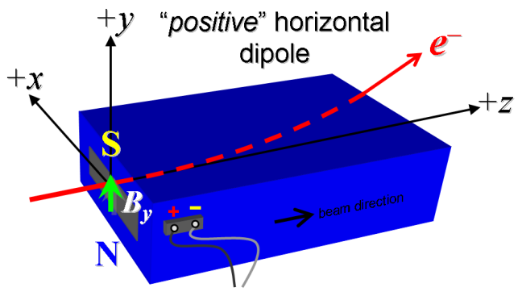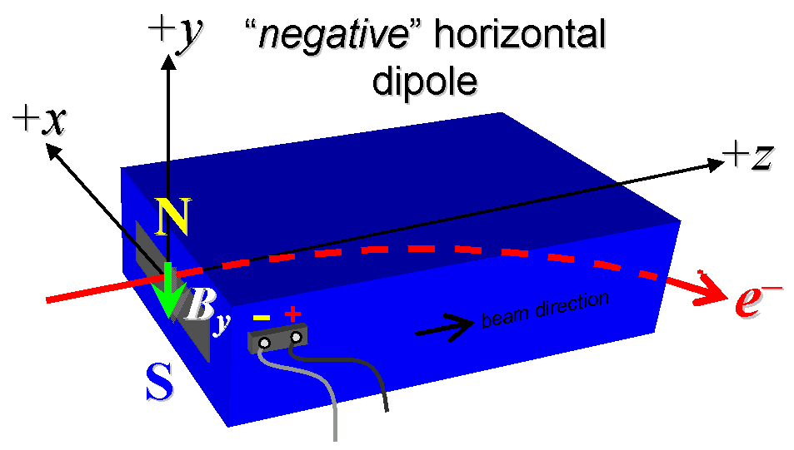
Figure 1. BCX22 and BCX23 are “positive” (left), while BCX21 and BCX24 are “negative” (right).

- Mark the polarity near the main magnet leads with clear “+” and “−” labels as shown above.
Main coil polarity chosen from Fig. 1 is (P or N): | P

- Also mark the trim leads with clear “+” and “−” labels such that, with the trim supply outputting positive current, the trim coil increases the absolute value of the magnetic field established by the main coil. This will set the trim polarity as “positive” for BCX22 and BCX23 and “negative” for BCX21 and BCX24, as described in LCLS-II-2.4-PR-0064 (https://docs.slac.stanford.edu/sites/pub/Publications/Polarity.pdf).
Trim coil polarity chosen from Fig. 1 is (P or N): | P

- Connect the main magnet terminals (not the trims), in the correct polarity as established above, to a unipolar power supply with maximum current I ≥ 200 A (assuming this current produces about 8.6 kG-m integrated field). Leave the trim coil disconnected for now.

- Connect magnet to LCW supply. Adjust supply pressure to a delta P of ~119 psi to achieve a flow rate of 2.25 gpm. Run the magnet up to 200 A for ~1 hour to warm it up (record, delta P, flow rate, and temperature).
LCW delta P (psi) | 110 psi
LCW flow rate (gpm) | 2.6 gpm
LCW delta T (°C) | 7.6 °C
Ambient temperature (°C): | 31.9 °C
Final magnet temperature (°C): | 31.1°C

- Standardize the magnet, starting from zero to 200 A and back to zero, through three full cycles, finally ending at zero, with a flat-top pause time (at both 0 and 200 A) of 10 seconds. Use a ramp rate of 10 A/sec, if possible, and record the ramp rate used.
Standardization complete (initials): | SDA
Ramp rate used (A/sec): | 10 A/sec

- Maintaining this cycle history, measure the length-integrated vertical dipole field, ∫B_{y}dl, from 0 to 200 A in 20-A steps, including zero (11 ‘up’ measurements). Please record (below) the current necessary to achieve 5.0 kG-m. Then, still maintaining the cycle history, measure ∫B_{y}dl back down from 200 A to 0 in 20-A steps, including zero (11 ‘down’ measurements).
Main coil excitation current at 5.0 kG-m: | 113.252 Amps
Filename & run number of ∫B_{y}dl up & down data: | Wireplt.ru1

- With the main coils still hooked up, connect the trim coil to a bipolar 12-A (MCOR12) supply with proper trim polarity as determined above.

- Set the main coil to 0 current by ramping first up to 200 A, then down to zero at the same ramp rate used in the standardization cycle. Measure ∫B_{y}dl as a function of trim coil current from 0 to −12 in 1-A steps, including zero (13 ‘down’ measurements), and again from −12 to +12 A in 1-A steps (25 ‘up’ measurements). Set the trim current to 0.
Filename & run # of ∫B_{y}dl trim data at I_{main} = 0: | Wireplt.ru2

- For all four dipoles, with stretched wire, measure the vertical length-integrated field component over a horizontal span of ±44 mm (±1.7 inches), at each 2-mm interval, at the following main and trim coil current settings.
- I_{main} = 115 A, and I_{trim} = 0
- I_{main} = 115 A, and I_{trim} = +12 A
- I_{main} = 200 A, and I_{trim} = 0
Filename & run # of ∫B_{y}dl vs. x data at 115, 0 A: | Wirevsxplt.ru3
Filename & run # of ∫B_{y}dl vs. x data at 115, +12 A: | Wirevsxplt.ru4
Filename & run # of ∫B_{y}dl vs. x data at 200, 0 A: | Wirevsxplt.ru5

- For the BX24 magnet only, and at a main current of 115 A, with trim current at zero, measure the vertical magnetic fringe field component, B_{y}, at x = y = 0, as a function of the longitudinal beam-direction coordinate, z (from −10 cm to +30 cm in 1-cm steps, where z = 0 is defined at the iron edge), at the downstream end of this one magnet. Please also measure the background field at z = +30 cm with magnet switched off (separate file).
Filename of B_{y} vs. z data for BCX24 exit edge: | N/A
Background filename of B_{y}(z = 30 cm), magnet OFF: | N/A

- For the BX24 magnet only, perform this final thermal test. Run the main current up to 200 A, and with trim also set at its maximum operating current of +12 A, measure the magnet temperature after it stabilizes (~1 hour). Record the temperature below.
Ambient temperature (°C): | N/A °C
Final stable BX24 magnet temperature at 200 A (°C): | N/A °C

- Measure the inductance and resistance of the main and trim magnet coils for each magnet:
Inductance of main coil (mH): | 11.55 mH
Resistance of main coil (Ohms): | 0.153 Ohm
Inductance of trim coil (mH): | 4.25 mH
Resistance of trim coil (Ohms): | 0.283 Ohm

- Upon completion of tests, send traveler to Paul Emma at mailstop 54.

This section is to be completed by P. Emma.
Magnet accepted (signed): | Mark Woodley Via Email
Assigned beamline location (MAD-deck name): | BCX22

- Upon full completion, send this traveler to John Amann at mailstop 52.

