SLAC Traveler for LCLS-II LTUS BY1B, BY2B Vertical Dipole Magnets
(Mar. 22, 2016)

This traveler is intended to cover reception, preparation, mechanical fiducialization, and magnetic measurements of the two LTUS (BY1B & BY2B) vertical dipole magnets. These magnets are newly manufactured versions of the 3D39 (SA-235-623-30) that were previously installed in the FFTB enclosure, are about 1 m long, and have LCLS-II MAD designations of ‘BY1B’ and ‘BY2B’. It is assumed that the magnets will be oriented with horizontal fields (vertical bends) during magnetic measurements; therefore the field is described as B_{x} below.

Receiving:
The following information is to be noted upon receipt of the magnets by the SLAC MFD group:
Received by (initials): | SDA
Date received (dd-mmm-yyyy): | 3/14/2016
SLAC barcode number: | 4500
Vendor serial number from magnet label: | 16079
SLAC approved electrical safety covers? (Y or N): | N
SLAC approved lifting eyes? (Y or N): | N
Magnet damage? (Y or N): | N

Place a barcode sticker on the magnet and
also duplicate the barcode sticker here →

Preparation:
A beam direction arrow, with text “beam direction”, is to be applied to the top and/or connector side of the magnet with a sticker supplied by LCLS-II. John Amann will indicate the beam direction.
Beam-direction arrow in place (initials): | SDA

Fiducialization:
Fiducialization may be done before or after magnetic measurements. The magnet is to be fiducialized by the CMM group. This will require the installation of removable tooling balls, location of the geometric axis of the poles of the magnet, and location of tooling balls with respect to the center of this geometric axis when the poles are aligned precisely horizontal.

CMM technician (initials): | KC

Enter URL of on-line CMM fiducialization data (please modify or correct if necessary):
http://www-group.slac.stanford.edu/met/MagMeas/MAGDATA/LCLS-II/Dipole/BY1B/3D39%20Dipole%204500%20RPO.pdf

Magnetic Measurements:
- Verify that the magnets are complete and undamaged, including wiring connections.
Incoming inspection OK (initials): | sda
Date of arrival to mag. meas.(mmm-dd-yyyy): | 7/18/2016

Enter URL of on-line magnetic measurements data (please modify or correct if necessary):
http://www-group.slac.stanford.edu/met/MagMeas/MAGDATA/LCLS-II/Dipole/BY1B/

- Mark each magnet as BY1B or BY2B. The magnets have the same polarities which are “positive” (bending electrons up).
Magnet marked as (BY1B or BY2B): | BY1B

- Determine the main-coil connection polarity (with main supply outputting positive current) which produces a “positive” field polarity for BY1B and BY2B, as shown below:

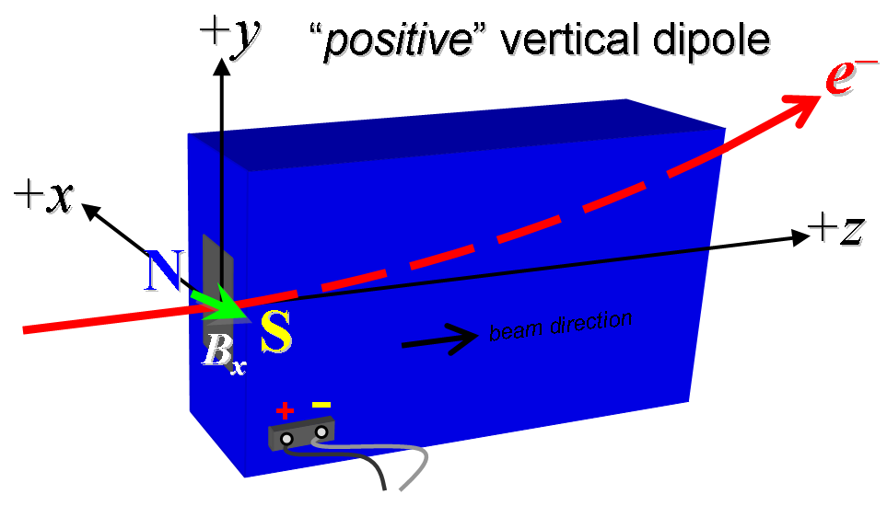
Figure 1. BY1B and BY2B are “positive” vertical bends (bending electrons up).

- Mark the polarity near the magnet leads with clear “+” and “−” labels as shown above. If trim coils exist, they are not used.
Polarity is marked according to Fig. 1 (initials): | SDA

- Connect the magnet terminals, in the correct polarity as established above, to a unipolar (or bipolar) power supply with maximum current I ≥ 10 A.

- Run the magnet up to 10 A for ~2 hours to warm it up (record temperature).
Ambient temperature (°C): | 25.36 °C
Final magnet coil temperature (°C): | 35.67 °C

- Standardize the magnet, starting from zero to 10 A and back to zero, through three full cycles, finally ending at zero, with a flat-top pause time (at both 0 and 10 A) of 10 seconds. Use a ramp rate of 5 A/sec, if possible, and record the ramp rate used.
Standardization complete (initials): | SDA
Ramp rate used (A/sec): | Three Linear Ramp at 5 A/sec

- Maintaining this cycle history, measure the length-integrated horizontal dipole field, ∫B_{x}dl, from 0 to 10 A in 1-A steps, including zero (11 ‘up’ measurements). Then, still maintaining the cycle history, measure ∫B_{x}dl back down from 10 A to 0 in 1-A steps, including zero (11 ‘down’ measurements).
Filename & run number of ∫B_{x}dl up & down data: | Wiredat.ru9

- For both magnets, with main coil still at 7 A, use a stretched wire to measure the vertical length-integrated field (assuming the magnet is oriented on the bench with a vertical field). With the wire located at the vertical mid-plane (y = 0), measure the vertical length-integrated field at each 1-mm step of horizontal wire position, from x = −10 mm to +10 mm, with x = 0 centered at the magnet’s horizontal center. Record data file name:
Harmonics filename: | wirevsx.ru8

- Measure the inductance and resistance of the main magnet coils:
Inductance of main coil (mH): | 106 mH
Resistance of main coil (Ohms): | 1962.3 mOhm

- Measure the pole tip field at 10 amps:
Current of main coil (A): | 10.00517 A
Pole Tip Field (T): | 0.1488 T

- Upon completion of tests, email traveler for review to: John Amann (amann@slac.stanford.edu).

This section is to be completed by P. Emma.
Magnet accepted (signed): | Via email
Assigned beamline location (MAD-deck name): | BY1B

- Upon full completion, send this traveler to Kathleen Ratcliffe at mailstop 52.

