SLAC Magnetic Measurements Test Plan for LCLS-II BYDG0

(BXS Type Spectrometer) Dipole Magnet
(July 21, 2020) Rev 2

This traveler is intended to cover setup, mechanical fiducialization, and magnetic measurements of the BYDG0 (BXS type) straight-through spectrometer dipole magnet. This magnet nominally bends the 100-MeV electron beam up by 35 degrees with a pole-face rotation of 7.5 degrees and a main coil and no trim coil. Note that as installed in the tunnel, the BYDG0 is a vertical dipole (main field is horizontal), but for magnetic measurements it will be measured as a horizontal dipole, with the main field vertical. In an attempt to avoid confusion in the future, the data file coordinates will be given as if the BYDG0 was measured as it will be installed, as a vertical dipole. The axes directions and signs will correspond to the beam direction and “Top” sticker labels on the BYDG0 magnet. Thus, the measurement plane in which the hall probe will move will be designated in the data files as y-z and the axis of the main field will be designated as x. This test plan will also follow this convention.

Receiving:
The following information is to be noted upon receipt of the magnets by the SLAC MM group:
SLAC barcode number: | 4173
SLAC approved electrical safety covers? (Y or N): | N
SLAC approved lifting eyes? (Y or N): | N
Shipping Damage? (Y or N): | N
SLAC drawing number: | SA-380-317-40, SA-375-500-80
Date of arrival to magnetic meas.(mmm-dd-yyyy): | 8-21-2020

Preparation:
A beam direction arrow, with text “Beam Direction”, is to be applied, as shown in Figure 1 and drawing SA3755002800, to the top and power connector side of the magnet using stickers supplied by LCLS-II. A “Top” sticker label will also be affixed to the top of the magnet. Looking from the upstream end of the magnet toward the downstream end the power connections are down and to the right hand side.
Beam-direction arrow and “Top” in place (initials): | SDA

Fiducialization:
The magnet is to be fiducialized by the CMM group. This will require the installation of removable tooling balls, location of the geometric center of the magnet poles, location of the pole faces, and location of tooling balls with respect to these points.
The CMM group will establish a horizontal mid-plane and coordinate axis on this plane with origin at the geometric center of the poles. The geometry should be taken from the poles of the magnet, not the exterior yoke.
CMM technician (initials): | BR

URL of on-line CMM fiducialization data (please modify or correct URL if necessary):
http://www-group.slac.stanford.edu/met/MagMeas/MAGDATA/LCLS-II/Fiducial%20Reports/4173_Fiducial_Report.pdf

Magnetic Measurements:
- Enter URL of on-line magnetic measurements data (please modify or correct if necessary):
http://www-group.slac.stanford.edu/met/MagMeas/MAGDATA/LCLS-II/dipole/4173

- Connect water cooling to the manifolds. The design maximum pressure drop is 60 psi across the manifolds which should give a flow of 1.7 gpm. Measure and record flow rate.
- Determine the connection polarity (with power supply outputting positive current) which produces a bend as shown in Figure 1 below. Mark the polarity near the magnet leads with clear “+” and “−” labels. Connect the magnet terminals in the correct polarity as established above to a unipolar power supply with maximum current I ≥ 240 A.

Magnet polarity (Fig. 1) has been marked (initials): | SDA

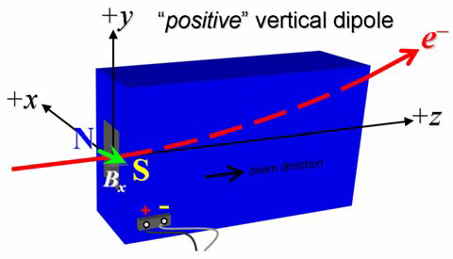
Figure 1: The BYDG0 magnet is defined as a “positive” vertical dipole magnet, bending the electron beam up as the beam leaves the observer.

- Run the magnet up to 160 A for ~2 hours to warm it up to nominal (record temperature).
Record Flow Rate | 1.8 gpm
LCW delta T (°C) | 3.7 °C
Ambient temperature (°C): | 28.1 °C
Magnet Coil temperature: | 32.1 °C
Magnet Core temperature: | 29.4 °C

- Standardize the magnet, starting from zero to 240 A and back to zero, through three full cycles, finally ending at zero. Use a cosine type of ramp with a ramp rate of 10 A/sec and a 10 second pause for both the standardize and trim ramps. Record the ramp type and rate used.
Standardization complete (initials): | SDA
Ramp rate used (A/sec): | 10 A/sec

- Using a Hall probe, measure the peak horizontal field in the mid-plane (x = 0) at “point a” in Fig. 2, which is at (y, z) = (−19, 0) mm and based on the fiducial data. The field is measured while varying the excitation current from 0 to 240 A, and back to 0, in 5-A steps.
Name and run number of Hall probe data file: | bhvsxydat.ru2, bhvsxyplt.ru2

- Record the current, I_{nom}, corresponding to the approx. nominal operating field (at pole center) of 0.375 T (approximately 105 A).
Current needed to obtain 0.375 T field (Amperes): | I_{nom} = 107.3631 Amps

- At I = 105 A (unless I_{nom} is more than 10% different), use a Hall probe to measure the horizontal magnetic field, B_{x}, in a small y-z grid (at y = 0), as shown below in Fig. 2 (blue). Use a transverse grid-width of 10 cm and a longitudinal grid-length of 20 cm, each with 0.5-cm spacing (800 field measurements). The grid should be in the mid-plane (x = 0), centered at the downstream edge of the poles with a 19-mm shift in the +y direction from the pole-face’s transverse center (established by CMM), and rotated 17.5° CCW with respect to the z-axis (i.e., rotated 7.5° CCW with respect to the pole face plane), as shown in Fig. 2. The y-z coordinates shown in Fig. 2 have their origin at the geometric center of the poles.

Filename of Hall probe grid data file (I = 105 A): | bhvsxydat.ru3, bhvsxyplt.ru3
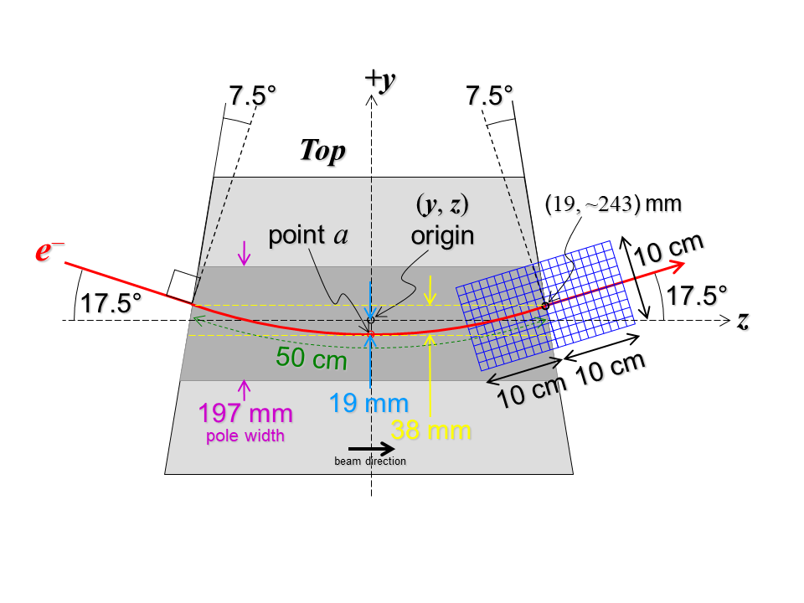
Figure 2: Schematic top view of magnet on measurement bench, showing beam trajectory (red), Sagitta (cyan), arc-length (green), pole-face rotation angle, and Hall probe measurement grid (blue). The y-z coordinate system used here has its origin at the geometric center of the poles, with the grid centered at y = +19 mm and z at the pole-face edge (z ≈ +243 mm), and rotated 17.5° CCW with respect to the z-axis (i.e., rotated 7.5° CCW with respect to the pole face plane).

- At this point the data analysis is done (M. Woodley) and a determination is made as to whether to machine the pole end-plates. If new end-plates are machined and re-installed on the magnet, the grid measurement is again repeated at 105 A. If the field quality now meets specifications, the grid measurement is repeated twice more at 85 and 125 A. If not, these steps will need to be repeated. (Please attach the pole end-plate machining specifications and related details to this traveler.)
Pole end-plates required machining (Yes or No)? | No
Pole end plates machining spec. attached (initials): | N/A
Filename of Final Hall probe grid file (I = 105 A): | bhvsxydat.ru3, bhvsxyplt.ru3
Filename of Final Hall probe grid file (I = 85 A): | bhvsxydat.ru4, bhvsxyplt.ru4
Filename of Final Hall probe grid file (I = 125 A): | bhvsxydat.ru5, bhvsxyplt.ru5

- At I = 105 A, and with a Hall probe at the mid-plane (y = 0), measure the horizontal field, Bx, every 1-cm step while moving along the ‘design’ electron trajectory arc shown in Fig. 2 (red, passing through “point a”). This trajectory consists of a straight line at −17.5° (prior to magnet entrance), a semi-circle (curved trajectory inside the magnet), and another straight line at 17.5° (after magnet exit). These measurement x-z coordinates are numerically prescribed in Table 1 below, out to 15 cm beyond the pole-face edges. Figure 3 shows a plot of this trajectory. (Assuming the excitation current is identical to that in step 7, please verify that the field measured at “point a” in Fig. 2 is identical to that measured in step 7 above to within 0.2%.) Repeat this measurement twice more at I = 85 A and I = 125 A.

Table 1. The trajectory coordinate pairs here are ordered first from top to bottom (rows 1-20), and then left to right (columns 1-4) and the data is plotted in Fig. 3.
column-1 |  | column-2 |  | column-3 |  | column-4
y  (mm) | z  (mm) | y  (mm) | z  (mm) | y  (mm) | z  (mm) | y  (mm) | z  (mm)
63.89 | -389.18 | 5.22 | -198.01 | -19.00 | 0 | 5.22 | 198.01
60.89 | -379.65 | 2.86 | -188.29 | -19.02 | 10.00 | 7.70 | 207.70
57.88 | -370.11 | 0.62 | -178.55 | -18.84 | 19.99 | 10.29 | 217.36
54.87 | -360.57 | -1.49 | -168.78 | -18.53 | 29.99 | 13.01 | 226.98
51.87 | -351.03 | -3.50 | -158.98 | -18.11 | 39.98 | 15.84 | 236.57
48.86 | -341.50 | -5.38 | -149.16 | -17.56 | 49.96 | 18.79 | 246.13
45.85 | -331.96 | -7.14 | -139.31 | -16.89 | 59.94 | 21.80 | 255.66
42.85 | -322.42 | -8.78 | -129.45 | -16.09 | 69.91 | 24.80 | 265.20
39.84 | -312.89 | -10.30 | -119.57 | -15.18 | 79.87 | 27.81 | 274.74
36.83 | -303.35 | -11.70 | -109.66 | -14.14 | 89.81 | 30.82 | 284.27
33.82 | -293.81 | -12.98 | -99.75 | -12.98 | 99.75 | 33.82 | 293.81
30.82 | -284.27 | -14.14 | -89.81 | -11.70 | 109.66 | 36.83 | 303.35
27.81 | -274.74 | -15.18 | -79.87 | -10.30 | 119.57 | 39.84 | 312.89
24.80 | -265.20 | -16.09 | -69.91 | -8.78 | 129.45 | 42.85 | 322.42
21.80 | -255.66 | -16.89 | -59.94 | -7.14 | 139.31 | 45.85 | 331.96
18.79 | -246.13 | -17.56 | -49.96 | -5.38 | 149.16 | 48.86 | 341.50
15.84 | -236.57 | -18.11 | -39.98 | -3.50 | 158.98 | 51.87 | 351.03
13.01 | -226.98 | -18.53 | -29.99 | -1.49 | 168.78 | 54.87 | 360.57
10.29 | -217.36 | -18.84 | -19.99 | 0.62 | 178.55 | 57.88 | 370.11
7.70 | -207.70 | -19.02 | -10.00 | 2.86 | 188.29 | 60.89 | 379.65

Field at “point a” agrees measured step 7: | Yes. Ratio = 0.367061/ 0.367057 = 1.00001
Filename of Hall probe line-integral file (I = 105 A): | bhvsxydat.ru6, bhvsxyplt.ru6
Filename of Hall probe line-integral file (I = 85 A): | bhvsxydat.ru7, bhvsxyplt.ru7
Filename of Hall probe line-integral file (I = 125 A): | bhvsxydat.ru8, bhvsxyplt.ru8

- At I = 105 A, with a Hall probe at the mid-plane (y = 0), measure the horizontal field, Bx, every 0.5 cm step in Z from -390 mm to +390 mm while moving along a straight line trajectory shown along x = +2, 0, -2 mm, Fig. 2 (at 0 and +/- 2 mm around black dashed line going through origin)
Filename of Hall probe Straight Ahead file (I = 105 A): | bhvsxydat.r10, bhvsxyplt.r10

- If deemed necessary. At I = 105 A, with a stretched wire at the mid-plane (x = 0), measure the integral horizontal field, Integral Bx, along a straight z line trajectory at y = 0 mm with a delta y movement of 4 mm, Fig. 2 (black dashed line going through origin).
Filename of Wire Straight Ahead file (I = 105 A): | Wiredat.r13, wireplt.r13
Ratio of Step 12 integral field to mean of Step 11 integral fields. | 1.9259e-01/1.9253e-01 = 1.00032

- Perform a final thermal test. Run the current up to 240 A for 4 hours. Measure the magnet temperature after it stabilizes Record the temperature below.
Record Flow Rate | 1.8 gpm
LCW delta T (°C) | 7.9 °C
Ambient temperature (°C): | 25.3 °C
Magnet Coil temperature: | 34.9 °C
Magnet Pole temperature: | 29.6 °C

- Measure the inductance and resistance of the full magnet.
Inductance of full magnet (mH): | 6.434 mH
Resistance of full magnet (Ohms): | 0.1114 Ohm

- Upon completion of tests, email URL of on-line data to Mark Woodley. Mark Woodley will determine if the magnet is accepted. Upon acceptance of magnet, analysis data will be placed in on-line data folder.
Magnet accepted and Analysis file(s) put into on-line data folder (initials): | SDA
Assigned beamline location (MAD-deck name): | BYDG0

