SLAC Magnetic Measurement Plan for LCLS-II PEPPEx Chicane Corrector Magnets
(November 24, 2021)

This measurement plan covers the magnetic measurements of the four PEPPEx chicane corrector magnets. These are SLAC modified Type-4 correctors, whose gaps have been modified to be 2.19 inches, instead of 4 inches. Their MAD names are: XCPEPX1, XCPEPX2, XCPEPX3, and XCPEPX4 and they have drawing numbers DSG-000013399. The table below gives the MAD names, engineering name, barcode and polarities of the PEPPEx chicane corrector magnets. The install drawing file for the magnets is DSG-000015031.

MAD Name | Eng. Name | Barcode | Polarity
XCPEPX1 | 2.19 Gap Type 4 | 4778 | N
XCPEPX2 | 2.19 Gap Type 4 | 4779 | P
XCPEPX3 | 2.19 Gap Type 4 | 4780 | P
XCPEPX4 | 2.19 Gap Type 4 | 4781 | N
Table 1
Receiving:
The following information is to be noted upon receipt of the magnets by the SLAC MM group:
Received by (initials): | SDA
Date placed on test stand (dd-mmm-yyyy): | 12/1/2021
SLAC barcode number: | 4781

Preparation:
A beam direction arrow, with text “Beam Direction”, is to be applied to the top side of the magnet. The MAD name label should also be attached to the magnet.
Beam-direction arrow and MAD name in place (initials): | SDA

Fiducialization:
Fiducialization is not required for these magnets, since they are clamped on the beam pipe. A bubble level on the magnet steel frame will be used for roll and picth and the inside of the steel frame is used to the center the magnet onto the centerline beam axis.

Magnetic Measurements:
- Verify that the magnets are complete and undamaged, including wiring connections.
Incoming inspection OK (initials): | SDA
Date of arrival to mag. meas.(mmm-dd-yyyy): | 12/1/2021

- Measure the inductance and resistance of the main and trim magnet coils and also verify the concurrent magnet temperature:
Magnet Coil temperature on top surface (ºC): | 21.0
Inductance of main coil (mH): | 67.43
Resistance of main coil (Ohms): | 2.342

Enter URL of on-line magnetic measurements data (please modify or correct if necessary):
https://www-group.slac.stanford.edu/met/MagMeas/MAGDATA/LCLS-II/Corr/4781

- Determine the main-coil connection polarity and mark the polarity near the magnet leads with clear “+” and “-” labels as shown below.
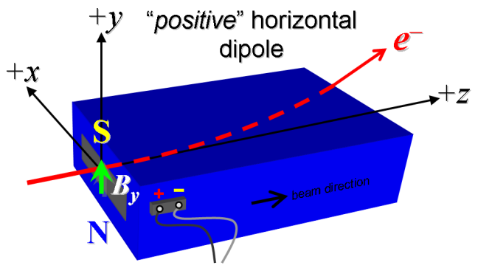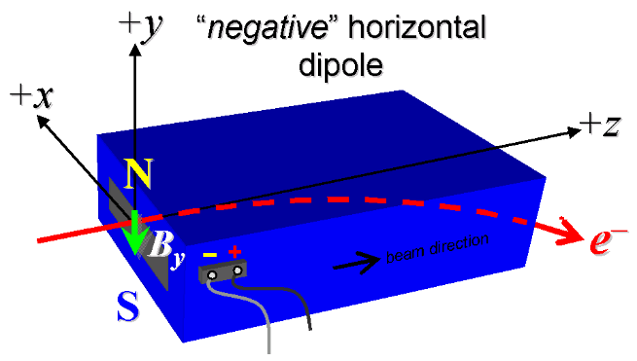

Figure 1. “Positive” polarity (bending electrons left) . “Negative” polarity (bending electrons right).
Marked Main Coil Polarity, must match Polarity in Table 1: | N

- Connect the magnet terminals, in the correct polarity as established above, to a bipolar power supply with maximum current I ≥ 6 A. Measure the field in the center of the magnet with the main at 6 A.
Center Field and Current | 0.0432 T at 5.9986 Amps

- For one of the magnets, set the magnet’s main to 6 A for ~5 hours to warm it up (verify this is steady-state temp. and record value). Do not let the coil temperatures exceed 65 °C.
Ambient temperature (°C): | Measured on 4778
Final magnet top frame surface temperature (°C): | Measured on 4778
Final magnet top coil surface temperature (°C): | Measured on 4778

- Standardize magnet using a three cycles, starting from zero to 6 A, then to −6 A, and finally back to zero, through three of these full cycles, and ending again at -6 A, all with a flat-top pause time (at each setting of −6 and +6 A) of 10 seconds. Use a cosine ramp rate of 1.0 A/sec and record the ramp rate used.
Standardization complete (initials): | SDA
Ramp rate used (A/sec): | 1 A/sec

- Maintaining the cycle history, measure the length-integrated vertical dipole field, ∫B_{y}dl, from -6 to +6 A in 1.0 A steps (13 ‘up’ measurements) with at least a 10-sec pause at each setting). Then, still maintaining the cycle history, measure ∫B_{y}dl back down from +6 A to −6 A in 1.0 A steps . The integrated field at 6 Amps must be greater than 0.012 T-m.
Filename & run number of ∫B_{y}dl up & down data: | Wiredat.ru1, wireplt.ru1

- Repeat the bipolar standardization of step #6 above and measure the length-integrated vertical dipole field, ∫B_{y}dl, at I_{main} = 0.
Filename & run number of ∫B_{y}dl at I_{main} = 0: | Wiredat.ru2, wireplt.ru2

- For all four dipoles, with a stretched wire, measure the length-integrated vertical field over a horizontal span of ±9 mm at each 3-mm interval, at the +6 Amps on the main coil.

Filename & run # of ∫B_{y}dl vs. x data at 6 A: | Wirevsx.ru1, wirepltvsx.ru1

- Upon completion of tests, send data link to Mark Woodley who will produce a data analysis file. Place data analysis file in magnetic measurements data directory
Magnet data accepted and data analysis file produced | SDA

Enter URL of on-line magnetic measurements analysis data :
https://www-group.slac.stanford.edu/met/MagMeas/MAGDATA/LCLS-II/Corr/4781/XCPEPX4.pptx

