LCLS-II Traveler for the PEP-II Corrector Magnets
May 16, 2021
This traveler is intended to cover magnetic measurements of the PEP-II steering coil corrector magnets. This test will be done for one of each magnet of this type. These correctors are 2.9XC7.25 type have a yoke length of 7.25 inches and a gap of 2.9 inches. The difference between the 4 types are the number of winding in the coils. The coil color delineates the type. Green has 24 turns, Purple has 48 turns, White has 88 turns and Blue has 108 turns of 12 AWG round wire.

Receiving:
The following information is to be noted upon receipt of the magnets by the SLAC MM group:
Received by (initials): | SDA
Date of magnetic measurements (mmm-dd-yyyy): | 5/19/2021
Color of Coil | White
SLAC Barcode Number: | L204776
SLAC Drawing Number: | SA-344-117-01

Preparation:
- Measure the inductance and resistance of this magnet:
Magnet Inductance (mH) (1 V @ 100 Hz): | 36.5 mH
Magnet Resistance (Ohms): | 0.6796 Ohm

Fiducialization:
No fiducialization needs to be done for these small steering coil magnets.

Magnetic Measurements:
Enter URL of on-line magnetic measurements data (please modify or correct if necessary):
https://www-group.slac.stanford.edu/met/MagMeas/MAGDATA/LCLS-II/Corr/4776

- Determine connection polarity with power supply outputting positive current for both the coils and giving a positive field as shown in Figure 1. Verify the polarity and label the magnet leads with clear “+” and “−” labels as shown above.
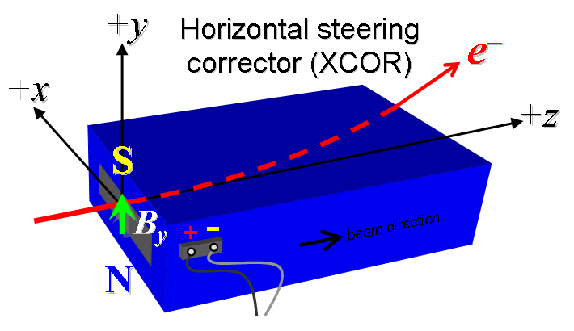
Figure 1. XCOR configuration. All steering coils are defined as “positive” and are powered by bipolar supplies.

- Connect the magnet terminals, in the correct polarity as established above, to a bipolar power supply with maximum current I ≈ ±6 A. Record ramp parameters used.

Ramp Type | Linear
Ramp Rate | 1 A/s
Settle Time | 5 seconds

- Run the coil up to 6 A for 2 hours to warm it up (record temperatures).
Ambient temperature (°C): | 21.1 °C
Final Top Coil temperature (°C): | 35.0 °C
Final Bottom Coil temperature (°C): | 34.0 °C

- Measure the length-integrated, vertical dipole field, ∫B_{y}dl, from −6 to +6 A in 1-A steps, including zero (13 ‘up’ measurements), and then back down from +6 A to −6 in 1-A steps, including zero (13 ‘down’ measurements).
Filename & run number of ∫B_{y}dl data: | Wiredat.ru1, wireplt.ru1

- Measure the dipole field B_{y} in the center of the gap with Hall probe from −6 to +6 A in 1-A steps, including zero (13 ‘up’ measurements), and then back down from +6 A to −6 in 1-A steps, including zero (13 ‘down’ measurements).
Filename & run number of B_{y} data: | Bhvszdat.ru2, bhvszplt.ru2

