LCLS-II Traveler for the Class-6 Corrector Magnets – SA-375-150-81
Oct. 11, 2017 – (approved by P. Emma)

This traveler is intended to cover magnetic measurements of the Class-6 steering corrector magnets. These are small bipolar steering coils used primarily in the LCLS-II injector and BC1 area. Each magnet consists of one pair of coils used to generate a vertical (XCOR) or a horizontal (YCOR) field, depending on its orientations (see Fig. 1). The YCOR is simply a 90-deg rotated XCOR magnet.

Receiving:
The following information is to be noted upon receipt of the magnets by the SLAC MFD group:
Received by (initials): | SDA
Date placed on test stand (dd-mmm-yyyy): | 10/19/2017
SLAC barcode number: | 4642
Vendor serial number from magnet label: | 023
SLAC approved electrical safety covers? (Y or N): | N
SLAC approved lifting eyes? (Y or N): | N/A
Shipping Damage? (Y or N): | N
Vendor tests passed on magnet label? (Y or N):
SLAC drawing number (enter number): | SA-375-150-81

Preparation:
A beam direction arrow, with text “beam direction”, is to be applied to the top and/or connector side of the magnet, preferably by stenciling or rubber stamp, or by sticker supplied by LCLS-II. Place the beam direction arrow pointing as shown in Fig. 1.
Beam-direction arrow in place (initials): | SDA

Fiducialization:
No fiducialization needs to be done for these small steering coil magnets.

Magnetic Measurements:
Enter URL of on-line magnetic measurements data (please modify or correct if necessary):
http://www-group.slac.stanford.edu/met/MagMeas/MAGDATA/LCLS-II/Corr/4642/

- Determine connection polarity (with power supply outputting positive current) which produces a “positive” field polarity as shown below:
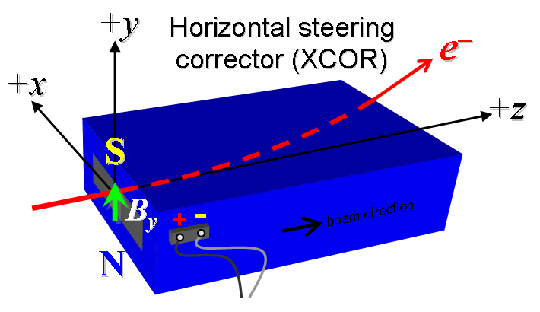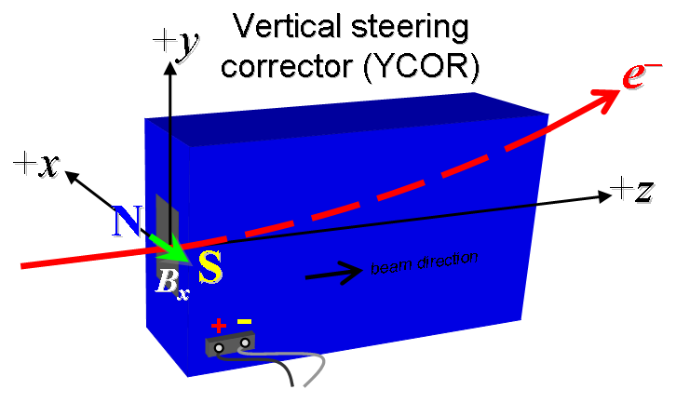
Figure 1. All steering coils are defined as “positive” with both configurations (XCOR at left and YCOR at right) shown. Each magnet is powered by an independent bipolar power supply. The YCOR is simply a 90-deg rotated XCOR magnet.

- Mark the polarities near the magnet leads with clear “+” and “−” labels as shown above.
Labels and polarities have been marked (initials): | SDA

- Connect the magnet terminals, in the correct polarity as established above, to a bipolar power supply with maximum current of at least I ≈ ±6 A.

- For one magnet only, run the coil up to 6 A for ~4 hours to warm it up (record temperature).
Ambient temperature (°C): | N/A (see corr 4610 for data) °C
Final magnet temperature (°C): | N/A (see corr 4610 for data) °C

- For each magnet, measure the dipole field B_{y} in the center of the gap with Hall probe from −6 to +6 A in 1-A steps, including zero (13 ‘up’ measurements), and then back down from +6 A to −6 in 1-A steps, including zero (13 ‘down’ measurements).
Filename & run number of B_{y} data: | bhvszdat.ru1

- For one magnet only, measure the length-integrated dipole field, ∫B_{y}dl, from −6 to +6 A in 1-A steps, including zero (13 ‘up’ measurements), and then back down from +6 A to −6 in 1-A steps, including zero (13 ‘down’ measurements).
Filename & run number of ∫B_{y}dl data: | N/A (see corr 4610 for data)

- Measure the inductance and resistance of this magnet:
Inductance of XCOR coils (mH): | 10.34 mH
Resistance of XCOR coils (Ohms): | 1.367 Ohm

- Upon completion of tests, send data link to Mark Woodley who will produce a data analysis file. Place data analysis file in magnetic measurements data directory.

Magnet data accepted and data analysis file produced | Type 6 Analysis.pptx

Enter URL of on-line magnetic measurements analysis data:
http://www-group.slac.stanford.edu/met/MagMeas/MAGDATA/LCLS-II/Corr/4642/

