LCLS-II Traveler for the Class 1A Corrector Magnets
May 5, 2017

This traveler is intended to cover magnetic measurements of the Class 1A corrector magnets.

Receiving:
The following information is to be noted upon receipt of the magnets by the SLAC MFD group:
Received by (initials): | SDA
Date placed on test stand (dd-mmm-yyyy): | 11/9/2017
SLAC barcode number: | 4608
Vendor serial number from magnet label: | 002
SLAC approved electrical safety covers? (Y or N): | Y
SLAC approved lifting eyes? (Y or N): | n/a
Shipping Damage? (Y or N): | N
Vendor tests passed on magnet label? (Y or N): | N
SLAC drawing number (enter number): | SA-380-314-26

Preparation:
A beam direction arrow, with text “beam direction”, is to be applied to the top and/or connector side of the magnet, preferably by stenciling or rubber stamp, or by sticker supplied by LCLS-II. Place the beam direction arrow pointing as shown in Fig. 1.
Beam-direction arrow in place (initials): | SDA

Fiducialization:
No fiducialization needs to be done for these small steering coil magnets.

Magnetic Measurements:
Enter URL of on-line magnetic measurements data (please modify or correct if necessary):
http://www-group.slac.stanford.edu/met/MagMeas/MAGDATA/LCLS-II/Corr/4608/

- Determine connection polarities (with power supply outputting positive current) for both the coils, which produce a “positive” field polarity as shown below:

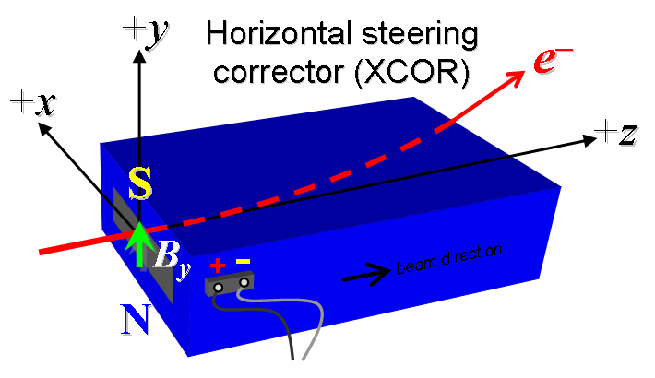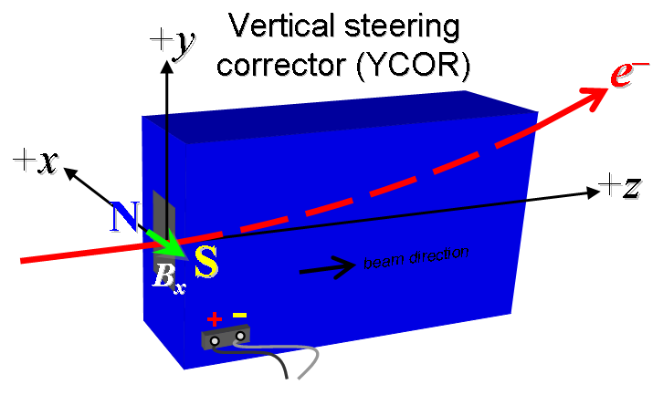
Figure 1. All steering coils are defined as “positive” and are powered by bipolar supplies.

- Mark the polarities near both pairs of magnet leads with clear “+” and “−” labels as shown above.
Labels and polarities have been marked (initials): | SDA

- Connect the magnet terminals, in the correct polarity as established above, to a bipolar power supply with maximum current I ≈ ±6 A.

- Measure the dipole field B_{x} in the center of the gap with Hall probe from −6 to +6 A in 1-A steps, including zero (13 ‘up’ measurements), and then back down from +6 A to −6 in 1-A steps, including zero (13 ‘down’ measurements).
Filename & run number of B_{x} data: | Bhvszdat.ru2

- Measure the dipole field B_{y} in the center of the gap with Hall probe from −6 to +6 A in 1-A steps, including zero (13 ‘up’ measurements), and then back down from +6 A to −6 in 1-A steps, including zero (13 ‘down’ measurements).
Filename & run number of B_{y} data: | Bhvszdat.ru1

- For one magnet only, measure the length-integrated dipole field, ∫B_{x}dl, from −6 to +6 A in 1-A steps, including zero (13 ‘up’ measurements), and then back down from +6 A to −6 in 1-A steps, including zero (13 ‘down’ measurements).
Filename & run number of ∫B_{x}dl data: | N/A

- For one magnet only, measure the length-integrated dipole field, ∫B_{y}dl, from −6 to +6 A in 1-A steps, including zero (13 ‘up’ measurements), and then back down from +6 A to −6 in 1-A steps, including zero (13 ‘down’ measurements).
Filename & run number of ∫B_{y}dl data: | N/A

- Measure the inductance and resistance of each of the two coils on this magnet:
Inductance of XCOR coils (mH): | 0.768 mH
Resistance of XCOR coils (Ohms): | 0.161 Ohm @ 22.1 ºC
Inductance of YCOR coils (mH): | 0.607 mH
Resistance of YCOR coils (Ohms): | 0.149 Ohm @ 22.1 ºC

- Upon completion of tests, send data link to Mark Woodley who will produce a data analysis file. Place data analysis file in magnetic measurements data directory

Magnet data accepted and data analysis file produced | Via email

Enter URL of on-line magnetic measurements analysis data :
http://www-group.slac.stanford.edu/met/MagMeas/MAGDATA/LCLS-II/Corr/4608/Type 1a.pptx

