Manual
Remote Rotary Switcher (RRS)

RRS – Remote Rotary Switcher allows personnel to operate remotely the rotary control switch from outside the arc flash boundary – reducing or eliminating the possibility of serious injury or death resulting from an arc flash.
Components:
The components of the RRS shown in the picture 1, and listed below:
Camera
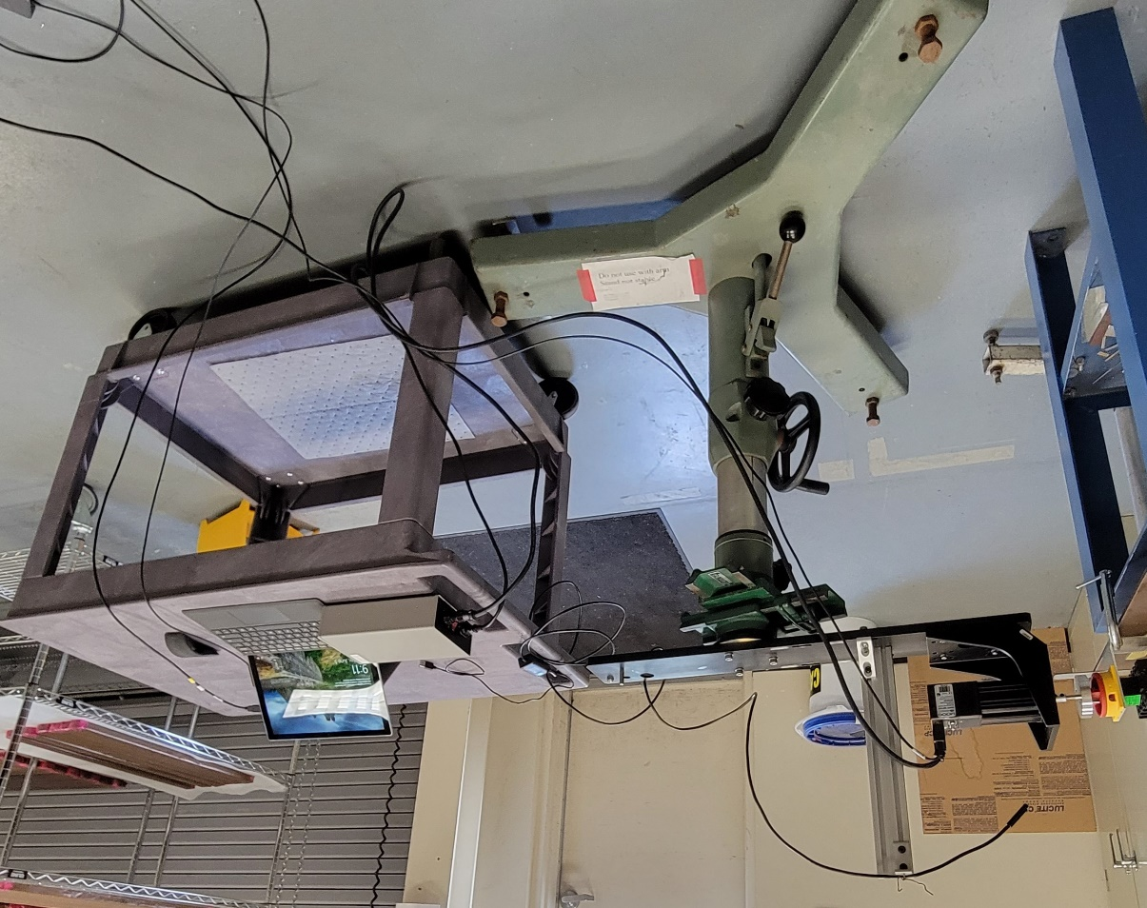
Control
switch
Alignment
stages
Alignment
pedestal
PS
Laptop
Switch key
Motor
Picture 1. Remote Rotary Switcher components.
- Motor
- Camera
- Switch key
- Alignment pedestal with stages
- Power supply
- Laptop

Installation:
- Position the system next to the control switch.
- Align the switching key to the control switch handle as shown in the picture 2 below with the use of the pedestal vertical adjustment mechanism and stages. Make sure the motor shaft is level. The gap between the key and the handle should be 1÷2mm.
- Rotate the key clockwise until it touches the switch handle.
- Turn the motor power ON with the power switch on the back of the PS.
- Login into the SLAC user account on the system laptop and start the camera software.
- Adjust the camera position until the control switch is visible on the screen.
- Make sure nobody is in the room.
- Exit the room, lock the doors, and install a danger tape to prevent other personnel to come into the room. Leave the system laptop in the room.

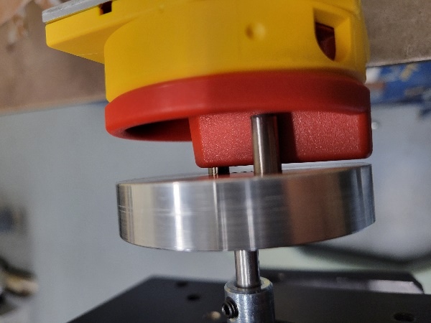
1÷2 mm gap
Picture 2. The RRS key aligned to the control switch handle
Operation:
- In the outside room, login into a separate computer.
- Remotely login into the system laptop.
- Start the system operating software. The user interface looks like in the picture 3 below.
- Press the “Turn Switch On” button to turn the control switch into ON position. Verify that the switching is complete by checking the camera image.
- If the switching is not complete (partly rotates), “Stop Motor” button to remove the torque from the switch then press the “Turn Switch Off “ button to disengage it from the key. It will prevent the switch from rotation into ON position by itself. Check the camera image of the control switch.
- Press the “Turn Switch Off“ button again to turn the control switch into OFF position. Check the camera image.
- Move into the room and make sure the key aligned properly to the control switch handle.
- Repeat the procedure.

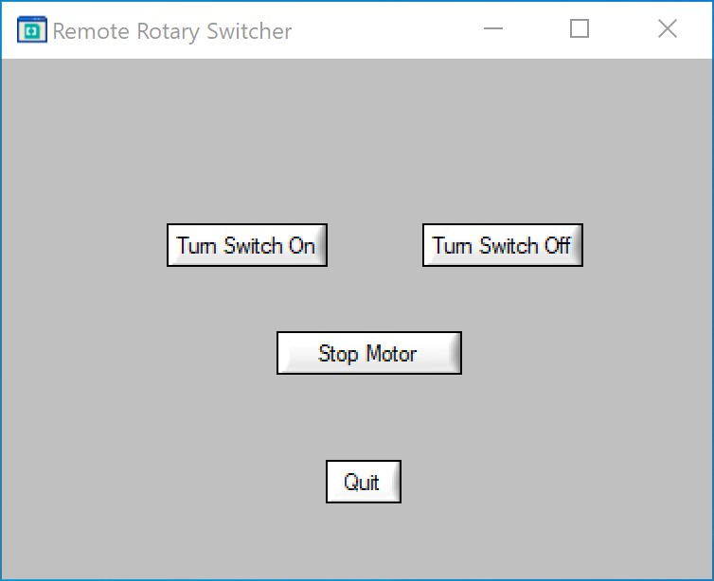
Picture 3. The RSS User Interface

Safety:
To eliminate the possibility of serious injury or death resulting from an arc flash:
- The system operated remotely from another room or from proper distance.
- No other personal in the same room when the system is in use.
- Entry doors locked, danger tape is in place to keep people from entering the room.

