LCLS-TN-22-nn

Magnetic Measurements of SXU-HE Short Prototype

Yurii Levashov, Zack Wolf

*SLAC National Accelerator Laboratory*

January, 2022

**Abstract**

The magnetic structures of the SXR undulator line will be replaced with higher field, longer period structures. Two 0.37m long new magnet assemblies were manufactured at LBNL. The assemblies were installed on a 1m long frame to make a short undulator prototype. The prototype was measured on the SXU measurement bench at the SLAC MMF. The results of the measurements are presented.

1. **Introduction[1]**

The next upgrade to LCLS-II FEL will double the energy of the LCLS-II superconducting linac from 4GeV to 8 GeV[2]. To keep the same range of photon energy in the soft X-ray line, the undulator period will be increased from 39mm to 56mm, and the effective undulator magnetic field *Beff* will be >1.76T. The corresponding undulator K is 9.21 or higher. Tolerances on the field integrals are the same as for LCLS-II undulators: ±50µTm for the first field integrals and ±200µTm2 for the second field integrals. The phase errors should be below 5° rms.

A prototype of the new magnetic structure was designed, and two 14 pole, 366 mm long, magnet assemblies were fabricated at LBNL. At the SLAC MMF, the assemblies were secured on a 1m long frame, left over from the LCLS-II project. The gap motion system was upgraded by SLAC with two new motors and a new controller. There are no gap encoders. The gap is set by absolute rotary motor encoders.

The assembled SXU-HE short prototype was placed in the MMF on the SXU measurement bench, as shown in picture 1.

Figure 1. SXU-HE short prototype on the measurement bench

Several tests were performed to study the properties of the new magnetic structure, tunability of field integrals, and accuracy of Hall probe measurements of high magnetic fields.

**2. Hall probe measurements for pole saturation study**

The field measurements of the prototype were made with a Sentron 2-D probe calibrated up to 1.9T.

Before the measurements, the magnet structures were aligned w.r.t each other and to the bench granite with the use of a laser tracker. The taper in the magnetic field along the beam axis was corrected to a minimum by inserting shims in between the magnets’ keepers and supporting strongbacks. The frame is rigid but the gap adjustment mechanics, especially rail slides, are not strong enough to keep the gap at constant value. This was known from the previous measurements for the LCLS-II project. The looseness in the slides could result in gap drifts, and in larger than usual measurement errors. The errors should still be small enough for our tests.

The initial measurements of magnetic fields on the axis at minimum (7.2mm) gap are shown in figure 2. The *Bx* field is below 10G. This indicates that there are no large magnetization errors, and the pole alignment is good.



Figure 2. *Bx* and *By* fields vs z at 7.2mm gap

The absolute peak fields are shown in figure 3. Three poles from each end are excluded from analysis. The core poles are shown only. The average field is 1.8364±0.0073T, which is higher than required by 4.4%.

Figure 4 shows the second field integrals along the beam axis calculated from the Hall probe measurements. There are ~25µTm2 shifts after each end section of the vertical field integral in the same direction, ~50µTm2 intotal. It agrees with simulations done by LBNL. The shifts are well below the tolerance of 200µTm2. They could be easily corrected in the tuning process.

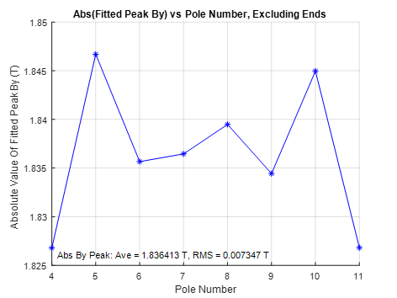

Figure 3. Absolute peak fields for core poles Figure 4. Second field integrals and corresponding 10-point averages vs z.

The absolute average field peaks are shown in figure 5. There is a small saturation at gaps below 9mm (*B* > 1.5T) visible in the difference between a fit to the measurements and the Halbach formula for hybrid undulators.[3]

Phase errors for core poles are shown in figure 6. The rms phase error is 2.2°, which is well below 5° tolerance. The magnets are made very well, so that even with a limited sorting, the field quality is very high.



Figure 5. Absolute average field peaks vs gap Figure 6. Phase errors for poles in the undulator core.

**3. Field integrals measurements**

The field integrals were measured by the 3.6m long coil used in the LCLS and LCLS-II projects. Only the first field integrals were measured because the LCLS-HE prototype is too short to make significant second field integrals. The background fields were subtracted from the measurements as constants; 50G-cm for the *Bx* first field integral, and -105G-cm for the *By* first field integral. Figure 7 shows the integrals measured by the long coil with the background subtracted. The small wiggles in the fits are due to measurement errors, which are estimated to be below 5G-cm.



Figure 7. *Bx*and *By* first field integral vs gap, background subtracted.

The first field integrals vs gap calculated from the Hall probe measurements are shown in figure 8 for comparison. There is a discrepancy in the *Bx* integral at small gaps because the Hall probe *Bx* sensor was not exactly on the magnetic axis. The planar Hall effect results in erroneous *Bx* measurements, especially at small gaps. For future measurements of the field integrals the long coil will be used.



Figure 8. Field integrals calculated from Hall probe measurements.

**3. Shim signatures**

A shim signature shows how installation of a shim changes the field integrals vs gap. Knowing the signatures is vital for using proper shims in the tuning process. Shim signatures are usually very smooth non-linear functions. A big deviation from smoothness at small gaps is an indicator of pole saturation.

There are three options for tuning available with the new magnetic structure: vertical pole motion, small slugs, and big slugs. The slugs are extra magnets in form of tablets of different thicknesses and diameters, which could be inserted into dedicated threaded holes in a magnet keeper horizontally or vertically. The main dipole, the transverse dipole, and the skew quadrupole fields could be created by installing the slugs in a certain way, as shown in figure 10. Pole shift in the vertical direction could be used to make the main dipole, normal quadrupole, and transverse dipole fields (not shown).

**Main dipole field** **Transverse dipole field**

Large V-slugs

Large H-slugs

Small slugs

Large H-slugs

Large V-slugs

Pole

**Skew quadrupole**

Large V-slugs

Large H-slugs

Magnet

Figure 10. Slug installation for shimming next to the magnets (poles are shown in blue dashed lines)

Shim signatures for all possible slug configurations and pole motions were measured. The results are shown in figures 11 and 12.

Figure 11. Shim signatures for dipole fields.



Figure 12. Shim signatures for quadrupole fields

There is no shim signature for the main dipole field which could match in shape the field errors in figure 8, especially around 10mm gap. Also, the available shims are too week to correct the skew quadrupole field errors, which could be as large as 200G.

As an addition to available shimming options, the signatures of a ferromagnetic shim made of 1010 steel were measured, see figure 13. The shim makes a much stronger skew quadrupole field than slugs. The shape of the dipole field signature has a small bump around 10mm gap. Used in combination with other types of shims, the steel shim produces a signature as shown in figure 14. It is close to the required field shape, as in figure 8.

There is 0.14mm recess of the magnets w.r.t. the poles. To make the steel shim option available for tuning, the recess should be not less than 0.3mm. This way the shims will not protrude into the gap, keeping the clearance for the vacuum chamber the same. The bigger recess could be accomplished by setting the magnets lower after removing extra material from the magnet keeper, or by raising the poles higher in the process of the magnet keeper assembly. There is enough motion range for shifting the poles up.

Figure 13. Steel shim 15mm x 7.5mm x 0.17mm signatures for dipole and skew quadrupole fields

Figure 14. *By* field signatures for combinations of shims

The larger magnet recess was simulated and tested on the prototype. All poles but the first and the last ones were shifted up by 0.150mm. The final pole positions for the top and bottom magnet keepers were checked and aligned on the CMM. After the reassembly, the prototype was re-measured on the bench. The average field dropped down by 0.5% to 1.8371T. It is still 4% higher than needed. There is no significant change either in field integrals or in phase errors.

The prototype field integrals were tuned to tolerances, see figure 15, by applying combinations of shims.



Figure 15. Short prototype first field integrals after tuning

**4. Hall probe calibration accuracy**

For the LCLS-HE soft X-ray line the magnetic field should be >1.76T, and the undulator *K* should be known with ±5∙10-4 accuracy2. We would like to limit the field measurement error to 20% of the total tolerance or to ±1∙10-4. The field is much higher than in previous projects, see the table below.

**Table 1**

|  |  |  |
| --- | --- | --- |
| **Project** | ***Bund*(T)** | ***Bcalib*(T)** |
| LCLS-I | 1.25 | 1.5 |
| LCLS-II | 1.62 | 1.7 |
| LCLS-II-HE | 1.76 | 1.9 |

From LCLS and LCLS-II experience, the Hall probe measurement relative error was ±5∙10-5. There are 3 major components in the error: Hall probe calibration error, Hall probe gain drift in time, and Hall probe alignment errors (pitch and roll on the bench and the probe positioning error inside the calibration magnet due to field roll-off). The last two errors are mostly the same but the first one is unknown because of much higher field in LCLS-II-HE undulators.

The maximum calibration field for LCLS-II-HE is close to the maximum field the Hall probe could measure, which is 2.0T. The calibration errors for fields close to 1.9T are big even with a 15-th order polynomial fit to the calibration data because of the rapid change in nonlinearity of the Hall probe gain in this field region, see figure 16. Instead of polynomials, we switched to using cubic spline fits to the data.



Figure 16. Hall probe output non-linearity. Linear term and offset are subtracted.

The gap of the calibration magnet was reduced from 40mm to 35mm to make the roll-off smaller. The field roll-off in the calibration magnet is shown in figure 17. The probes were positioned inside the magnet with ±1mm accuracy to keep the measurement error due to misalignment below ±2∙10-5 at maximum field.

Figure 17. Relative field roll-off in calibration magnet for different fields, in 10-4 units

The typical fit residuals for a probe calibration are below ±0.1G, as shown in figure 18. Figure 19 shows the change in Hall probe calibration w.r.t. the initial one. The gain change is clear but the errors from the gain drift are below ±0.5G.



Figure 18. Cubic spline fit residuals for every second point



Figure 19. Hall probe calibration history. The first calibration subtracted from each measurement.

After each Hall probe recalibration, a one-point check was performed at the SXU measurement bench by measuring the field inside a 3.8kG reference magnet and by comparing the results with NMR probe measurements. The changes in the field readings at 3.8kG for different Hall probe calibrations agree with the probe gain changes measured inside the reference magnet, as shown in figure 20.

Figure 20. Change in Hall probe gain in time

**4. Undulator field measurement accuracy**

The measurement precision was checked by measuring the prototype repeatedly. The test consists of alternate Hall probe recalibrations and the prototype re-measurements.

The gap of the prototype was set to 7.3mm and was not changed during the test. We have expected the change in the gap due to the gap drift under the magnetic field force and the gap change due to ambient temperature variations. The jaw~~s~~ temperature was measured by 4 thermistors and averaged.

Results of the test are shown in figure 21. The scale for the temperature plot is reversed.

A polynomial of 3’rd order was fit to the measurements. The deviations from the fit are below

±5∙10-5. The temperature variations of ±0.05 °C, typical for the Lab, result in the *K* changes of ±6∙10-5 with ~2 days delay. The correlation between *K* changes and the temperature changes is negative because the temperature coefficient of magnetization is negative. There is *K* drift at the beginning of the measurements due to the gap drift, which stabilized after a few days.

There are actually two points shown on the plot at 10/29/2021 (looks like a single point), which are calculated with the use of two Hall probe calibrations; the initial calibration done before the test and the calibration done on this date. The both calibrations applied to the same Hall probe measurements result in exactly the same *K* value.

We ignored the first 6 measurements during the gap initial drift. A linear fit without the measurements made before 10/29/2021 is shown as a red dashed line. The deviations from the linear fit are less than ±9∙10-5, which is within the required measurement accuracy of ±1∙10-4. The measurement errors include the calibration, alignment, and the temperature drift errors. The Hall probe measurement accuracy for fields up to 1.9T meets the LCLS-HE requirements.

Figure 21. Undulator *K* change in time. The Hall probe calibrations are marked with vertical lines.

**6. Undulator/phase shifter magnet crosstalk**

The phase shifters will be calibrated without undulators. In the tunnel, the steel poles of an undulator will truncate the phase shifter fringe fields changing the field integrals. We did a test to figure out how close we could place the phase shifter next to the undulator so that the field integrals change would be insignificant. We specified the limit on field integrals as 3G-cm.

The HE phase shifter prototype with a new magnet structure was mounted on a slide which could be moved along a rail, as in the picture 22.

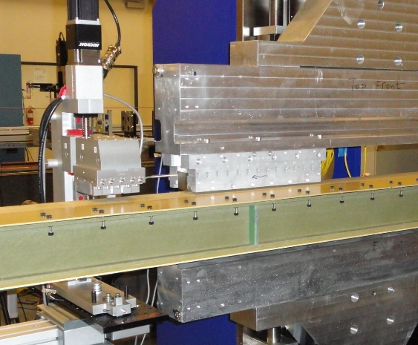

SXHEPS prototype

SXU-HE prototype top magnet array

Measuring coil

Slide

Rail

Figure 22. Undulator and phase shifter on the measurement bench

The gaps are set for maximum interference; the undulator to 7.2mm - minimum operational gap and the phase shifter to 35mm - maximum operational gap. The distance between the undulator and the phase shifter is set from the downstream side of the last pole of the undulator to the upstream side of the first magnet of the phase shifter.

Results of the measurements are shown in the figures 23 and 24.

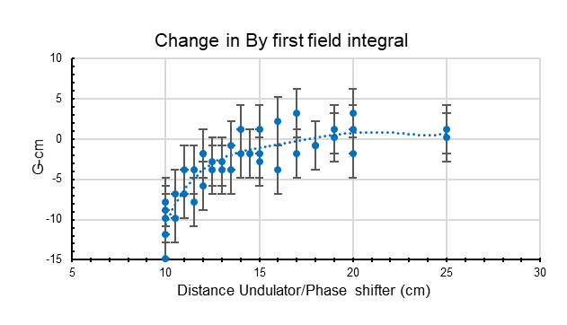

Figure 23. Main field integral change vs. distance between undulator and phase shifter.

A dotted line is a polynomial fit of 3-rd order to the measurements. The fit line crosses the 3G-cm limit at 13cm distance between phase shifter and undulator. In the tunnel, the undulator/phase shifter distance will be 14.4cm. From these measurements the change in field integral is expected be <2G-cm, which is below accuracy with which we measure the field integrals. There is no change in *Bx* field integrals. The cross-talk is insignificant.

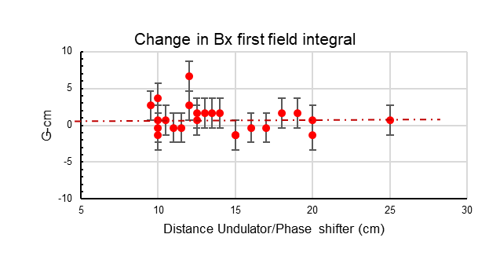

Figure 24. Horizontal field integral change vs distance between undulator and phase shifter

**7. Conclusion**

A short prototype of the LCLS-II-HE SXU with a new 56mm period magnet structure was measured in the SLAC MMF at the SXU measurement bench. The main field strength exceeds the requirement of >1.76 T. The pole saturation at gaps below 9mm is negligible. The end design is adequate for minimizing the first and second field integrals. The magnetization errors of the magnet blocks result in a unique field integral gap dependence, with a big nonlinearity around 10mm gap. The magnets structure design meets the LCLS-HE requirements.

The shim signatures of all shimming options were measured and evaluated. In combination with ferromagnetic shims, the correct shim signature could be produced for the main and the skew quadrupole fields. The shimming options are sufficient for SXU-HE tuning.

The Hall probe calibration and measurement accuracy was evaluated. The repeatability of the prototype measurements at fixed small gaps was estimated as ±9∙10-5. It meets the requirements for SXU-HE undulator calibration.

The undulator/ phase shifter cross talk is insignificant <2G-cm at 14.4cm distance.

1. Work supported in part by the DOE Contract DE-AC02-76SF00515. This work was performed in support of the LCLS-II-HE project at SLAC.
2. LCLS-II-HE-1.3-PR-0049-R0 - LCLS-II-HE SXR Undulator Systems Physics Requirement Document
3. K. Halbach, Nucl. Instr. and Meth. 169 (1980) 1