Short Prototype Magnetic Measurements
Diego Arbelaez Release Date:

Document Number: LC-1006-3218 Revision: A
Document Status: Working
Document Type: NOTE
Category Code: LC0119
LCLS-II - UNDULATORS
SXR-HE SHORT MAGNETIC PROTOTYPE

LCLS-II-HE Project Lawrence Berkeley National Laboratory
All officially released LBNL documents are watermarked and contain LBNL Document
Control Center release information in the lower-left corner of the document's pages. Printed hard copies of this document are for reference only.
.

TABLE OF CONTENTS
1 Revision History 2
2 Approvals 2
3 Abbreviations and Acronyms 2
4 Introduction 3
5 Requirements 3
6 Measurement Results 5
7 Discussion of Requirement Satisfaction 11
8 Reference Documents 12

REVISION HISTORY
Rev. | CM Number | Description of Change
A |  | Baseline

APPROVALS
The following individual(s) shall approve this document:
Approver | Project Role
Matthew Williamson | CAM
Windchill Approved / Concurred By

ABBREVIATIONS AND ACRONYMS
LCLS-II Linac Coherent Light Source
LCLC-II-HE LCLS-II High Energy Upgrade
LBNL Lawrence Berkeley National Laboratory
SXR Soft X-Ray
SXU Soft X-Ray Undulator

INTRODUCTION
For the high-energy upgrade of the LCLS-II, the existing SXR undulator will be reconfigured to have a longer period length due to the increase in electron energy from 4 to 8 GeV. The period length of the undulator will be changed from 39 mm for the original SXR undulators to 56 mm for the new SXR undulators. This requires that new magnetic modules be designed, assembled, and tested. This note describes the magnetic measurements that were performed on a short prototype (14 pole) of the LCLS-II-HE SXU magnet modules. The magnetic design for the LCLS-II-HE SXR undulators is covered in LBNL document number LC-1006-1957. The mechanical design of the magnet modules is covered in LC-1006-2180. The assembly process and mechanical measurements for the short prototype, that is the topic of this note, are covered in LC-1006-2727.

REQUIREMENTS
In this section the LCLS-II-HE SXU requirements that are relevant to the short prototype are described. The listed requirements are the relevant subset from the LCLS-II-HE Undulator Physics Requirement Document (LCLSII-HE-1.3-PR-0049-R1). The undulator has been designed with a period length of 56 mm. This is verified through mechanical and magnetic measurements. The undulator is of planar hybrid permanent magnet type (soft magnetic poles and NdFeB permanent magnets) and produces horizontally polarized radiation (vertical field orientation). The operational gap range is 7.2 mm to 33 mm, and the effective magnetic field requirement at minimum gap (7.2 mm) is 1.76 T. The effective field requirement (PRD0049.4026) can be fully verified on the short prototype . The K value requirement at minimum gap (PRD0049.4027) is redundant since the period length is specified separately. For the horizontal field roll-off, two equivalent / redundant requirements are specified (PRD0049.4034, PRD0049.4035). These can also be fully verified on the short prototype. The final requirements listed are related to field quality: phase shake, x/y field integrals, and x/y second field integrals. For these requirements, the short prototype is used for partial verification of requirements since the short length is not representative of a full-length undulator. The partial verification is done through demonstration that requirements are satisfied over the short length.

Table 1. Undulator requirements as specified in document LCLSII-HE-1.3-PR-0049-R1.
Requirement # | Parameter | unit | Value | Verif. Method
PRD0049.4014 | Undulator period length | mm | 56 | Test
PRD0049.4018 | Undulator type | - | Planar | Inspection
PRD0049.4019 | Undulator magnet type | - | PM Hybrid | Inspection
PRD0049.4020 | Gap type | - | Variable | Inspection
PRD0049.4021 | Magnet material | - | Nd₂Fe₁₄B | Inspection
PRD0049.4022 | Linear polarization direction of the x-ray radiation | - | Horizontal | Inspection
PRD0049.4023 | Magnetic Field Symmetry | - | Antisymmetric | Inspection
PRD0049.4024 | Minimum operational magnetic gap | mm | 7.2 | Inspection
PRD0049.4025 | Maximum operational magnetic gap | mm | 33 | Inspection
PRD0049.4026 | On-axis vertical effective field at min. oper. gap | T | >1.76 | Test/ Analysis
PRD0049.4027 | Keff at minimum operational gap |  | >9.21 | Test/ Analysis
PRD0049.4029 | Minimum operational K values | T | 1.51 | Test/ Analysis
PRD0049.4034 | Horizontal K sextupole  1  1⁄𝐾𝐾𝑒𝑒𝑒𝑒𝑒𝑒𝜕𝜕2𝐾𝐾𝑒𝑒𝑒𝑒𝑒𝑒⁄𝜕𝜕𝑥𝑥2  2 | 1/mm² | <5×10⁻⁴ | Test/ Analysis
PRD0049.4035 | Equivalent ∆𝐾𝐾⁄𝐾𝐾@ x =  ±0.4 mm |  | <0.8×10⁻⁴ | Test/ Analysis
PRD0049.4038 | Phase shake (rms) over  Lcell | deg Xray | <5.0 | Test/ Analysis
PRD0049.4040 | First field integral of By per cell (abs) 10 | μTm | <50 | Test/ Analysis
PRD0049.4041 | Second field integral of By per cell (abs) | μTm² | <200 | Test/ Analysis
PRD0049.4042 | First field integral of Bx per cell (abs) | μTm | <50 | Test/ Analysis
PRD0049.4043 | Second field integral of Bx per cell (abs) | μTm² | <200 | Test/ Analysis

MEASUREMENT RESULTS
The short prototype magnet modules were assembled at LBNL and sent to SLAC for magnetic characterization (measurement performed by Y. Levashov). Figure 1 shows the hall probe measurement setup at SLAC, including the magnet modules mounted on the short test frame.

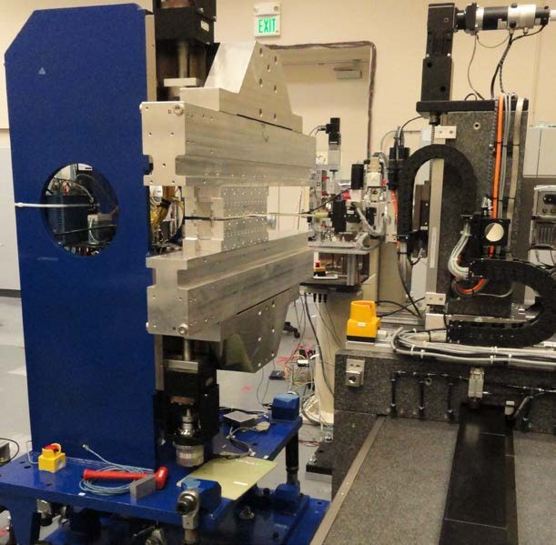
Figure 1. Hall probe measurement setup for the short prototype. The short magnet modules are mounted on the 1 m short frame from the LCLS-II project.

Figure 2 shows the vertical magnetic field measured at the minimum gap of 7.2 mm. Note that the antisymmetric field symmetry (req. # PRD0049.4023) is demonstrated here. The measured period length, based on the peak field at the poles, is 56.004 mm (req. # PRD0049.4014). Figure 3 shows the measured effective field requirement. The measured effective field value is 1.85 T at minimum gap, which corresponds to a Keff value of 9.69. This is approximately 5% above the requirement (PRD0049.4026, PRD0049.4027).
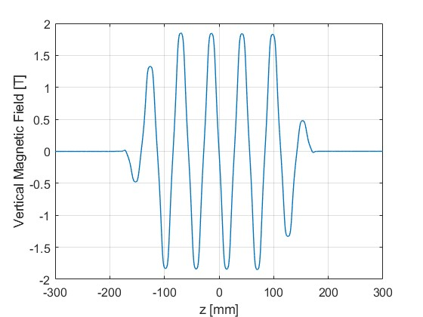
Figure 2. Vertical magnetic field along the short prototype length.

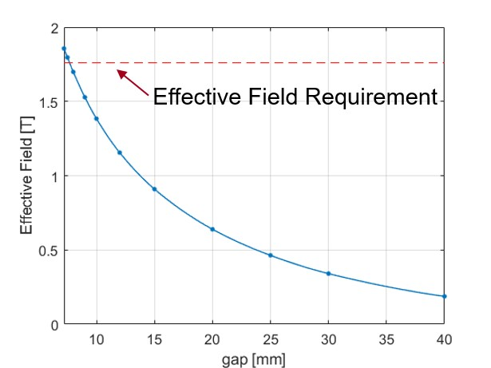
Figure 3. Measured effective field magnetic field as a function of gap. At the minimum gap, the short prototype exceeds the required effective magnetic field strength by approximately 5% above the requirement.

Figure 4 shows the measured and calculated magnetic field roll-off at the maximum gap of 33 mm. The measured roll-off, based on a quadratic fit of the data, is 3.5 × 10⁻⁴ 1/mm2, which satisfies the required value of 5.0 × 10⁻⁴ 1/mm2 (PRD0049.4034). This also satisfies the redundant requirement, PRD0049.4035, with a ∆𝐾𝐾⁄𝐾𝐾@ x = ±0.4 mm of 5.6 × 10⁻⁵.
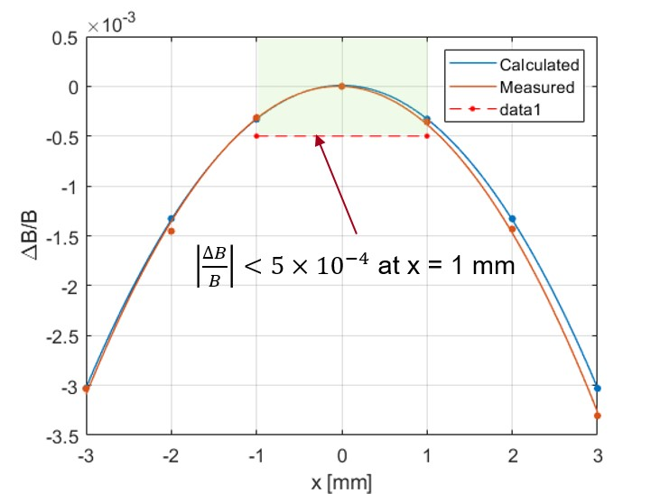
Figure 4. Magnetic field roll-off measurement at maximum gap (33 mm) and calculation comparison. The measured magnetic field roll-off is 3.5 × 10⁻⁴ 1/mm², which satisfies the requirement of 5.0 × 10⁻⁴ 1/mm².

In the remainder of this section, the field quality requirements are considered: RMS phase error (i.e. phase shake), vertical and horizontal first field integral, vertical and horizontal second field integrals. As it relates to a full length undulator, only partial satisfaction of these requirements is claimed due to the short length of the prototype. The following phase error results that are presented are without undulator tuning. Figure 5 shows the calculated phase error at the peak field locations (left) and the resulting RMS phase error (phase shake) as a function of the undulator gap (right). The RMS phase error for this short prototype is largest at 10 mm gap with a value of 2.4⁰, this is below the full length undulator requirement of 5⁰ (PRD0049.4038).
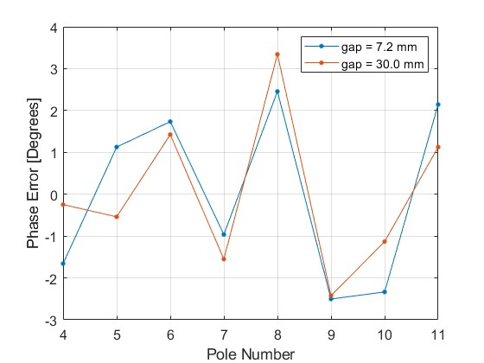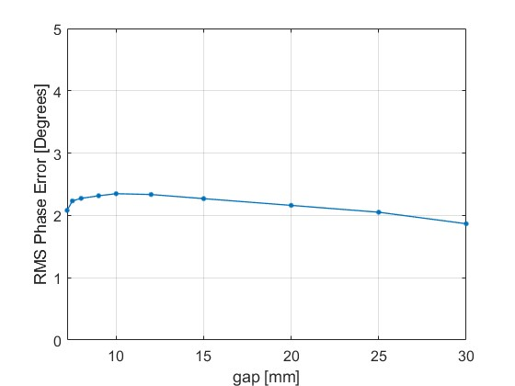
Figure 5. Calculated phase error at the poles from measurement data at 7.2 mm gap (left). Calculated RMS phase error for gap range between 7.2 mm and 30 mm (right). The results presented are without tuning.

Figure 6 and Figure 7 show the first and second field integral measurements before tuning in the vertical and horizontal directions. The un-tuned field integrals are slightly above the required value of 50 μTm. The vertical field integral Figure 6 (left) shows a fast change below approximately 10 mm gap. Tuning methods to correct these fast changing errors were developed at SLAC by combining pole adjustments with ferromagnetic shims. The resulting field integrals after tuning are shown in Figure 8. Within the operational gap range, the absolute value resulting field integrals in x and y is below 12 μTm, which satisfies the full length undulator requirement of 50 μTm (PRD0049.4040, PRD0049.4042). The measured second field integrals (before tuning) are below 50 μTm² for the vertical direction (right plot on Figure 6) and below 20 μTm² for the horizontal direction (right plot of Figure 7). Both of these satisfy the full length undulator vertical and horizontal second field integral requirement of 200 μTm2 (PRD0049.4041, PRD0049.4043). Figure 9 shows the measured and calculated vertical second field integral along the length of the undulator. As can be seen from the plot, there is a “jump” in the second field integral at each end of the undulator of approximately 20 μTm2. Based on the simulation results from OPERA3D, this “jump” is expected to be lower for the full length undulator as is shown in Figure 10, and it should only consume a small amount of the overall margin for the second integral requirement.
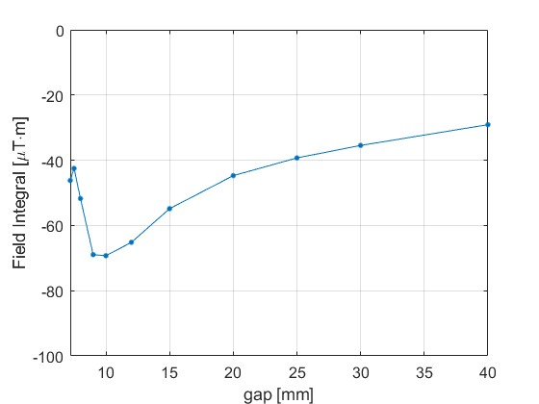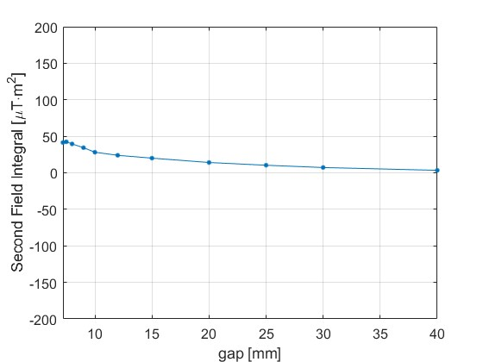
Figure 6. Vertical field integral (left) and vertical second field integral (right).

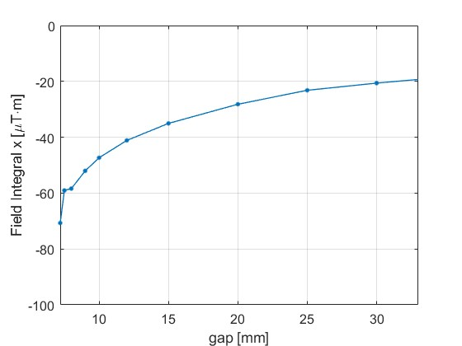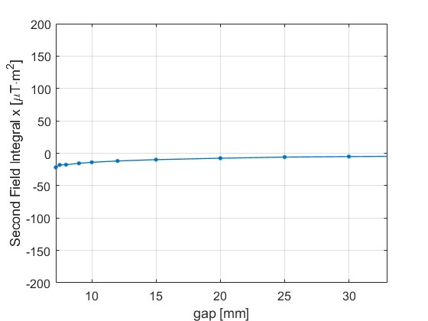
Figure 7. Horizontal field integral (left) and horizontal second field integral (right).

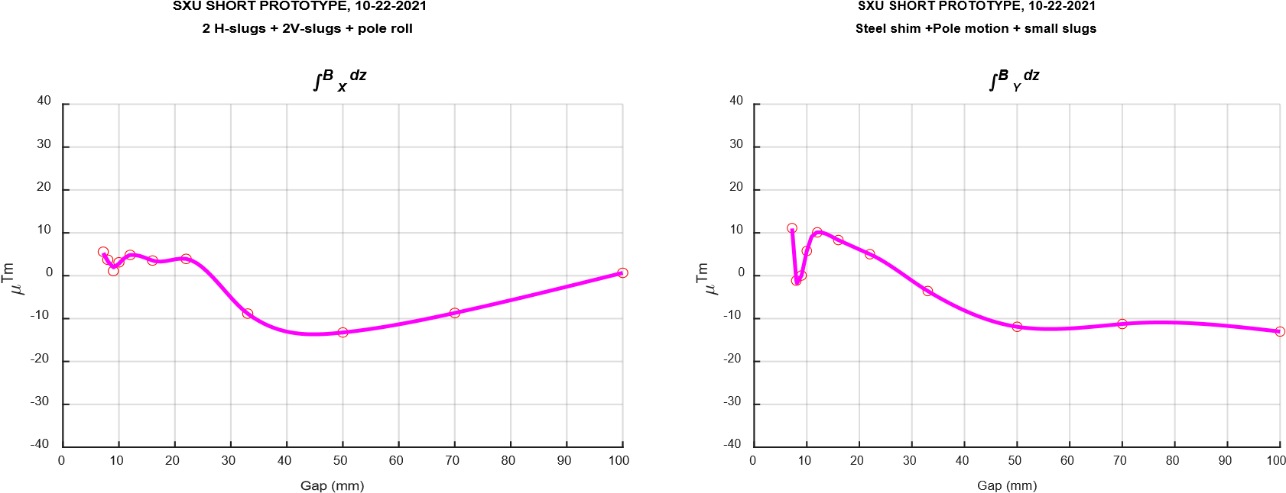
Figure 8. Measured x and y field integral after tuning (courtesy of Y. Levashov).

Page
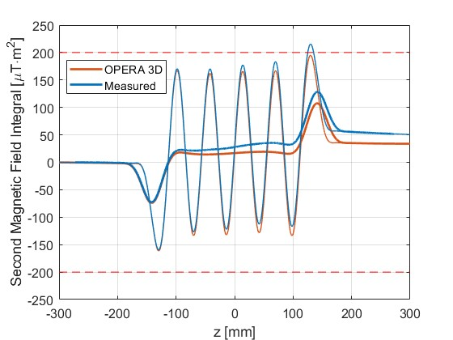
Figure 9. Second field integral as a function of z. Good agreement between the measurements and calculations is seen in the “jump” of the second field integral at the entrance and exit of the undulator.

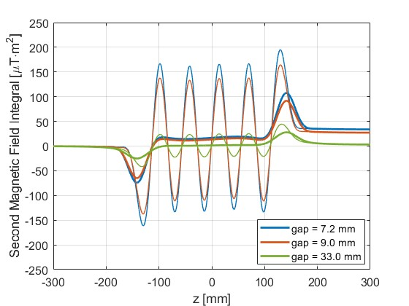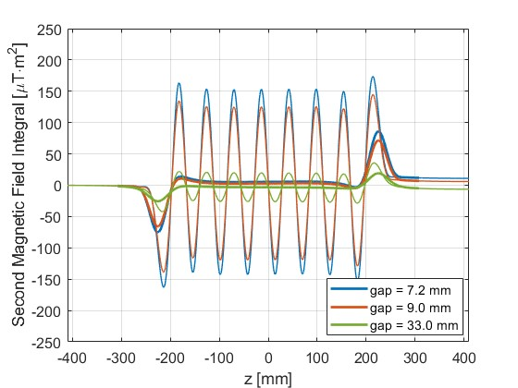

Figure 10. Calculated second field integral as a function of z for various gaps. The left plot shows the calculation for the short prototype, while the right plot shows the calculation that is representative of a long undulator. The second field integral “jump” error at the ends is expected to decrease for the full length undulators when compared to the short prototype.

Page

DISCUSSION OF REQUIREMENT SATISFACTION
Table 2 shows the list of requirements along with the values achieved for the short prototype. The cells that are highlighted in green are ones where the length of the short prototype is sufficient to demonstrate full satisfaction of the requirement. For the orange cells, the measured values are reported; however, the short prototype is not fully representative of a production undulators, since the accumulation of random errors is limited by the short device length.

Table 2. Undulator requirements as specified in document LCLSII-HE-1.3-PR-0049-R1.
Requirement # | Parameter | unit | Req. Value | Meas. Value
PRD0049.4014 | Undulator period length | mm | 56 | 56.004
PRD0049.4018 | Undulator type | - | Planar | Planar
PRD0049.4019 | Undulator magnet type | - | PM Hybrid | PM Hybrid
PRD0049.4020 | Gap type | - | Variable | Variable
PRD0049.4021 | Magnet material | - | Nd₂Fe₁₄B | Nd₂Fe₁₄B
PRD0049.4022 | Linear polarization direction of the x-ray radiation | - | Horizontal | Horizontal
PRD0049.4023 | Magnetic Field Symmetry | - | Antisymmetric | Antisymmetric
PRD0049.4024 | Minimum operational magnetic gap | mm | 7.2 | 7.2
PRD0049.4025 | Maximum operational magnetic gap | mm | 33 | 33
PRD0049.4026 | On-axis vertical effective field at min. oper. gap | T | >1.76 | 1.85
PRD0049.4027 | Keff at minimum operational gap |  | >9.21 | 9.69
PRD0049.4029 | Minimum operational K values | T | 1.51 | 1.51
PRD0049.4034 | Horizontal K sextupole  1  1⁄𝐾𝐾𝑒𝑒𝑒𝑒𝑒𝑒𝜕𝜕2𝐾𝐾𝑒𝑒𝑒𝑒𝑒𝑒⁄𝜕𝜕𝑥𝑥2  2 | 1/mm² | <5×10⁻⁴ | 3.5×10⁻⁴
PRD0049.4035 | Equivalent ∆𝐾𝐾⁄𝐾𝐾@ x = ±0.4 mm |  | <0.8×10⁻⁴ | 0.56×10⁻⁴
PRD0049.4038 | Phase shake (rms) over Lcell | deg Xray | <5.0 | 2.4
PRD0049.4040 | First field integral of By per cell (abs) 10 | μTm | <50 | 12
PRD0049.4041 | Second field integral of By per cell (abs) | μTm² | <200 | 50
PRD0049.4042 | First field integral of Bx per cell (abs) | μTm | <50 | 12
PRD0049.4043 | Second field integral of Bx per cell (abs) | μTm² | <200 | 20

Page

REFERENCE DOCUMENTS
Document Number | Title
LCLSII-HE-1.3-PR-0049-R1 | LCLS-II-HE SXR Undulator System PRD
LC-1006-1957 | HE-SXR Undulator Magnetic Design
LC-1006-2180 | HE-SXR Magnet Module Design
LC-1006-2727 | Short Prototype Fabrication and Mechanical Measurements

The effective field strength depends strongly on the as received permanent magnet and pole properties. For production, the properties are specified in documents LC-1006-1866 and LC-1006-1820. For the short prototype, manufacturer material catalog grades, with similar properties as for the production specification, were specified.

