Revision History
Revision | Date Released | Description of Change
R0 | January 6, 2022 | Original Release.

This traveler is for the magnetic measurements of one type 1.085Q4.3, QE4, quadrupole magnet. These measurements are needed for the FACET-II Injector QE quadrupoles which are going to be run at +/-12 and +/- 30 amps, which is lower than their 200 A nominal operating currents. The 1.085Q4.3 quad to be tested is a LCLS-II spare with barcode L204244.
Receiving:
The following information is to be noted upon receipt of the magnets by the SLAC MFD group:
Received by (MMG initials): | SDA
Date received (dd-mmm-yyyy): | 1/15/2022
SLAC barcode number: | L204244
Vendor serial number on the magnet: | QE040

Preparation:
Magnet beam direction and polarity are already marked.
Fiducialization:
Fiducialization was done previously.
URL of on-line CMM fiducialization data (please modify or correct if necessary):
https://www-group.slac.stanford.edu/met/MagMeas/MAGDATA/LCLS-II/Fiducial%20Reports/L204244_Fiducial_Report.pdf
Magnetic Measurements:
Enter URL of on-line magnetic measurements data (please modify or correct if necessary):
http://www-group.slac.stanford.edu/met/MagMeas/MAGDATA/FACET_II/quad/1.085Q4.31_L204244

- The connection polarity of a “positive” quadrupole will maintained (see Figure 1):
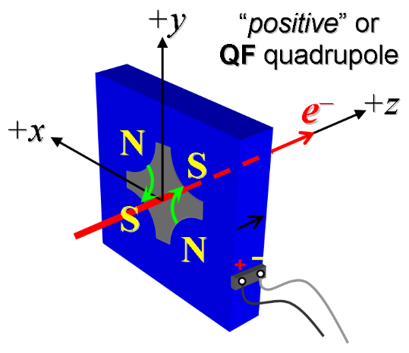
Figure 1: A “QF” focuses the electron beam in the horizontal plane, represented as positive k-value in the MAD-deck.

- Connect the magnet terminals in the correct polarity as established above, to a bipolar power supply with maximum current I ≥ 30 A (intended power supply type in installation is MCOR 30).
- Train magnet in +/- 30 Range. Standardize the magnet, starting from -30 A then go through 15 full cycles from -30 A to +30 A, finally ending down at -30 A from which the first operating current will be reached, with a flat-top pause time (at both -30 and +30 A) of 10 seconds. Use a “Linear” ramp rate of 3 A/sec, record the ramp rate, type and pause used.
Ramp Type | Linear
Ramp rate used (A/sec): | 1 A/sec
Ramp Pause | 10 sec

- After the standardize 3 cycles, measure the length-integrated field gradient, ∫Gdl, at -30 A. Trip magnet off at -30 amps and then standardize 3 cycles and measure the length-integrated field gradient, ∫Gdl, at -30 again.
Filename & run number of ∫Gdl, at -30 A data: | Strdat.ru1, strplt.ru1

- Confirm the pole-tip field using a Hall probe at an excitation current of +30 A. Run magnet to 0 and turn off supply.
Hall probe pole-tip field at +30 A (mean of 4 poles): | 0.173 Tesla @ 30.00841 amps

- Start full measurement run. Run the magnet up to 30 A for 10 min for a thermal warmup, record the following data after the warmup.
Ambient temperature (°C): | 16.4 °C
Final Coil temperature at 30 A maximum (°C): | 24.4 °C
Final Core temperature at 30 A maximum (°C): | 21.6 °C
Water Flow (GPM) | 1.6 gpm
∆ Pressure (PSI) | 117 psi

- Standardize the magnet, starting from -30 A then go through 3 full cycles from -30 A to +30 A Measure the length-integrated field gradient, ∫Gdl, from -30 to +30 A in 3-A steps (21 ‘up’ measurements), and then back down from +30 A to -30 A in 3-A steps (20 ‘down’ measurements).
Filename & run number of ∫Gdl up & down data: | Strdat.ru2, strplt.ru2

- With rotating coil, measure the magnet harmonics at the +30 A current setting. Multipole values should be given as a percentage of the quadrupole moment evaluated at the probe radius.
Filename & run number of harmonic data: | Hardat.ru2, harplt.ru2
Probe radius used for harmonics (m): | 0.009347 m
Rotating Coil Designation (Name) | 0.75DQB26

- Connect the magnet terminals in the correct polarity as established above, to a bipolar power supply with maximum current I ≥ 12 A (intended power supply type in installation is MCOR 12).
- Train magnet in +/- 12 A Range. Standardize the magnet, starting from -12 A then go through 15 full cycles from -12A to +12 A, finally ending down at -12 A from which the first operating current will be reached, with a flat-top pause time (at both -12 and +12 A) of 10 seconds. Use a “Linear” ramp rate of 1 A/sec. Record the ramp rate used, the ramp type and the pause duration.
Ramp Type | Linear
Ramp rate used (A/sec): | 1 A/sec
Ramp Pause | 10 sec

- After the standardize, measure the length-integrated field gradient, ∫Gdl, at -12 and +12 A.
Filename & run number of ∫Gdl, at -12 and +12 A data: | Strdat.ru3, strplt.ru3

- Confirm the pole-tip field using a Hall probe at an excitation current of +12 A. Run magnet to 0 and turn off supply.
Hall probe pole-tip field at +12 A (mean of 4 poles): | 0.071 Tesla @ 12.00167 Amps

- Standardize the magnet, starting from -12 A then go through 3 full cycles from -12 A to +12 A Measure the length-integrated field gradient, ∫Gdl, from -12 to +12 A in 1-A steps (25 ‘up’ measurements), and then back down from +12 A to -12 A in 1-A steps (24 ‘down’ measurements).
Filename & run number of ∫Gdl up & down data: | Strdat.ru4, strplt.ru4

- With rotating coil, measure the magnet harmonics at the +12 A current setting. Multipole values should be given as a percentage of the quadrupole moment evaluated at the probe radius.
Filename & run number of harmonic data: | Hardat.ru4, harplt.ru4
Probe radius used for harmonics (m): | 0.009347 m
Rotating Coil Designation (Name) | 0.75DQB26

- Standardize the magnet, starting from 0 A then go through 10 full cycles from 0 A to +30 A Measure the length-integrated field gradient, ∫Gdl, from 0 to +30 A in 1-A steps (31 ‘up’ measurements), and then back down from +30 A to 0 A in 1-A steps (30 ‘down’ measurements).
Filename & run number of ∫Gdl up & down data: | Strdat.ru5, strplt.ru5
- With rotating coil, measure the magnet harmonics at +12 and +30 A . Multipole values should be given as a percentage of the quadrupole moment evaluated at the probe radius.
Filename & run number of harmonic data: | Hardat.ru5, harplt.ru5
Probe radius used for harmonics (m): | 0.009347 m
Rotating Coil Designation (Name) | 0.75DQB26

- Measure the inductance and resistance of the magnet:
Inductance of coil (mH): | 7.41 mH @ 100 Hz
Resistance of coil (Ohms): | 0.0834 Ohm
Coil temperature in degrees C | 23.1 ºC

- Upon completion of tests, email URL of on-line data to Mark Woodley. Mark Woodley will determine if the magnet data is accepted. Upon acceptance of magnet data, analysis data will be placed in on-line data folder.
Magnet data accepted and Analysis file(s) put into on-line data folder (initials): | SDA

Enter URL of on-line magnetic measurements analysis data :
https://www-group.slac.stanford.edu/met/MagMeas/MAGDATA/FACET_II /QUAD/1.085Q4.31-L204244/1.085Q4.31_4244.pptx

