Revision History
Revision | Date Released | Description of Change
R0 | September 13, 2017 | Original Release.
R1 | February 12, 2019 | Updated contact, URL, and labeling information

This traveler is intended to cover reception, preparation, mechanical fiducialization, and magnetic measurements of the six sector 14 bunch-compressor (BC14) chicane type 1.34D19.3 dipole magnets. There are two variants of this dipole,
- “center” variant SA-257-060-44, with straight pole edges (4 pcs), corresponding to MAD designations BCX14796 and BCX14808
- “edge” variant SA-257-060-40 with pole featuring an entrance/exit angle (2 pcs), corresponding to MAD designations BCX14720 and BCX14883
to be used at the beamline locations shown in Figure 2 at the end of this document. The magnet design is based on the existing LCLS-II BC2 dipole 1D19.7, featuring the same main and trim coils, and this traveler is also based on the LCLS-II version, containing the same tests but with current levels and target values updated where appropriate.

Receiving:
The following information is to be noted upon receipt of the magnets by the SLAC MM group:
Received by (initials): | SDA
Date received (dd-mmm-yyyy): | 3/25/2019
Vendor serial number from magnet label: | Center 2
SLAC approved electrical safety covers? (Y or N): | Y
SLAC approved lifting eyes? (Y or N): | N
Shipping Damage? (Y or N): | N
Vendor tests passed on magnet label? (Y or N): | Y
SLAC drawing number (enter number): | SA-257-060-44

Fiducialization:
Fiducialization may be done before or after magnetic measurements. The magnet is to be fiducialized by the CMM group. This will require the installation of removable tooling balls, location of the geometric axis of the poles of the magnet, and location of tooling balls with respect to the center of this geometric axis when the poles are aligned precisely horizontal.

CMM technician (initials): | MR

URL of on-line CMM fiducialization data (please modify or correct if necessary):
http://www-group.slac.stanford.edu/met/MagMeas/MagData/FACET_II/Fiducial%20Reports/http://www-group.slac.stanford.edu/met/MagMeas/MAGDATA/FACET_II/Fiducial%20Reports/1.34D19.3%20BC14%20PO180085%20CENTER%20SN002.xlsx

Magnetic Measurements:
- Verify that the magnets are complete and undamaged, including wiring connections.
Incoming inspection OK (initials): | SDA
Date of arrival to mag. meas.(mmm-dd-yyyy): | 3/25/2019

Enter URL of on-line magnetic measurements data (please modify or correct if necessary):
http://www-group.slac.stanford.edu/met/MagMeas/MagData/FACET_II/Dipole/ BCX14808/

- Determine the main-coil connection polarity (with main supply outputting positive current) which produces a “positive” field polarity for the “edge” variant dipoles (below left), but a “negative” field polarity for the “center” variant dipoles (below right), as shown in Figure 1 below.

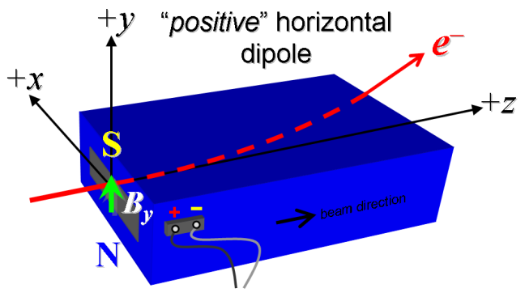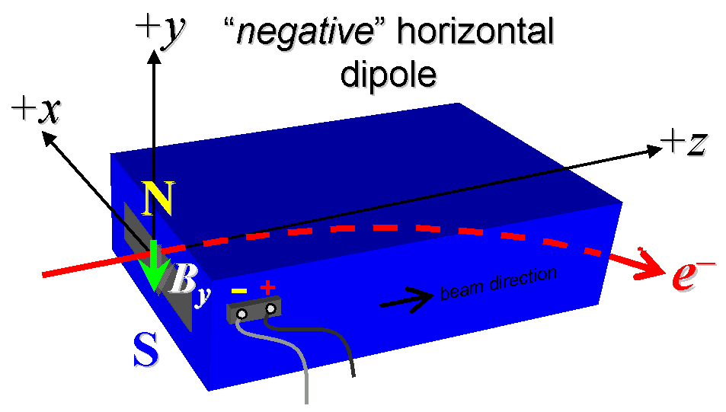
Figure 1: “edge” dipoles SA-257-060-40 are “positive” (left), while “center” dipoles SA-257-060-44 are “negative” (right).

- Mark the polarity near the main magnet leads with clear “+” and “−” labels as shown above.
Main coil polarity chosen from Figure 1 is (P or N): | N

- Also mark the trim leads with clear “+” and “−” labels such that, with the trim supply outputting positive current, the trim coil increases the absolute value of the magnetic field established by the main coil. This will set the trim polarity as “positive” for the “edge” variant dipoles and “negative” for the “center” variant dipoles, following the same conventions as for LCLS-II.
Trim coil polarity chosen from Fig. 1 is (P or N): | N

- Connect the main magnet terminals (not the trims), in the correct polarity as established above, to a unipolar power supply with maximum current I ≥ 200 A (assuming this current produces about 8.6 kG-m integrated field). Leave the trim coil disconnected for now.

- Connect magnet to LCW supply. Adjust supply pressure to a delta P of ~119 psi to achieve a flow rate of 2.25 gpm. Run the magnet up to 200 A for ~1 hour to warm it up (record, delta P, flow rate, and temperature).
LCW delta P (psi) | 117 psi
LCW flow rate (gpm) | 2.7 gpm
LCW delta T (°C) | 6.0 °C
Ambient temperature (°C): | 20.0 °C
Final magnet temperature (°C): | 23.6 °C

- Standardize the magnet, starting from zero to 200 A and back to zero, through three full cycles, finally ending at zero, with a flat-top pause time (at both 0 and 200 A) of 10 seconds. Use a ramp rate of 10 A/sec, if possible, and record the ramp rate used.
Standardization complete (initials): | SDA
Ramp rate used (A/sec): | 10 A/sec

- Maintaining this cycle history, measure the length-integrated vertical dipole field, ∫B_{y}dl, from 0 to 200 A in 20-A steps, including zero (11 ‘up’ measurements). Please record (below) the current necessary to achieve 6.3 kG-m. Then, still maintaining the cycle history, measure ∫B_{y}dl back down from 200 A to 0 in 20-A steps, including zero (11 ‘down’ measurements).
Main coil excitation current at 6.3 kG-m: | 144.0762 Amps
Filename & run number of ∫B_{y}dl up & down data: | Wiredat.ru1, wireplt.ru1

- With the main coils still hooked up, connect the trim coil to a bipolar 12-A (MCOR12) supply with proper trim polarity as determined above.

- Set the main coil to 0 current by ramping first up to 200 A, then down to zero at the same ramp rate used in the standardization cycle. Measure ∫B_{y}dl as a function of trim coil current from 0 to −12 in 1-A steps, including zero (13 ‘down’ measurements), and again from −12 to +12 A in 1-A steps (25 ‘up’ measurements). Set the trim current to 0.
Filename & run # of ∫B_{y}dl trim data at I_{main} = 0: | Wiredat.ru2, wireplt.ru2

- For all four dipoles, with stretched wire, measure the vertical length-integrated field component over a horizontal span of ±45 mm (±1.7 inches), at each 3-mm interval, at the following main and trim coil current settings.
- I_{main} = 143 A, and I_{trim} = 0
- I_{main} = 143 A, and I_{trim} = +12 A
- I_{main} = 200 A, and I_{trim} = 0
Filename & run # of ∫B_{y}dl vs. x data at 143, 0 A: | Wirevsx.ru3, wirepltvsx.ru3
Filename & run # of ∫B_{y}dl vs. x data at 143, +12 A: | Wirevsx.ru4, wirepltvsx.ru4
Filename & run # of ∫B_{y}dl vs. x data at 200, 0 A: | Wirevsx.ru1, wirepltvsx.ru1

- For the first “edge” variant dipole only, and at a main current of 143 A, with trim current at zero, measure the vertical magnetic fringe field component, B_{y}, at x = y = 0, as a function of the longitudinal beam-direction coordinate, z (from −10 cm to +30 cm in 1-cm steps, where z = 0 is defined at the iron edge), at the angled end of this one magnet. Please also measure the background field at z = +30 cm with magnet switched off (separate file).
Filename of B_{y} vs. z data: | Measured on BCX14720
Background filename of B_{y}(z = 30 cm), magnet OFF: | Measured on BCX14720

- For one magnet only, perform this final thermal test. Run the main current up to 200 A, and with trim also set at its maximum operating current of +12 A, measure the magnet temperature after it stabilizes (~1 hour). Record the temperature below.
Ambient temperature (°C): | Measured on BCX14720
Final stable magnet temperature at 200 A (°C): | Measured on BCX14720

- Measure the inductance and resistance of the main and trim magnet coils for each magnet:
Inductance of main coil (mH): | 5.061 mH
Resistance of main coil (Ohms): | 0.1453 Ohm
Inductance of trim coil (mH): | 3.846 mH
Resistance of trim coil (Ohms): | 0.2632 Ohm

- Upon completion of tests, send traveler to Glen White at MS 54.
This section is to be completed by Glen White.
Magnet accepted: | Accepted via email
Assigned beamline location (MAD-deck name): | BCX14808
Magnet marked with assigned MAD-deck name (initials): | SDA
Beam-direction arrow in place (initials): | Not applied, no drawing given
The beam direction arrow, with text “beam direction”, is to be applied to the top and/or tunnel aisle side of the magnet with a sticker supplied by FACET-II. The beam direction should agree with the magnet mechanical orientation at the assigned location according to the sector 14 bunch compressor installation drawing ID-257-002-01.
- Upon full completion, send this traveler to Eric Bong at MS 51.

Figure 2: from “FACET-II-PR-042” sector 14 bunch compressor layout schematic in Z,X coordinates with magnet MAD-deck names indicated. The electron beam path goes through the +X side of bunch compressor and the positron beam path goes through the –X side. The “center” variant dipole, drawing number SA-257-060-44 is used at lattice locations BCX14796 and BCX14808 (electron side) and at lattice locations BCX141796 and BCX141808 (positron side). The “edge” variant dipole, drawing number SA-257-060-40, is used at lattice locations BCX14720 and BCX14883.

LCLS-II-2.4-PR-0064, https://docs.slac.stanford.edu/sites/pub/Publications/Polarity.pdf

