Revision History
Revision | Date Released | Description of Change
R0 | June 26, 2018 | Original Release.

This traveler is intended to cover reception, preparation, mechanical fiducialization, and magnetic measurements of four type 1.69D6.82T drawing number SA-388-320-05 dipole magnets needed for the FACET-II sector 11 bunch compressor (sector 11).
Receiving:
The following information is to be noted upon receipt of the magnets by the SLAC MFD group:
Received by (MMG initials): | SDA
Date received (dd-mmm-yyyy): | 7/12/2018
SLAC purchase order number: | 178701
Vendor serial number on the magnet: | 7

Preparation:
A beam direction arrow, with text “beam direction”, is to be applied to the top and/or connector side of the magnet. The magnet orientation shall be such that looking in the beam direction, the electrical terminals are on the right side of the magnet.
Beam-direction arrow in place (initials): | SDA

Fiducialization:
Fiducialization may be done before or after magnetic measurements. The magnet is to be fiducialized by the CMM group. This will require the installation of removable tooling balls, location of the geometric axis of the poles of the magnet, and location of tooling balls with respect to the center of this geometric axis when the poles are aligned precisely horizontal.
CMM technician (initials): | KC

URL of on-line CMM fiducialization data (please modify or correct if necessary):
http://www-group.slac.stanford.edu/met/MagMeas/MAGDATA/FACET_II/Fiducial Reports/ 1.69D6.28T-178701-007.pdf
Magnetic Measurements:
Enter URL of on-line magnetic measurements data (please modify or correct if necessary):
http://www-group.slac.stanford.edu/met/MagMeas/MAGDATA/FACET_II/Dipole/ 1.69D6.28T-178701-7

- Mark each magnet as BCX11314, BCX11331, BCX11338, or BCX11355. By choosing the magnet location initially, they will be tested in their proper polarities, since two are to be positive and two negative. Choose the “best” two magnets for the -331 and -338 locations.
Magnet marked as (BCX11###): | BCX11314

- Determine the main coil connection polarity (with supply outputting positive current) which produces a “positive” field polarity for BCX11314 and -355 (below left), but a “negative” field polarity for BCX11331 and -338 (below right), as shown below:
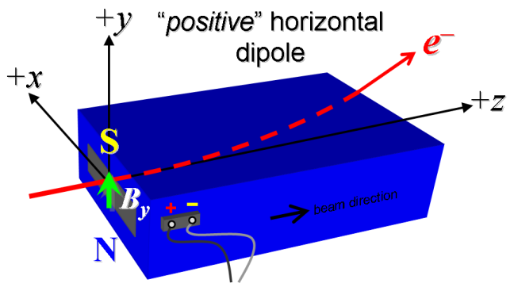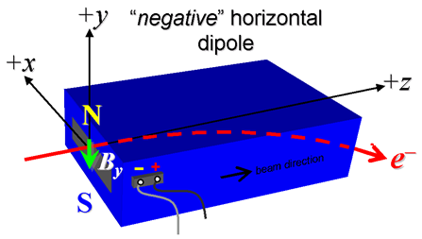
Figure 1: BCX11314 and BCX11355 are “positive” (left), while BCX11314 and BCX111338 are “negative” (right).

- Mark the main coil terminals where the ps cables are connected with clear “+” and “-” labels.
Main coil polarity has been labeled (initials): | Positive - SDA

- Determine the trim coil connection polarity (with supply outputting positive current) which produces the same field polarity as the main coils.
- Mark the trim coil terminals where the ps cables are connected with clear “+” and “-” labels.
Trim coil polarity has been labeled (initials): | Positive - SDA

- Connect the main coil terminals to a unipolar power supply with maximum current > 380 A and connect the trim coil terminals to a bipolar power supply with max current > 12 A, both in the correct polarity as established above.
- Connect magnet to LCW supply. Adjust supply pressure to a ∆P of ~100 psi to achieve a flow rate of ~2 gpm. Run the magnet up at main coils = 308 A, trim coils = 0 A, to thermal steady state (min 1 h). Record delta P; flow rate; inlet, outlet, coil and ambient temperatures; main coil current; voltage over main coil terminals. Estimated ∆T ≈ +7 °C at 308 A, 100 psi.
LCW delta P (psi) | 110 psi
LCW flow rate (gpm) | 2.4 gpm
final LCW ∆T (°C) | 3.8 °C
final coil surface temperature (°C) | 31.0 °C
Ambient temperature (°C) | 27.9 °C

- Confirm the pole gap field using a Hall probe. Nominal ≈ 0.52 T at 308 A.
at 308 A, Hall probe (T) | 0.52 T

- Standardize the magnet, starting from 0 A to 380 A and back to 0 A, through three full cycles, finally ending at 0 A, with a flat-top pause time (at both 0 and 300 A) of 10 seconds. Use a “3-linear” ramp rate of 10 A/sec, if possible, and record the ramp rate used. Trim coils at 0 A throughout.
Standardization complete (initials): | SDA
Ramp rate used (A/sec) | 10 A/sec

- Maintaining this cycle history, measure the length-integrated vertical dipole field, ∫B_{y}dl, from 0 A to 380 A in 14 A steps, including 0 A (29 ‘up’ measurements). Please record (below) the measured ∫B_{y}dl at 308 A (nom. ~0.105 Tm). Then, still maintaining the cycle history, measure ∫B_{y}dl back down from 300 A to 0 in 14-A steps, including 0 A (28 ‘down’ measurements). Trim coils at 0 A throughout.
at 308 A, ∫B_{y}dl (Tm) | 0.106337 Tm
Filename & run number of ∫B_{y}dl up & down data: | Wiredat.ru1, wireplt.ru1

- Still maintaining the main coils cycle history, measure the length-integrated vertical dipole field, ∫B_{y}dl, at main coils 308 A for trim coils 0 A to 12 A in 1-A steps, including 0 A (13 ‘up’ measurements) and then back down from +12 A to -12 A in 1-A steps (25 ‘down’ measurements). Then set the trim current back to 0 A, and take one last measurement. Use a linear ramp rate of 1 A/s with 10 s settle time, if possible, and record the ramp rate used.
Filename & run # of ∫B_{y}dl trim data at main = 308 A | Wiredat.ru2, wireplt.ru2

- Still maintaining the main coils cycle history, measure the length-integrated vertical dipole field, ∫B_{y}dl, at main coils 380 A for trim coils 0 A to 12 A in 1-A steps, including 0 A (13 ‘up’ measurements) and then back down from +12 A to -12 A in 1-A steps (25 ‘down’ measurements). Then set the trim current back to 0 A, and take one last measurement.
Filename & run # of ∫B_{y}dl trim data at main = 380 A | Wiredat.ru3, wireplt.ru3

- Ramp down the main coils to 0 A, and measure the length-integrated vertical dipole field, ∫B_{y}dl, at main coils 0 A for trim coils 0 A to 12 A in 1-A steps, including 0 A (13 ‘up’ measurements) and then back down from +12 A to -12 A in 1-A steps (25 ‘down’ measurements). Then set the trim current back to 0 A, and take one last measurement.
Filename & run # of ∫B_{y}dl trim data at main = 0 A | Wiredat.ru4, wireplt.ru4

- Measure the length-integrated vertical dipole field, ∫B_{y}dl, over a horizontal span of ±76 mm in 4 mm steps, at the following main and trim coil currents,
Filename & run # of ∫B_{y}dl vs. x data at 308 A, 0 A | Wirevsx.ru5, wirepltvsx.ru5
Filename & run # of ∫B_{y}dl vs. x data at 308 A, 12 A | Wirevsx.ru6, wirepltvsx.ru6
Filename & run # of ∫B_{y}dl vs. x data at 380 A, 0 A | Wirevsx.ru7, wirepltvsx.ru7

- For one magnet of the series only, at main coils 308 A and trim coils 0 A, measure the vertical dipole field By at x,y = 0,0 as function of longitudinal coordinate z from -100 to +300 mm in 10 mm steps, where z = 0 is the downstream pole edge. Please also measure the background field at z = +300 mm with the magnet switched off.
Filename of B_{y} vs. z data at 308 A, 0 A | Measurement done on #6
Background filename of B_{y}(z = +300), magnet OFF | Measurement done on #6

- Measure the inductance and resistance of the magnet:
Inductance of main coil circuit (mH) | 0.583 mH
Resistance of main coil circuit (Ohms) | 0.0378 Ohm
Inductance of trim coil circuit (mH) | 0.177 mH
Resistance of trim coil circuit (Ohms) | 0.0489 Ohm
Ambient temperature (°C) | 27.3 °C

- Upon completion of tests, email URL of on-line magnetic measurements data folder where traveler is saved to FACET-II beam physicist (Glen W, whitegr@slac.stanford.edu) for final acceptance with cc to FACET-II magnet engineer (Martin J, martinj@slac.stanford.edu).
Magnet accepted (signed): | VIA EMAIL

Choose the two that have the best (lowest) parallelism between the pole faces in the Fiducial Report.

