SLAC Traveler for FACET-II Laser Heater Dipole Magnets
(Modified from LCLS Traveler from Jan. 22, 2008)

This traveler is intended to cover reception, preparation, mechanical fiducialization, and magnetic measurements of the four laser heater chicane dipole magnets. These magnets are about 11 cm long and have MAD designations of: BCX10451 (1st Bend), BCX10461 (2nd Bend), BCX10475 (3rd Bend), and BCX10481 (4th Bend), and each has both main and trim coils. Instructions in this traveler will refer to “1st to 4th Bend” for simplicity but MAD designations should be associated as listed.

Receiving:
The following information is to be noted upon receipt of the magnets by the SLAC MFD group:
Received by (initials): | SDA
Date received (dd-mmm-yyyy): | 7/12/2022
SLAC barcode number: | PC100885
Vendor serial number from magnet label: | 2316-26142-03
SLAC approved electrical safety covers? (Y or N): | Y
SLAC approved lifting eyes? (Y or N): | N
Shipping Damage? (Y or N): | N
Vendor tests passed on magnet label? (Y or N): | Y

Preparation:
A beam direction arrow, with text “beam direction”, is to be applied to the top and connector side of the magnet per SA-380-331-01.

Beam-direction arrow in place (initials): | SDA

Fiducialization:
Fiducialization may be done before or after magnetic measurements. The magnet is to be fiducialized by the CMM group. This will require the installation of removable tooling balls, location of the geometric axis of the poles of the magnet, and location of tooling balls with respect to the center of this geometric axis when the poles are aligned precisely horizontal. The gap of the dipoles should be measured at 6 points evenly spaced points at each end.

CMM technician (initials): | Keith Caban

URL of on-line CMM fiducialization data (please modify or correct if necessary):
V:\MET\MagServe\MagData\FACET_II\Fiducial Reports\100885_Fiducial_Report.pdf

Magnetic Measurements:
- Verify that the magnets are complete and undamaged, including wiring connections.
Incoming inspection OK (initials): | SDA
Date of arrival to mag. meas.(mmm-dd-yyyy): | 7/12/2022

Enter URL of on-line magnetic measurements data (please modify or correct if necessary):
http://www-group.slac.stanford.edu/met/MagMeas/MAGDATA/FACET_II/dipole/1.18D3.17-BCX10475-3

- Mark each magnet as BCX10451 (1st Bend), BCX10461 (2nd Bend), BCX10475 (3rd Bend), or BCX10481 (4th Bend). By choosing the magnet location initially, they will be tested in their proper polarities, since two are to be positive and two negative.
Magnet marked as (BCX10451, BCX10461, BCX10475, or BCX10481): | BCX10475

- Determine the main-coil connection polarity (with main supply outputting positive current) which produces a “positive” field polarity for 1st Bend and 4th Bend (below left), but a “negative” field polarity for 2nd Bend and 3rd Bend (below right), as shown below:

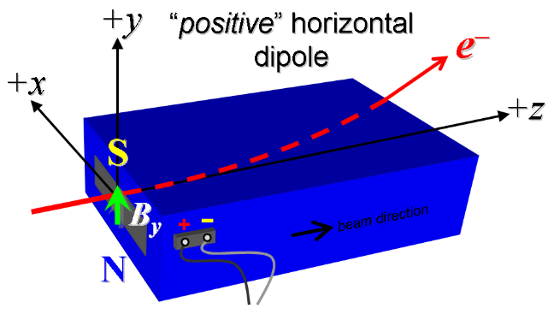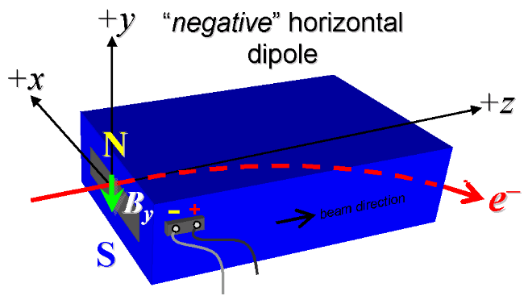
Figure 1. 1st BEND and 4th BEND are “positive” (left), while 2nd BEND and 3rd BEND are “negative” (right).

- Measure the inductance and resistance of the main and trim magnet coils:
Inductance of main coil (mH): | 1.0927 mH
Resistance of main coil (Ohms): | 0.0396 Ohm
Inductance of trim coil (mH): | 0.147 mH
Resistance of trim coil (Ohms): | 0.0615 Ohm

- Mark the polarity near the main magnet leads with clear “+” and “−” labels as shown above.
Main coil polarity chosen from Fig. 1 is (P or N): | N

- Also mark the trim leads with clear “+” and “−” labels such that, with the trim supply outputting positive current, the trim coil increases the absolute value of the magnetic field established by the main coil. This will set the trim polarity as “positive” for 1st BEND and 4th BEND and “negative” for 2nd BEND and 3rd BEND, as described in PRD 1.1-010.
Trim coil polarity chosen from Fig. 1 is (P or N): | N

- Connect the main magnet terminals (not the trims), in the correct polarity as established above, to a unipolar power supply with maximum current I ≥ 185 A (assuming this current produces about 0.7 kG-m integrated field as estimated by Mark Woodley). Leave the trim coil disconnected for now.

- Run the magnet up to 165 A for ~2 hours to warm it up and record the following parameters:
Ambient temperature (°C): | 27.5
Final Coil temperature (°C): | 29.8
Final Core temperature (°C): | 27.7
Input Water temperature (°C): | 29.1
Output Water temperature (°C): | 31.3
Water Flow (gpm) | 2.0
Water Delta Pressure (psi) | 111.6

- Standardize the magnet, starting from zero to 185 A and back to zero, through three full cycles, finally ending at zero, with a flat-top pause time (at both 0 and 185 A) of 10 seconds. Use a Cosine ramp rate of 15 A/sec, if possible, and record the ramp type and ramp rate used.
Standardization complete (initials): | SDA
Ramp rate used (A/sec): | 15 A/sec

- Measure the pole tip field with the Main at 185 amps.
Current (Amps) | 185.08275 Amps
Pole Tip Field (Tesla) | 0.612 Tesla

- Maintaining this cycle history, and with the trim coils not yet powered, measure the length-integrated vertical dipole field, ∫B_{y}dl, from 0 to 185 A in 15-A steps, including zero (16 ‘up’ measurements). Please record (below) the current necessary to achieve 0.7 kG-m (max.) and call Jerry Yocky if it is more than 20 A different than 185 A. If the maximum integrated field is <0.7 kG-m at 185 A, and after informing Jerry, please record the current necessary to achieve this field and re-standardize up to the new current, starting the procedure again from that point. Then, still maintaining the cycle history, measure ∫B_{y}dl back down from 185 A to 0 in 15 A steps, including zero (15 ‘down’ measurements).
Main coil excitation current at 0.7 kG-m: | 183.979 Amps
Filename & run number of ∫B_{y}dl up & down data: | Wiredat.ru1, wireplt.ru1

- With the main coils still hooked up, connect the trim coil to a bipolar 12 A supply with proper trim polarity as determined above.

- With the trim coil at zero, standardize the magnet as described above in step 8, leaving the main coil at I = 0. Then measure ∫B_{y}dl as a function of trim coil current from 0 to −12 in 0.5-A steps, including zero (25 ‘down’ measurements), and again from −12 to +12 A in 1-A steps (25 ‘up’ measurements). Set the trim current to 0.
Filename & run # of ∫B_{y}dl trim data at I_{main} = 0: | Wiredat.ru2, wireplt.ru2

- Measure the pole tip field with the Main at 0 amps and the trim at 12 amps.
Current (Amps) | 12.00009 Amps
Pole Tip Field (Tesla) | 0.01449 Tesla

- For all four dipoles (except as noted below), with stretched wire, and after re-standardization, measure the vertical length-integrated field component over a horizontal span of ± 35 mm (±1.38 inches), at each 5-mm interval, at the following main and trim coil current settings (no vacuum chamber in place for these steps).
- I_{main} = 155 A, and I_{trim} = 0
- I_{main} = 155 A, and I_{trim} = 12 A (2nd BEND only)
- I_{main} = 185 A, and I_{trim} = 0 (2nd BEND only)
Filename & run # of ∫B_{y}dl vs. x data at 155, 0 A: | Wirevsx.ru1, wirepltvsx.ru1
Filename & run # of ∫B_{y}dl vs. x data at 155, 12 A: | N/A
Filename & run # of ∫B_{y}dl vs. x data at 185, 0 A: | N/A

- For the 2nd BEND magnet only, with main coil at 155 A (trim at zero), measure the harmonics with a rotating coil with at least 1-inch diameter (use smaller only if 1-inch not available, staying with largest possible). Record probe designation, radius, and data file names:
Coil designation (text): | N/A
Coil radius (m): | N/A
2ND BEND harmonics filename: | N/A

- For the 4th BEND magnet only, and at a main current of 155 A with trim at zero, measure the vertical magnetic field component, B_{y}, at x = y = 0, as a function of the longitudinal beam-direction coordinate, z (from −10 cm to +30 cm in 1-cm steps, where z = 0 is defined at the iron edge), at the downstream end of this one magnet. Please also measure the background field at z = +30 cm with magnet switched off (separate file).
Filename of B_{y} vs. z data for 4th BEND exit edge: | N/A
Background filename of B_{y}(z = 30 cm), magnet OFF: | N/A

- For the 4th BEND magnet only, perform a final thermal test. Run the main current up to 185 A and the trim to its maximum current of 12 A, and measure the magnet coil temperature after it stabilizes (2-4 hours?). Record the temperature below.
Ambient temperature (°C): | N/A
Final Coil temperature (°C): | N/A
Final Core temperature (°C): | N/A
Input Water temperature (°C): | N/A
Output Water temperature (°C): | N/A
Water Flow (gpm) (°C): | N/A
Water Pressure (psi) (°C): | N/A

- Upon completion of tests, send traveler to Jerry Yocky, and CC Mark Woodley. Jerry Yocky will confirm acceptance by email to Magnetic Measurements.
Magnet accepted and Analysis file put into on-line data folder (initials): | SDA
Assigned beamline location (MAD-deck name): | BCX10475

