Revision History
Revision | Date Released | Description of Change
R0 | February 14, 2018 | Original Release.

This traveler is intended to cover reception, preparation, mechanical fiducialization, and magnetic measurements of two type 1.182D6.82T drawing number SA-380-300-00 dipole magnets needed for the FACET-II Injector dogleg (sector 10).
Receiving:
The following information is to be noted upon receipt of the magnets by the SLAC MFD group:
Received by (MMG initials): | SDA
Date received (dd-mmm-yyyy):
Vendor order number or SLAC PO number: | 23445
Vendor serial number on the magnet: | 2

Preparation:
A beam direction arrow, with text “beam direction”, is to be applied to the top and/or connector side of the magnet. The magnet orientation shall be such that looking in the beam direction, the electrical terminals are on the left side of the magnet.
Beam-direction arrow in place (initials): | SDA

Fiducialization:
Fiducialization may be done before or after magnetic measurements. The magnet is to be fiducialized by the CMM group. This will require the installation of removable tooling balls, location of the geometric axis of the poles of the magnet, and location of tooling balls with respect to the center of this geometric axis when the poles are aligned precisely horizontal.
CMM technician (initials): | HI
URL of on-line CMM fiducialization data (please modify or correct if necessary):
http://www-group.slac.stanford.edu/met/MagMeas/MAGDATA/FACET_II/Fiducial%20Reports/
Magnetic Measurements:
Enter URL of on-line magnetic measurements data (please modify or correct if necessary):
http://www-group.slac.stanford.edu/met/MagMeas/MAGDATA/FACET_II/Dipole/

- Determine the main coil connection polarity (with supply outputting positive current) which produces a “positive” field polarity for the magnet as shown below:
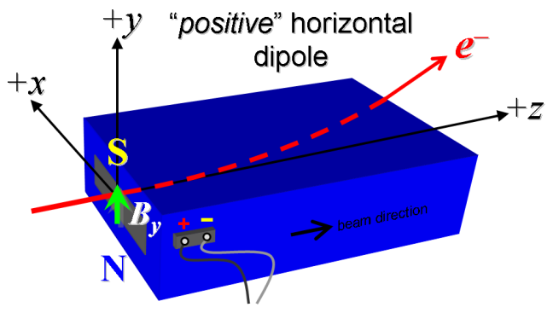
Figure 1: The dogleg dipoles should bend the beam to the left, see ID-388-025-01.

- Mark the main coil terminals where the ps cables are connected with clear “+” and “-” labels.
Main coil polarity has been labeled (initials): | SDA
- Determine the trim coil connection polarity (with supply outputting positive current) which produces a “positive” field polarity as shown in Figure 1 above.
- Mark the trim coil terminals where the ps cables are connected with clear “+” and “-” labels.
Main coil polarity has been labeled (initials):
- Connect the main coil terminals to a unipolar power supply with maximum current > 300 A and connect the trim coil terminals to a bipolar power supply with max current > 6 A, both in the correct polarity as established above.
- Connect magnet to LCW supply. Adjust supply pressure to a ∆P of ~100 psi to achieve a flow rate of ~0.5 gpm. Run the magnet up at main coils = 300 A, trim coils = 0 A, to thermal steady state (min 1 h). Record delta P; flow rate; inlet, outlet, coil and ambient temperatures; main coil current; voltage over main coil terminals. Estimated ∆T ≈ +18 °C at 300 A, 100 psi.
LCW delta P (psi) | 110 psi
LCW flow rate (gpm) | 0.5 gpm
final LCW ∆T (°C) | °C
final coil surface temperature (°C) | °C
Ambient temperature (°C) | °C

- Confirm the pole gap field using a Hall probe. Nominal ≈ 0.68 T at 225 A.
at 225 A, Hall probe (T) | T

- Standardize the magnet, starting from 0 A to 300 A and back to 0 A, through three full cycles, finally ending at 0 A, with a flat-top pause time (at both 0 and 300 A) of 10 seconds. Use a ramp rate of 10 A/sec, if possible, and record the ramp rate used. Trim coils at 0 A throughout.
Standardization complete (initials):
Ramp rate used (A/sec) | A/sec

- Maintaining this cycle history, measure with rotating coil the length-integrated vertical dipole field, ∫B_{y}dl, from 0 A to 300 A in 15-A steps, including 0 A (21 ‘up’ measurements). Please record (below) the measured ∫B_{y}dl at 225 A (nom. ~0.137 Tm). Then, still maintaining the cycle history, measure ∫B_{y}dl back down from 300 A to 0 in 15-A steps, including 0 A (20 ‘down’ measurements). Trim coils at 0 A throughout.
at 225 A, ∫B_{y}dl (Tm) | Tm
Filename & run number of ∫B_{y}dl up & down data:

- Present the measured the magnet harmonics at 225 A (with trim coils at 0 A). Multipole amplitudes should be given as a percentage of the dipole amplitude evaluated at the probe radius. Compare measured b1/b0 and b2/b0 to physics requirement scaled to probe radius, and confirm with FACET-II magnet engineer (Martin J, martinj@slac.stanford.edu) for acceptance.
Filename & run number of harmonic data:
measured b1/b0 (%) | %
measured b2/b0 (%) | %
Probe radius used for harmonics (mm) | mm
Rotating Coil Designation (Name):
Results accepted (signed):

- Still maintaining the main coils cycle history, measure with rotating coil the length-integrated vertical dipole field, ∫B_{y}dl, at main coils 225 A for trim coils 0 A to 6 A in 1-A steps, including 0 A (7 ‘up’ measurements) and then back down from +6 A to -6 A in 1-A steps (12 ‘down’ measurements). Then set the trim current back to 0 A, and take one last measurement.
Filename & run # of ∫B_{y}dl trim data at main = 225 A

- Still maintaining the main coils cycle history, measure with rotating coil the length-integrated vertical dipole field, ∫B_{y}dl, at main coils 300 A for trim coils 0 A to 6 A in 1-A steps, including 0 A (7 ‘up’ measurements) and then back down from +6 A to -6 A in 1-A steps (12 ‘down’ measurements). Then set the trim current back to 0 A, and take one last measurement.
Filename & run # of ∫B_{y}dl trim data at main = 300 A

- Ramp down the main coils to 0 A, and measure with rotating coil the length-integrated vertical dipole field, ∫B_{y}dl, at main coils 300 A for trim coils 0 A to 6 A in 1-A steps, including 0 A (7 ‘up’ measurements) and then back down from +6 A to -6 A in 1-A steps (12 ‘down’ measurements). Then set the trim current back to 0 A, and take one last measurement.
Filename & run # of ∫B_{y}dl trim data at main = 0 A

- Measure the inductance and resistance of the magnet:
Inductance of main coil circuit (mH) | 6.30 mH
Resistance of main coil circuit (Ohms) | 0.0237 Ohm
Inductance of trim coil circuit (mH) | 5.31 mH
Resistance of trim coil circuit (Ohms) | 0.1409 Ohm
Ambient temperature (°C) | 16.8 °C

- Upon completion of tests, email URL of on-line magnetic measurements data folder where traveler is saved to FACET-II beam physicist (Glen W, whitegr@slac.stanford.edu) for final acceptance and choice of lattice location, with cc to FACET-II magnet engineer (Martin J, martinj@slac.stanford.edu).
Magnet accepted (signed):
Assigned beamline location (MAD-deck name):
Magnet marked with assigned location (initials):

Beam direction on the magnet drawing SA-380-300-00 is wrong. Correct magnet orientation is shown on ID-388-025-01.
FACET-II-PR-010, table 6

