Shim Adjustment Range For The Soldered Magnets
Z. Wolf
11/5/12

At present, one quadrant of the delta undulator magnet arrays has been assembled. This was done using soldered blocks. We wish to do a tuning test on this array without doing major modifications to the magnet keeper. In order to do the tuning, the magnets must be moved as shown in the following figure:
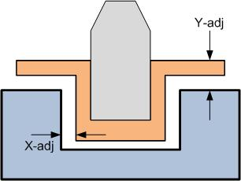
We will leave the X-adj dimension unchanged. At present the full range of motion in x is approximately 125 microns, so X-adj = +- 62.5 microns.
The value of Y-adj is presently 125 microns for all blocks. We will only move blocks away from the beam, so we only need an assortment of smaller shims to do the tuning. The assortment we wish is as follows:
0.002" - 50 each
0.003" - 50 each
0.004" - 50 each
0.005" - we have them

These numbers come from Yurii, except that I have divided his quantities by 4 since we will only tune one quadrant using these shims. We will ask for these same shim sizes for shimming the AA-International magnets. Since only one order needs to be placed, please see the AA-International magnet shimming document for the complete list of shim sizes.

