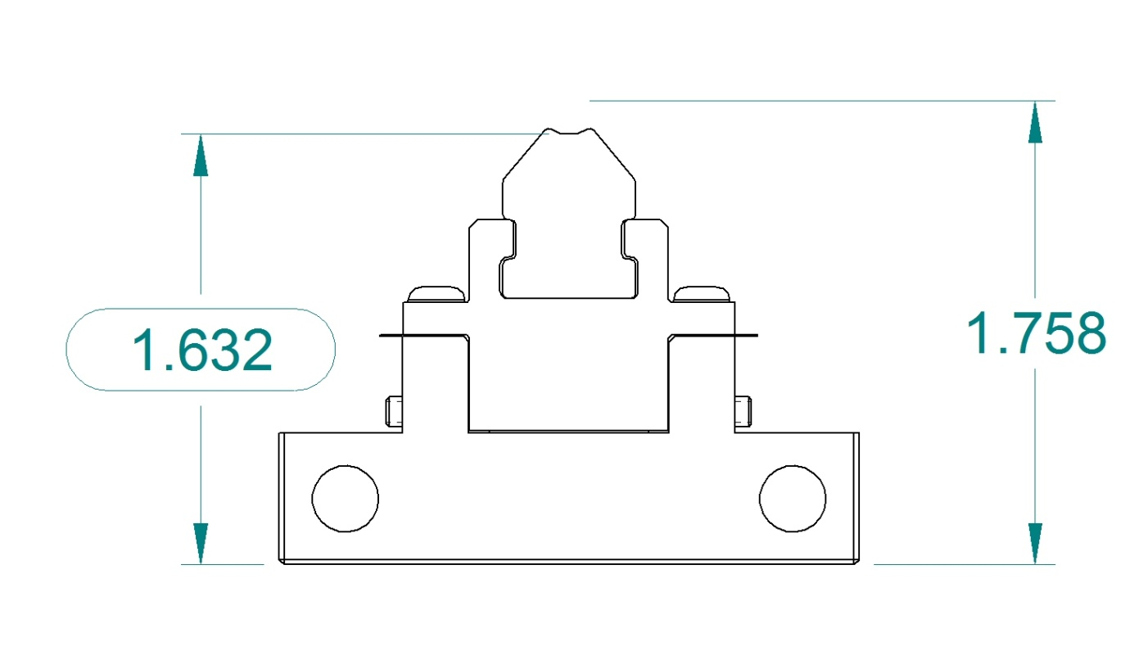
Magnet Base to Magnet Tangent Point Dimension with a .005” Shim

