Magnetic Measurements

Magnetic measurements are performed in accordance with “A Magnetic Measurement Plan for the Delta Undulator” [1] and “Delta undulator 2015 test plan”. A table of row settings was prepared for field mapping. Each line in the table corresponds to a dataset, stored in a folder on v-drive. First set of measurements was made in October 2014 (V:\MET\MagServe\MagData\DELTA\Delta data\Assembled Measurements\Final Measurements\). Due to the tight schedule, no wire measurements were done at that time.
The second set, made in August 2015, included the repeated measurements of 2014 with the same table of row settings used and an additional set of measurements made with a new 2015 table. Field integrals measurements with a stretched wire were also added to the set (V:\MET\MagServe\MagData\DELTA\Delta Data 2015\).

Hall probes.
When DELTA undulator is assembled, the only access to the beam axis for field measurements is through the 3.2m long bore with 6.6mm ID. Since magnets are not perfectly aligned, a special guiding tube is required. A spare 3.9m long vacuum pipe with 6.3mm OD and 5mm ID was used as a guiding channel. A package of 6 Hall probes was prepared to map the magnetic field. The probes were pulled through the pipe by Kugler bench using a 4.8m long carbon fiber tube with 4.7mm OD and 4.5mm ID. Two 3-D Hall probes made by Senis with extra-long signal cables (5.5m) were first fed through the tube and then mounted in a G-10 holder. The first package of 3 Hall elements was mounted as close as possible to the holder axis and the second package was deliberately shifted off the axis by 0.3mm. On-axis and off-axis field measurements provide information about the magnetic center location and magnetic field strength on the axis [2-4]. Before the holder was glued to the one end of the tube by DUCO cement, relative locations and all the angles between probe elements were measured and 2 x-probes and 2 y-probes were calibrated inside the calibration magnet. The probes were calibrated with the same DMMs as in use. For x, y, and z – probe location measurements a pointed magnet was used. The probe package was fixed and the pointed magnet was moved by 3 stages. The angles between the probe elements were measured inside a big dipole with the use a special precision cube (figure1).

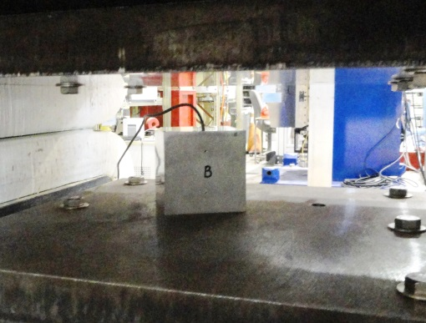
Cube
Magnet poles
Set screw holes
Figure 1. Calibration cube inside a dipole magnet gap.
Probe is fixed parallel to one of the sides of the cube by 2 plastic set screws. Probe orientation has been changed 90 degrees exactly by placing the cube on its different sides. Output signal of the probe is proportional to the yaw, pitch and roll angles.
The results were calculated in DELTA coordinate system but the Hall probe package was oriented differently during the measurements. Therefore, sign corrections were applied, as shown below.
Senis probe in holder, probe coordinate system
(The holder opening is UP)
Z
Y
X
119
120

DELTA coordinate system:
Z
Y
X

Probes’ position measurement results (DELTA coordinate system):
Probe # | ΔX(mm) | ΔY(mm) | ΔZ(mm) | Roll(°) | Pitch(°) | Yaw(°)
119-X | -0.089 | 0.056 | -2.081 | 0 | - | +0.351
119-Y | 0 | 0 | 0 | 1.72648 | 0.288 | -
119-Z | +0.066 | 0.126 | 0.902 | - | 0.007 | -0.002
120-X | -0.189 | 0.298 | -34.592 | 0.181 | - | -0.734
120-Y | -0.130 | 0.279 | -32.677 | 2.01783 | 0.404 | -
120-Z | -0.034 | 0.263 | -31.761 | - | 0.129 | +0.345

During the field measurements, the probe was rotated around the X-axis. Therefore the Y and Z coordinates change sign, the X coordinate stays the same. Probe Y direction matches the undulator Y direction; X and Z are in opposite direction. Roll and Pitch have the opposite sign, Yaw has the same sign.
Results (measurement coordinate system):

Probe # | ΔX(mm) | ΔY(mm) | ΔZ(mm) | Roll(°) | Pitch(°) | Yaw(°)
119-X | -0.089 | -0.056 | 2.081 | 0 | - | +0.351
119-Y | 0 | 0 | 0 | -1.72648 | -0.288 | -
119-Z | +0.066 | -0.126 | -0.902 | - | -0.007 | -0.002
120-X | -0.189 | -0.298 | 34.592 | -0.18100 | - | -0.734
120-Y | -0.130 | -0.279 | 32.677 | -2.01783 | -0.404 | -
120-Z | -0.034 | -0.263 | 31.761 | - | -0.129 | +0.345

Measurement set-up.
The undulator was placed next to the bench on pedestals with the cam mover system, see figure 2. (V:\LCLS\Group\Undulator\Delta\Fixtures\Field Mapping Fixture\ReadyForRelease\)
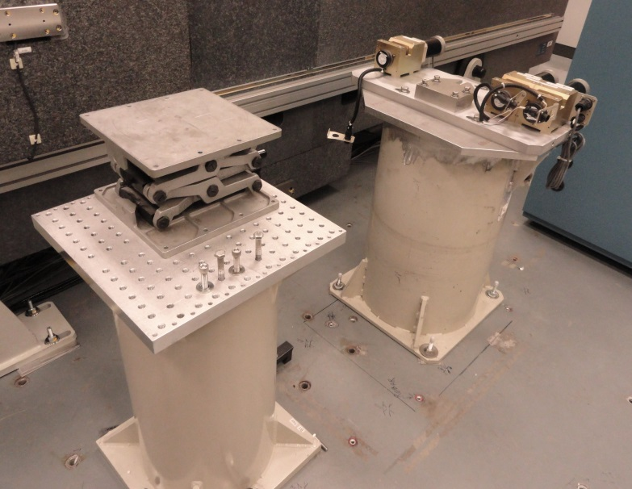
Cam mover pedestal
Instrument pedestal
DS cam movers
Figure 2. DELTA support pedestal with the cam mover and an instrument pedestal

Special feet were attached instead of the flat ones, see figure 3.

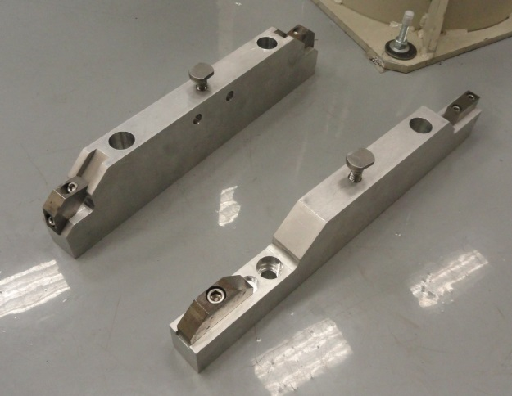
US foot
T-bolts
DS foot
Figure 3. DELTA feet for magnetic measurements

Alignment to the bench was performed with the use of fiducial marks on the undulator and the cam movers.
Two zero-Gauss chambers were mounted on pedestals at each end of the undulator. The field mapping starts inside the one zero gauss chamber and ends inside the second zero gauss chamber. It provides information about the probe zero drift.
The guiding pipe was inserted and fixed on the both ends of the undulator by special brackets. To prevent the pipe from shifting during the measurements, additional sleeves with plastic screws were attached to both sides of the pipe. When the probes are in the start location (Upstream), the total weight of the probes and the carbon fiber tube is supported by the undulator magnets. But when the probes are at the downstream end, their weight causes the guiding pipe to bend. Therefore, an extra bracket is required to support the pipe downstream. To prevent the carbon fiber tube from excessive sag when it is out, an additional support channel was used. Teflon tape was applied to the bottom of the channel to minimize the friction, see figure 4.

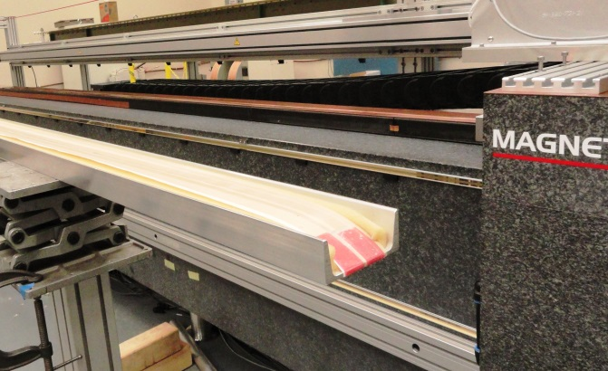
Teflon tape
Foam
Aluminum U-channel
Figure 4. Tube support channel.

The carbon tube was attached to the bench carriage by a bracket with a rotary stage. The rotary stage was used to set the roll of the probes, see figure 5.

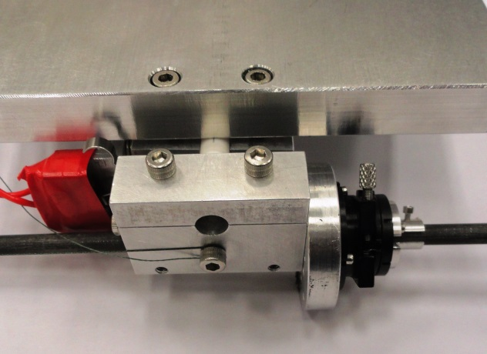
Ceramic rod
switch
Rotary stage
Figure 5. Carbone fiber tube connection to the stage bracket
The tube is fixed to the manual rotary stage. If ceramic rod breaks, the switch will disable the stage motion.

There are two extra limit switches added to the Kugler bench. The first one disables all motions when the probe ceramic is broken. It should be set to “closed” without the probes installed, and set to “open” with probes installed. The second switch is to limit the stage z-motion after the stage initialization. For Kugler bench initialization, the probes and brackets should be removed and the switch should be in “closed” position. After initialization and installation of the probes, the switch should be in the “open” position.

Probe alignment.

Roll angle of the probes was set by using the dipole magnet with parallel poles (vertical field standard). The magnet was placed on a pedestal and leveled, see figure 6.

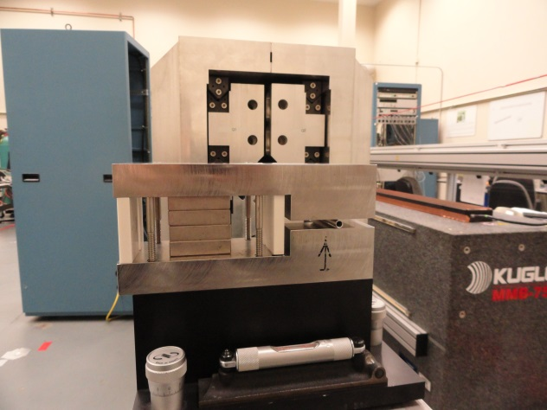
Levelling block
Bubble level
Vertical field magnet
Figure 6. Vertical field magnet.

Probe 119-X was chosen as having zero roll. It was set inside the magnet. The probe package was rotated until the probe output does not change when vertical field magnet is flipped over. There is no control of the roll inside the undulator during the measurements. Pitch and yaw angles are supposed to be negligible due to constrains of the guiding tube.
There is no way to make scans and align the probes in transverse directions or to set pitch and yaw of the probes. Positions of the probes (x and y) along the undulator were measured by laser system positioned upstream (V:\MET\MagServe\MagData\LCLS\Undulator\DELTA\ Delta_undulator_Rev_Hall Probe Position Measurement System.pptx).

Measurement programs.
A special PC program (LabWindows CVI) was used for field mapping, (V:\MET\Repository\Applications\Delta Undulator Test\DUTestKugler.cws). Triggering was done with the use of separate FPGA program (Kugler Delta Moving Zero Gauss Negative Trigger FPGA.vi) running independently on NI PXI-1042, S/N V08X0839E. It takes signals from the z-stage encoder and generates triggers at the specified interval. Separate intervals are set for zero Gauss chamber triggers and for the undulator triggers. The zero Gauss chambers and the undulator start positions should be set correctly on the User Interface and the “Trigger reset “ button to be pressed. The program will calculate the number of triggers. The total number of triggers minus number of triggers inside the zero Gauss chambers should be inputted into the PC program.
Six DMMs are used for measuring the probes’ output signals. Reading voltmeters’ data takes about 1minute/voltmeter and starts when the stage is on the way back, returning the probes into initial position. The stage returning speed is set so that the DMM memory reading is done at about the same time as probes have been returned into the initial position.

Setting quadrants’ zero positions
In 2014 the quadrants zero positions were set based on mechanical measurements. The settings were good to 0.2mm. In 2015 the quadrants zero were set based on magnetic measurements.
Section 4.3 of the “Delta undulator 2015 test plan” describes steps to find the zeroes . The procedure didn’t work because the iterations in zero setting didn’t converge to the same values. The procedure was changed as following.
All quadrants were set at old zero, which supposed to make the K-value maximum. Quadrants #2 and #4 stay at zero. The K was measured as a function of relative shift of quadrants #1 and #3 the same amount in opposite directions in ±0.4mm range, 0.1mm step. A second order polynomial fit was made to the K-function to find positions at maximum K. Quadrant #1 and #3 were left at new found maximum and the same procedure was repeated for quadrants #2 and #4. On the third iteration the quadrant positions’ changes were less than 10µm. These positions were set to be new zeroes.

References.
- LCLS - TN - 13 - 4
- LCLS - TN - 13 – 9
- LCLS - TN - 13 - 11
- LCLS - TN - 14 - 1
- LCLS - TN - 13 - 10

