SLAC Traveler for the LCLS ‘0.91Q17.72’ BSY Quadrupole Magnet Q5
(April 9, 2014)

This traveler covers mechanical fiducialization and magnetic measurements of the LCLS “0.91Q17.72” BSY quadrupole magnet Q5. These quadrupole magnets are each ~46 cm long, with a 0.023114 m diameter and were originally located in the FFTB beamline.
Account # 7720080

Receiving:
The following information is to be noted upon receipt of the magnets by the SLAC MFD group:
Received by (initials): | SDA
Date received (dd-mmm-yyyy): | 6/4/2014
SLAC barcode number: | 1052
Serial number on the magnet: 156

Place a barcode sticker on the magnet and
also duplicate the barcode sticker here →

Preparation:
Verify that a beam direction arrow is in place applied to the top and/or connector side of the magnet.
Beam-direction arrow in place (initials): | SDA

Fiducialization:
Fiducialization may be done before or after magnetic measurements. The magnet is to be fiducialized by the alignment group. This will require the installation of removable tooling balls, location of the geometric axis of the poles of the magnet, and location of tooling balls with respect to the center of this geometric axis when the poles are aligned precisely horizontal.

Alignment technician (initials):

URL of on-line Alignment fiducialization data (please modify or correct if necessary):
\\web002\www-group\met\Quality\FIDUCIAL REPORTS\

Magnetic Measurements:
Enter URL of on-line magnetic measurements data (please modify or correct if necessary):
http://www-group.slac.stanford.edu/met/MagMeas/MAGDATA/LCLS/quad/Q5/

- Connect the magnet to cooling water flow (rate = 1.4 GPM).

- Q5 is a “QD” (negative polarity”) quad.
Magnet marked as (please enter “QD”): | SDA

- Determine the connection polarity (with supply outputting positive current) which produces the correct field polarity for the “QD” magnet as shown below:

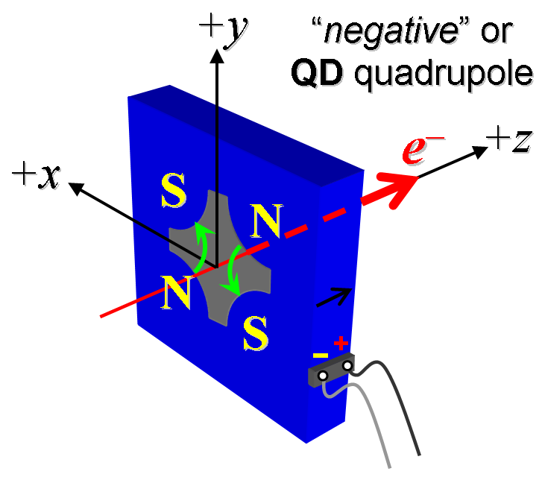
Figure 1. Q5 is a QD

- Mark the polarity near the magnet leads with clear “+” and “−” labels as shown above.
Polarity has been labeled (initials): | SDA

- Connect the magnet terminals in the correct polarity as established above, to a unipolar power supply with maximum current I ≥ 144 A.

- Run the magnet up to 100 A for ~1 hr to warm it up (record temperature).
Ambient temperature (°C): | 28.5 °C
Magnet Steel temperature (°C): | 30.1 °C
Magnet Coil temperature (°C): | 30.3 °C

- Training: Standardize the magnet, starting from zero to 144 A and back to zero, through ≥ 30 full cycles, finally ending at zero, with a flat-top pause time (at both 0 and 144 A) of 10 seconds. Use a ramp rate of 5 A/sec, and ramp style three-linear, and record the ramp rate and ramp style used.
- Standardize the magnet, starting from zero to 144 A and back to zero, through three full cycles, finally ending at zero, with a flat-top pause time (at both 0 and 144 A) of 10 seconds. Use a ramp rate of 5 A/sec, and ramp style three-linear, and record the ramp rate and ramp style used.
Standardization complete (initials): | SDA
Ramp rate used (A/sec): | 5 A/sec

- Measure the length-integrated field gradient, ∫Gdl, from 0 to 144 A in 12-A steps (13 ‘up’ measurements), and then back down from 144 A to 0 in 12-A steps (13 ‘down’ measurements).
Filename & run number of ∫Gdl up & down data: | Strdat.ru2

- Confirm the pole-tip field using a Hall probe at an excitation current of 72 A.
Hall probe pole-tip field at 72 A (mean of 4 poles): | 0.305 T at 71.985 Amps

- Measure the field harmonics at a 100-A current setting using a 0.8-inch diameter probe.
Rotating coil designation (coil name): | DC 34
Rotating coil radius (m): | 0.008998 m
Harmonics data file name: | Hardat.ru3

- Measure the inductance and resistance of the magnet:
Inductance of coil (mH): | 1.06 mH @ 1000 Hz
Resistance of coil (Ohms): | 114.838 mOhm

- Training: Standardize the magnet, starting from zero to 72 A and back to zero, through ≥ thirty full cycles, finally ending at zero, with a flat-top pause time (at both 0 and 72 A) of 10 seconds. Use a ramp rate of 5 A/sec, and ramp style three-linear, and record the ramp rate and ramp style used.
- Standardize the magnet, starting from zero to 72 A and back to zero, through three full cycles, finally ending at zero, with a flat-top pause time (at both 0 and 72 A) of 10 seconds. Use a ramp rate of 5 A/sec, and ramp style three-linear, and record the ramp rate and ramp style used
Standardization complete (initials): | SDA
Ramp rate used (A/sec): | 5 A/sec

- Measure the length-integrated field gradient, ∫Gdl, from 0 to 72 A in 6-A steps (13 ‘up’ measurements), and then back down from 72 A to 0 in 6-A steps (13 ‘down’ measurements).
Filename & run number of ∫Gdl up & down data: | strdat.ru4

- Training: Standardize the magnet, starting from zero to 48 A and back to zero, through ≥ thirty full cycles, finally ending at zero, with a flat-top pause time (at both 0 and 48 A) of 10 seconds. Use a ramp rate of 5 A/sec, and ramp style three-linear, and record the ramp rate and ramp style used.
- Standardize the magnet, starting from zero to 48 A and back to zero, through three full cycles, finally ending at zero, with a flat-top pause time (at both 0 and 48 A) of 10 seconds. Use a ramp rate of 5 A/sec, and ramp style three-linear, and record the ramp rate and ramp style used
Standardization complete (initials): | SDA
Ramp rate used (A/sec): | 5 A/sec

- Measure the length-integrated field gradient, ∫Gdl, from 0 to 48 A in 4-A steps (13 ‘up’ measurements), and then back down from 48 A to 0 in 4-A steps (13 ‘down’ measurements).
Filename & run number of ∫Gdl up & down data: | strdat.ru5

- Upon completion of tests, attach the traveler to the magnet and send a copy to Rick Iverson at mailstop 51.

This section is to be completed by R. Iverson.
Magnet accepted (signed):
Assigned beamline location (MAD-deck name): | Q5 spare

