SLAC Magnetic Measurement Plan and Traveler for Unipolar
LCLS-II Quadrupoles of Type 1.26Q12 (SA-380-327-00)
Scott Anderson March 2022

This is the magnetic measurements plan for the 1.26Q12 quadrupole magnet with LCLS barcode 002013, which was originally installed as QEM2, but it had a coil fault and LCLS-II Quad 4063 put into the QEM2 position in February of 2022. Due to the swap, LCLS 002013 will be installed as LCLS-II Quad QSP11H, which means it must be re-measured from 0-165-0 amps, because its original measurement was from -120 to 120 to -120 Amps. The QSP11H has “positive” polarity, as did QEM2.

Receiving:
The following information is to be noted upon receipt of the magnets by the SLAC MM group:
Received by (MMG initials): | SDA
Date received (dd-mm-yyyy): | 4/4/2022
SLAC barcode number: | LCLS 002013
Vendor serial number on the magnet: | 014

Preparation:
A beam direction arrow, with text “beam direction”, is to be applied to the top and/or connector side of the magnet with a sticker supplied by LCLS-II .
Beam-direction arrow in place (initials): | SDA

Fiducialization:
Fiducialization may be done before or after magnetic measurements. The magnet is to be fiducialized by the CMM group. This will require the installation of removable tooling balls, location of the geometric axis of the poles of the magnet, and location of tooling balls with respect to the center of this geometric axis when the poles are aligned precisely horizontal.
CMM technician (initials): | KC

URL of on-line CMM fiducialization data (please modify or correct if necessary):
https://www-group.slac.stanford.edu/met/quality/fiducial%20reports/LCLS%20LTU%20Q150kG%20QUADS/002013.pdf

Magnetic Measurements:
Enter URL of on-line magnetic measurements data:
http://www-group.slac.stanford.edu/met/MagMeas/MAGDATA/LCLS/Quad/002013/

- Check the connection polarity (with main supply outputting positive current) which produces a “positive” field polarity for QSP11H, as shown below:

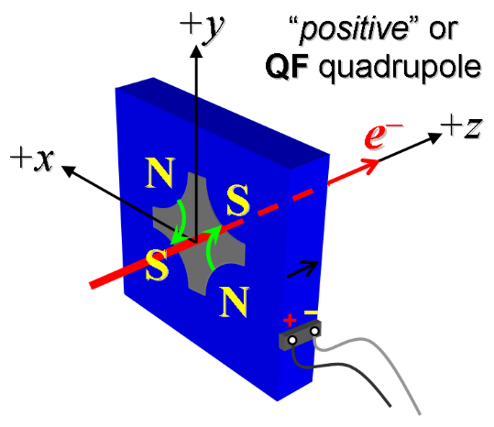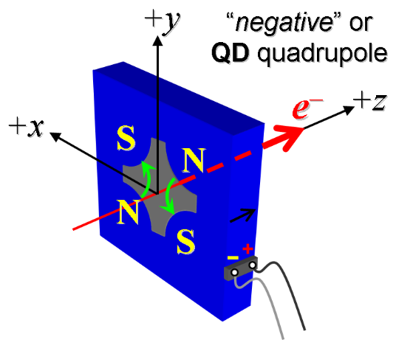
Figure 1. The QSP11H, magnet is “positive” (left).

- Mark the polarity near the magnet leads with clear “+” and “−” labels as shown above.
Magnet polarity chosen from Fig. 1 is (P or N): | P

- Connect the magnet to the LCW supply. Record the delta pressure and flow rate below.

Record delta Pressure (psi) | 89
Record flow rate (gpm) | 4.5
- Connect the magnet terminals in the correct polarity as established above, to a unipolar power supply with maximum current I ≥ 165 A.

- Run the magnet up to 165 A for 10 minutes to warm it up (record temperatures).
Ambient temperature (°C): | 22.8
Final Core temperature (°C): | 25.6
Bottom Coil (°C): | 27.0
Bottom Coil – Repaired (°C): | 26.7

- To train the magnet to the new current range, standardize the magnet, starting from zero to 165 A and back to zero, through 15 full cycles, finally ending at zero, with a flat-top pause time (at both 0 and 165 A) of 10 seconds. Use a three liner ramp rate of 20 A/sec, and record the ramp rate used.
Standardization complete (initials): | SDA
Ramp rate used (A/sec): | 3 Linear Ramp at 20 A/sec

- Standardize the magnet three times and then measure ∫Gdl from 0 to 20 A in 2-A steps (11 ‘up’ measurements), and then continue monotonically in 14.5-A steps from 20 A to 165 A (10 more ‘up’ measurements) and then back down from 165 A to 20 A in −14.5-A steps (10 ‘down’ measurements), and finally 20 A to 0 in −2-A steps (11 more ‘down’ measurements).
Filename & run number of ∫Gdl up & down data: | Strdat.ru5, strplt.ru5

- Measure the magnet harmonics at 78 and 165 A current setting. Multipole values should be given as a percentage of the quadrupole moment evaluated at the probe radius.
Filename & run number of harmonic data: | Hardat.ru5, harplt.ru5
Probe radius used for harmonics (m): | 0.0127
Rotating Coil Designation (Name) | 1DQB26

- Upon completion of tests, email URL of on-line data to Mark Woodley. Mark Woodley will determine if the magnet is accepted. Upon acceptance of magnet, analysis data will be placed in on-line data folder.
Magnet accepted and Analysis file(s) put into on-line data folder (initials):
Assigned beamline location (MAD-deck name): | QSP11H

