**Senis Hall Probe output drift**

To meet FEL tolerances on the field quality in undulators, Hall probes, used for the magnetic field mapping, must be very carefully calibrated to accuracy better then 10-4. We calibrate our probes in a temperature controlled room (±0.1°C), using a special calibration magnet with flat 20cm in diameter poles and with a stable power supply (Danfysik System 8500). As a field standard we use Metrolab PT2025 NMR with 5 probes to cover field range from 1.5T to 700G.

The NMR probes have overlapping measurement ranges, so we have overlapping points on the final calibration curve. An example of a nonlinearity curve is shown in a picture below.



Figure 1. *Probe output non-linearity. Zero offset and linear term are subtracted from the measurements. Time between probe changes varyes from 1.5hours to 30 minutes.*

From the picture one could clearly see that the overlapping points do not match. It means, that something drifts in the system in time between the change of the NMR probes. So, we started to look into the problem.

First, the magnet power supply drift should not have such effect. The NMR probe and the Hall probe are close together, at equal distance from the center of the magnet. Change in the magnet field would result in change both in Hall probe and NMR outputs.

Second, all our instruments are re-calibrated this year. To check if NMR calibration is correct we have measured the same fields with different overlapping probes. The difference between NMR probes’ readings was less than 0.02G (probes #3 and #4, #4 and #5) for both negative and positive fields.

Third, our DMM was checked w.r.t voltage standard before and after the calibration. No drift detected.

Next, we started to look into the Hall probe output stability. Inside a zero-Gauss chamber the probe output is very stable, see picture below.

Figure2. *Hall probe zero drift. Probe is inside a zero-Gauss chamber.*

Finally, we did the following test. We put the probe inside the calibration magnet, set constant current, and measure 5 parameters at the same time: NMR output, Hall probe voltage, Probe temperature, Temperature around the probe (the probe is enclosed inside a water cooled copper block), and temperature inside of the electronics box. We did it for 1.5T, 1.0T, 0.2T, 0.09T fields, and with the magnet current OFF. The results show a drift in the probe output which is correlated with the box temperature, when high magnetic field is present, see pictures below.

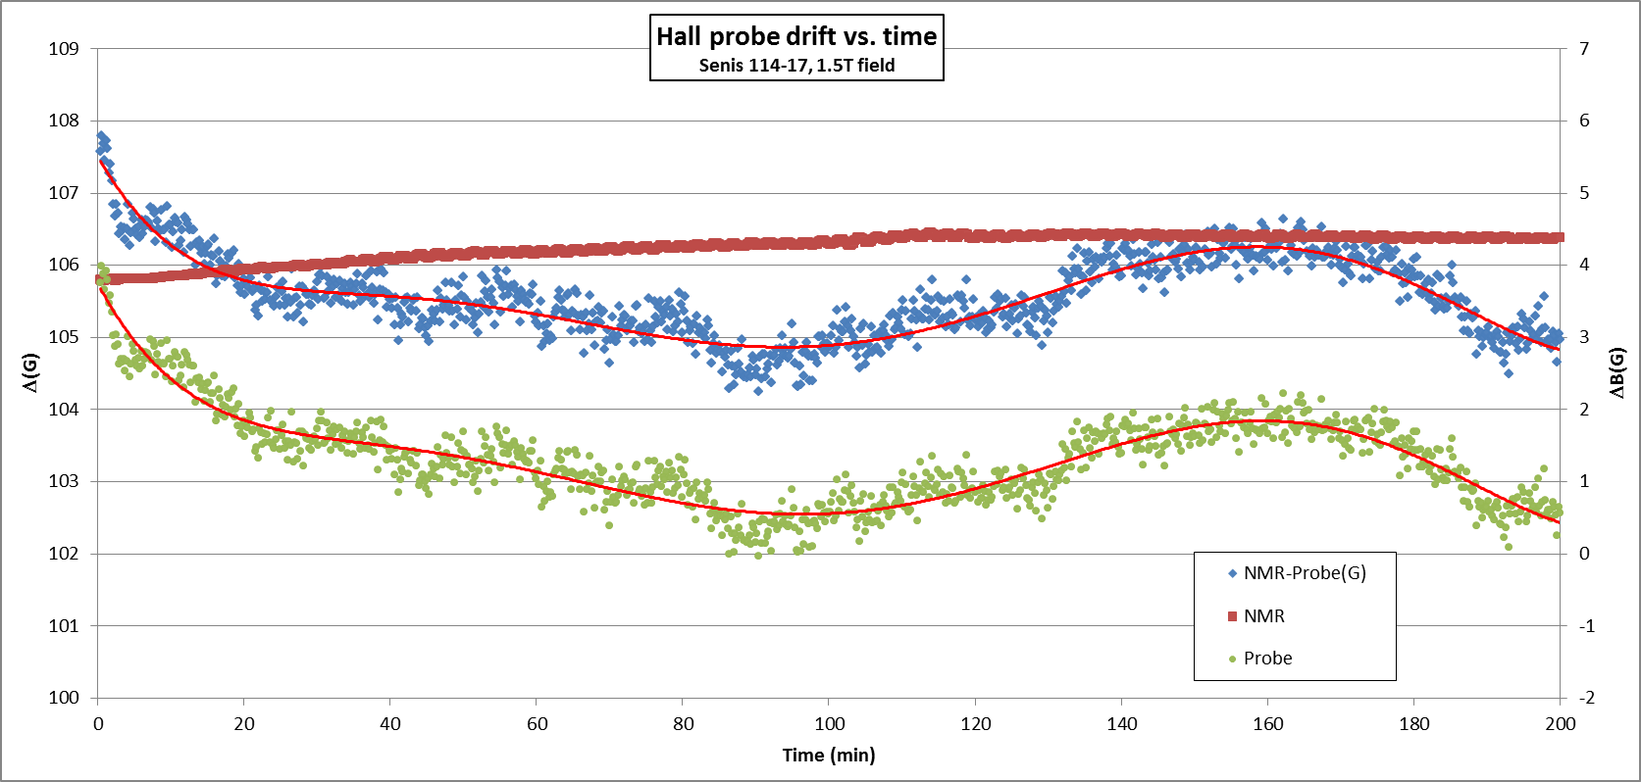

Figure 3. *Probe output drift. Magnet current is 71A. Left axis is for difference NMR – Hall probe, right axis is for NMR and probe outputs. Constants are subtracted from data to bring the outputs on the same scale. NMR output is stable while the probe output drifts as does the difference.*

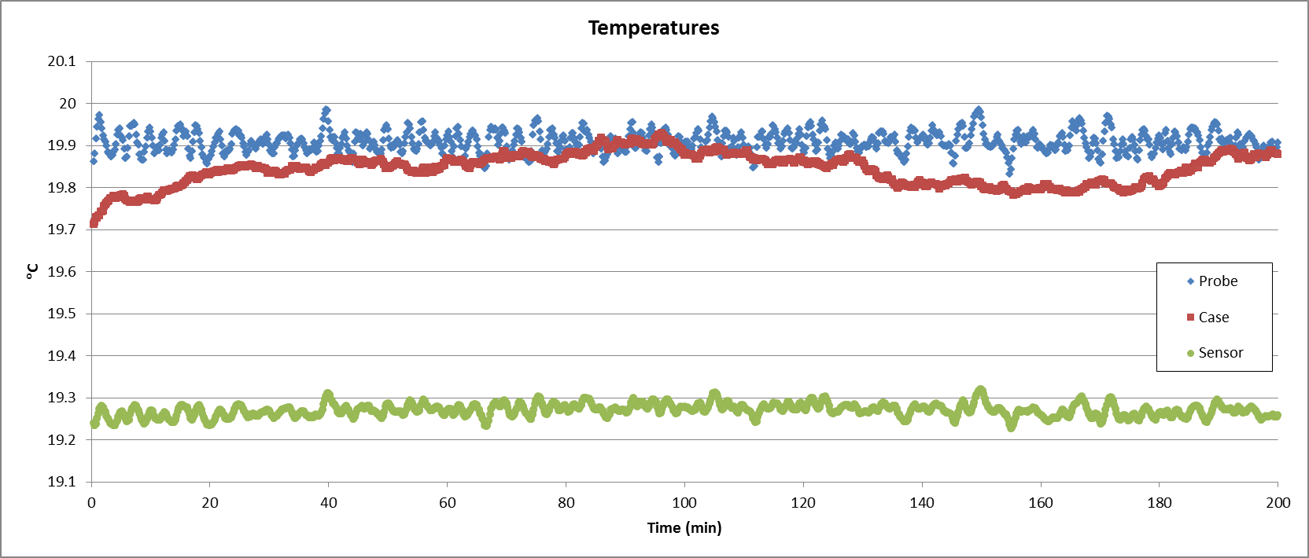

Figure4. *Probe temperature and temperature around the probe are stable but the Box temperature drifts.*

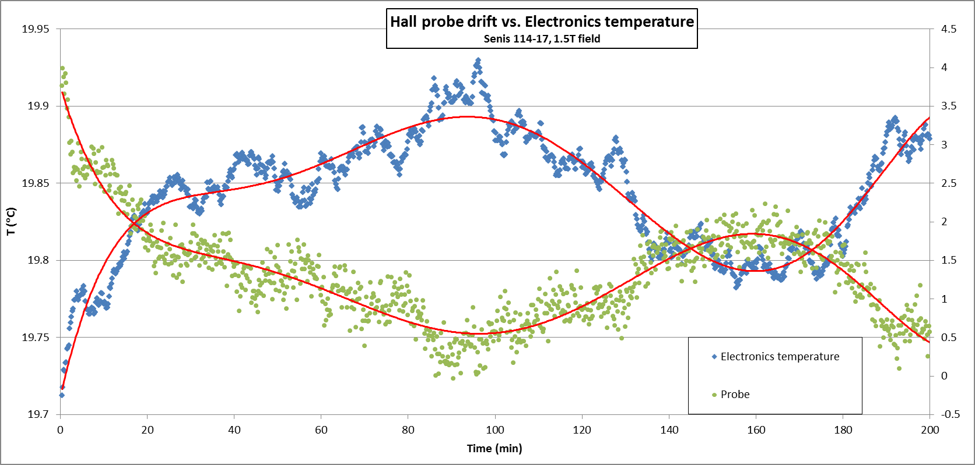

Figure 5. *Probe output drift – right axis and the box temperature – left axis.*

For low magnetic fields the drift is insignificant. This agrees with measurement results inside the zero-Gauss chamber.

We’ve got similar pictures for the other magnet fields. The magnitude of the drift scales with the applied field.

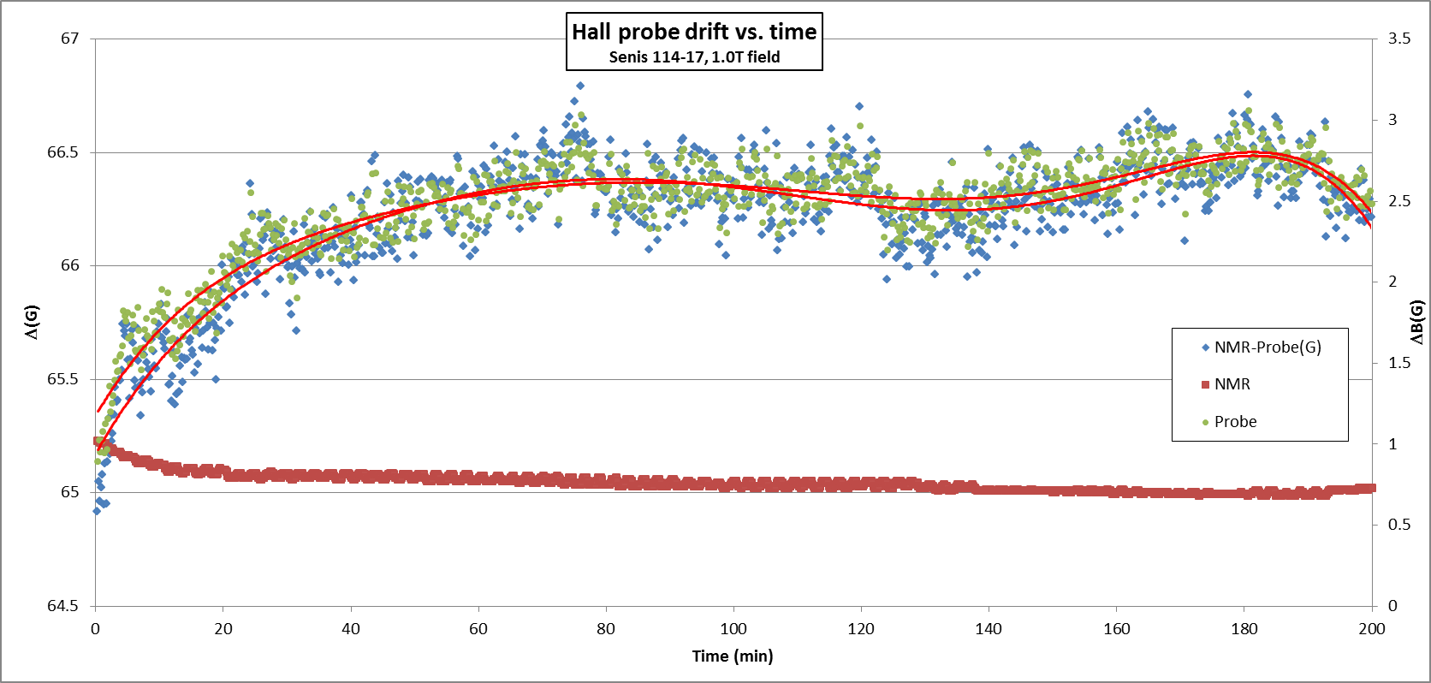

Figure 6. *Probe output for magnet current 45A. Left axis is for difference NMR – Hall probe, right axis is for NMR and probe outputs. Constants are subtracted from data to bring the outputs on the same scale.*

It looks like the sensitivity of the probe heavily depends on the electronics temperature. On the next pictures, when fields are low, the output is less sensitive to the temperature change.

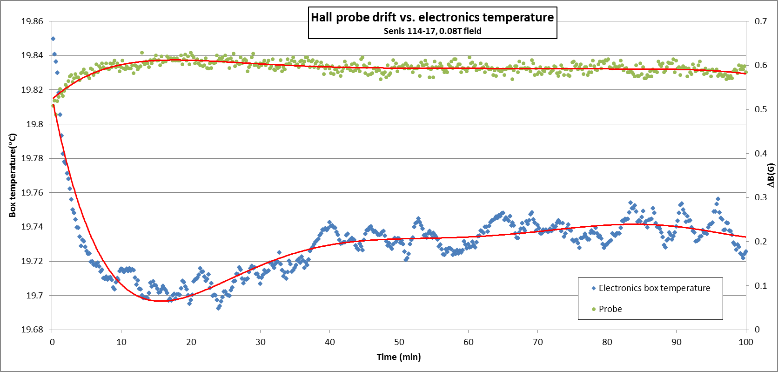

Figure 7. *Probe output, magnet current set to minimum. Almost no drift for low magnetic field.*

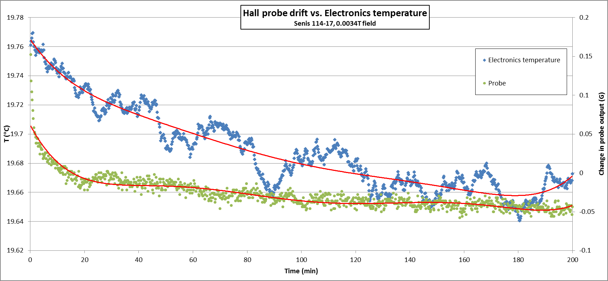

Figure 8. *Probe output, magnet current OFF.*

The tests are done for Senis probe #114-17 but other probes (#118-14, #120-12, #119-12) show similar behavior.