Magnetic Measurements for the LCLS

Hard X-Ray Self-Seeding (HXRSS) Chicane Dipole Magnets
Contact: P. Emma or D. Walz (Oct 10, 2011)
Account number: 617710

This traveler is intended to prescribe the magnetic measurements plan of the four Hard X-ray Self-Seeding (HXRSS) chicane dipole magnets (1.25D14-C). These rectangular C-type dipole magnets are 14 inches long with 8-mm gap height and have MAD names of: “BXHS1”, “BXHS2”, “BXHS3”, and “BXHS4”, with each magnet including both main coils and ~1% trim coils. The main and trim coils are each designed for excitation at up to 6 Amperes, requiring no water cooling and no over-temperature trip relays.

Receiving:
The following information is to be noted upon receipt of the magnets:
Received by (initials): | SDA
Date received (dd-mmm-yyyy): | 10-OCT-2011
Magnet serial number, if available: | 101
SLAC barcode number: | 1049

Place a barcode sticker on the magnet, if available, and enter the barcode number here →

Preparation:
A beam direction arrow, with text “beam direction”, is to be applied to the connector side of the magnet on the iron between terminal strips. With the C-magnet’s open-gap side facing away from the observer (terminal strips toward observer), the beam direction is to the left. If this is not done please contact D. Walz (2786) or P. Emma (2458).
Beam-direction arrow properly in place (initials): | SDA

Initial Setup:
- Verify that the magnets are complete and undamaged, including wiring connections.
Incoming inspection OK (initials): | SDA

Enter URL of on-line magnetic measurements data (please modify, append, or correct this URL as necessary):
http://www-group.slac.stanford.edu/met/MagMeas/MAGDATA/LCLS/dipole/BXHS1

- Mark each magnet as BXHS1, BXHS2, BXHS3, or BXHS4. By choosing the magnet names (locations) initially, they will be tested in their proper polarities, since two are to be positive and two negative.
Magnet marked as (BXHS1, BXHS2, BXHS3, or BXHS4): | BXHS1

- Determine the main-coil connection polarity (with MCOR6 main supply outputting positive current) which produces a “negative” (N) field polarity for BXHS1 and BXHS4 (below right), but a “positive” (P) field polarity for BXHS2 and BXHS3 (below left), as shown below:

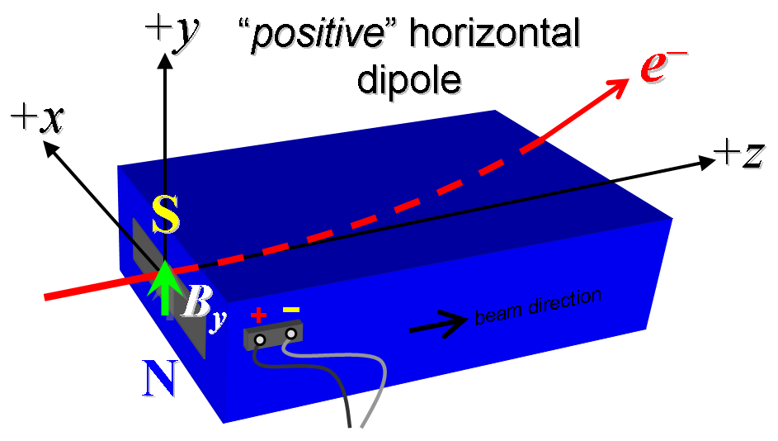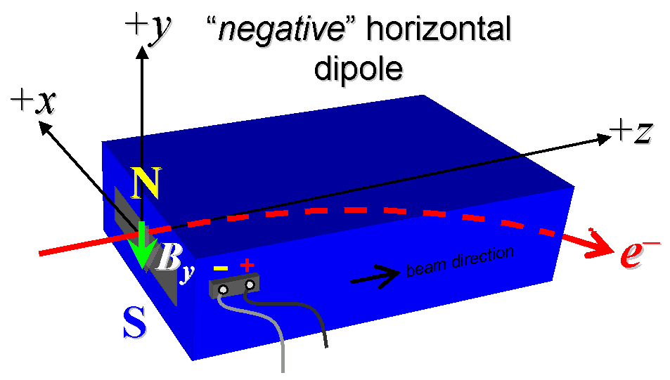
Figure 1. Dipole magnet sketch indicating field polarities. Note that BXHS1 and BXHS4 are “negative” (right), while BXHS2 and BXHS3 are “positive” (left). The C-magnet’s open-gap side (not shown here) is the side seen facing the observer.

- Mark the polarity near the main magnet leads with clear “+” and “−” labels as shown above.
Main coil polarity chosen from Fig. 1 is (P or N): | N

- Also mark the trim leads with clear “+” and “−” labels such that, with the trim supply outputting positive current, the trim coil increases the absolute value of the magnetic field established by the main coil. This will set the trim polarity as “negative” (N) for BXHS1 and BXHS4 and “positive” (P) for BXHS2 and BXHS3, as described in LCLS-I PRD 1.1-010.
Trim coil polarity chosen from Fig. 1 is (P or N): | N

- Connect the main magnet terminals (not the trims) in the correct polarity as established above, to a bipolar MCOR6 power supply with maximum current I_{main} = ±6 A. Leave the trim coil disconnected for now.

- In an environment with ambient temperature of about 20°C (68°F), excite the magnet’s main coils at 4 A for ~5 hours to warm it up (verify this is steady-state temp. and record value).
Ambient temperature (°C): | 24.99 °C
Final magnet top surface temperature (°C): | 26.32 °C

Magnetic Measurements:
- Standardize the magnet using the main coils (trim coils not yet powered) starting from zero to +6 A and back to zero, through three of these full cycles, finally ending again at zero, and with a flat-top pause time (at each setting of 0 and +6 A) of 5 seconds. Use a ramp rate of 2 A/sec, if possible, but record the ramp rate used. Throughout this entire procedure, the “three-linear” type of ramp should be used when changing the field.
Unipolar standardization complete (initials):
Ramp rate used (A/sec):

- Maintaining this cycle history, and with the trim coils still not powered, measure the length-integrated vertical dipole field, ∫B_{y}dl, from 0 to +6 A in 0.5-A steps (13 ‘up’ measurements with at least a 2-sec pause at each setting). Then, still maintaining the cycle history, measure ∫B_{y}dl back down from +6 A to 0 in 0.5-A steps (13 ‘down’ measurements).
Filename & run number of ∫B_{y}dl up & down data:

- Repeat the standardization again, but now using a bipolar cycle, starting from zero to +6 A, then to −6 A, and finally back to zero, through three of these full cycles, and ending again at zero, all with a flat-top pause time (at each setting of −6 and +6 A) of 5 seconds. Use a ramp rate of 2 A/sec, if possible, but record the ramp rate used.
Bipolar standardization complete (initials): | SDA
Ramp rate used (A/sec): | 2 A/sec

- Maintaining this bipolar cycle history, and with the trim coils still not powered, measure the length-integrated vertical dipole field, ∫B_{y}dl, from 0 to +6 A in 0.5-A steps (13 ‘up’ measurements with at least a 2-sec pause at each setting). Then, still maintaining the cycle history, measure ∫B_{y}dl back down from +6 A to −6 in 0.5-A steps (25 ‘down’ measurements), and finally up from −6 A to +6 in 0.5-A steps (25 ‘up’ measurements).
Filename & run number of ∫B_{y}dl up, down, up data: | Wiredat.ru2

- Repeat the bipolar standardization of step #10 above, ending at I_{main} = 0, and with the trim coils still not powered, measure the length-integrated vertical dipole field, ∫B_{y}dl, at I_{main} = 0. Then physically disconnect the power supply from the magnet and measure the length-integrated vertical dipole field again.
Filename & run number of ∫B_{y}dl at I_{main} = 0: | Wiredat.ru3 1st measurement
Filename & run number of ∫B_{y}dl when disconected: | Wiredat.ru3 2nd measurement

- With the main coils still hooked up, connect the trim coil to a bipolar 6-A supply (MCOR6) with proper trim polarity as determined above.

- With the trim coil at zero, standardize the magnet in the bipolar cycle as described above in step #8, finishing with the main coil at I_{main} = 0. Then measure ∫B_{y}dl as a function of trim coil current from 0 to −6 A in 0.25-A steps, including zero (25 ‘down’ measurements), and again from −6 to +6 A in 0.5-A steps (25 ‘up’ measurements). Then set the trim current to zero.
Filename & run # of ∫B_{y}dl trim data at I_{main} = 0: | Wiredat.ru4

- Run the best degauss procedure known using cycling of the main coil current (trim current at zero) and record the smallest final measured |∫B_{y}dl| achievable and reproducible with I_{main} = 0. Please also finish the degauss procedure with a positive step, by setting the current in the positive direction to zero (i.e., from I_{main} < 0 to I_{main} = 0). Record the degauss procedure applied (ramp rate, hold times, current sequence, etc).
Degauss procedure’s minimum achieved |∫B_{y}dl|: | Relay open = -5.3354E-05 T-m  = -5.3354E-04 kG-m
Ramp rate: | 10 A/s
Hold times: | 2 sec
Current sequence: | Currents listed in file:  ‘Degauss Currents f = 0.88.txt’
Further comments (separate sheet?):

- With the degauss procedure finished, the trim coil still at zero, and without having changed the main coil current at all from its I_{main} = 0 setting after step #15 above, please vary the trim coil current from 0 to +6 A in 0.25-A steps, while measuring the length-integrated vertical dipole field, ∫B_{y}dl, at each setting, including zero (25 ‘up’ measurements), and again from +6 A to −6 A in 0.5-A steps (25 ‘down’ measurements), and finally from −6 A to +6 A in 0.5-A steps (25 more ‘up’ measurements). These field integral values will be quite small, so please take care to resolve the measurements at the level of <0.001 kG-m, if possible.
Filename & run # of ∫B_{y}dl vs. trim after degauss: | Wiredat.ru9 (relay open)

- For all four dipoles (except as noted below), with stretched wire, and after re-standardization using the bipolar method of step #10, measure the length-integrated vertical field over a horizontal span of ±5 mm at each 1-mm interval, at the following main and trim coil current settings.
- I_{main} = +4 A, and I_{trim} = 0 (all 4 magnets)
- I_{main} = +4 A, and I_{trim} = +3 A (BXHS2 only)
- I_{main} = +6 A, and I_{trim} = +6 A (BXHS2 only)
Filename & run # of ∫B_{y}dl vs. x data at 4 A, 0 A: | Wirevsx.r16
Filename & run # of ∫B_{y}dl vs. x data at 4 A, 3 A:
Filename & run # of ∫B_{y}dl vs. x data at 6 A, 6 A:

- For the BXHS1 magnet only, after bipolar standardization (step #10 above), with main coil at +4 A, and with trim at zero, measure the harmonics with a rotating coil with at least a 5-mm diameter but less than 8-mm diameter (if not available we may need to skip this step). Record probe designation, radius, and data file names:
Coil designation (text): | 26BC0.25
Coil radius (mm): | 2.90
BXHS1 harmonics filename: | Hardat.r21

- For the BXHS4 magnet only, after bipolar standardization (step #10 above), and after a degauss produces (see step #15 above), and with the trim current starting at zero, measure the length-integrated vertical dipole field, ∫B_{y}dl, as a function of very small variations of the trim current in the following sequence: 0, −0.2 A, +0.2 A, −0.3 A, +0.3 A, −0.4 A, +0.4 A, and −0.5 A, +0.5 A. Also please record the trim current rms regulation variations (contact Briant Lam for help, 2360) and try to correlate the current ripple with the measured field ripple, if possible.
Filename of ∫B_{y}dl vs. trim current tweaks for BXHS4:
Current regulation rms variations of trim for BXHS4:

- For the BXHS4 magnet only, after bipolar standardization (step #10 above), and at a main current of +4 A and with trim at zero, measure the vertical magnetic field component, B_{y}, at x = y = 0, as a function of the longitudinal beam-direction coordinate, z (from −10 cm to +10 cm in 0.5-cm steps, where z = 0 is defined at the iron edge and z < 0 is inside the magnet), at the downstream (exit) end of this one magnet. Please also measure the background field at z = +10 cm (outside the magnet) after the magnet is set to I_{main} = 0, starting from I_{main} = +4 A (separate file).
Filename of B_{y} vs. z data for BXHS4 exit edge:
Background filename of B_{y} (z = +10 cm), magnet OFF:

- For the BXHS4 magnet only, after bipolar standardization (step #10 above), and at a main current of +4 A and with trim at zero, measure the vertical magnetic field component, B_{y}, at the longitudinal and vertical centers of the magnet (z = −17.8 cm and y = 0), but as a function of the horizontal coordinate, x, extending from −16 mm to +64 mm in 4-mm steps, where x = 0 is defined at the horizontal edge of the iron poles and x < 0 is inside the magnet gap. Please also measure the vertical field component at z = −17.8 cm, y = 0, and x = +62 mm after the magnet is set to I_{main} = 0, starting from I_{main} = +4 A (separate file).
Filename of B_{y} vs. x data for BXHS4 gap edge: | Bhvszdat.r17
Filename of B_{y} at x = +62 mm for BXHS4: | Bhvszdat.r19

- Measure the inductance and resistance of the main and trim magnet coils and also verify the concurrent magnet temperature:
Main Ambient Temp | 24.5 °C
Main Present magnet temperature on top surface: | 27.1 °C
Inductance of main coil (mH): | 157.9 mH at 100 Hz
Resistance of main coil (Ohms): | 1.121
Trim Ambient Temp | 29.0 °C
Trim Present magnet temperature on top surface: | 27.1 °C
Inductance of trim coil (mH): | 0.107 mH at 100 Hz
Resistance of trim coil (Ohms): | 0.158

- For the BXHS4 magnet only, perform a final thermal test. Run the main current up to 6 A and the trim to its maximum current of 6 A, and measure the magnet coil temperature after it stabilizes (~5 hours?). Record the temperature on the top surface of the magnet.
Ambient temperature: | °C
Final BXHS4 temperature at I_{main} = 6 A, I_{trim} = 6 A: | °C

- Switch off the power to the magnet and allow it to cool down to ambient room temperature (preferably 68°F or 20°C). Then re-connect the magnet’s main coil only and re-standardize the magnet in the bipolar cycle as described above in step #10 above, finishing with the main coil at I_{main} = 0. Then with the magnet still cold, measure the length-integrated vertical dipole field, ∫B_{y}dl, from 0 to +6 A in 0.5-A steps, including zero (13 ‘up’ measurements). Then, still maintaining the cycle history, measure ∫B_{y}dl back down from +6 A to −6 in 0.5-A steps, including zero (25 ‘down’ measurements), and finally up from −6 A to +6 in 0.5-A steps (25 ‘up’ measurements).
Filename & run number of ∫B_{y}dl up, down, up data:

- Upon completion of tests, send traveler to Paul Emma at “PEmma@LBL.gov”.

This section is to be completed by P. Emma.
Magnet accepted (signed):
Assigned beamline location (MAD-deck name):

