SXR Integration Work Instructions (WI)
LBNL LCLS-II SXR-WI-29A804-B
Windchill Unique ID: LC-1002-6449
Issued August 11th, 2016

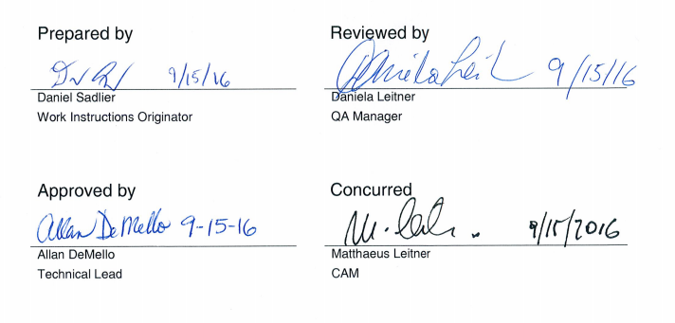
Contents
Revision History 3
Purpose 3
Scope 3
Definitions 3
Reference Documents 5
Tools Required 6
Hardware Required 8
Work Instructions 10
1 Overview 10
2 Tying down the Frame 10
3 Process for adjusting pole heights 11
4 Strongback Setup 11
5 Mounting Modules 12
6 CMM Measurements of Strongback Magnetic Assembly 22
7 Shim Calculations 24
8 Level the Frame 26
9 Mount Lower Strongback to Flex Plates 27
10 Alignment of the Strongback Assemblies 33
11 Gap Encoder 35
12 Switches 46
13 Pinch Guards 50
14 Completion 52
Verification Signoff Sheet 53

Revision History
Revision | Issued | Changes
A | 1/20/16 | Original issue.
B | 8/11/16 | Reference documents added, tooling clarified, alignment procedure updated,  gap encoder installation procedure updated, verification points updated

Purpose
The purpose of these Work Instructions is to describe the process of mounting the magnet modules onto the strongbacks, the strongbacks onto the frame, and performing the mechanical alignment of the undulator.

Scope
These Work Instructions describe the processes with aligning the magnet and pole heights, aligning the strongbacks onto the mechanical frame, and installation of the gap encoders and limit switches

Definitions
5PM/6PM End Module – “PM” refers to the number of Permanent Magnets in the end module. The 6PM end module is the upstream/beam entrance end module and the 5PM end module is the downstream/beam exit end module. Another way to distinguish is that the 6PM end module requires a magnet retaining plate, thus must be installed upstream of another module, while the 5PM end module ends in a pole, which is the end of the undulator.

X, Y, Z, Front, Back, Upstream, Downstream – The coordinate system for the undulator is defined as follows: Positive Z is in the direction of the beam line, positive Y is opposite gravity, and positive X is in the direction that makes the coordinate system follow the right-hand rule. Upstream is in the direction of negative Z, and downstream is in the direction of positive Z. The “front” of the undulator is the side where the strongbacks are mounted; the “back” is the side where the electronics are mounted and left and right are located based on the definition of front. See Figures 1 and 2.

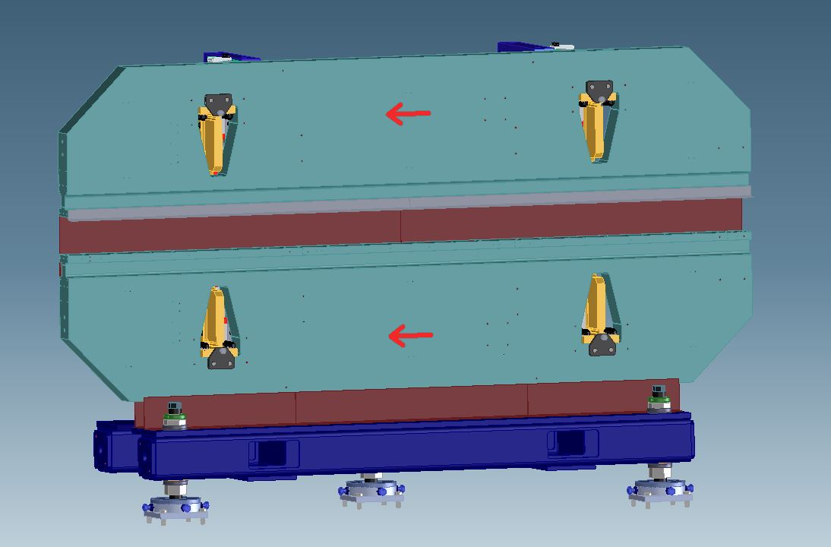
Downstream
Upstream
Coordinate System
Axis Z = Beamline
x
z
y
Figure 1: Mechanical Assembly, Front View, with xyz Coordinate System
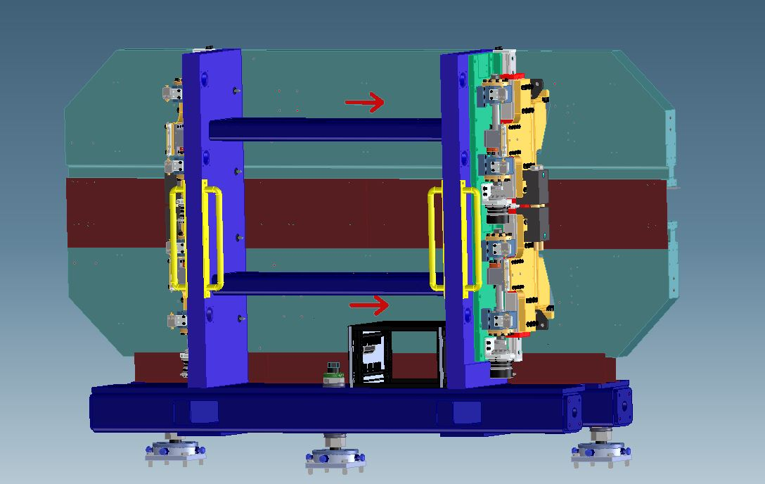
Bottom Downstream Flex Plate
Top Downstream Flex Plate
Upstream
Figure 2: Mechanical Assembly, Rear View
Left, Right (when referring to the Strongback or Magnet Modules) – When transferring data about the strongback, the observer is imagined to be looking down the beamline
Left = front on the lower strongback and back on the upper strongback
Right = back on the lower strongback and front on the upper strongback
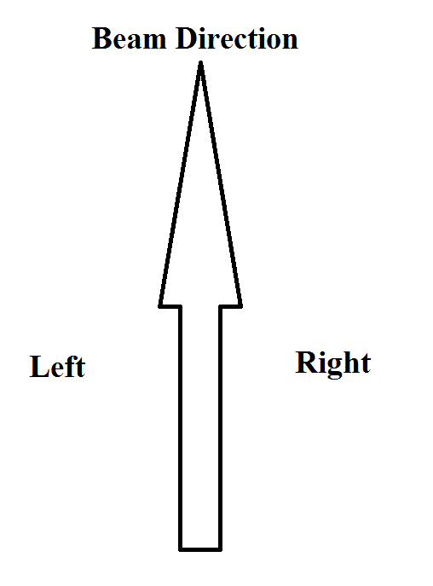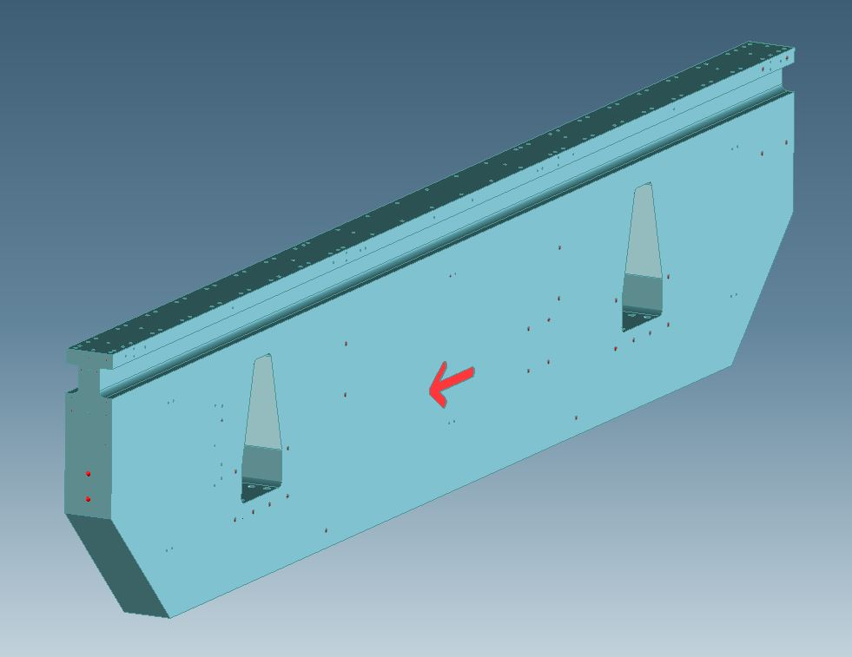
Right
Left
Figure 3: Strongback Left-Right definition

Reference Documents
- Mechanical Assembly Acceptance Criteria List SXR-ACL-29A811
- Magnetic Assembly Acceptance Criteria List SXR-ACL-29A663
- SXR Alignment Work Instructions SXR-WI-ALIGNMENT
- SXR Mechanical System Work Instructions SXR-WI-29A811
- SXR Magnet Module Assembly Work Instructions SXR-WI-29A663
- Undulator Integration Work Instructions Acceptance Criteria List SXR-ACL-29A804
- SXR Gap Control Acceptance Plan
- LCLS-II Undulator Motion Controls Checkout Procedure # LCLSII-WBS-EN-00 ##-R#

Tools Required

Required Tools:
- Metric Allen wrenches
  - Including an M16 ball-end Allen driver at least 84 mm, 3.375” long
- Jack screw wrench (90 mm, 4-5 ft of leverage needed)
- Precision squares and straight edges
- Lubrication for screws (Impact All Purpose Grease, PTFE -65F to 650F or equivalent)
- Lubrication for between magnet modules and strongback (alcohol based lubricant that will evaporate after use)
- Overhead crane – minimum 14,000 lbs., 7 ton capacity (estimated total weight 6 tons)
  - Slings, chain falls, eye hooks, similar rating
  - Lift hoist rings
  - Spreader bar – 2 ton capacity
- Precision level
- Platform to put 1.9 m/6’3” high upper strongback fastener below shoulder height while torqueing (this can be a man-lift)
- Magnet retaining plate temporary replacement
- Push block
- Magnet protection covers
Required Tools that Need Calibration:
- Coordinate Measuring Machine (CMM)
  - Clamps, squares, associated hardware
- Torque wrench for 0.5 N·m
- Torque wrench up to 200 ft·lbs
- Torque wrench up to 330 ft·lbs/447 N·m with M20 head
- Laser tracker using Spatial Analyzer software, with maximum 30 µm error in a multiple station network or maximum 10 µm error in a 2-point distance measurement
  - Retro-reflector, fiducial nests, hot glue gun
  - Fiducial nests
  - Hot glue gun
- Room temperature thermometer
- Z-alignment fixture

Recommended Tools:
- Non-magnetic M4 Allen wrench
- Screw jacks
- Ladder
- Calipers
- Dial indicators
- Feeler gauge, assorted sizes
- Clamps
- Bracket 29A701
- Gloves
- Mirrors

Hardware Required
Fabricated Parts & Hardware:
For 29A804:
Part # | Description | REQ’D
29A883 | SUPPORT FRAME WITH DRIVE ASSY | 1
29A856 | GAP ENCODER ASSY 1 | 1
29A855 | GAP ENCODER ASSY 2 | 1
29A849 | PITCH LIMIT SWITCH MOUNT BRACKET | 4
29A848 | ACTUATOR BRACKET | 2
29A870 | END COVER | 2
29A790 | HARD STOP X-DIRECTION | 8
29A670 | LOWER PINCH GUARD 1 | 1
29A671 | LOWER PINCH GUARD 2 | 2
29A672 | LOWER PINCH GUARD 3 | 1
29A673 | LOWER PINCH GUARD 4 | 1
29A675 | LOWER PINCH GUARD 5 | 1
29A678 | MIDPLANE PINCH GUARD 3 | 2
29A931 | LIMIT SWITCH ADJUST ASSY | 8
29A884 | COMPENSATION SPRING ASSY | 2
29A846 | DRIVE SAFETY SHIELD | 2

For 29A743:
29A877 | MAGNETIC STRUCTURE STRONGBACK | 1
29A744 | MODULE ASSEMBLY, PERIODIC, UPPER | 3
29A738 | 5PM UPPER END MODULE ASSY | 1
29A736 | 6PM UPPER END MODULE ASSY | 1
29A880 | MODULE SPACER | 4
29A857 | PRESS PAD | 2
29A836 | MODULE END CLAMP | 2

For 29A742:
29A877 | MAGNETIC STRUCTURE STRONGBACK | 1
29A663 | MODULE ASSEMBLY, PERIODIC, LOWER | 3
29A737 | 5PM LOWER END MODULE ASSY | 1
29A734 | 6PM LOWER END MODULE ASSY | 1
29A880 | MODULE SPACER | 4
29A857 | PRESS PAD | 2
29A836 | MODULE END CLAMP | 2

Work Instructions

Overview
- Assign assembly number to each of two (2) strongbacks and one (1) frame. Attach label per assembly print 29A743, 29A742 and 29A804.
- Enter the following information on the Verification Signoff Sheet:
  - Serial numbers from step one
  - Work instructions number and revision
  - Start date
  - Ambient temperature at assembly start
  - Serial numbers of all component parts to be used in the assembly.
- Ensure that the two strongbacks and frame have been released per Acceptance Criteria List SXR-ACL-29A811 and the ten magnet modules have been released per Acceptance Criteria List SXR-ACL-29A663.
- Ensure that there is a shim map for each of the two strongbacks. (Shim map created after stoning top surface if needed).
- Ensure that the there is a map of which periodic module serial number is the top upstream, top center, top downstream, bottom upstream, bottom center, bottom downstream magnet module.
- If any of steps 3-5 are missing, speak to QA.

Tying down the Frame
- Use a forklift or crane and hoist rings to lift the frame and drive assembly.
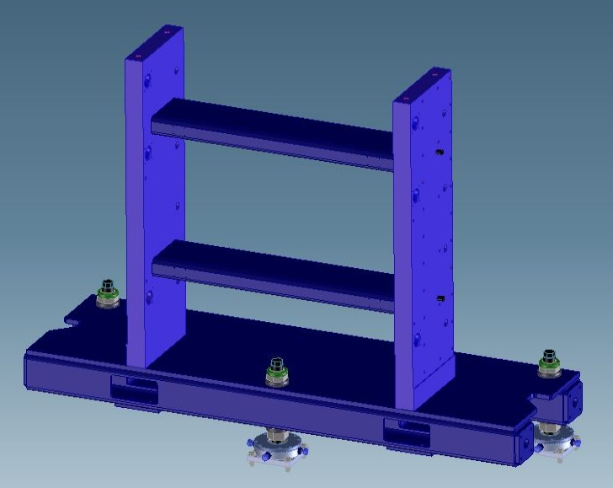
Forklift Points
Lift Hoist Ring
Attachment Points
Figure 4: Lift and Support Locations (drives not shown)
CAUTION: Do not attempt to lift frame from any other point without prior engineering approval.
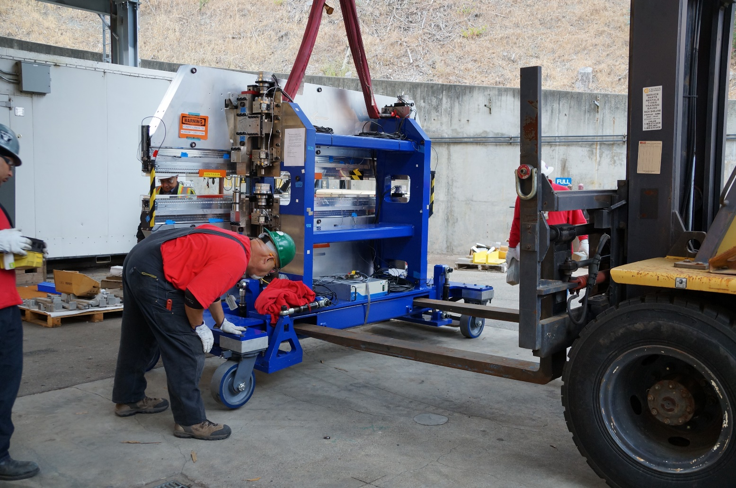
Figure 5: Transferring the prototype from crane to forklift
- Place the frame and drive assembly on the seismic floor plate stands, and secure with anchor bolts.

Process for adjusting pole heights
- See the Magnet Module ACL-VP and the Magnet Module Assembly Work Instructions for making adjustments if the magnet modules are not in tolerance.

Strongback Setup
- Steam clean the strongbacks if needed.
- Using the strongback mobile fixture assembly (29A752), secure the strongback in a vertical position with the magnet mounting surface at the top.

Mounting Modules

Hardware required for the lower strongback:
Part # | Description | REQ’D
29A877 | MAGNETIC STRUCTURE STRONGBACK | 1
29A663 | MODULE ASSEMBLY, PERIODIC, LOWER | 3
29A737 | 5PM LOWER END MODULE ASSEMBLY | 1
29A734 | 6PM LOWER END MODULE ASSEMBLY | 1
29A880 | MODULE SPACER | 4
 | Shims – 0.001”, 0.002”, 0.004”, according to map | A/R
#10 on 29A742 | SCR SOCHD M8 X 55L | 56
#11 on 29A742 | WASHER M8 X 16OD | 56
#12 on 29A742 | WASHER LOCK M8 X 14, 8OD | 56

Hardware required for the upper strongback:
Part # | Description | REQ’D
29A877 | MAGNETIC STRUCTURE STRONGBACK | 1
29A744 | MODULE ASSEMBLY, PERIODIC, UPPER | 3
29A738 | 5PM UPPER END MODULE ASSEMBLY | 1
29A736 | 6PM UPPER END MODULE ASSEMBLY | 1
29A880 | MODULE SPACER | 4
 | Shims – 0.001”, 0.002”, 0.004”, according to map | A/R
#10 on 29A743 | SCR SOCHD M8 X 55L | 56
#11 on 29A743 | WASHER M8 X 16OD | 56
#12 on 29A743 | WASHER LOCK M8 X 14, 8OD | 56

Hardware required for end module clamps:
Part # | Description | REQ’D
29A836 | MODULE END CLAMP | 4
29A857 | PRESS PAD | 4
#8 on 29A742 & 29A743 | SCR, BUTNHD, M3 X 8L, SST | 8
#10 on 29A742 & 29A743 | SCR, SOCHD, M6 X 20L, SST | 8
#13 ON 29A742 & 29A743 | SCR, SET, BRS TIP, SST, M6 X 10L | 4
#14 ON 29A742 & 29A743 | SCR, SET, M10 X 16L, SST | 4

Tools required:
- Z-alignment fixture
- Magnet retaining plate temporary replacement
- Push block
- Crane
- Chain fall
- Slings
- Grease (Impact All Purpose Grease, PTFE -65F to +650F, or equivalent) (for screws)
- Non-magnetic tools
- Magnet protection covers
- Alcohol based lubricant (that will evaporate after use, for between modules and strongback)

CAUTION: STRONG PERMANENT MAGNETS! The two largest risks are 1) that the magnetic field will interfere with an implanted medical device or 2) that a tool will be attracted to the magnets and strike with enough force to shatter the magnets, which are very brittle and 2) is that scratching or denting the magnets will alter change their performance.
Avoid use of ferromagnetic tools. Remove all objects from your person which might have ferromagnetic material (i.e. watches, keys) or might be affected by the magnets (i.e. credit cards, phones) before working. Tie glasses on securely. Wear safety glasses. Cover magnets with 1” thick foam and protective covering whenever possible. Stay away from magnets if you have an implanted medical device.
- The center periodic module is mounted first. Check the bottom of the module and stone smooth if necessary.

Note: All arrows on magnetic module keepers should point in the same direction as the arrow on the strongback.

- Use the z-alignment fixture to accurately place the central magnetic module in reference to the datum on the upstream edge of the strongback. The pins in the strongback are used to accurately place the module relative to the x-axis.

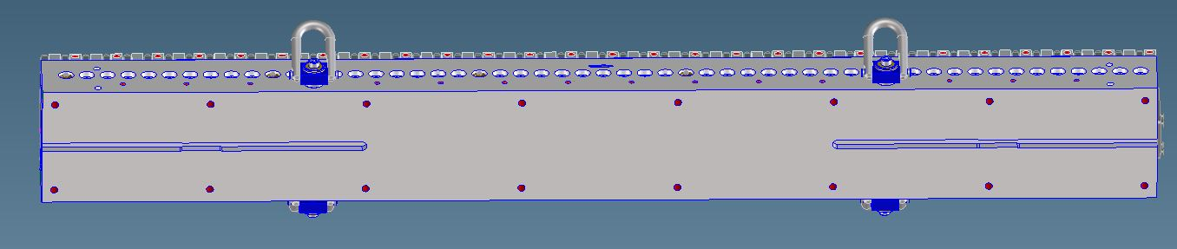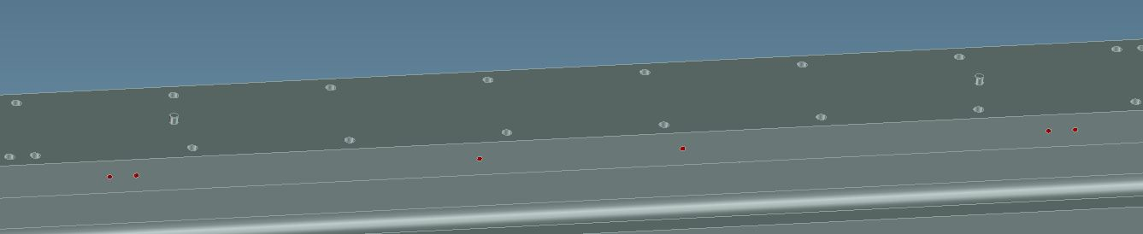
Figure 6: Strongback pins and module grooves
- The magnet module has a row of M6 tapped holes along the length. Attach 4 swivel hoist rings symmetrically in these holes to attach the module to an overhead crane.
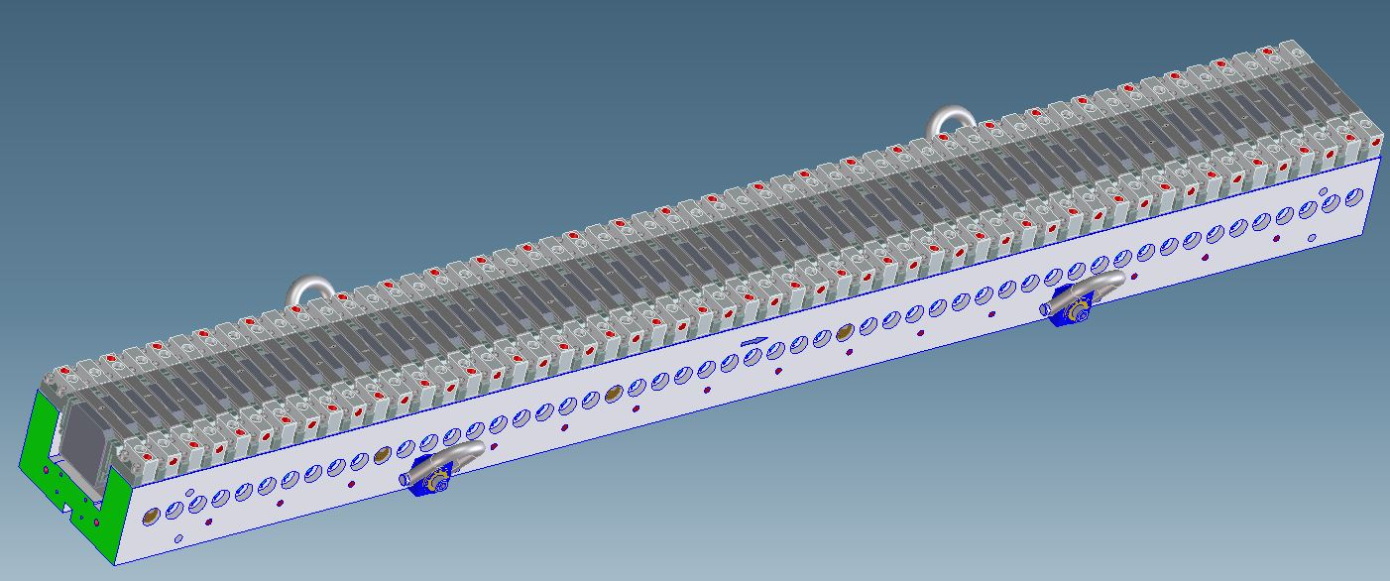
Figure 7: Hoist rings attached to periodic magnet module
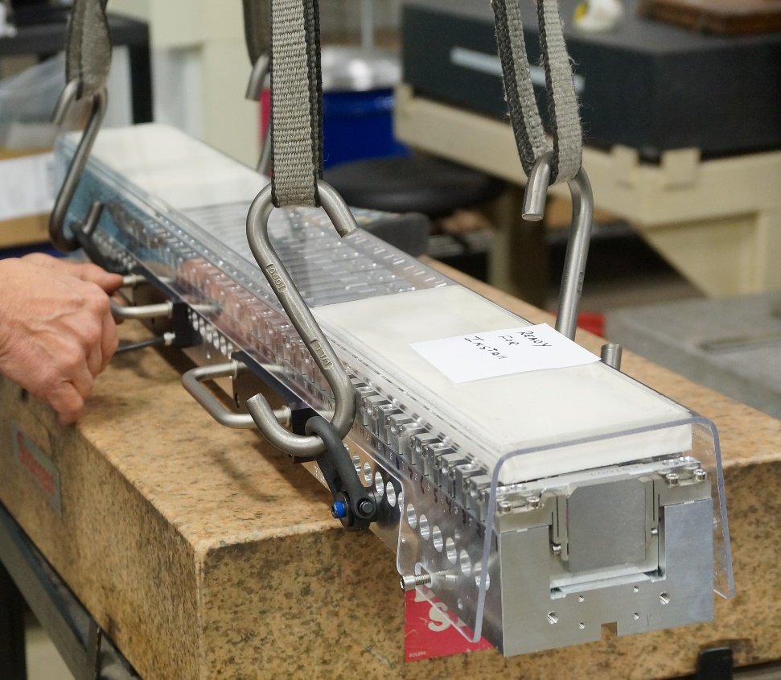
Figure 8: Hoist rings and handles attached to preproduction unit magnet module
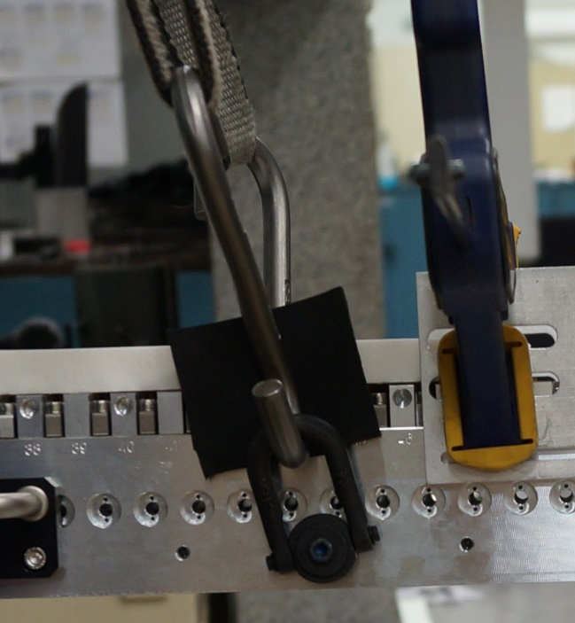
Figure 9: Protect magnets from direct contact with lifting devices
- Attach slings to the swivel hoist rings and use a chain fall for more control while lowering the module. May also need a spreader bar to avoid “shoving” magnets.
- With the central module held above the strongback with the crane, fit lubricated M8 screws, washers and lock washers through holes in strongback, and lightly screw into magnet module bottom.
- Insert shim stacks according to shim map. Upload the shim map to Windchill.

VERIFICATION POINT 1
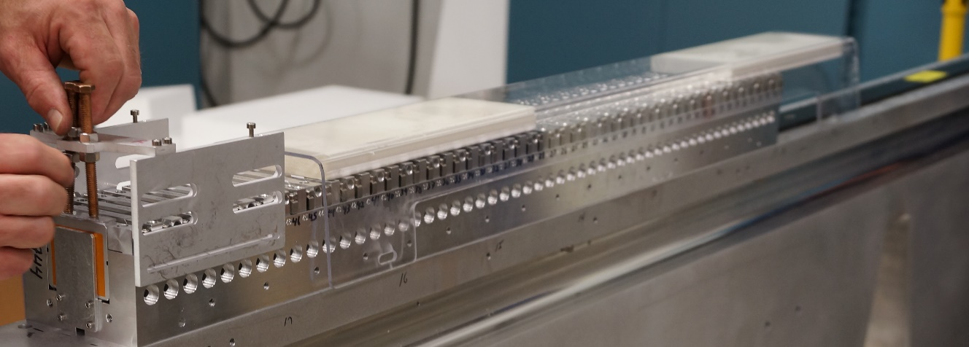
Figure 10: Z-alignment fixture (black part in rear of picture) and center module
- Settle the module on top of the strongback, using the z-alignment fixture and pins to place it. Use alcohol based lubricant as necessary.
- Torque the fasteners to 21.7 N·m (16 ft·lbs).

VERIFICATION POINT 2
- The downstream module is mounted second. Check bottom and stone smooth if required.
- Attach swivel hoist rings, slings, chain fall, and crane as in the first module.
- Attach a temporary magnet retaining fixture to the central module and remove the retainer plate (29A869).
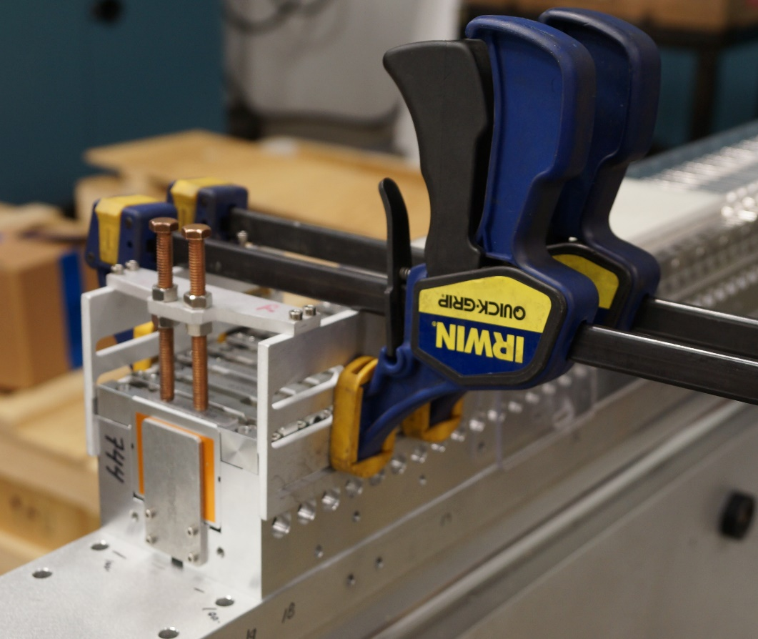
Figure 11: Temporary magnet retaining fixture, note piece of plastic between the screws and the magnet.
- With the module held above the strongback with the crane, fit lubricated M8 screws, washers, and lock washers through holes in strongback and lightly screw into magnet module bottom.
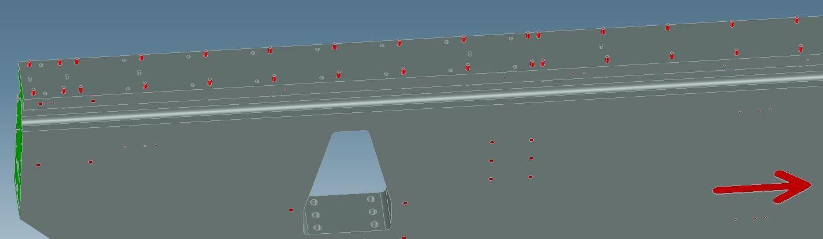
Figure 12: The strongback has holes for both SXR and HXR, shown here are the strongback with screws (red) in position for SXR.
- Insert shim stacks according to shim map. Upload shim map to Windchill.

VERIFICATION POINT 3
- Settle the module on top of the strongback, with the strongback pins fitting into the grooves on the bottom of the module.
- Insert the module spacer (29A880) between the two modules.
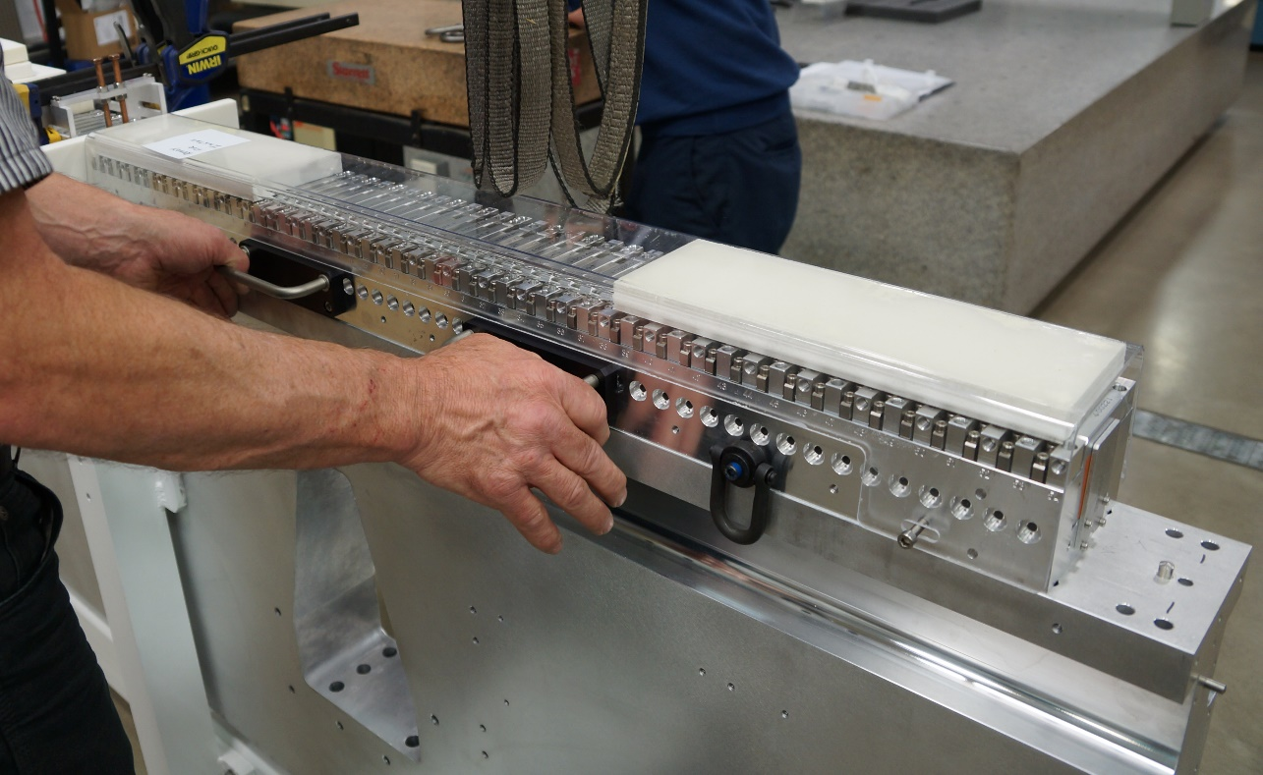
Figure 13: Use handles to push the module.
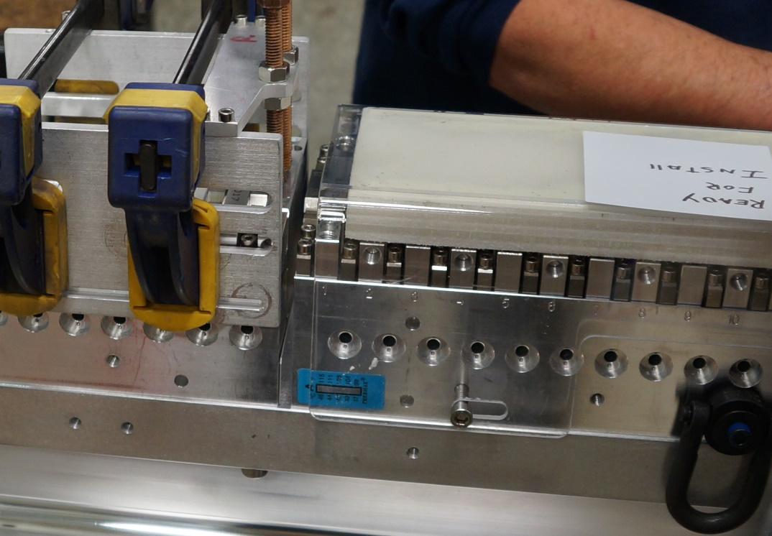
Figure 14: Spacer inserted between modules
- Push the downstream module against the center module and torque the fasteners to 21.7 N·m (16 ft·lbs). Use an alcohol lubricant to help it slide.

VERIFICATION POINT 4
- Remove the temporary magnet retaining fixture. Verify that the modules are close enough together by attempting to move the module spacer (29A880) if it doesn’t move, it is tight enough.
- Repeat the process with the upstream periodic module.
- Put the temporary magnet retaining fixture on the upstream magnet module, and remove the retainer plate (29A869).
- Attach the upstream periodic module to the crane.
- Lubricate and loosely attach M8 screws & washers.
- Insert shims according to shim map.

VERIFICATION POINT 7
- Insert the module spacer (29A880).
- Lower the module onto the pins and push it against the central module.
- Torque the fasteners to 21.7 N·m (16 ft·lbs).

VERIFICATION POINT 8
- Verify that the module spacer does not move if prodded.
Move the temporary magnet retaining fixture to the downstream periodic module, and remove the retainer plate (29A869).
- Attach the 5PM end module to the push block tooling.
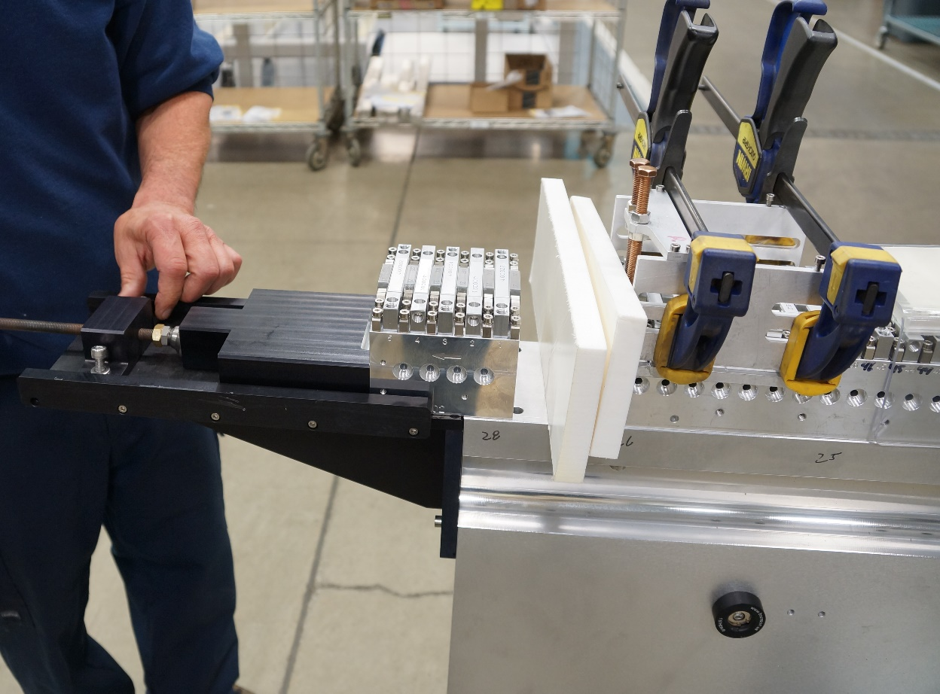
Figure 15: Push block tool, temporary magnet retaining fixture on downstream module
- Attach temporary magnet retaining fixture to 5PM end module and remove the retainer plate (29A869).
- Use the push block to slide the 5PM end module in place. Ensure that the groove goes over the pins in the strongback. Insert the module spacer (29A880) between the two modules.
- Fit lubricated M8 screws, washers, and lock washers through holes in the strongback and lightly screw into magnet module bottom.
- Insert shims according to shim map.

VERIFICATION POINT 5
- Using the push block fixture to hold the 5PM end module against the downstream periodic module, torque the fasteners to 21.7 N·m (16 ft·lbs).

VERIFICATION POINT 6
- Remove the temporary magnet retaining fixture. Verify that the modules are close enough together by attempting to move the module spacer (29A880) if it doesn’t move, it is tight enough.
- Attach the 6PM end module to the push block tooling. Attach the temporary magnet retaining fixture to the 6PM end module.
- Use the push block to slide the 6PM end module in place. Ensure that the groove goes over the pins in the strongback. Insert the module spacer (29A880) between the two modules.
- Fit lubricated M8 screws, washers, and lock washers through holes in the strongback and lightly screw into the magnet module bottom.
- Insert shims according to shim map.

VERIFICATION POINT 9
- Using the push block fixture to hold the 6PM end module against the downstream periodic module, torque the fasteners to 21.7 N·m (16 ft·lbs).

VERIFICATION POINT 10
- Remove the temporary magnet retaining fixture. Verify that the module spacer (29A880) does not move if prodded.
- Put the module spacer (29A880) and the press pad (29A857) on both ends.
- Repeat all steps in Sections 4 & 5 for the upper strongback.
- Place the press pad (29A857) on the lower and upper strongbacks and attach with M3 screws (#8 on 29A742 & 29A743).
- Mount the module end clamp (29A836) onto the upper and lower strongbacks using M6 bolts (#10 on 29A742 & 29A743).
- Screw the M10 bolt gently into the press pad and tighten the set screw. See Figure 16.

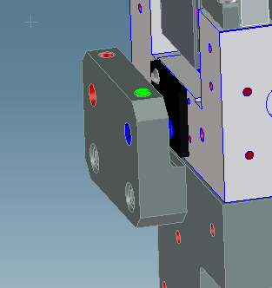
Figure 16: Module End Clamp Assembly is mounted onto the lower and upper strongback assemblies.

CMM Measurements of Strongback Magnetic Assembly
After the magnet modules are installed onto the strongback, the assembly will be measured on the CMM.
- For transport into the lab for measurement, cover the magnet modules with protective covers, 29A829 and 29A828.
- When lifting with the crane, use the holes in the strongback marked “with magnets” to lift at the center of mass.
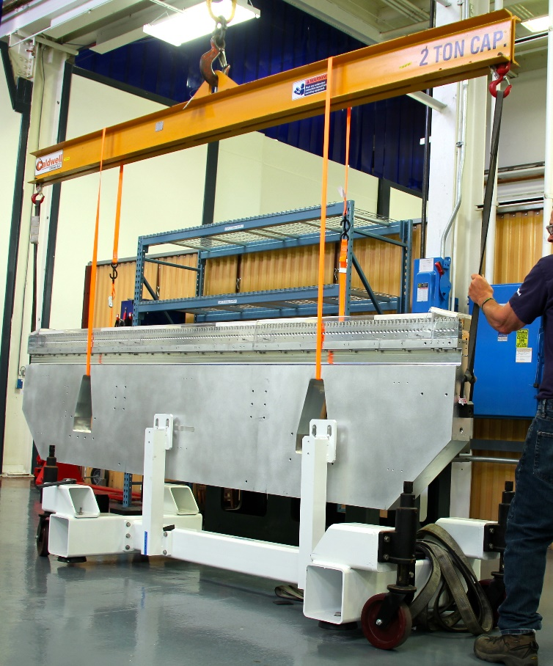
Figure 17: Lifting the strongback with the holes marked “with magnets”.
- The largest allowable distance between the tallest and the shortest pole top on the mounted magnetic modules is 20 µm.
- Add or remove shims between the strongbacks and modules to achieve the required tolerances.
- Note any changes to the shims in the verification line. If there are no changes to the shims, note “NONE” in the verification line.

VERIFICATION POINT 11
- On the CMM
  - Datum A is the best fit plane through a subset of the pole tops (at least 10% of them).
  - Datum B is the midline created by taking points on the front and back of the strongback, at least 6 points on each side.
  - Datum C must be established using the strongback, not the modules.
- Required measurements:
  - Every pole height compared to datum A, both left and right side of the pole
  - X, Y, Z coordinate of center of all 12 fiducial balls (use 1.5” steel balls, McMaster-Carr part 9642K73 or equivalent)
  - Front pole face to front pole face spacing of the poles over the module ends
  - The height relative to datum A of each bolt hole on the magnet module mounting surface. Label holes “left” or “right” according to definitions of this work instruction (where viewer is looking downstream) and begin with hole number 1 as the most upstream hole.
The height relative to datum A of each bolt hole on the 2 flex plate interface surfaces (see Figure 18) Label holes Upstream/Downstream flex plate mounting surface, Upstream/Downstream set of 3 holes, and Left/Center/Right hole, i.e. hole UUL is on the upstream flex plate surface, upstream set of holes, left side, hole DUC is on the downstream flex plate mounting surface, upstream set of holes, right side.

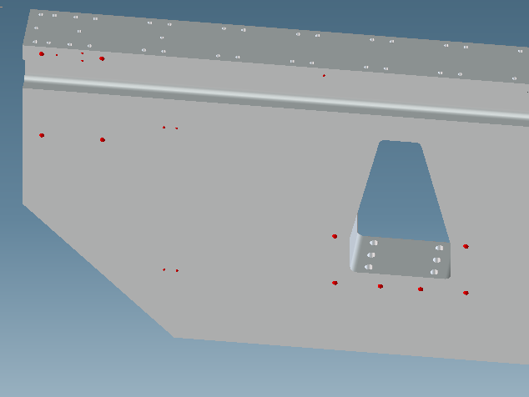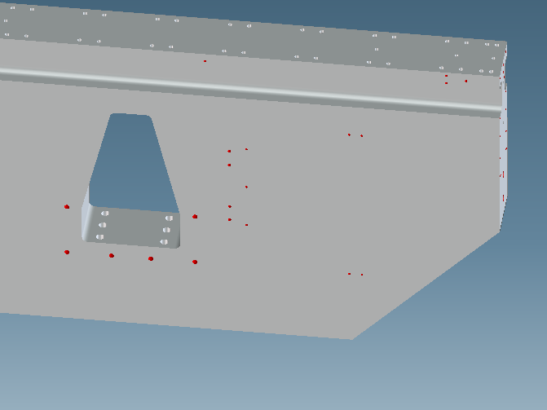
LLL
LUR
LUC
LLR
LLC
LUL
UDR
UDC
UDL
UUR
UUC
UUL
Figure 18: Measurement locations and notation. Beam is in the direction of the red arrow.

VERIFICATION POINT 12
- Send all data to the QA engineer and upload to Windchill.

Shim Calculations
In order to eliminate roll, it is necessary to insert shims between the flex plate and the strongback. On the prototype, type 18-8 Stainless Steel Round Shims, 7/8" ID, 1-3/8" OD, of various thicknesses were placed around each bolt. See Figure 19.
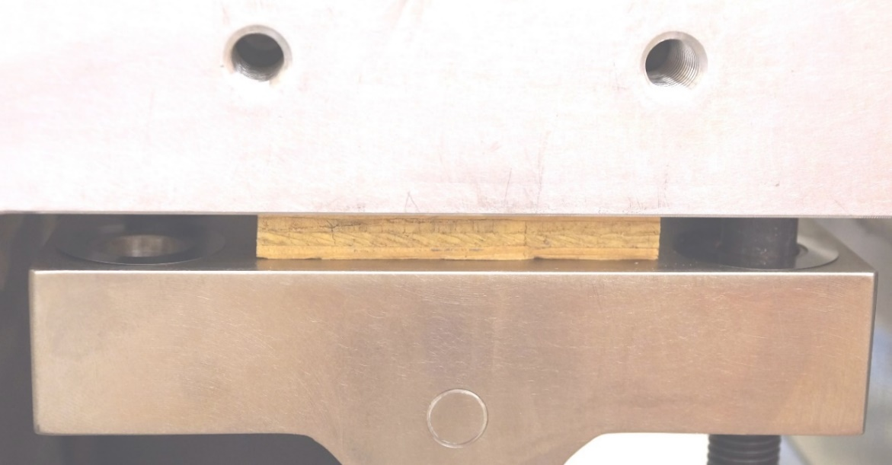
Figure 19: Shims being installed (upper strongback)
- Take the flex plate data (from mechanical ACL data) and calculate how much material would need to be added to bring all 6 points to the same Y-coordinate. (The red measurement in Figure 20).
- Take the strongback data and calculate how much material would need to be added to bring each bolt-hole location to the same Y-coordinate. (The red measurement in Figure 20).
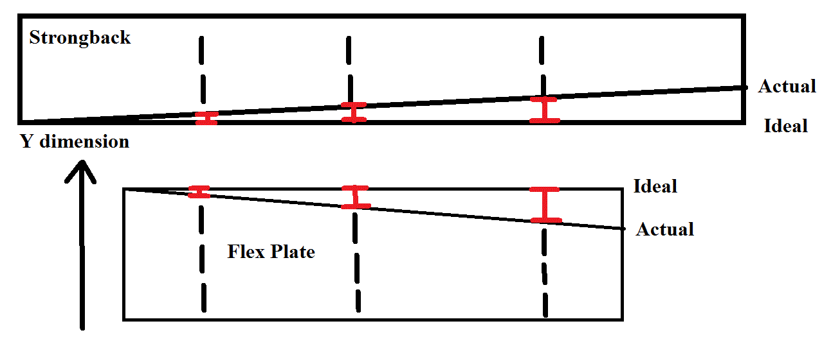
Figure 20: Y-dimension deviation of strongback and flex plate from ideal plane
- Add the two measurements together for each bolt hole, and round to the nearest 25 µm or 0.001”.
- Create a shim map for the assembly.

VERIFICATION POINT 13

Level the Frame
Tools Required:
- Precision level
- 90 mm wrench
- Laser tracker

- Level the frame, orienting to gravity (OTG), to less than 1 mrad in both the pitch (x) and roll (z) axes using the laser tracker. Adjust the floor jack screws to ensure the tolerances are met.
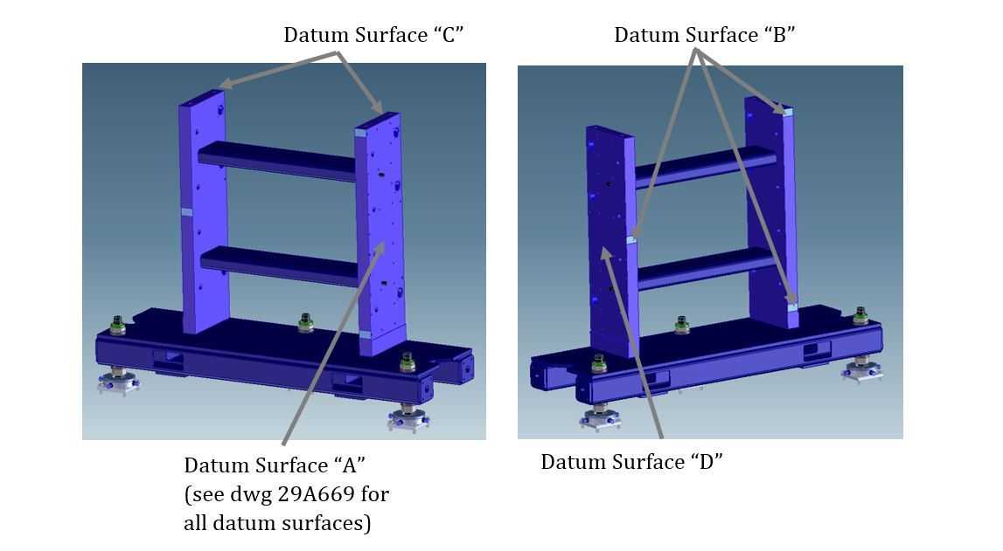
Figure 21: Datum Locations (drives not shown)

Mount Lower Strongback to Flex Plates

Hardware required for this step:
Part # | Description | REQ’D
29A877 | MAGNETIC STRUCTURE STRONGBACK | 2
#17 on 29A811 | SCR SOCHD M16 X 180L, BLK OX | 24
#18 on 29A811 | WASHER, LOCK M16 X 27 OD, SST | 24
#19 on 29A811 | WASHER, M16 X 30OD, SST | 48
#22 on 29A811 | NUT M16X2, SST | 24
29A790 | HARD-STOP-X-DIRECTION | 8
#14 | SCR, SOCHD, M12 X 20L, SST | 16
#16 | SCR, HEXHD, M16 X 35L, STL | 8

Tools required for this step:
- Crane with minimum 2 ton capacity
- Eyebolt rated for at least 1550 lbs/700 kg
- Ball end Allen driver, M16, more than 84mm/3.375” long
- Torque wrench
- Platform of suitable height and sturdiness to safely torque the upper strongback
- Wrench of suitable length (~4 ft) to have good leverage for torqueing the upper strongback
- Laser tracker

- Ensure that the drive system is wired correctly and is able to move appropriately as per the LCLS-II Undulator Motion Control Checkout Procedure.
- Move lower drives to uppermost position to ensure adequate room to work underneath.
- Install hoist rings on strongback in the holes marked “with magnets”. The twelve M16 x180mm bolts cannot be inserted with the strongback in place, so insert them in advance and hold them in place with tape.
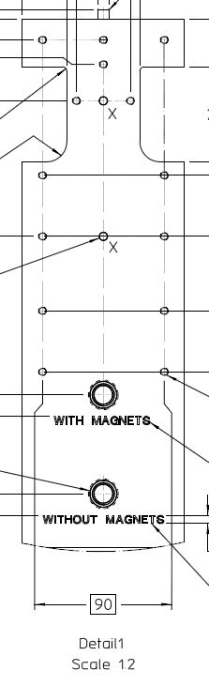
Figure 22: Center-of-mass locations with and without the magnet module assemblies

- Use a spreader bar and crane to lift the strongback in place. Ensure the arrow is pointing as shown in Figure 23. You may choose to support the strongback from underneath using screw jacks. Do not remove from crane yet.
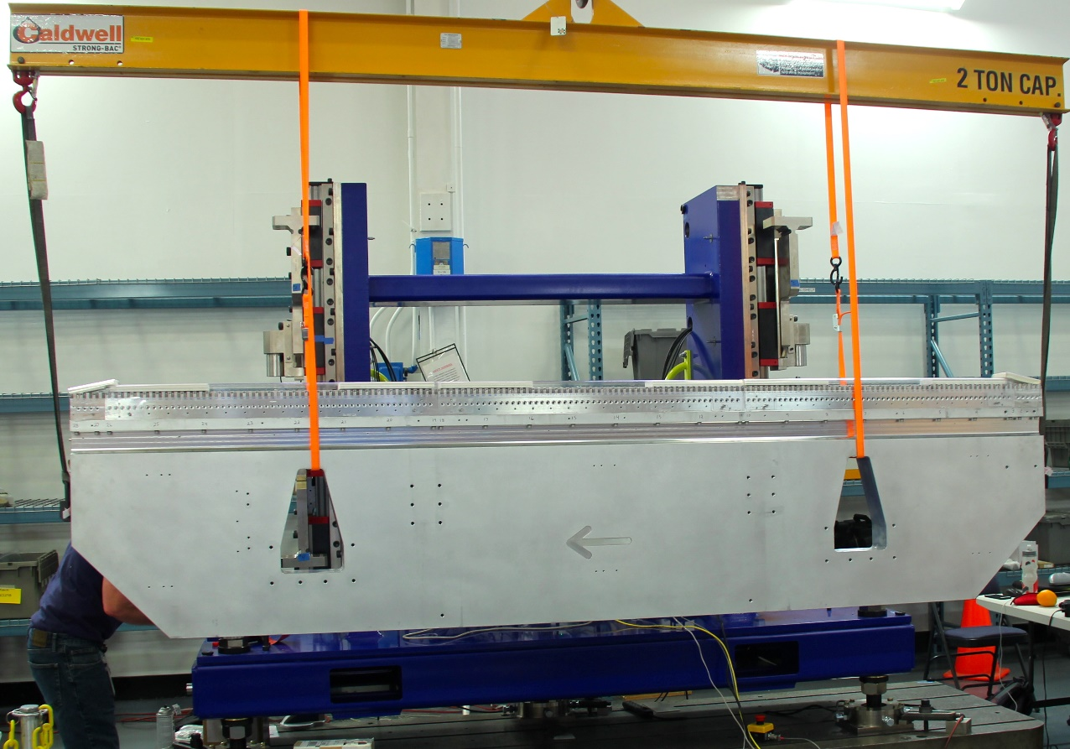
Figure 23: Mounting lower strongback
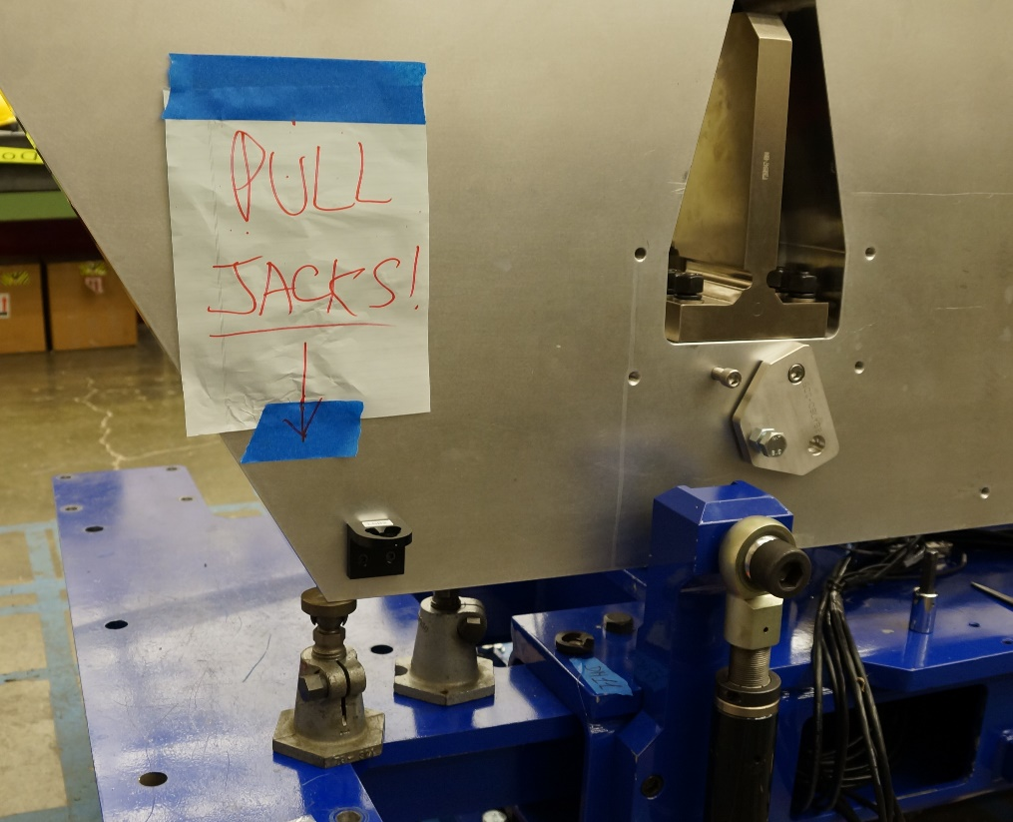
Figure 24: Use of screw jacks on prototype

VERIFICATION POINT 14
- Insert shims according to shim map. Use a mirror to see if necessary.
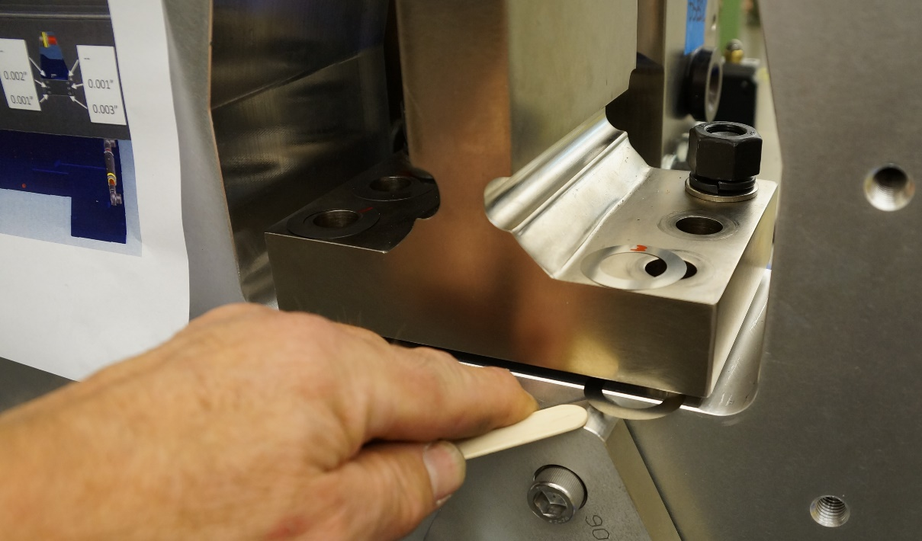
Figure 25: Inserting shims using shim map
- Assemble each of the twelve M16x180mm socket head cap screws and snug tight.
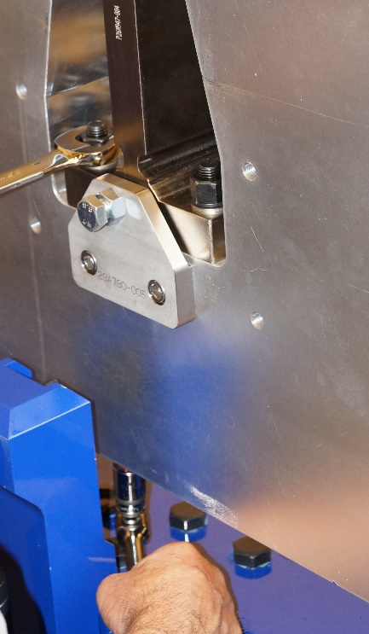
Figure 26: Tighten bolts on lower strongback

- Mount the four Hard Stop X-Direction Plates, 29A790, to both sides, and both ends, of the lower strongback. Use M16x35 SHCS screws to adjust in the x-axis to fine position the lower strongback flush with the outside vertical surface of the Flex Plates in the “x” direction. Use a hand-held gauge block to verify flush surfaces.
- Position strongback in center of flex plate cutouts, even gaps, for adjustment of z-axis. See Figure 27 for method of moving strongback in Z-direction.
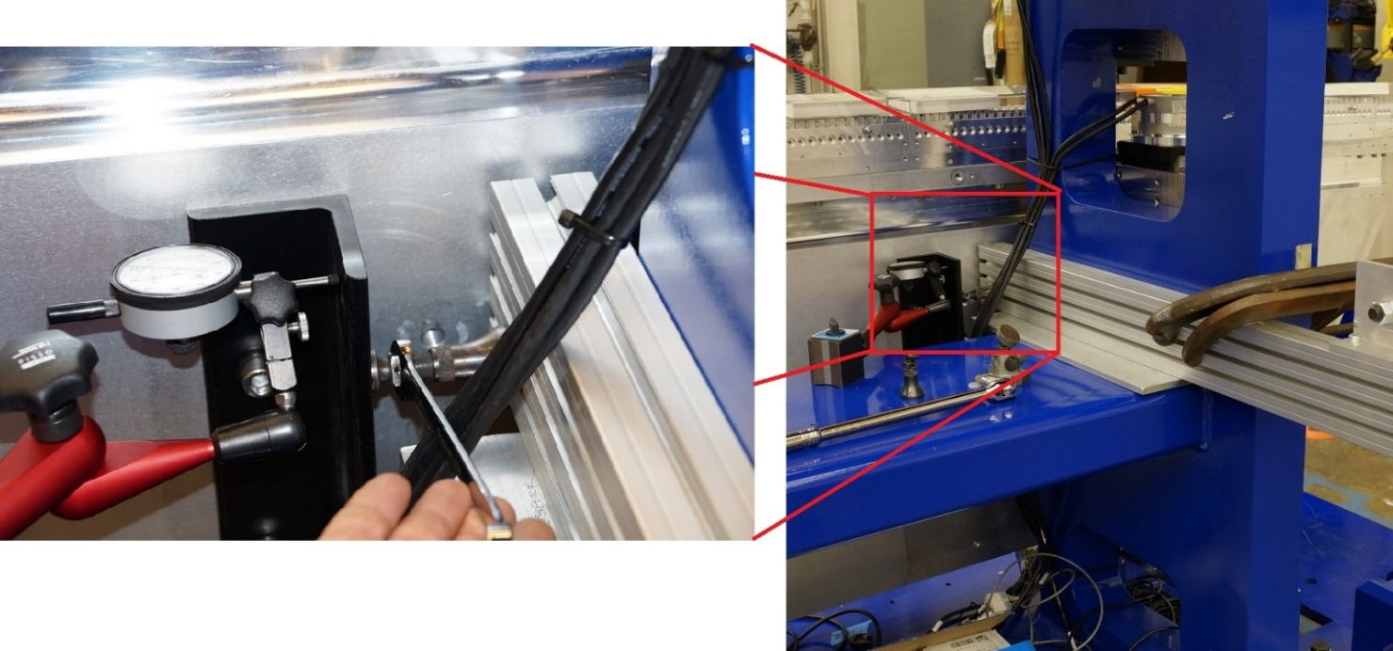
Figure 27: Method of making fine adjustments to the Z-position of the strongback uses 29A701 bracket, dial indicator, jack, wrench, stiff piece of metal clamped to frame

- Measure the strongback position compared to the frame coordinate system with the laser tracker using the fiducial points of the frame and strongback. Adjust X, Z, yaw and roll.

VERIFICATION POINT 15
- Once the lower strongback is positioned, torque the twelve M16x180mm SHCS bolts to 265 N·m/195 ft·lbs, at 20℃ (+/- 1℃). Record the measurements.

VERIFICATION POINT 16
- Check and maintain the strongback position during bolt tightening. The lower strongback is now the set reference for the upper strongback alignment.

NOTE: Once the lower strongback is aligned and attachment bolts are torqued, move the Lower Motor Drives in unison only. Do not operate independently.

VERIFICATION POINT 17
- Use the same method to lift the upper strongback. Ensure that the hoist rings go in the holes labeled “with magnets” as that is the center of gravity for the part and will make turning the strongback over easier.
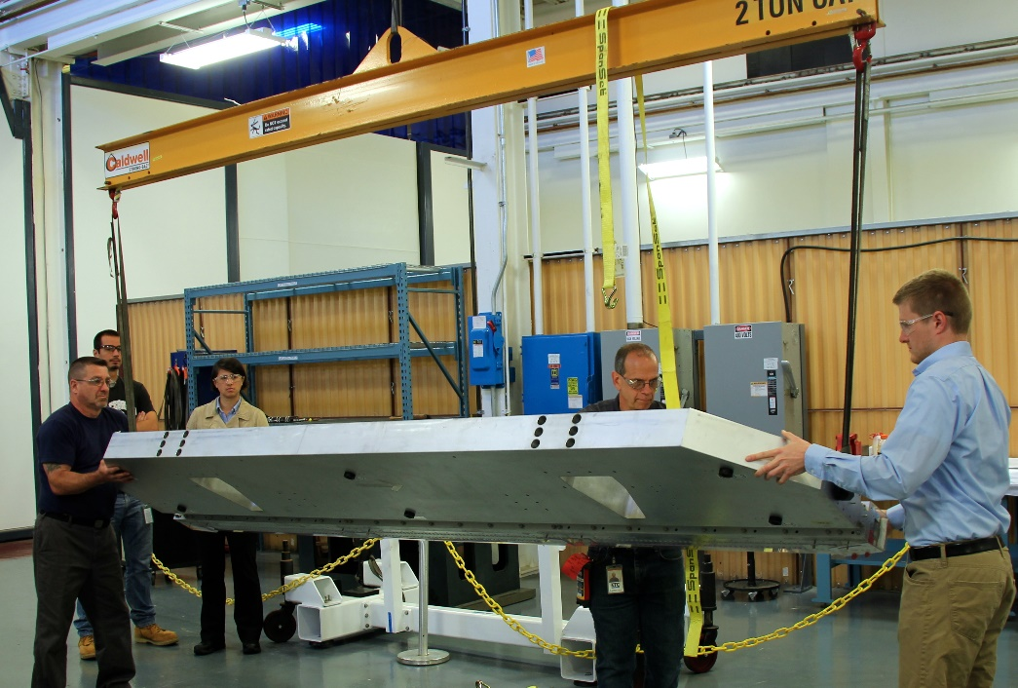
Figure 28: Flipping the upper strongback
- Lift and mount the upper strongback near its nominal location, with arrow pointing in same direction as bottom strongback and with the outer vertical broadside surface flush with the vertical ‘⟙’ flexure surface.
- Insert shims according to shim map. Use a mirror to see if necessary. Use wood block to keep strongback and flexplate separate while inserting shims if necessary.
- Assemble using twelve M16 bolts lightly tightened, allowing sliding contact between the mounting surfaces for adjustment.
- Mount the Push-Stop X-Direction Plates, 26M670 to both sides of the upper strong back.

Alignment of the Strongback Assemblies

NOTE: Position References of the Upper Strongback to Fixed Lower
z- axis
<0.06 mm
(<0.0023”)

x- axis
<0.2 mm
(<0.0079”)

Top view

y- yaw
<0.25 mrad

Top view

End view

z- roll
<0.25 mrad

Table 1: Assembly Tolerances, Upper Structure Relative to Lower
MECHANICAL DIRECTION | TOLERANCE REQUIREMENT
Z (AXIAL) | < 0.06 mm
X | < 0.2 mm
YAW (ABOUT Y-AXIS) | < 0.25 mrad
ROLL (ABOUT Z-AXIS) | < 0.25 mrad

- Use the laser tracker to measure the Z, X, yaw and roll of the lower strongback to the frame and the upper strongback to the lower strongback.
- Adjust the upper strongback position about screw clearance holes according to gap measurements to achieve x, z & y-yaw tolerances. To adjust z-roll measurement, add shims to front or back of flex plate surface accordingly to achieve tolerance.
- Record Final Measurements.

VERIFICATION POINT 18
CAUTION, ERGONOMIC HAZARD: EXTREME CARE MUST BE TAKEN DURING THE TORQUING OFTHE UPPER STRONGBACK TO AVOID INJURY. USE A PLATFORM (OR MAN-LIFT) TO BRING WORK BELOW SHOULDER HEIGHT, USE WRENCH WITH SUFFICIENT LEVERAGE. DO NOT USE A LADDER.

- Once the upper strongback is positioned within specs, install and torque the twelve M16x180mm SHCS bolts, washer and M16x2 hex nuts to 265 N·m/195 ft·lbs at 20℃ (+/- 1℃). Record Measurements.

VERIFICATION POINT 19
- Check and maintain the strongback position during bolt tightening.

VERIFICATION POINT 20

Gap Encoder

Note: instructions adapted from Engineering Note 10793
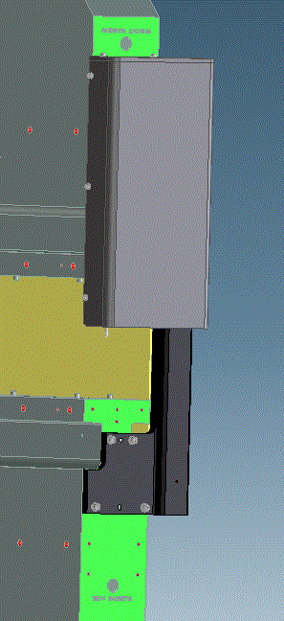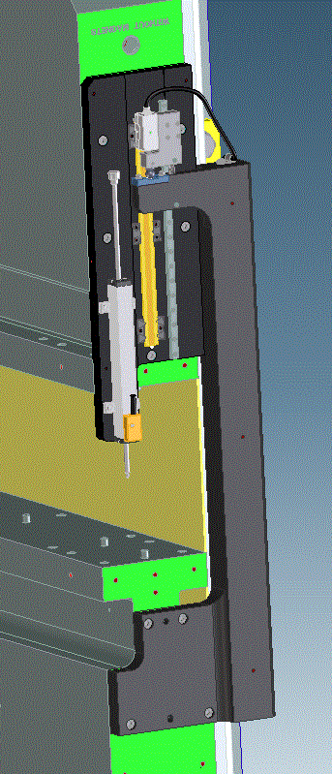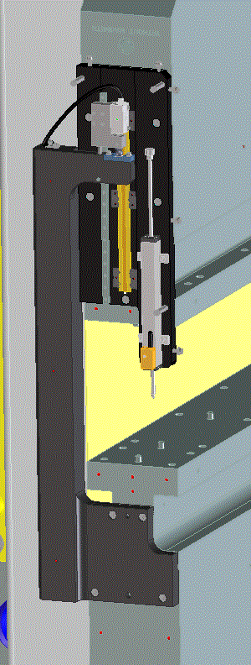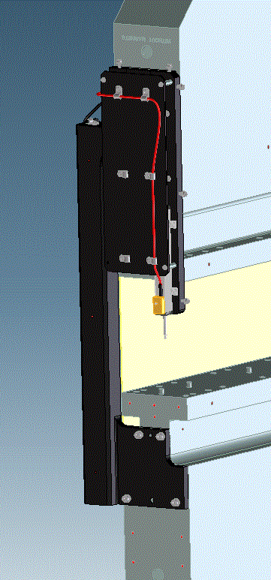
Figure 29: Gap Encoder 1 with lead shielding, Gap Encoder 1 without shielding, Gap Encoder 2 without shielding or cable guide plate, Gap Encoder 2 with cable guide plate

Hardware required for this step:
Part # | Description | REQ’D
29A835 | GAP ENCODER ACTUATOR ARM 1 | 1
29A826 | GAP ENCODER ACTUATOR ARM 2 | 1
29A866 | ENCODER MOUNT PLATE 1 | 1
29A867 | ENCODER MOUNT PLATE 2 | 1
29A854 | READHEAD MOUNT | 1
29H873 | READHEAD MOUNT 2 | 1
29A851 | ACTUATOR PLATE | 2
29H871 | ACTUATOR PLATE | 2
29A889 | CABLE GUIDE PLATE | 2
29A852 | LEAD SHIELD BACK | 2
29A842 | RADIATION SHIELD COVER | 2

Part # | Description | REQ’D
#9 on 29A855 and 29A856 | SCR, SOCHD, M2X12L, SST | 4
#10 on 29A855 and 29A856 | SCR, SOCHD, M2X20L, SST | 2
#11 on 29A855 and 29A856 | SCR, SOCHD, M2X6L, SST | 18
#12 on 29A855 and 29A856 | SCR SOCHD, M3X8L, SST | 3
#13 on 29A855 and 29A856 | SCR, SOCHD, M3X12L, SST | 2
#14 on 29A855 and 29A856 | SCR, SOCHD, M2X14L, SST | 2
#15 on 29A855 and 29A856 | SCR, SOCHD, M4X12L, SST | 5
#16 on 29A855 and 29A856 | SCR, SOCHD, M6X18L, SST | 9
#17 on 29A855 and 29A856 | SCR, SET, M3X4L, SST, THR LK | 1
#18 on 29A855 and 29A856 | SCR, MACH, M4X5L, SST | AR
#19 on 29A855 and 29A856 | WASHER M2X5OD, SST | 2
#20 on 29A855 and 29A856 | WASHER M3X7OD, SST | 3
#21 on 29A855 and 29A856 | WASHER, M4X9OD, SST | 5
#22 on 29A855 and 29A856 | WASHER, BELLEVILLE, M3, SST | 2
#23 on 29A855 and 29A856 | CLAMP, LOOP, .25 DIA, NYLON | AR
#24 on 29A855 and 29A856 | STANDOFF, HEX M3X22L, SST | 3
#25 on 29A855 and 29A856 | SCALE, 230L, RELA RENISHAW A-9766-0230 | 1
#26 on 29A855 and 29A856 | DATUM CLAMP, RENISHAW A-9584-2050 | 1
#27 on 29A855 and 29A856 | MOUNTING CLIP, RENISHAW A-9584-2049 | 2
#28 on 29A855 and 29A856 | ENCODER, LINEAR, RELA RENISHAW RL26BAE050D30A | 1
#29 on 29A855 and 29A856 | SLIDE RAIL, 265L, NB SEBS7BYMUU1T1-265P | 1
#30 on 29A855 and 29A856 | TOOLING BALL, .375" DIA | 1
#31 on 29A855 and 29A856 | LINEAR POSITIONER, NOVOTECHNIK TR-100 | 1
#32 on 29A855 and 29A856 | EXT SPRING, .25X1.375, SST | 1

Tools required for this step:
- Gloves to (1) keep optical scale free of grease and (2) protect from lead backing plate
- 0.5 N·m torque wrench
- N-heptane, Propan-2-ol or Acetone

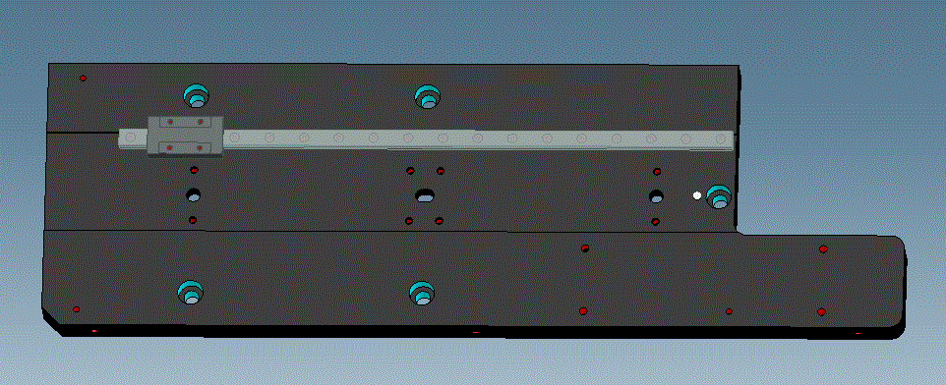
Figure 30: Mounting Plate (29A866) with Slide Guide
- Mount the slide guide with carriage (#29 on 29A855 and 29A856) to mounting plate (29A866 or 29A867). Register the rail with the edge of the machined surface as shown in Figure 30 using 18 M3 screws (#11 on 29A855 and 29A856).
- The slide guide is furnished with plastic clips to keep the carriage from rolling off the rail. Use these to keep the carriage in place. See Figure 31.
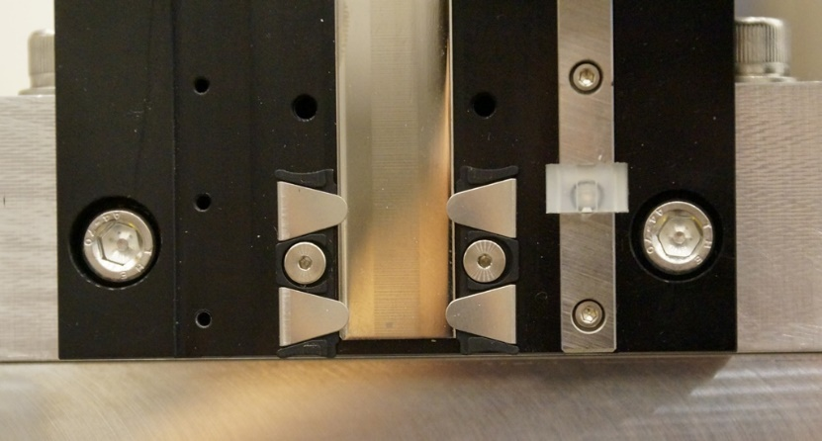
Figure 31: Plastic clip on the slide guide
Note: Take care to keep the optical scale clean and free from all scratches.
- Clean the mounting plate and the underside of the scale (#25 on 29A855 and 29A856) using N-heptane, Propan-2-ol or Acetone.
- Mount three mounting clips (#26 and 27 on 29A855 and 29A856) on the rail side of the optical scale using hardware provided in the kit. Only the special, low profile screws included in the kit should be used. Torque the mounting clip screws to 0.5 N·m.
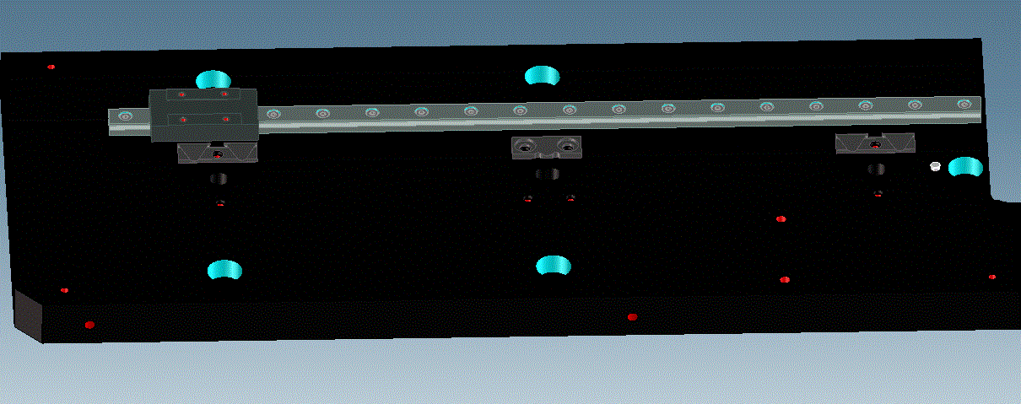
Figure 32: 3 mounting clips installed
- Install the optical scale (#25 on 29A855 and 29A856) into the 3 clips previously installed; push the end against the alignment pin.
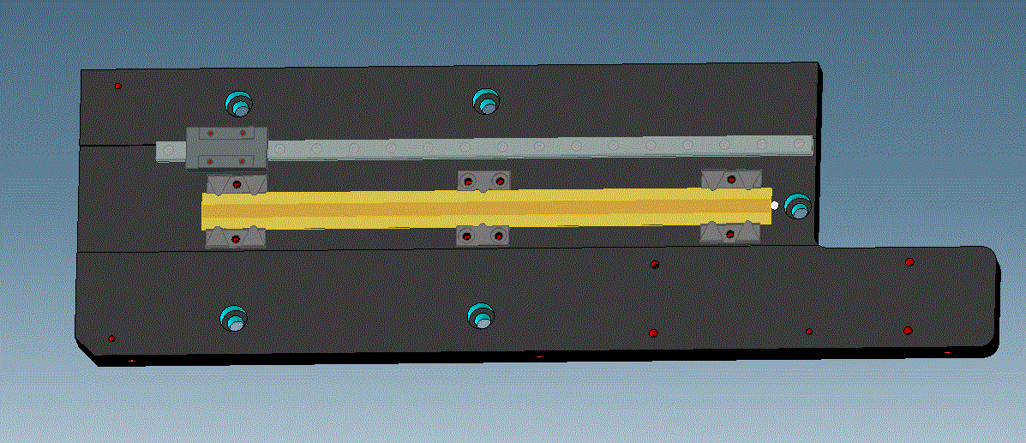
Figure 33: Scale installed
- Align the edge of the optical scale to the slide guide rail within 0.05 mm (0.002”)
- Install the three mounting clips on the opposite side. Torque the mounting clip screws to 0.5 N·m/ 0.37 ft·lbs.

VERIFICATION POINT 21
- Clean the scale with Acetone, N-heptane or Propan-2-ol.
- Slide the tooling ball (#30 on 29A855 and 29A856) into the read-head mount (29A854 or 29H873) and secure with set screw (#17 on 29A855 and 29A856). Refer to drawing for orientation.
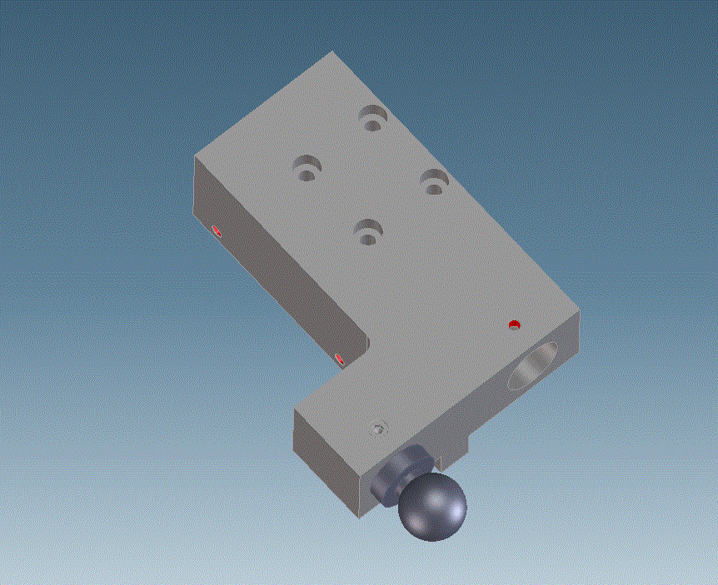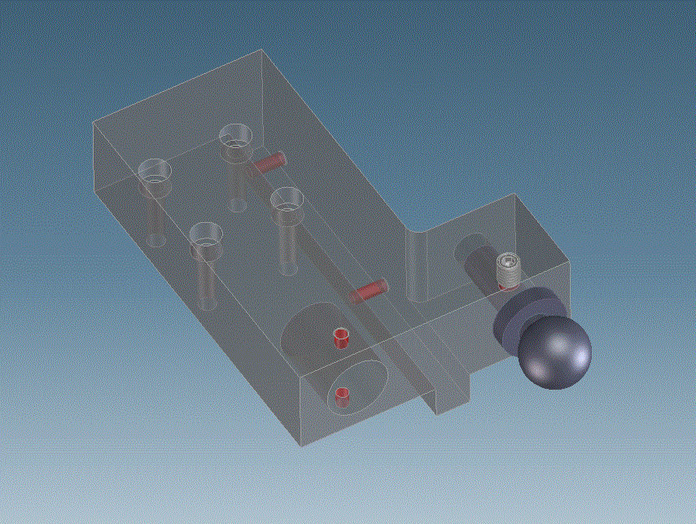
Figure 34: Tooling ball in read-head mount with set screw, assembly 1 (left) and assembly 2 (right)
- Mount the read-head mount (29A854 or 29H873) to the slide guide carriage using four M2 screws (#9 on 29A855 and 29A856).
- Mount the Renishaw read-head (#28 on 29A855 and 29A856) to the read-head mount (29A854 or 29H873) with two M2 washers and screws (#10 and 19 on 29A855 and 29A856)
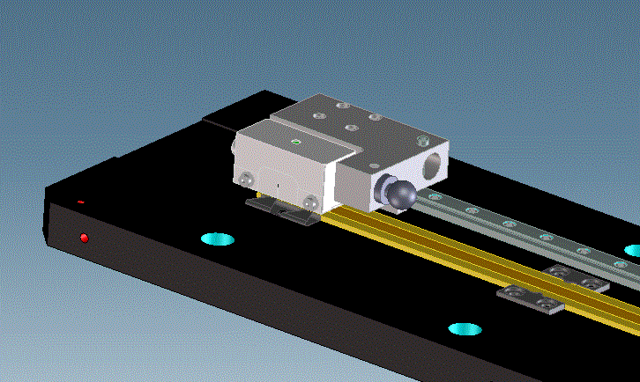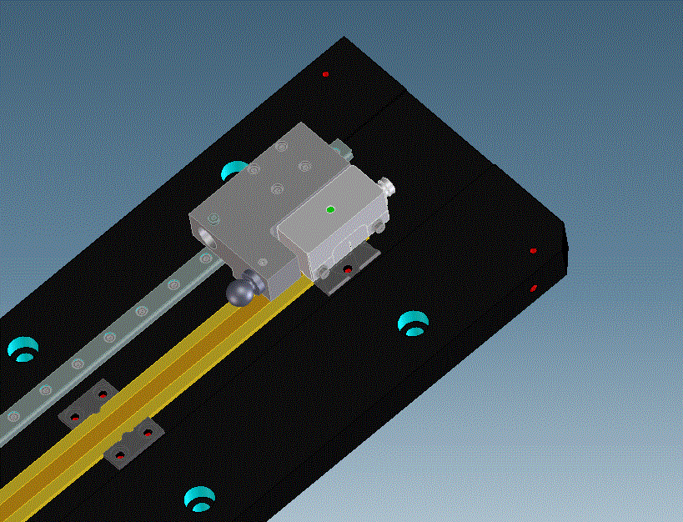
Figure 35: Read-head mounted to Read-head Mount mounted to slide rail, assembly 1 (left) assembly 2 (right)
- Provide power to read-head and ensure that LED on the top of the read-head is blue or green through full length of travel.

VERIFICATION POINT 22
Note: The distance between the optical scale and the bottom surface of the read-head is 0.8 mm ±0.15mm (.031” ± .006”) along the full length of travel.
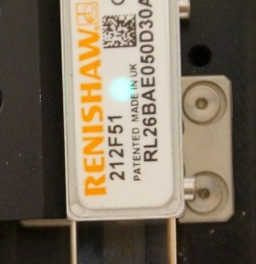
Figure 36: Green LED on read-head.
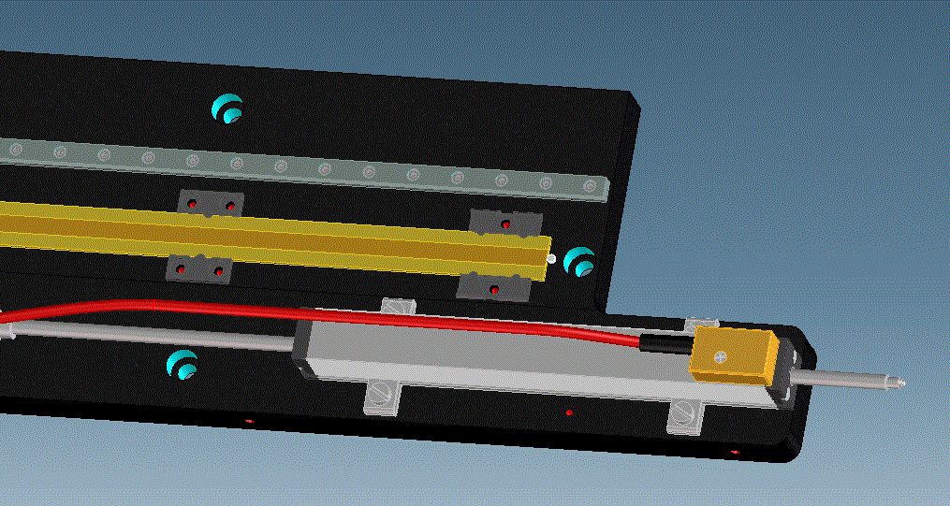
Figure 37: Position transducer mounted
- Mount the linear position transducer (#31 on 29A855 and 29A856) to the mount plate using the hardware provided with the transducer. Line the end of the transducer up with the end of the encoder mount plate.
- Put on gloves.
- Mount the assembly so far and the Lead Shield Back (29A852) to the upper strongback. The pins in the strongback should fit in the pin holes in the Lead Shield Back and the Encoder Mount Plate, and should not hit the optical scale. Ensure that the pins are not sticking out too far. Secure using five M6 screws (#16 on 29A855 and 29A856).
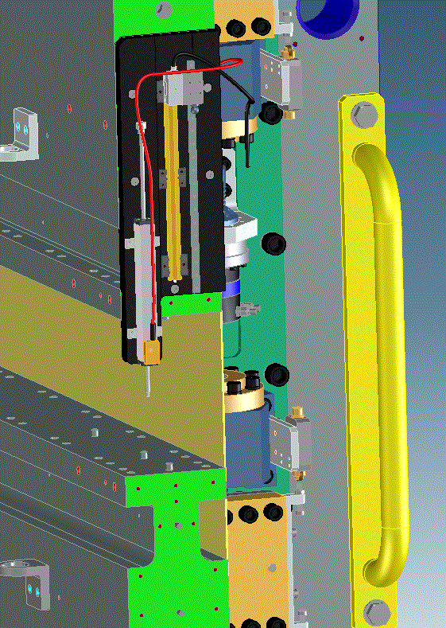
Figure 38: Assembly 1 attached to upper strongback
- Slide carriage to the uppermost location on the slide guide using the plastic retainer clips to keep the carriage in this location.
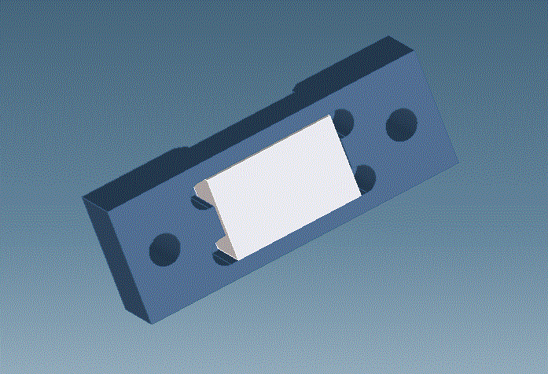
Figure 39: Actuator Plate (29A851) inserted into Actuator Plate Clamp (29H871)

- Put the ceramic Actuator Plate (29A851) into the Actuator Plate Clamp (29H871).
- Mount the actuator plate and clamp (29A851 and 29H871) to the encoder actuating arm (29A835 or 29A826) using two M3 screws and Belleville washers (#13 and 22 on 29A855 and 29A856).
- Attach spring (#32 on 29A855 and 29A856) to the Encoder Actuating Arm (29A835 or 29A826) using M2 screws (#14 on 29A855 and 29A856).
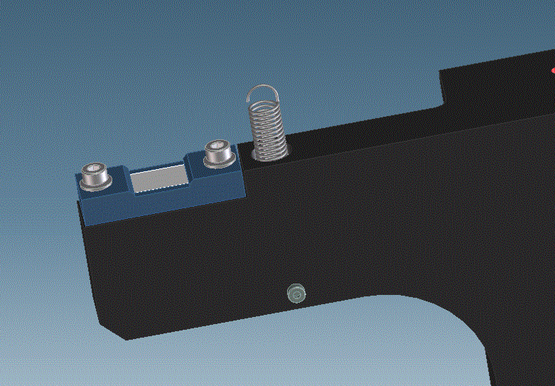
Figure 40: Actuator Plate, Actuator Plate Clamp and Spring attached to Encoder Actuating Arm
- Fit the Encoder Actuating Arm (29A835 or 29A826) over the pins in the lower strongback and fasten using four M6 screws (#16 on 29A855 and 29A856)
- Slide the carriage down so the tooling ball, mounted on the read-head (29A854 or 29H873), is in contact with the actuator plate (29A851). Attach the spring to the read-head mount using an M2 screw (#14 on 29A855 and 29A856)
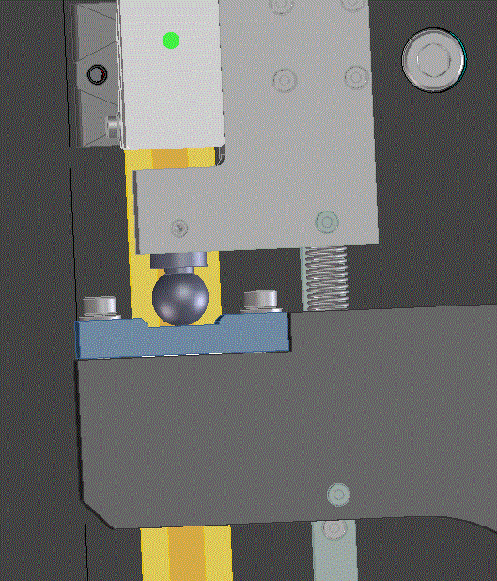
Figure 41: Spring connects read-head mount and actuating arm.
- Slide the plastic retainer clips that held the carriage in place to the farthest ends of the linear bearing slide guide.
- Open and close the strongbacks to ensure the parts move properly, and that the read-head light remains blue or green for the full length of travel.

VERIFICATION POINT 23
- Screw the standoff hex screws (#24 on 29A855 and 29A856) into the encoder mount plate (29A867 or 29A866). Attach the cable guide plate (29A889) to the standoff hex screws using three M3 washers and screws using (#12 and 20 on 29A855 and 29A856).
- Mount the linear positioner cables to the cable guide plate using parts #18 and #23 (on drawing 29A855 and 29A856) as required.
- Mount the read-head wire to the encoder actuating arm using parts #18 and #23 (on drawing 29A855 and 29A856) as required.
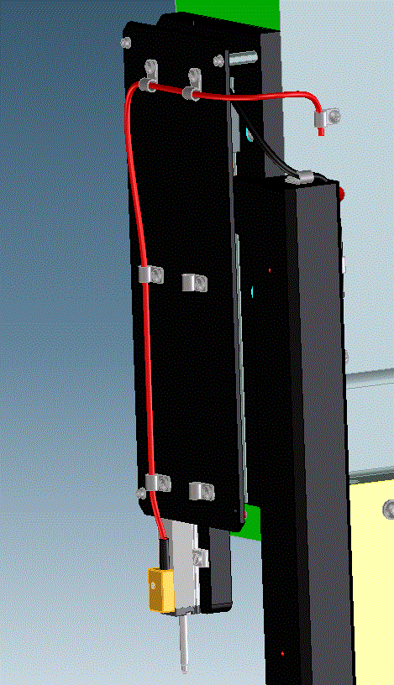
Figure 42: Cable guide mounted

Switches

Hardware required for this step:
Part # | Description | REQ’D
29A849 | PITCH LIMIT SWITCH MOUNT BRACKET | 4
29A848 | ACTUATOR BRACKET | 2
29A870 | END COVER | 2
29A931 | LIMIT SWITCH ADJUST ASSEMBLY | 8
29A839 | LIMIT SWITCH MOUNT BRACKET 1 | 2
29A840 | LIMIT SWITCH MOUNT BRACKET 2 | 2
#10 on 29A804 | SCR, SOCHD, M3 X 14L, SST | 4
#11 on 29A804 | SCR, SOCHD, M4 X 16L, SST | 8
#16 on 29A804 | WASHER, M4 X 90D, SST | 8
#15 on 29A811 | SCR SOCHD M3X14L, SST | 4
#16 on 29A811 | SCR BUTNHD M6X14L, SST | 6
#17 on 29A811 | SCR SOCHD M8X25L, SST | 8
#18 on 29A811 | SCR SOCHD M8X30L BO STL | 4
#22 on 29A811 | WASHER M6 X12OD, SST | 6
#23 on 29A811 | WASHER M8X16OD, SST | 12
#27 on 29A811 | LIMIT SWITCH -OMRON-D5A3300 | 8

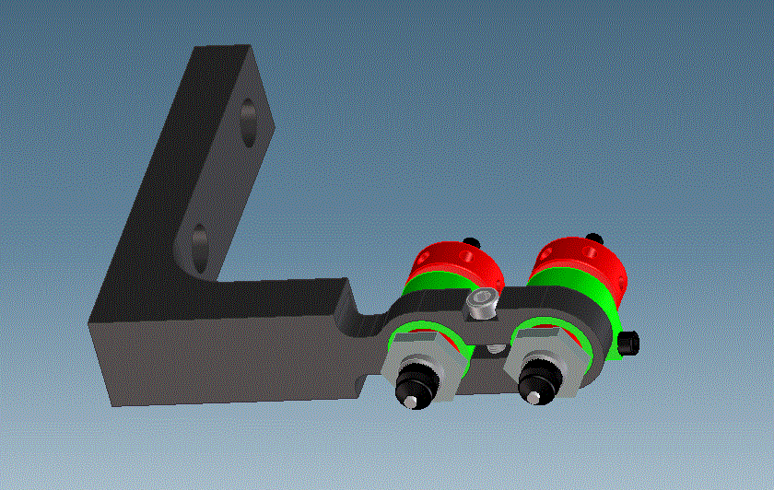
Figure 43: Omron switches in pitch limit switch mount bracket
- Attach Omron limit switches in their mount bracket (29A849) and screw tight using one M3 screw (#15 on 29A811). See figure 43.
- Attach the four mount brackets and their switches to the strongbacks using M8 screws and washers (#17 and 23 on 29A811).
- Attach the actuator bracket (29A848) to the flex plates. The end of the actuator bracket goes between the limit switches. Use M8 screws and washers (#18 and #23 on 29A811).
- There should be 0.008” between the limit switches and the actuator bracket. Use feeler gages to set the spacing.
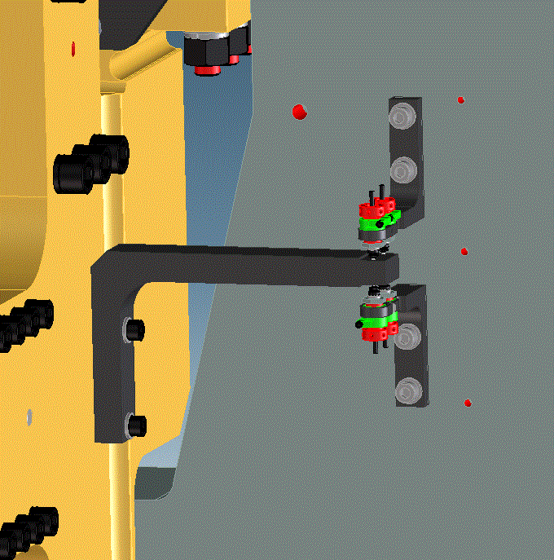
Figure 44: Mounted switches and actuator bracket
- Use three M6 washers and screws (#16 and 22 on 29A811) to secure the End Cover (29A870) over the switches.
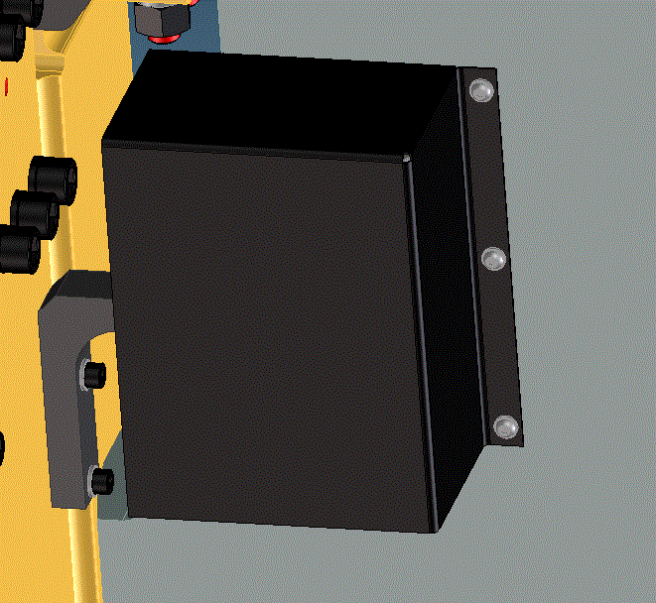
Figure 45: End cover mounted

- Attach the Omron limit switches to the mount brackets (29A839 and 29A840) and screw tight using an M3 screw (#10 on 29A804). See Figure 46.
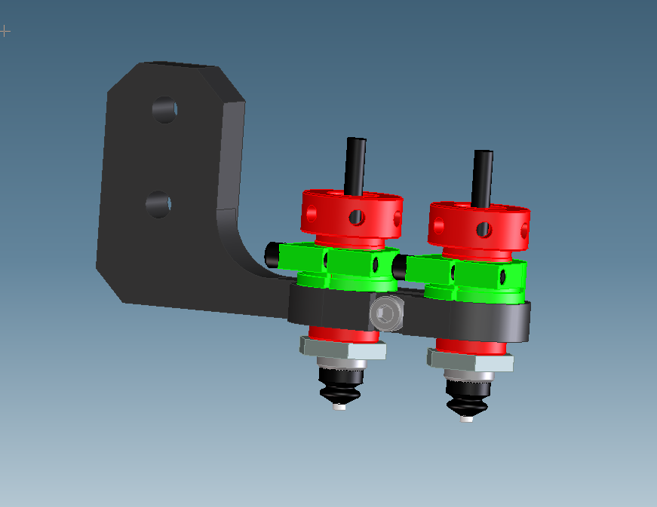
Figure 46: Assemble vacuum chamber limit switch bracket.

- Attach the mount brackets to the ends magnet module keepers using M4 screws and washers (#11 and #16 on 29A804). See Figure 47.

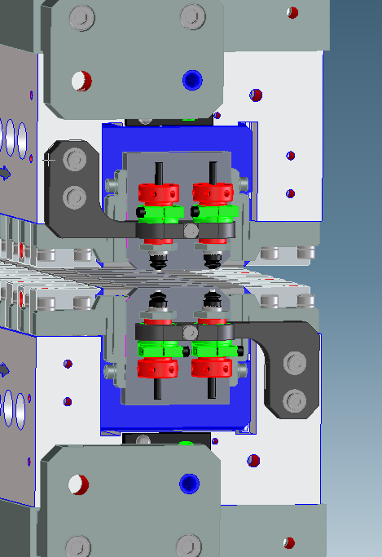
Figure 47: Vacuum chamber limit switches are attached to the magnet module keepers.

- Fit the lead shielding (29A842) over the assembly and secure using five M4 screws and washers (#15 and 21 on 29A855 and 29A856).

Pinch Guards

Hardware required for this step:
Part # | Description | REQ’D
29A670 | LOWER PINCH GUARD 1 | 1
29A671 | LOWER PINCH GUARD 2 | 2
29A672 | LOWER PINCH GUARD 3 | 1
29A673 | LOWER PINCH GUARD 4 | 1
29A675 | LOWER PINCH GUARD 5 | 1
29A678 | MIDPLANE PINCH GUARD 3 | 2
29A846 | DRIVE SAFETY SHIELD | 2
#13 on 29A804 | SCR, SOCHD, M10 X 20L, SST | 4
#14 on 29A804 | SCR, BUTNHD, M6 X 14L, SST | 12
#17 on 29A804 | WASHER, M6 X 120D, SST | 16
#18 on 29A804 | WASHER. OVERSIZED, M10, SST | 4
#16 on 29A811 | SCR, BUTNHD, M6 X 14L, SST | 36
#22 on 29A811 | WASHER, M6 X 12 OD, SST | 36

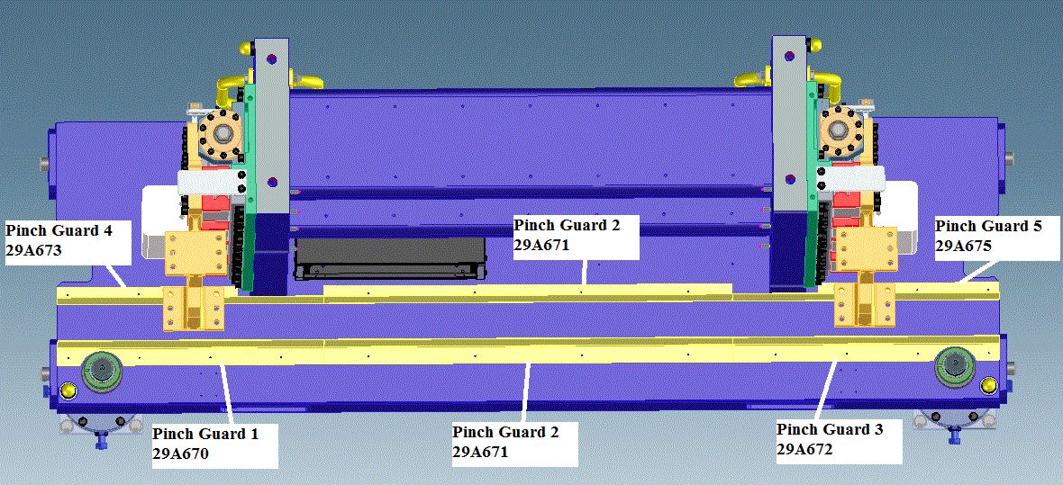
Figure 48: Lower Pinch Guard Placement
- Install lower pinch guards (29A670, 29A671, 29A672, 29A673, and 29A675) as shown in drawing 29A811 and Figure 48, using M6 screws and washers (#16 and 22 on 29A811).
- Slide the mid-plane pinch guards (29A678) into place and attach to the upper strongback using M6 screws and washers (#16 and 22 on 29A811).
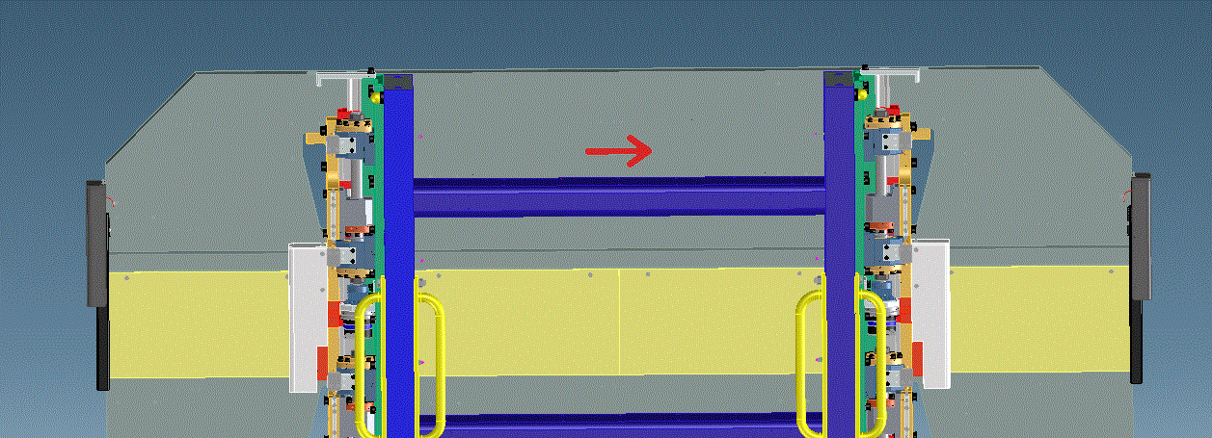
Figure 49: Mid-plane Pinch Guard Placement
- Verify that the undulator can open and close without interference from the pinch guards, and that the spring system actuator hits the spring stack squarely.
- Move the drive covers (29A846) into place and attach to the drive system using M6 (#14 and #17 on 29A804) and M10 (#13 and #18 on 29A804) bolts and washers. See Figure 50.
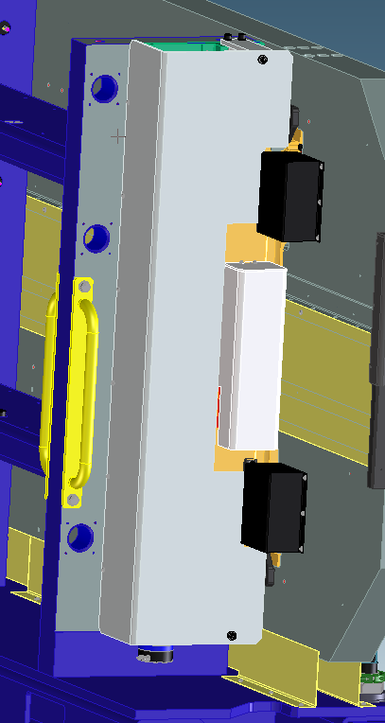
Figure 50: Drive covers are placed over the drive systems

Completion
- Ensure all component serial numbers are entered in the Verification Signoff Sheet.
- Enter the completion date and temperature in the Verification Signoff Sheet.
- Have Verification Signoff Sheet signed and dated by Quality Assurance.

Verification Signoff Sheet
EACH MECHANICAL SYSTEM IS REQUIRED TO HAVE A COMPLETED VERIFICATION SHEET.
VERIFICATION MUST BE DONE BY AN ENTITY OTHER THAN THE ASSEMBLY TECHNICIAN
SERIAL NUMBER:
ASSEMBLY START DATE: |  |  |  | ASSEMBLY COMPLETION DATE:
AMBIENT TEMPERATURE  AT ASSEMBLY START: |  |  |  | AMBIENT TEMPERATURE  AT ASSEMBLY COMPLETION:
WORK INSTRUCTIONS NUMBER AND REVISION:
COMPLETE ASSEMBLY VERIFIED BY (Sign and Date):
PART NUMBER | DESCRIPTION |  | QUANTITY REQUIRED |  |  | SERIAL NUMBER(S)

PART NUMBER | DESCRIPTION | QUANTITY REQUIRED | SERIAL NUMBER(S)

PART NUMBER | DESCRIPTION | QUANTITY REQUIRED | SERIAL NUMBER(S)
 |  | 1
 |  | 1
 |  | 2
 |  | 2
 |  | 1
 |  | 2
 |  | 1
 |  | 1
 |  | 1
 |  | 8

VERIFICATION POINT | ASSEMBLY TECHNICIAN  (Sign & Date) | RECORDED INFORMATION  (As Noted) | CAL  INFO | VERIFICATION BY  (Sign & Date)
1 |  | SHIMS INSERTED AND SHIM MAP UPLOADED TO WINDCHILL | TOOL ID  LAST CAL DATE
2 |  | BOLTS TORQUED TO 21.7 N·M (16 FT·LBS) | TOOL ID  LAST CAL DATE
3 |  | SHIMS INSERTED AND SHIM MAP UPLOADED TO WINDCHILL | TOOL ID  LAST CAL DATE
4 |  | BOLTS TORQUED TO 21.7 N·M (16 FT·LBS) | TOOL ID  LAST CAL DATE
5 |  | SHIMS INSERTED AND SHIM MAP UPLOADED TO WINDCHILL | TOOL ID  LAST CAL DATE
6 |  | BOLTS TORQUED TO 21.7 N·M (16 FT·LBS) | TOOL ID  LAST CAL DATE
7 |  | SHIMS INSERTED AND SHIM MAP UPLOADED TO WINDCHILL | TOOL ID  LAST CAL DATE
8 |  | BOLTS TORQUED TO 21.7 N·M (16 FT·LBS) | TOOL ID  LAST CAL DATE
9 |  | SHIMS INSERTED AND SHIM MAP UPLOADED TO WINDCHILL | TOOL ID  LAST CAL DATE
10 |  | BOLTS TORQUED TO 21.7 N·M (16 FT·LBS) | TOOL ID  LAST CAL DATE
11 |  | SHIM CHANGES NOTED | TOOL ID  LAST CAL DATE

VERIFICATION POINT | ASSEMBLY TECHNICIAN  (Sign & Date) | RECORDED INFORMATION  (As Noted) | CAL  INFO | VERIFICATION BY  (Sign & Date)
12 |  | STRONGBACK MEASUREMNT DATA UPLOADED TO WINDCHILL | TOOL ID  LAST CAL DATE
13 |  | FLEX PLATE SHIM MAP UPLOADED TO WINDCHILL | TOOL ID  LAST CAL DATE
14 |  | SHIMS INSERTED ACCORDING TO SHIM MAP | TOOL ID  LAST CAL DATE
15 |  | X, Z, YAW, AND ROLL DATA UPOADED TO WINDCHILL | TOOL ID  LAST CAL DATE
16 |  | BOLTS TORQUED TO 265 N·M (165 FT·LBS) | TOOL ID  LAST CAL DATE
17 |  | LOWER STRONGBACK DRIVE SYSTEMS COUPLED | TOOL ID  LAST CAL DATE
18 |  | FINAL X, Z, YAW, AND ROLL DATA UPLOADED TO WINDCHILL | TOOL ID  LAST CAL DATE
19 |  | BOLTS TORQUED TO 265 N·M (165 FT·LBS) | TOOL ID  LAST CAL DATE
20 |  | STRONBACK POSITION DATA VERIFIED | TOOL ID  LAST CAL DATE
21 |  | BOLTS TORQUED TO 0.5 N·M (0.37 FT·LBS) | TOOL ID  LAST CAL DATE
22 |  | VERIFY READ-HEAD LED IS BLUE OR GREEN | TOOL ID  LAST CAL DATE
23 |  | STRONGBACK MOVES PROPERLY AND READ-HEAD LED IS BLUE/GREEN | TOOL ID  LAST CAL DATE

