HGVPU Magnetic Assembly Work Instructions (WI)
LBNL LCLS-II HGVPU-WI-29H881
Windchill Unique ID: LC-1002-9198
Issued 16 March 2017
Prepared by Reviewed by
Katherine Ray |  | Daniela Leitner
Work Instructions Originator |  | QA Manager

Approved by Concurred
Allan DeMello |  | Matthaeus Leitner
Technical Lead |  | CAM

Contents
Revision History 2
Purpose 3
Scope 3
Definitions 3
Reference Documents 5
Tools Required 5
Hardware Required 6
Work Instructions 8
1 Setup and Overview 8
2 Special Machining Instructions for Keeper Components 9
3 Assemble the Keeper 10
4 Install the Poles 13
5 Magnet Sorting 18
6 Magnet Installation 24
7 Adjust the Pole Height 30
8 Install End Plates 34
9 Completion 35
Verification Signoff Sheet 36

Revision History
Revision | Issued | Changes
A | 29 Sep 2016 | Original issue.
B | 17 Jan 2017 | Updated keeper assembly procedures, removed pole adjustment procedures
C | 16 March 2017 | Added magnet sorting instructions, orientation definitions, more tools. Restored pole adjustment procedures, keeper inspection procedures. Removed troubleshooting details.

Purpose
The purpose of this Work Instruction is to describe the process of assembling and inspecting the magnetic modules for the Horizontal Gap, Vertically Polarizing Undulator (HGVPU) assembly. A magnetic module assembly is comprised of three main components: a keeper (itself comprised of three main components), poles, and the magnets. The Work Instructions below provide detailed step-by-step instructions for completing the assembly of the HGVPU magnetic modules.

Scope
This document covers the assembly of HGVPU magnetic systems at the supplier’s site. The work is comprised of aligning and assembling the keepers, installing the magnetic poles into the keepers, installing the magnets between the poles, leveling the poles. There are 3 keeper assemblies per strongback, and two strongbacks per HGVPU assembly.

Definitions
Term | Definition
LCLS-II | Linac (Linear Accelerator) Coherent Light Source upgrade program. This is the umbrella project under which the HGVPU undulator project is being built. This program will add a 4GeV superconducting linear accelerator.
HGVPU | Horizontal Gap Vertically Polarizing Undulator. This is the undulator being discussed within these work instructions. The undulator generates polarized magnetic field that the electron beam will pass through, resulting in the creation of a vertically polarized hard X-ray laser beam.  On some occasions the HGVPU may be referred to as simply the VPU for the sake of brevity.
Pole | A vanadium permadur component used to channel the magnetic forces of the magnets used in the HGVPU magnetic assembly across the beamline of the LCLS-II
Keeper | The assembly into which the magnets and poles are inserted and held.
Magnet | NdFeB permanent magnet block.

Overall Undulator Orientation Definitions:
The convention in undulators is that the electron beam direction is the Z direction. The Y-direction is up, and X is the direction that makes the coordinate system right-handed.

Upstream is the direction the beam comes from and Downstream the direction the beam leaves.

Left and Right are defined standing at the upstream end of the undulator, looking down the beamline

See following figure for graphic representation of these terms.
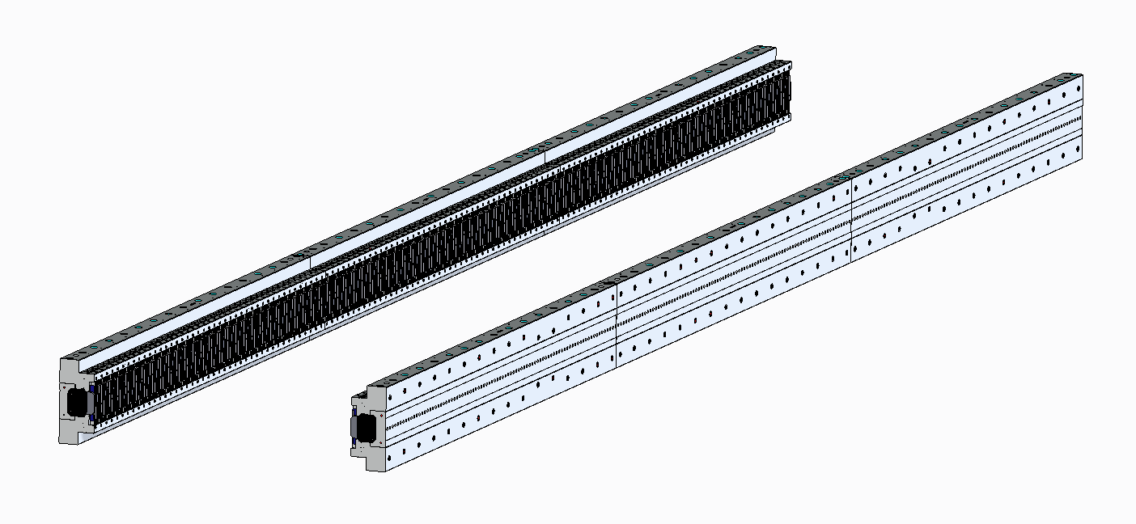
Downstream
Upstream
Beam Direction (Z)
Right to Left (X)
Opposite Gravity (Y)
Right Modules
Left Modules
5
1
2
3
4
6

- 29H881 – Entrance Module Right
- 29H872 – Center Module Right
- 29H882 – Exit Module Right
- 29H893 – Entrance Module Left
- 29H894 – Center Module Left
- 29H895 – Exit Module Left

When speaking of an individual module, Z-direction is defined the same as in the overall undulator, but left-right, up-down change.

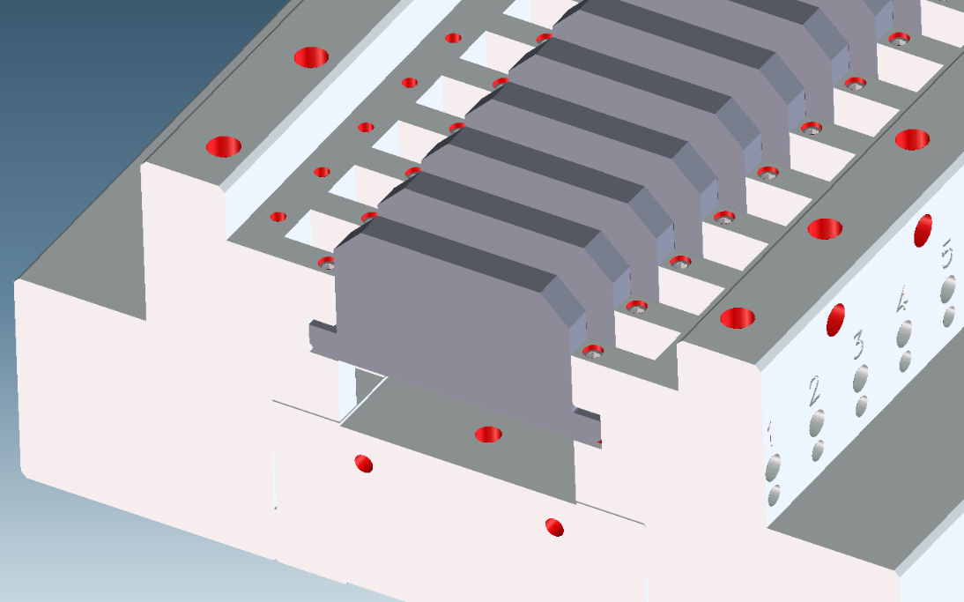
Left, Part A
(Top for Left Modules
Bottom for Right Modules)
Height
Right, Part B
(Bottom for Left Modules,
Top for Right Modules)
Beam Direction (Z)

Reference Documents
- Drawing Print
- Magnet handling best practices
- Magnetic System Acceptance Criteria Listing
- Shipping and Handling Note
- Component drawings
- Purchased part drawings

Tools Required
Required Tools
- Threaded insert locking tool
- Hammer
- Metric Allen Wrenches
- Powered Screwdriver with Metric Bits
- Clamps
- 0.2 mm (0.008”) non-magnetic (brass) shims (use 2 at a time, replace as necessary)
- Part cleaning tools
  - Alcohol
  - Clean cloth
  - Pressurized air

Required Calibrated Tools
- Ambient temperature room thermometer
- Torque Wrench, large and small, with calibration certificate
- Gauge Blocks
  - One width of keeper for keeper alignment
  - Several that fit in the magnet slot for pole installation
- Coordinate Measuring Machine (CMM)
  - 10-12 clamps
  - Ceramic/non-magnetic probe tips (magnetic field strong enough to interfere for 2.5 cm/1”)
  - Vision system or small probe tip for catching pole longitudinal position

Required Fixtures
- Keeper Assembly Fixture
  - Flat (granite) surface
  - Method of clamping all 3 keeper components to the flat surface
- Magnet Install Fixture
  - Magnet guide
  - Magnet pusher
  - Keeper positioner
- Pole Height Adjustment Fixture
  - 2 sensors
  - Bracket to hold sensors in place while providing access to screws

Hardware Required

29H881 – Entrance Module Right |  | 29H893 – Entrance Module Left
29H721 – Permanent Magnet |  | 29H721 – Permanent Magnet
29H724 – Pole Piece |  | 29H724 – Pole Piece
29H869 – Keeper End 1 |  | 29H869 – Keeper End 1
29H762 – Keeper End C (Center) |  | 29H762 – Keeper End C (Center)
29H753 – Keeper End 1B (Side B) |  | 29H753 – Keeper End 1B (Side B)
29H736 – Keeper End 1A (Side A) |  | 29H736 – Keeper End 1A (Side A)
29H764 – Keeper End Stock (makes sides A & B) |  | 29H764 – Keeper End Stock (makes sides A & B)
29H872 – Center Module Right |  | 29H894 – Center Module Left
29H721 – Permanent Magnet |  | 29H721 – Permanent Magnet
29H724 – Pole Piece |  | 29H724 – Pole Piece
29H868 – Keeper Center |  | 29H868 – Keeper Center
29H773 – Keeper Center C |  | 29H773 – Keeper Center C
29H738 – Keeper Center B (Side B) |  | 29H738 – Keeper Center B (Side B)
29H772 – Keeper Center A (Side A) |  | 29H772 – Keeper Center A (Side A)
29H771 – Keeper Center Stock (makes sides A & B) |  | 29H771 – Keeper Center Stock (makes sides A & B)
29H882 – Exit Module Right |  | 29H895 – Exit Module Left
29H721 – Permanent Magnet |  | 29H721 – Permanent Magnet
29H724 – Pole Piece |  | 29H724 – Pole Piece
29H870 – Keeper End 2 |  | 29H870 – Keeper End 2
29H762 – Keeper End C (Center) |  | 29H762 – Keeper End C (Center)
29H740 – Keeper End 2B |  | 29H740 – Keeper End 2B
29H766 – Keeper End 2A |  | 29H766 – Keeper End 2A
29H764 – Keeper End Stock (makes sides A & B) |  | 29H764 – Keeper End Stock (makes sides A & B)

Differences between Keeper End 1, Keeper Center, Keeper End 2
Keeper End 1 starts with a pole, ends with a magnet, and has 86 poles
Keeper Center starts with a pole, ends with a pole, and has 88 poles
Keeper End 2 starts with a magnet, ends with a pole, and has 86 poles
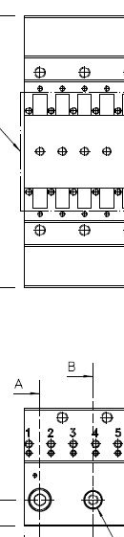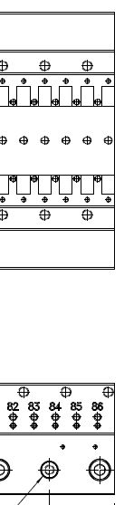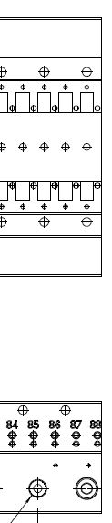
Keeper Center
29H868
Keeper End 2
29H870
Keeper End 1
29H869

Difference between Entrance Module Left and Entrance Module Right (applies to center and exit modules as well)
Magnets are installed in opposite orientation between Left and Right
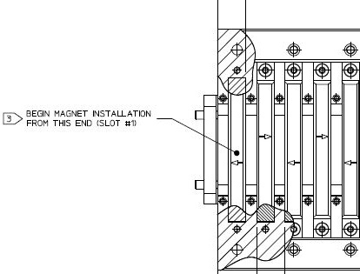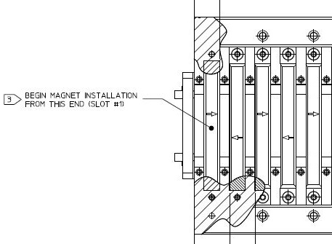
Entrance Module Right
29H881
Entrance Module Left
29H893

Part Number | Description | Quantity
29H878 | Magnet Slice Small Assembly | 1 per exit/entrance module
29H884 | Magnet Slice Medium Assembly | 1 per exit/entrance module
29H888 | Magnet Slice Big Assembly | 1 per exit/entrance module
29H794 | HGVPU Magnet Clamp Block | 172 (exit/entrance) 174 (center)
29H874 | Keeper End Plate | 2
MCM 92605A528 | Pole Adjustment Set Screws (M4x0.7x10) | 176 (exit/entrance) 180 (center)
MCM 91217A070 | Pole Locking Pointed Set Screws (M3x0.5x8) | 172 (exit/entrance) 176 (center)
MCM 92095A768 | Magnet Mounting Screws (M3x0.5x14) | 172 (exit/entrance) 174 (center)
MCM 92290A148 | Keeper End Plate Screws (M4x0.7x12) | 4
MCM 93715A610 | Threaded Inserts (Keenserts M10x1.25 outer, M6x1 inner) | 32
MCM 91292A208 | Keeper Assembly Screws (M8X1.25X45) | 34
 | 0.1 mm (0.004”) brass shims ~30 x 30 mm | 86 (exit/entrance) 87 (center)

CAUTION: STRONG PERMANENT MAGNETS.
Follow Best Practices for working with individual magnets. No more than one magnet outside of packaging & unsecured at a time. Pinch hazard is biggest risk.
When magnets are installed in modules, the two largest risks are 1) that the magnetic field will interfere with an implanted medical device or 2) that a tool will be attracted to the magnets and strike with enough force to shatter the magnets, which are brittle. The secondary risk is scratching, denting, or chipping the magnets enough to change their performance.
Avoid the use of ferromagnetic tools. Remove all objects from your person which might have ferromagnetic material (i.e. watches, keys) or might be affected by the magnets (i.e. credit cards, phones) before working. Tie glasses on securely. Wear safety glasses. Cover magnets with 1” thick foam and protective covering whenever possible. Stay away from magnets if you have an implanted medical device.

Work Instructions

Setup and Overview
Completion of this procedure will provide six (6) assembled, magnet system keepers, alternatively referred to as magnetic modules.
- Enter the following information on the Verification Signoff Sheet:
  - Work instructions number and revision
  - Start date
  - Ambient temperature at assembly start
  - Serial numbers of all component parts to be used in the assembly
  - Calibration date for all calibrated tools used during assembly
- Ensure magnet and pole pieces have been measured as required by HGVPU-ACL-29H881 prior to installation.

VERIFICATION POINT 1

Special Machining Instructions for Keeper Components
The precise alignment of the tabs on the left keeper versus the right keeper is absolutely critical to the final assembly process. Thus, to ensure that the spacing between the left and right magnet tabs are consistent, they are machined simultaneously. The design of the Keeper Stock components (29H764 & 29H771) is no accident; in an effort to minimize variability between the left and right sides of the keeper, the slots are designed to be machined simultaneously in a single pass, thereby eliminating all variability as a result of tool positioning, CNC setup, and tool wear.
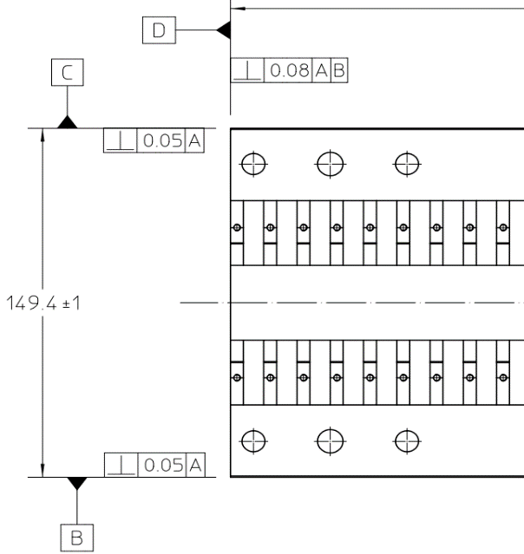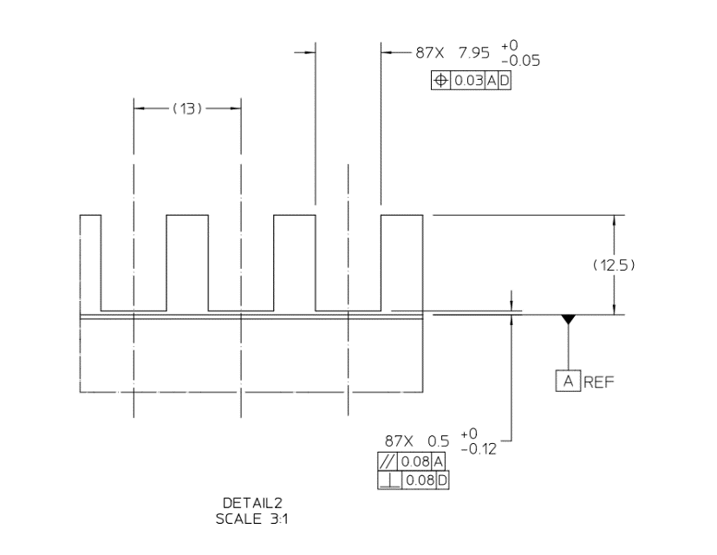
Figure 1 Tool path shown in red and amber is critical to achieving better than or equal to the highlighted tolerance to the right

In the highlighted true position callout above, the positional match of both the left and right sets of tabs must maintain a combined ±0.013mm tolerance in the normal to D-Datum axis. In other words, once the keeper stock is split, and the keeper is assembled with the D-Datum as a 0-reference, the tabs on the left must be within ±13μm of the tabs on the right.
Note: Machining using the following tool-paths WILL result in dimensional failures.
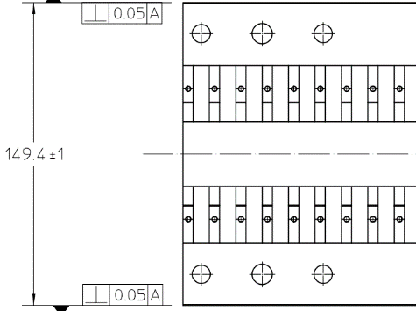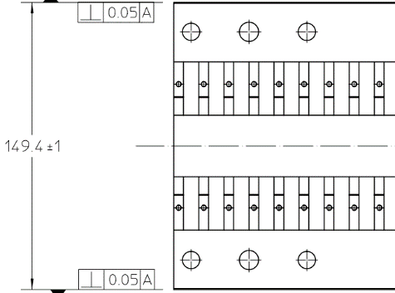
Figure 2: Unacceptable tool paths

Assemble the Keeper
The keeper assembly is comprised of three main components; the base and two sides. The process for assembling these three primary subcomponents is as follows
- Install the threaded inserts into the bottom of the A and B side parts.
  - Clean the threaded pockets thoroughly to prevent premature binding of the threaded inserts, use compressed air and cotton swabs as necessary
  - Screw in until the top surface of the threaded insert is below the surface of the keeper.
  - Using the tool provided with the threaded inserts, hammer the tabs until they are flush with the top surface of the threaded insert.
- Align keeper components
  - Begin by cleaning all surfaces with alcohol and a clean cloth
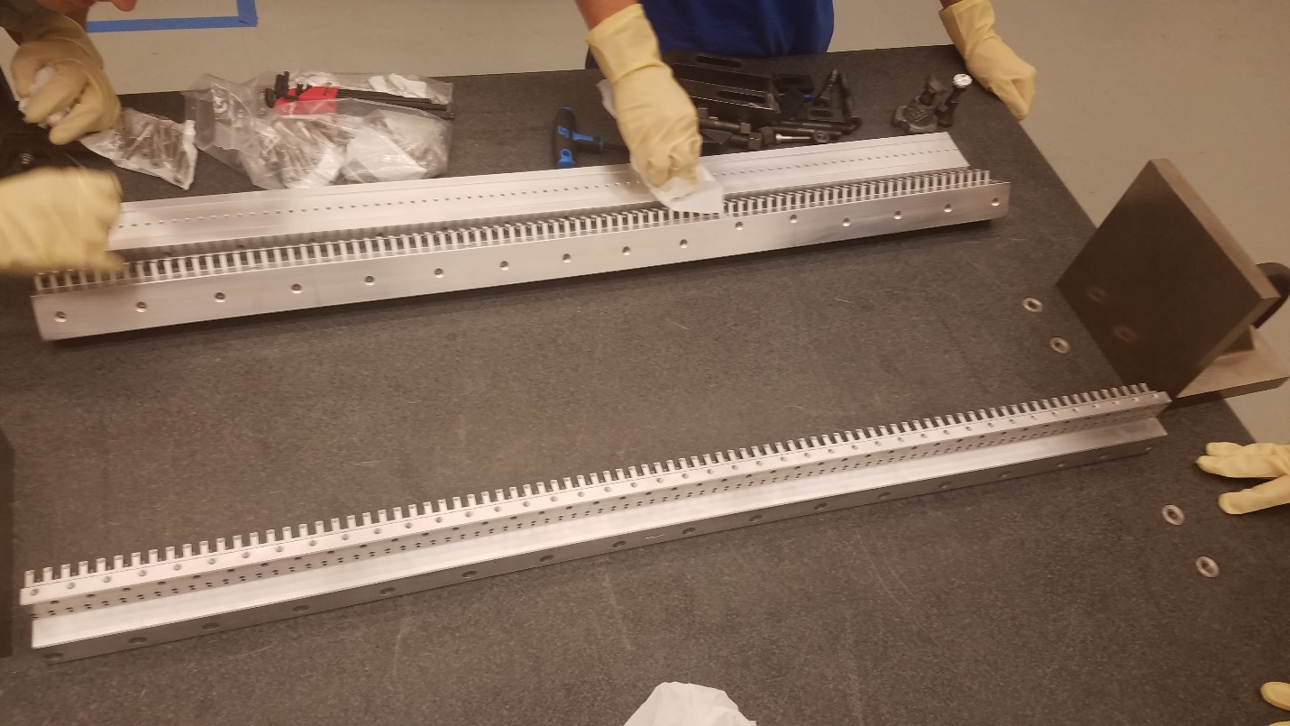
Figure 3 Cleaning 3 keeper sections on flat granite surface
  - Place all components on a granite surface and pre-align with screws loosely inserted
  - Lubricate and insert M8x45 screws (18-8 Steel) in the locations shown and hand tighten until contact is made, do not tighten.
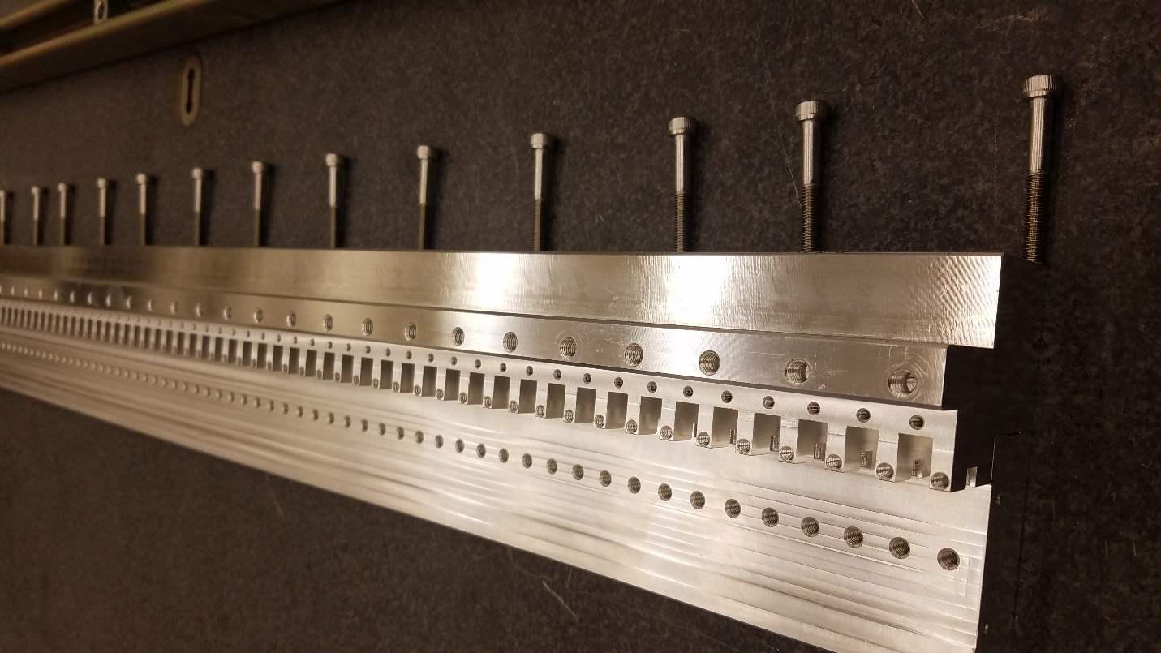
Figure 4 Screws ready to go into keeper
  - Place gauge block against tabs as shown in the figure below.
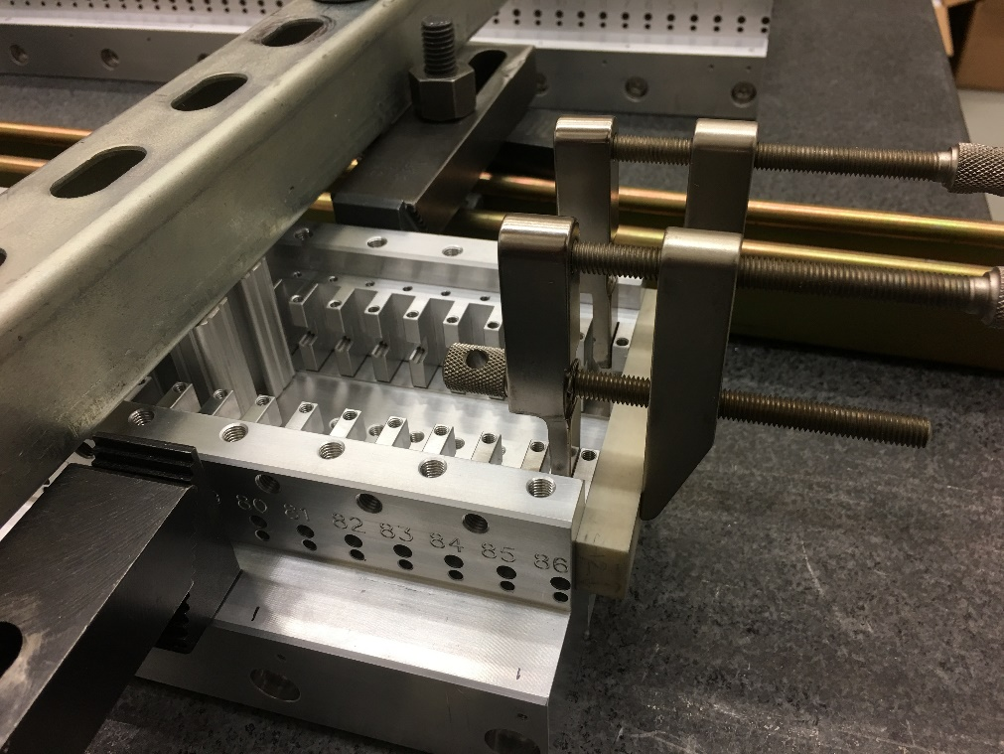
Figure 5 Precision ground gauge block clamped to two keeper side pieces
  - Tighten clamps evenly until both left and right tabs are snugly pressed against the gauge block. Thu purpose of this action is to ensure that both the tabs on the left side and the tabs on the right side are evenly aligned to one another.
  - Using clamps or threaded inserts in the granite table and other tooling (such as accustrut or aluminum extrusion) as necessary, apply even downward pressure on all three components (Side A, Side B and center), forcing them flat against the calibrated surface.

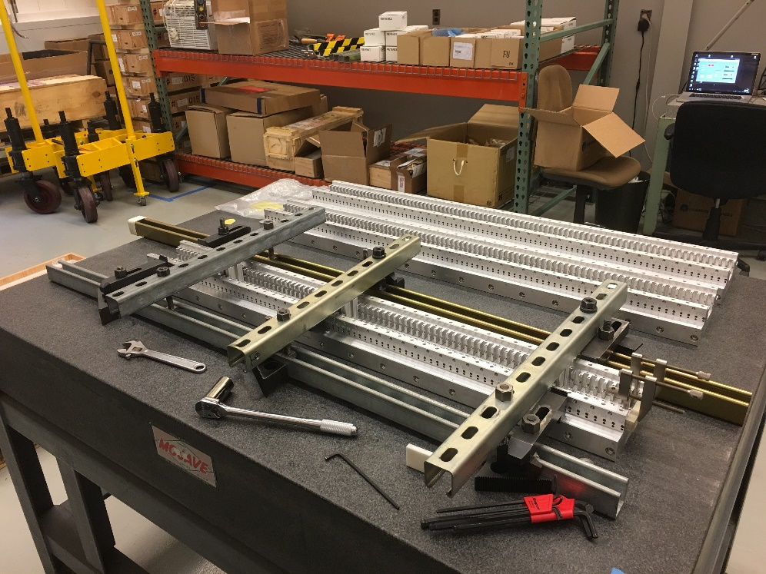
Figure 6 Holding down each of 3 keeper pieces in 3 locations
- Attach keeper sides to keeper base
  - Using the figure below for tightening order, tighten all screws to 12.2 N-m (9 ft-lb)
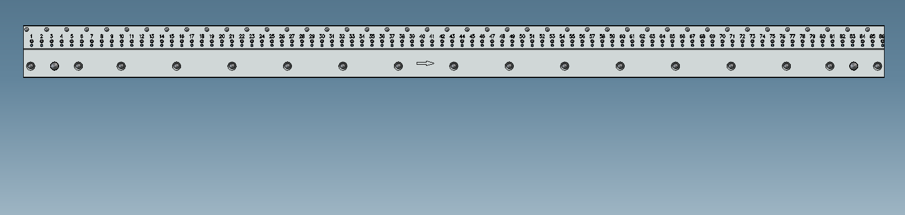
11
4
6
8
14
12
10
16
17
15
13
9
7
5
3
2
1
Figure 7 Torquing order for M8x45 keeper screws.

VERIFICATION POINT 2
Sign off on verification page for torque spec. Ensure that a calibrated torque wrench is used.
- Measure assembled keeper on the CMM.
Inspectable Features:
Differential between adjacent faces on keeper (critical to process dimension) and all other listed dimensions on assembled keeper prints. Record δ₁ through δ₈₄/δ₈₆ (end/center module) for all slots.
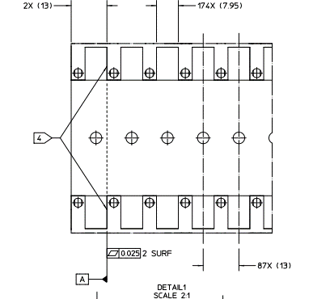
2
1
δ₄ = |Red_{Left} – Red_{Right}| ≤ 13μm
δ₃ = |Orange_{Left} - Orange_{Right}| ≤ 13μm
δ₂ = |Green_{Left} - Green_{Right}| ≤ 13μm
δ₁ = |Blue_{Left} - Blue_{Right}| ≤ 13μm
Figure 8 Z-position of each left tab must match Z-position of corresponding right tab within 0.025 mm (±12.5 µm). See Detail 1 of 29H869/29H868/29H870.

Note: While performing the inspection on the assembled keeper, attach the keeper to a calibrated flat surface (granite table) with bolts or other similar tools approximately every 25cm and torqued to 6 N-m.

VERIFICATION POINT 3
Sign off on verification page for keeper alignment

Install End Plates
The purpose of the end plates is to hold in the end-most magnet or pole on the magnetic module assembly, as well as to protect the magnets during shipping. Upon installation of the magnetic module one end plate will be removed from each of the end modules, and both end plates will be removed from the center module. The end plates are particularly important for protecting the magnets that are on the extreme end of the modules (no outside pole).
- Attach end plates (29H874) on both sides of all magnetic modules using the M4 x 12 stainless steel socket head cap screws.
- Hand tighten to snug, these are supposed to be removable, so do not use Loctite or similar bonding agents.

Install the Poles

Goal of Pole and Magnet Installation
The key dimension requirement is that longitudinal (Z) pole misalignment (rms) be less than 0.025 mm (25 µm). The plan for meeting this requirement is to accurately machine the keeper, and then ensure that all poles are precisely placed with respect to the keeper. We want the magnet to be pressed up against the keeper’s pole tabs, and the pole to be pressed up against the magnet, with a shim to ensure that the longitudinal position is maintained. See figure.

Any adjustments to the pole or magnet installation procedures should be made with this goal in mind.
Magnet
Keeper
Pole
Shim
Beam Direction
7.90-7.95
7.80-7.85
13 – RMS 0.025 required
5.03-5.05
5.05-5.1
Keep collinear:
Magnet DS side, Pole US side,
Keeper Tab US side

0.1-0.15
Figure 9 Magnified view of poles, magnets and shims installed in the keeper. Pole upstream side and magnet downstream side should be metal to metal. Largest shim that will fit should be used.

- Pole installation is to take place in a dust/debris controlled assembly area with a temperature of 20°C±1°C. Any debris on the keepers may result in the poles not seating properly into the keeper assembly; ensure that the keeper assembly is clean, and that all assembly is performed in a clean room.
- Pre-install the top (M4, flat-tipped) set-screws for poles. Screw in until the heads are flush with the top surface of the keeper.
- Pre-install the side (M3, cone point) set-screws for poles. Ensure that the screws are pulled back and will not touch poles during installation. They will be screwed fully in place during the pole height adjustment process.

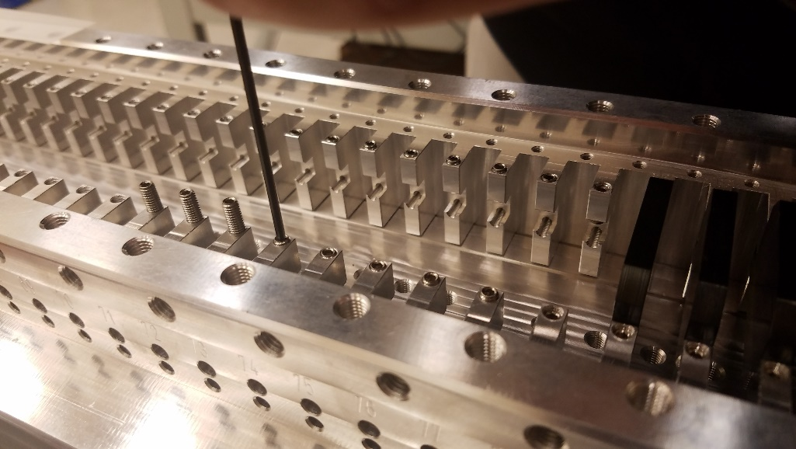
Figure 10 Installing pole adjustment top screws
- Place pole in position 1 with the serial number on the right-hand side and place spring tool in downstream magnet slot with the springs facing the pole.
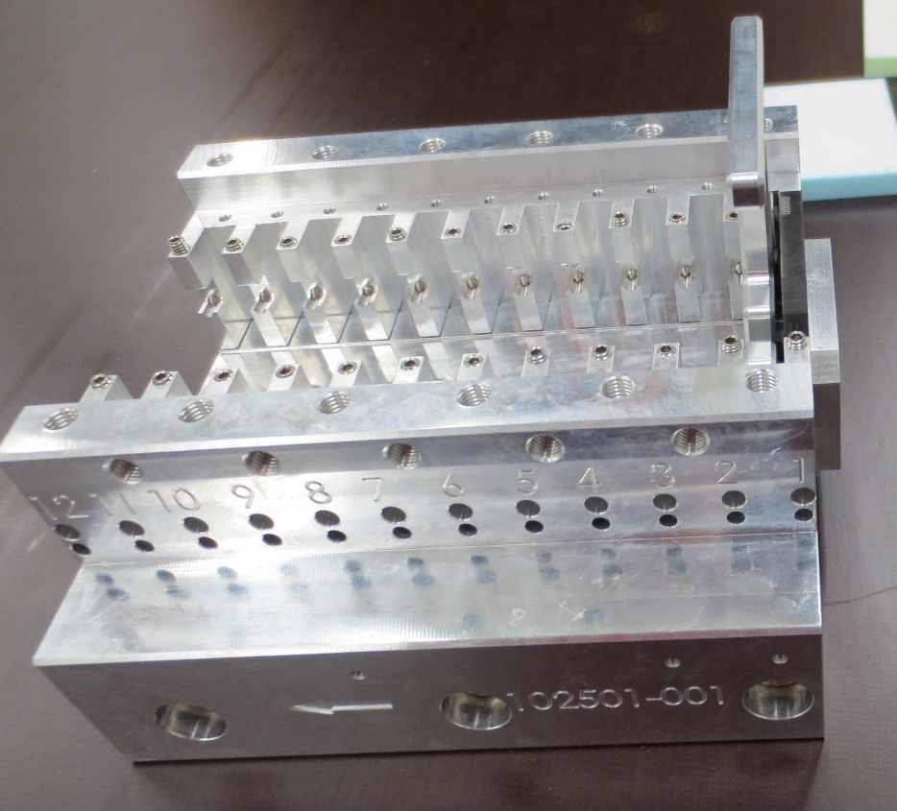
Figure 11: First pole pressed against end plate with spring tool in downstream magnet slot with springs facing pole
- Insert shim (0.008 in or 0.2mm) in-between pole and keeper tabs on both sides of the pole to center the pole in the keeper. (Can also use one shim & press with your finger as long as final pole position is aligned when CMM measurements are performed).
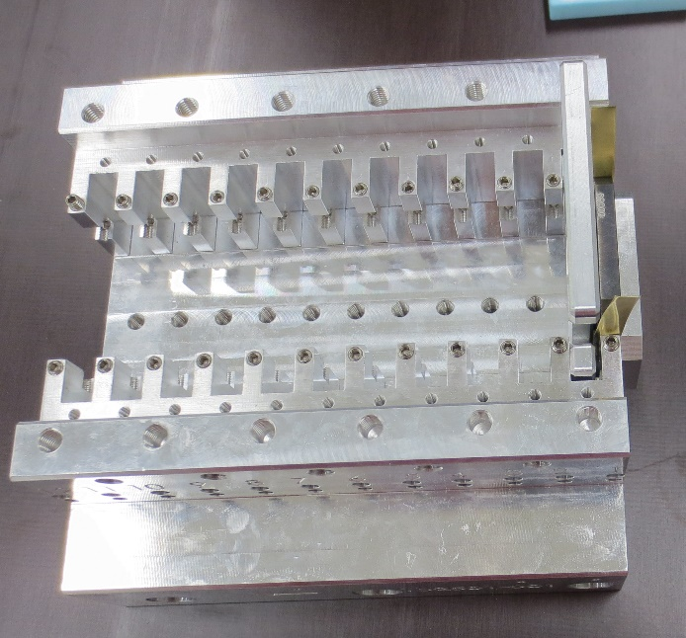
Figure 12: 0.2 mm (0.008”) shims in place.
- Lock pole in place by tightening the 2 set screws to 0.34 N-m (3 in-lb).
- Remove shims, they should lift out easily.
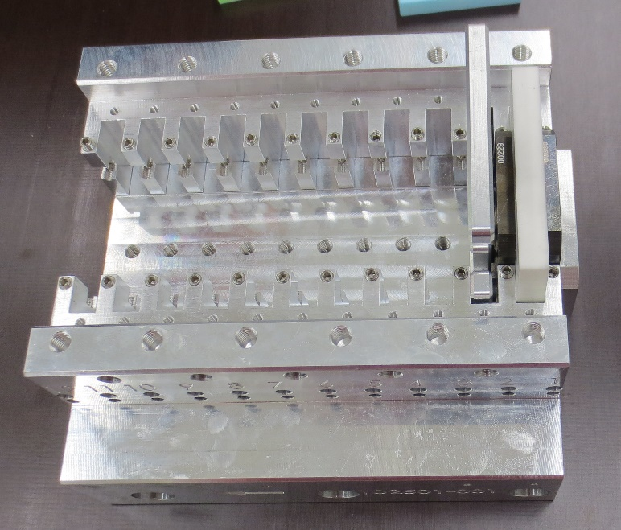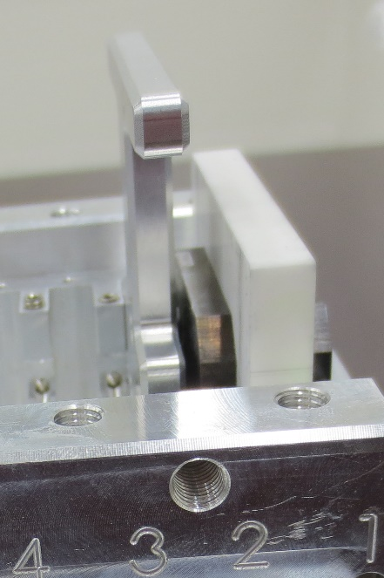
Figure 13 Second pole pressed up against magnet-sized gauge block
- Remove spring tool and replace it with the largest magnet-sized gauge block that will fit.
- Place next pole with serial number on the right-hand side.
- Put spring tool in downstream magnet slot with the springs facing the pole.
- Insert shim (0.008 in or 0.2mm) in-between pole and keeper tabs.
- Lock pole in place with a torque of 0.34 N-m (3 in-lb).
- Remove shim(s).
- Repeat steps 8-13 until all poles have been locked in place
Figure 14 Installing poles
- Use a gauge of maximum magnet thickness to ensure that the magnet will fit in each magnet slot.

Magnet Sorting
The five point measurement process is detailed in LBNL Engineering note 11057. Below are the instructions for using the five-point measurements and magnetic moments to sort the magnets.
Input File Format
There are two input files associated with the sorting program:
- “A1.dat” contains the individual magnet data
- “sort.in” contains parameters that are needed to run the optimization routine
Description of Magnet Data in “A1.dat”
The file “A1.dat” is a tab delimited ASCII file. The first row contains the number of magnets, N_{mag}, in the file. The following N_{mag} rows contain the magnet data. The magnet data is organized as follows by column:
- Magnet serial number
- Magnetic moment component in the x-direction
- Magnetic moment component in the y-direction
- Magnetic moment component in the z-direction
- Percent N/S point #1
- Percent N/S point #2
- Percent N/S point #3
- Percent N/S point #4
- Percent N/S point #5
- Allowed magnet orientation for chipped magnets (0 – any orientation allowed, 1 – one arrow orientation allowed, 2 – two arrow orientation allowed)
Figure 15 shows an example of a segment the file “A1.dat” with the format as described above. Figure 16 shows the numbering scheme for the 5-point N/S values which are entered in columns 5 – 9 in the “A1.dat” file.
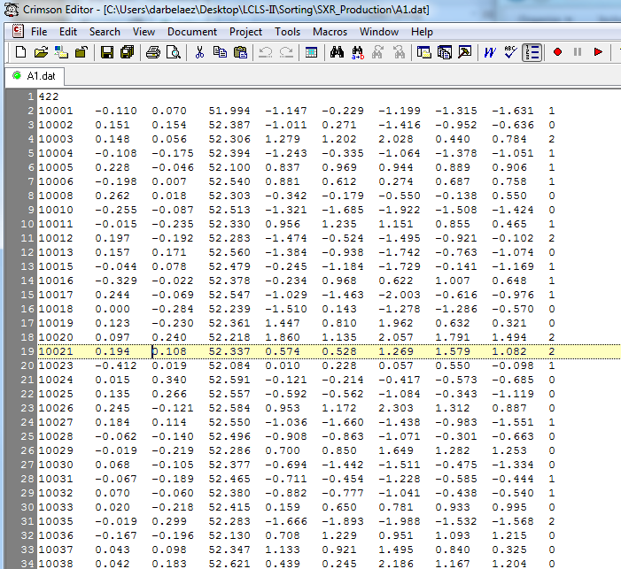
Figure 15: Example of file “A1.dat” showing the file format. Note that the white numbers in the left gray area of the window are part of the file editor and not in the file itself.

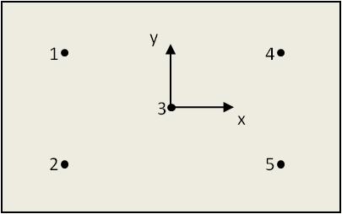
Figure 16: N/S point locations and numbering scheme. Note that the coordinate system is right-handed so that the z-direction (magnetization direction) is pointing outward from the page.

Description of magnet data in “sort.in”:
The file “sort.in” contains information that is needed to run the sorting program. This includes the basic undulator parameters (i.e. number of periods per module and number of modules), as well as, parameters that are used in the simulated annealing algorithm. These parameters do not need to be changed in the undulator production run. Figure 17 shows the parameters in the “sort.in” file. The text on the right of the values is a description of each parameter.

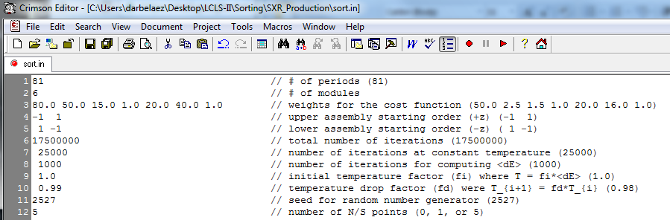
Figure 17: Screenshot of the “sort.in” file that contains the necessary parameters for the sorting procedure.

Running the Sorting Program:
The executable file for the sorting software is “sort.exe”. This input files should be placed in the same folder as the executable file. The executable file can be run by opening a Windows command prompt, navigating to the sorting directory, and typing sort.exe in the command line.

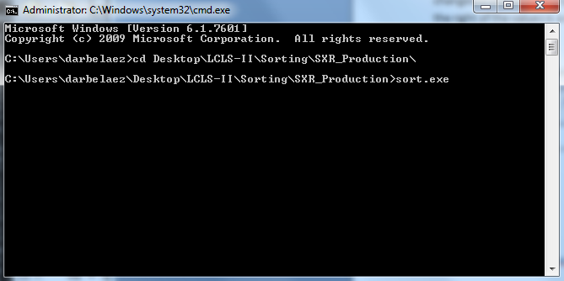
Figure 18: Command prompt used to run the executable file.
The program will then execute and display information with regards to the effectiveness of the sorting routine. This information is also recorded in the “sort.log” output file.

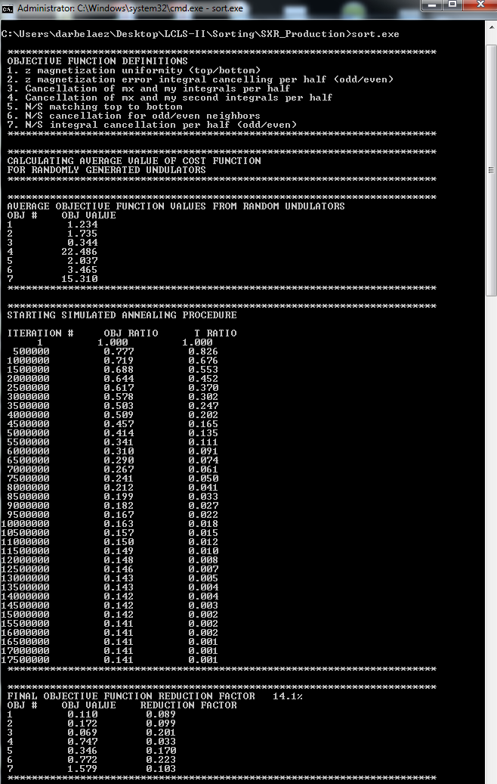
Figure 19: Program output to screen during the optimization process

Once the optimization process is finished, the program prompts the user for the serial numbers of the magnet modules. An example can be seen in Figure 20.

Figure 20: Example of serial numbers that were entered for the modules of one undulator.

The corresponding map from module number to the position along the undulator is shown in Figure 21 for the example above.

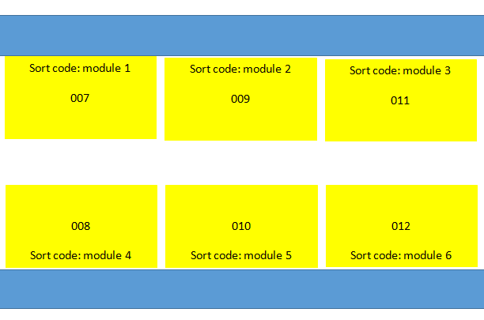
Figure 21: Example of module numbering corresponding to the values entered into the sorting program as shown in figure 6.

Program Output:
The sorting lists are output into six files with the name “module_sort_SN_xxx.html,” where “xxx” corresponds to the serial numbers that are entered into the command prompt. Figure 22 shows an example of the file “module_sort_SN_007.html” showing the magnet block serial number and the arrow orientation that would be seen on the top of the magnet block after insertion into the module. The header also shows the location for this specific module in the undulator (i.e. Upper Upstream).

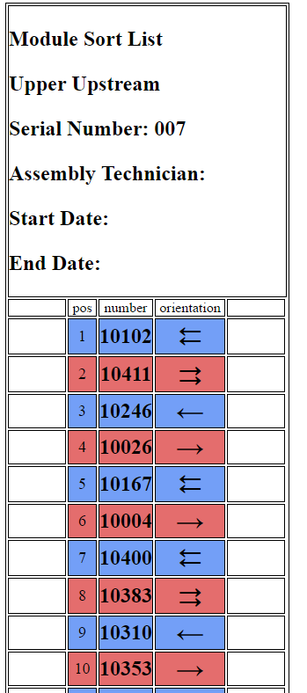
Figure 22: Example of the sorting list that is generated from the sorting program.

The files “sorted_blocks.dat” and “PMdata.dat” are also generated by the program. These files contain more information than the “module_sort_SN_xxx.html” files and are useful for verifying the effectiveness of the sort in a more detailed manner. The file “spare_blocks.dat” contains the information of the magnet blocks that were not used in the undulator modules. This file is used if a magnet block needs to be replaces as will be covered in the following section. The file “sort.log” contains the information that is shown on the command prompt screen as well as a time stamp for the day and time of program execution.

VERIFICATION POINT 4

Magnet Block Replacement:
If a magnet block needs to be replaced, this can be done with the program “replace_magnet.exe”. As with the sorting program, this can be run through the command prompt. The files “A1.dat” and “spare_blocks.dat” should be in the same folder as “replace_magnet.exe”. When the program is executed, the user will be asked to enter the serial number of the magnet that is to be replaced. After the user enters the number, the program will output a replacement magnet to the screen. An example is shown in Figure 23. The replacement magnet should be placed into the undulator in the same orientation as was specified for the original magnet. The “spare_blocks.dat” file is not updated automatically, and needs to be modified by the user in order to remove the replacement block.

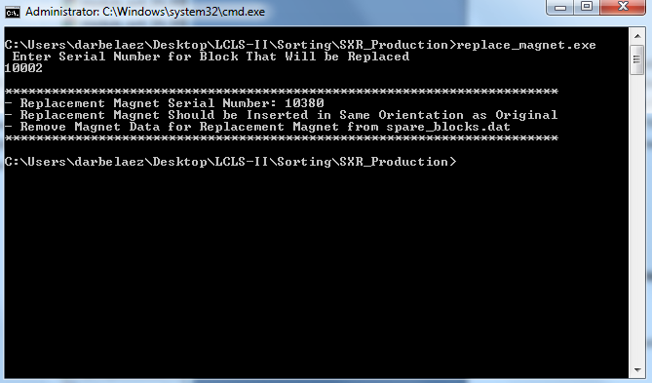
Figure 23: Example of magnet replacement procedure.

Magnet Installation
- Magnet installation is to take place in a controlled space with a temperature of 20°C±1°C. Any debris on the keepers or pole may result in the magnets not seating properly into the magnetic module assembly; ensure that the magnetic module assembly is clean, and that all assembly is performed in a dust-free room.
- Label keeper with the correct assembly number, in a position that will be visible in the final assembly.
  - Entrance, Center and Exit Module Right (29H881, 29H872, 29H882) should be labeled on keeper part B (29H753, 29H738, 29H740)
  - Entrance, Center and Exit Module Left (29H893, 29H894, 29H895) should be labeled on keeper part A (29H736, 29H772, 29H766)
- Gather the magnets and sort according to the provided sort list. Refer to LBNL Engineering Note 11057 for an explanation of how to read the files. Verify the correct keeper serial number.
- The 2 entrance keepers have 3 special magnets in slots 1-3. The 2 exit keepers have 3 special magnets in slots 84-86. These magnets (29H878, 29H884, 29H888) are not on the sort list, and should be assembled per the assembly print, with the correct north-south orientation.
- Start the magnet installation with slot 1, as indicated on the side of the keeper adjacent to the magnet slot. Ensure that the serial number and indicator arrow of the magnet is oriented as prescribed in the magnet sort list (or assembly print for 3 special magnets). Pay attention to whether the single arrow or double arrow is showing.
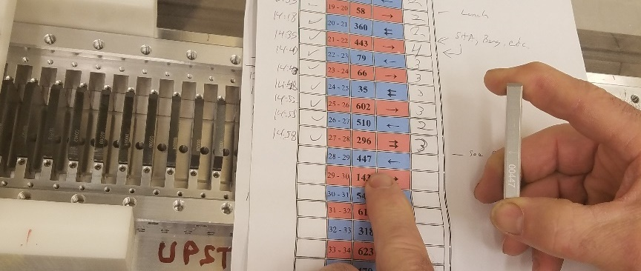
Figure 24: Checking correct magnet number and orientation
- Align the fixture with the pushing rod of the magnet installation fixture by extending the guide rod into the magnet slot.
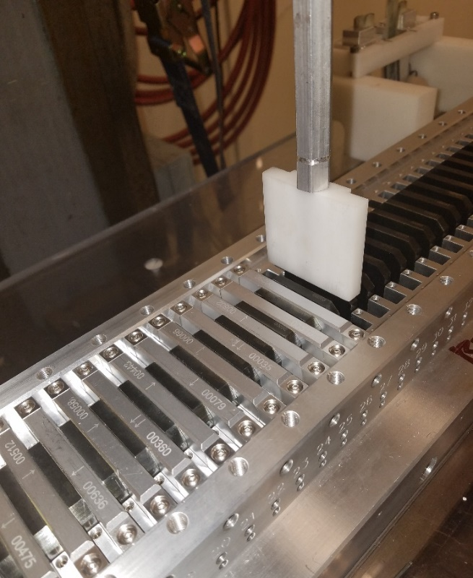
Figure 25 Using pushing portion of magnet insertion device to verify correct position of keeper
- Using compressed air, clean off the magnet and blow out the magnet slot.
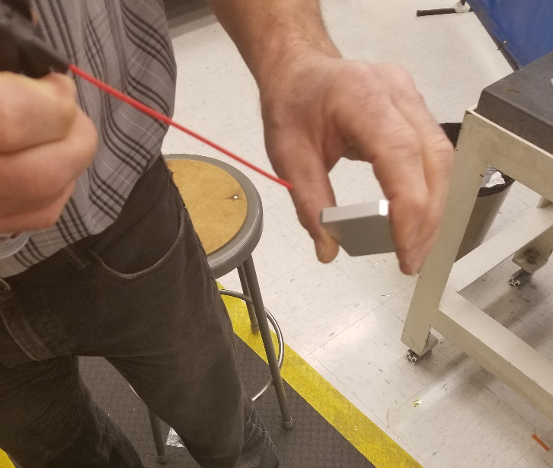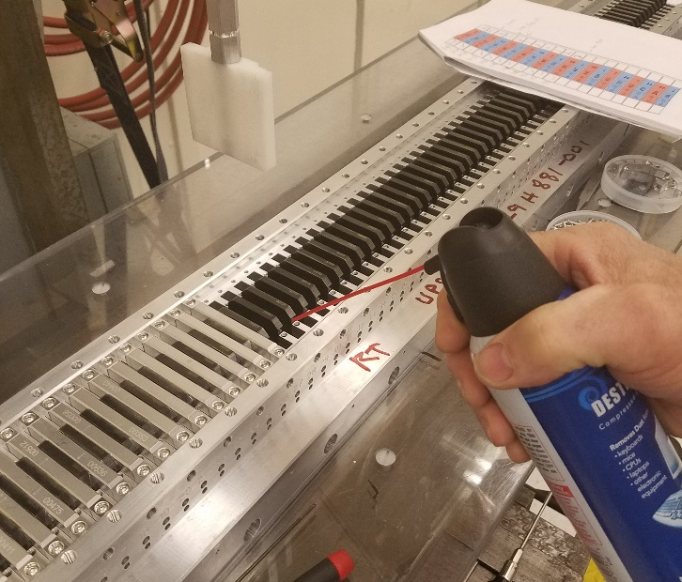
Figure 26: Cleaning magnet (left) and slot (right) with compressed air
- Put guide portion of installation tool in place.
- Put a stiff piece of plastic between the bottom of the guide portion of the installation tool and the top of the poles, to prevent the magnet from slamming into the poles.
- Insert the appropriate magnet block in the correct orientation into the installation tool and push it down until it hits the stiff piece of plastic from step 8. Remove the plastic.
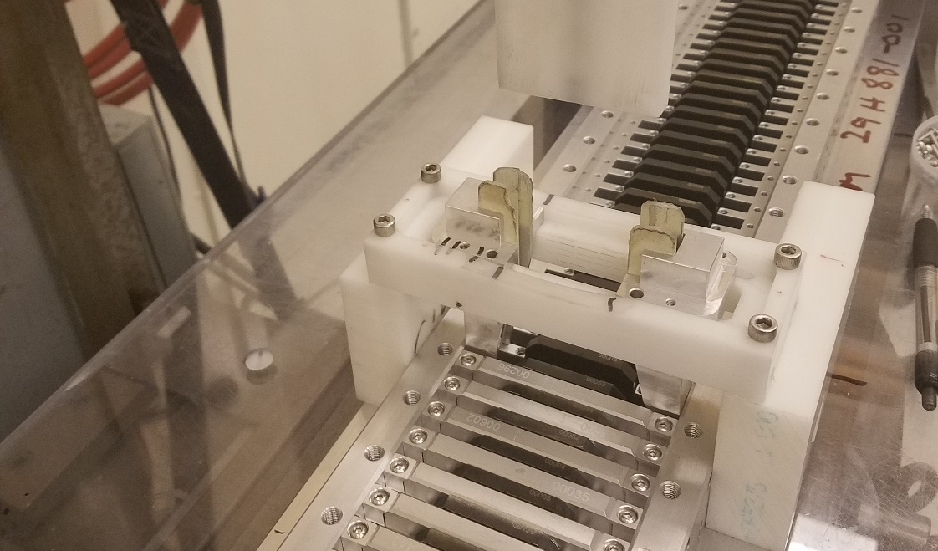
Figure 27: Guiding portion of magnet installation tool for pre-production unit
- Push the magnet the rest of the way into the magnetic module. You should hear a click when the magnet hits the bottom.
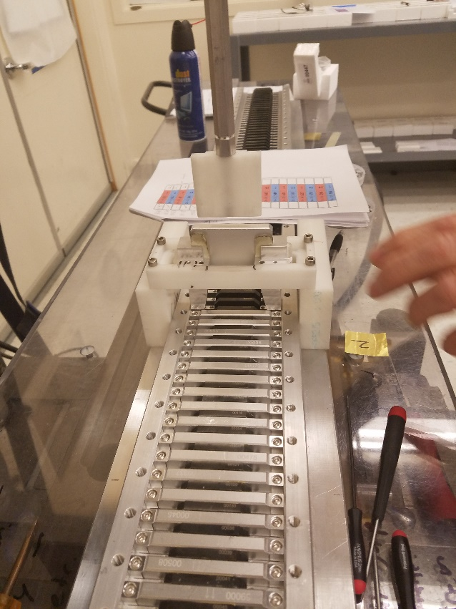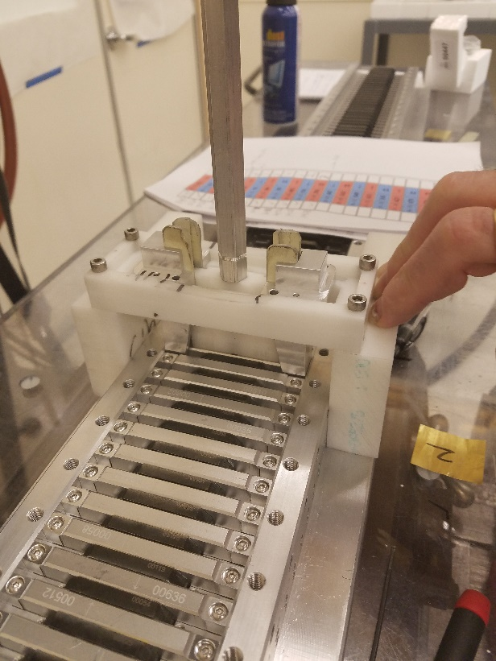
Figure 28 (Left) Place magnet in guide portion of installation tool. It will float. (Right) Use pushing part of installation tool to push the magnet all the way in. Magnetic force will change direction and pull it down.
- Loosen the downstream pole. The magnet and downstream pole will stick together. (May not be true for end magnets – push on pole/magnet to get them into place as necessary).
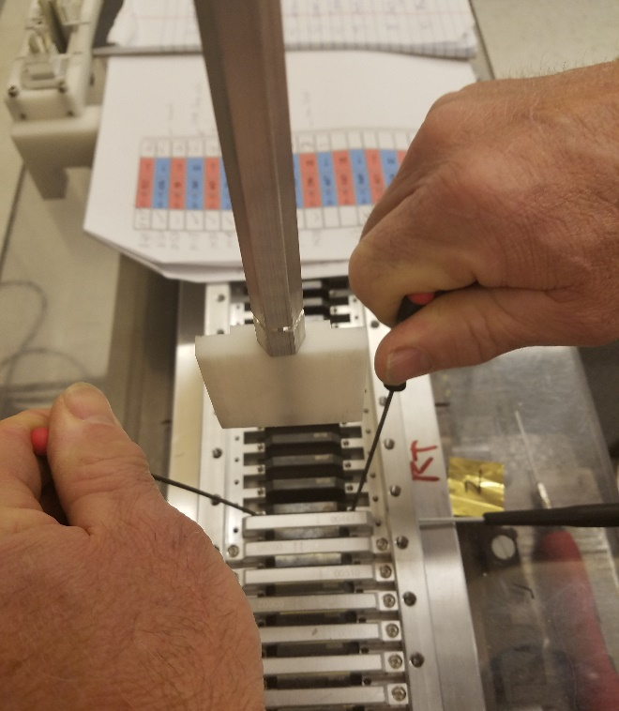
Figure 29 Loosening downstream pole
- Insert a 100µm (0.004”) shim between the newly inserted magnet and the upstream pole. The shim material must be non-magnetic. LBNL has had good results using standard brass shim material.
- Push the shim all the way down using either a fingernail or non-magnet flat-head screwdriver. Be sure that no part of the shim is higher than the pole.
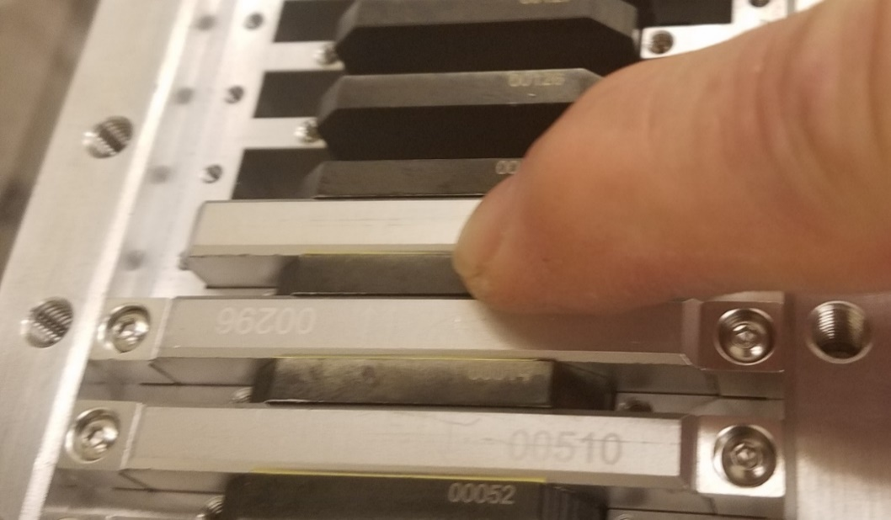
Figure 30 Pushing down shim
- Place 0.2 mm (0.008”) shim on either side of the pole to center it, and tighten top pole screws to 0.34 N-m (3 in-lb).
- Remove 0.2 mm (0.008”) shims.
- Install magnet clamps, (29H794) using magnet attachment screws (M3x0.5x14) to hold the magnet in place. Tighten until snug.
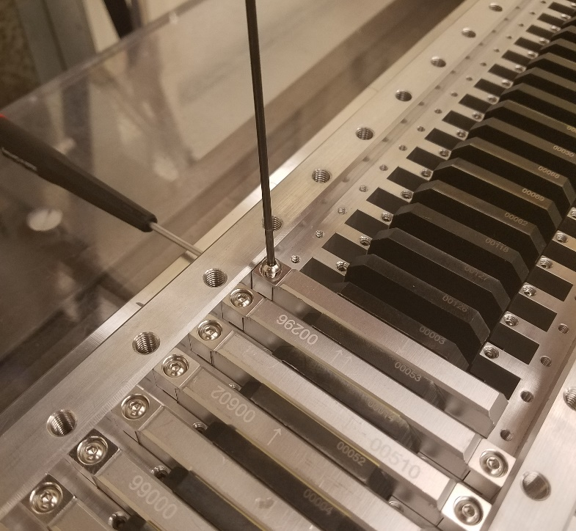
Figure 31 Installing Magnet Clamp Blocks
- Now torque magnet clamps to final value of 1.13 Nm (10 in-lb).
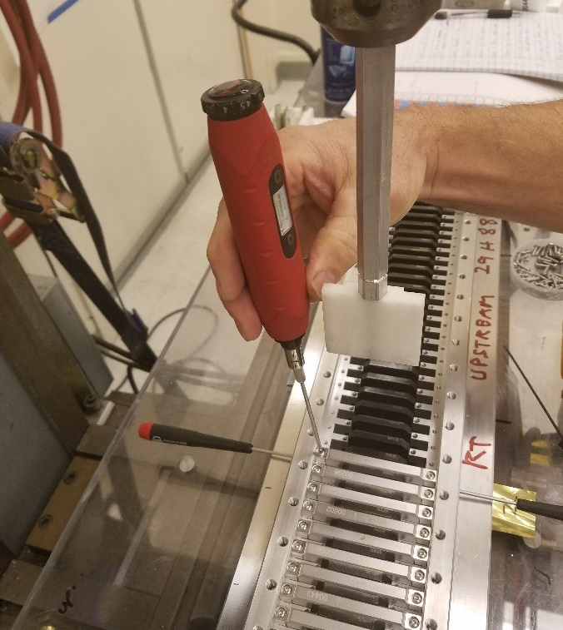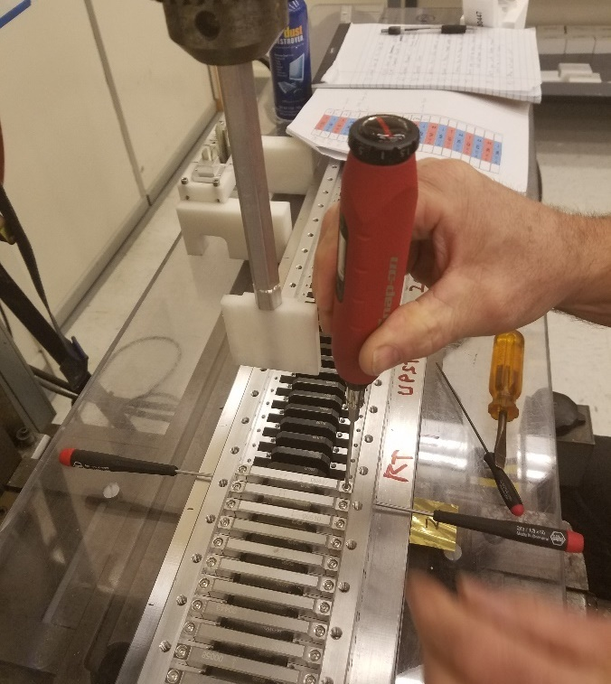
Figure 32 Torquing magnet clamps
- For first magnet only – loosen first pole and use set screws in the end plate to push first pole up against shim & first magnet, retighten.
- Repeat Steps 4-17, installing magnets sequentially from the lowest numbered magnet slot (number on side of keeper) to highest, until all magnets have been installed.

Record on the Verification Signoff Sheet that all of the magnet attachment screws have been installed to the correct torque spec.

VERIFICATION POINT 5
- Verify that magnets are installed in the correct orientation and in the order determined by the Magnet Sorting Algorithm.

Adjust the Pole Height
The poles are currently at the bottom of their travel. They need to be put in their final position. They need to be 140 µm above the average magnet height and flat within ±5 µm. The side locking set screws (M3, cone point) will be screwed in fully now.
Note: The drawing shows a 100 µm difference between pole and magnet height, but it uses the maximum magnet height. The average magnet height is expected to be 40 µm shorter.

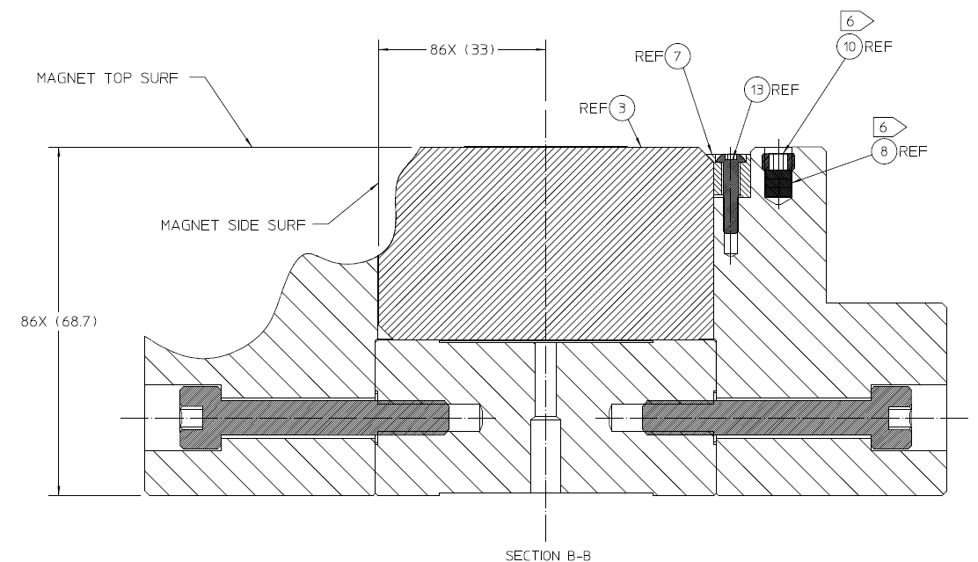
Figure 33 Magnet height on drawing. This is maximum height.

The meter long aluminum keeper is flexible when attempting to make ±5 µm measurements. All precise, absolute measurements must be made with the magnetic module clamped to a calibrated flat surface (such as granite surface of CMM). Relative motion measurements of an individual pole can be made with the module unclamped.

The first pass of pole adjustment is not required to be measured on the CMM so long as the following steps are accomplished. On the preproduction unit, this was done with height gauges.
- Determine average magnet height.
- Adjust the pole height to 140 µm above the average magnet height

CMM Instructions:
- Clamp the magnetic module assembly to the granite of the CMM approximately every 25cm with a force of 6 Nm.
- Measure the height of each magnet relative to Datum A, the bottom surface of the keeper, which is represented by the granite surface of the CMM, since the module is clamped down.
- Measure the height of each pole in two locations, as close the edge as allows for a clean measurement to be taken.

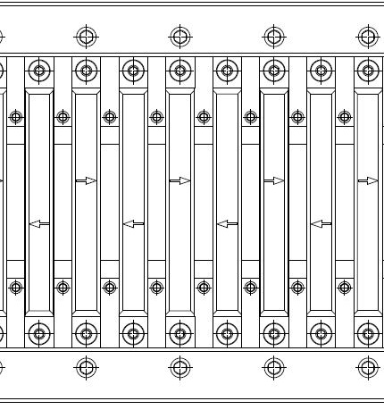
Figure 34 Measurement locations. Top view. Two points per pole, one per magnet.
- Ensure that no magnets are very far outside the expected 80 µm range, as this could be indicative of debris underneath the magnet. No magnet may be taller than the shortest pole once the poles are in their final position. The M5 threaded thru holes in the keeper center piece (29H762 and 29H773) can be used to push the magnets out if necessary.
- Find the average magnet height from this data.
- Determine how far to move each pole from this data.

Inspectable Feature:
Record the magnet baseline height with the corresponding part number and serial number on the verification sign off sheet.

VERIFICATION POINT 6
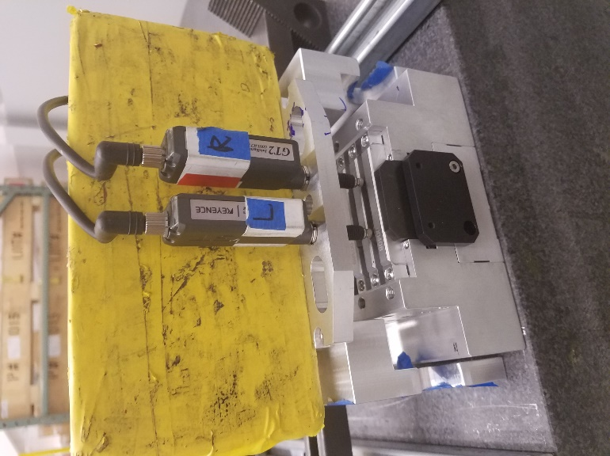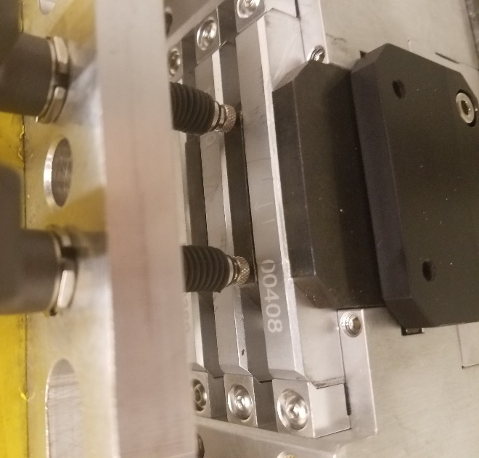
Figure 35 Monitoring pole position during adjustment process
- To adjust the poles:
  - Use two sensors (Keyence GT2-H12K or device with equivalent accuracy) to track the change in pole height.
  - Insert 0.2 mm (0.008”) shims on the sides of the pole to ensure it remains centered.
  - Loosen the top screws. This allows the magnetic forces to push the pole up. Adjust top screws until pole is just below target height.
  - Insert and tighten the locking screws to 0.36 Nm (3.2 in-lb). This will raise the pole a bit. If target height is not reached, unlock the side screws and adjust top screws again.
  - Tighten top screws to 0.34 Nm (3 in-lb).
  - Remove 0.2 mm (0.008”) shims.
Note: The end magnets may not push the pole up since the forces are weaker. Use the side screws to push the pole up.

VERIFICATION POINT 7
Sign off on verification page for side and top pole screws torque spec. Ensure that a calibrated torque wrench is used.

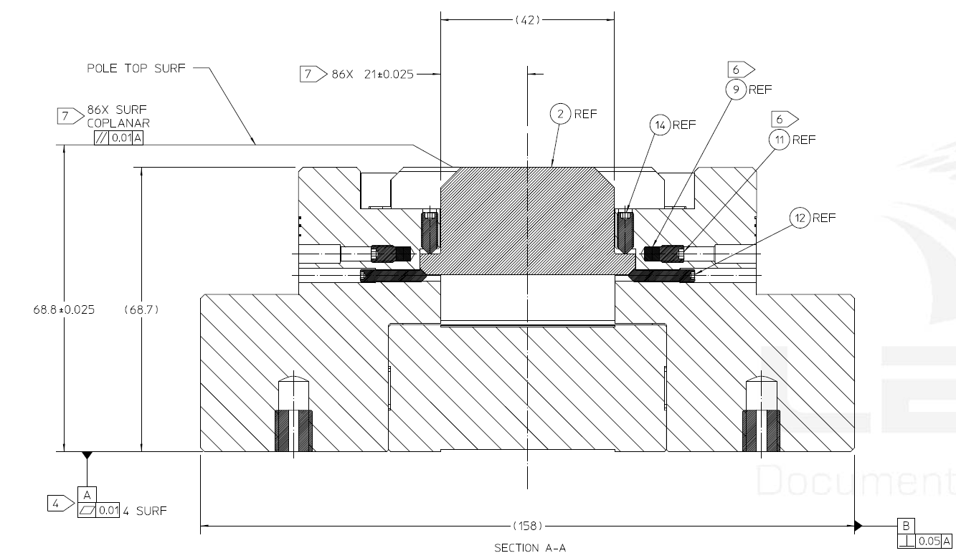
Figure 36 Using top and side screws to position pole. Magnet forces push pole up, so top screws control pole height.
- Repeat steps 1-7 until poles are co-planar within ±5 µm and 140 µm above the average magnet height.

Final inspection of magnet module:
- Clamp magnet module to CMM and measure
  - Pole height (X in final undulator coordinates)
  - Pole longitudinal position (Z, beam direction)
  - Pole centering (Y, gravity in final undulator coordinate)
  - Pole parallelism (Pitch, Roll) (i.e. take 2 points to measure height and longitudinal position)
  - Magnet height
  - Magnet longitudinal position

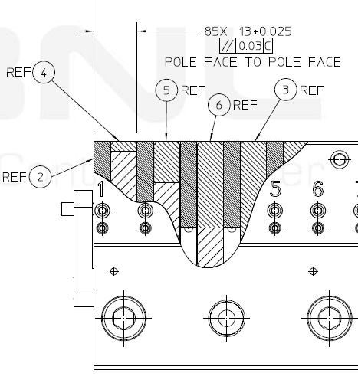
Figure 37: Pole longitudinal spacing requirements (from 29H893A, always refer to most current drawing)
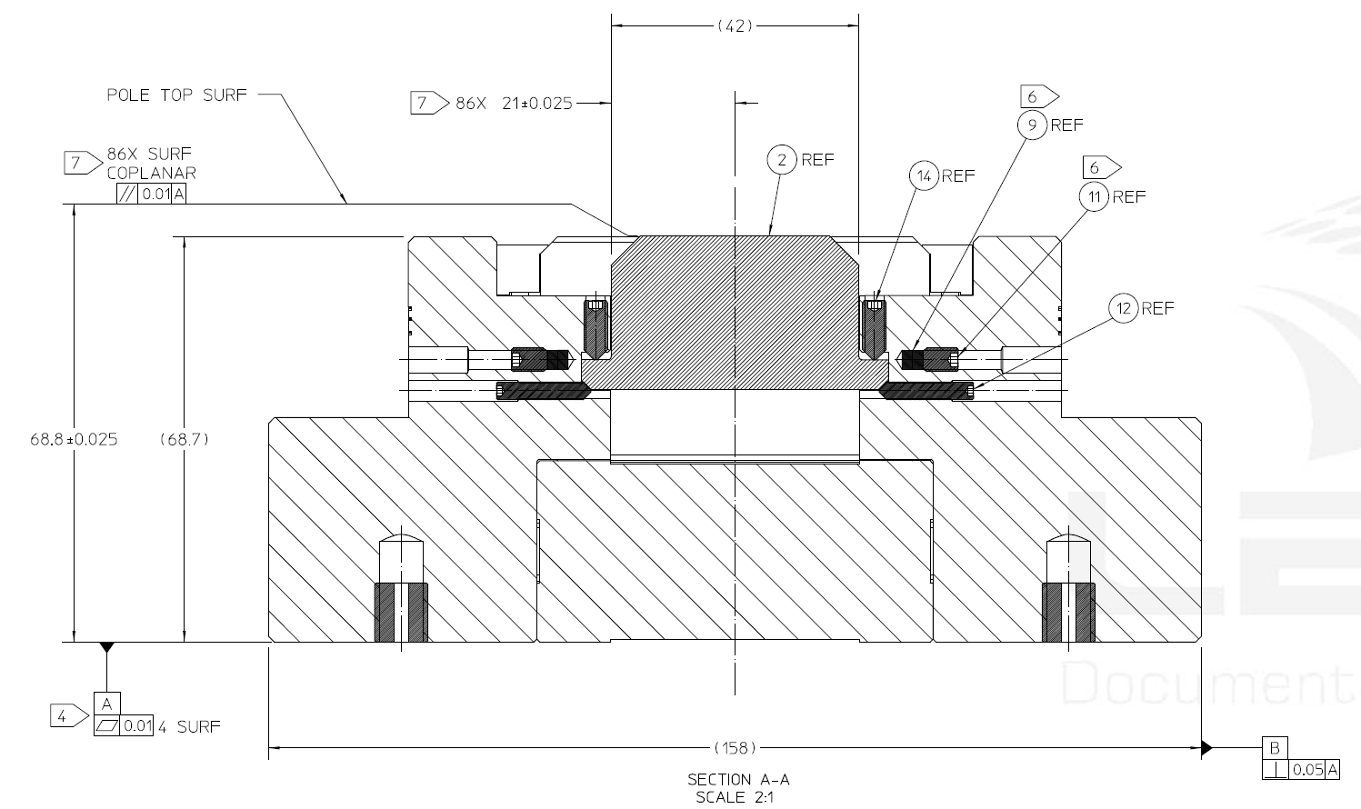
Figure 38: Pole height, centering requirements (from 29H881A, always refer to most current drawing)
- Upload report to Windchill.

VERIFICATION POINT 8

Completion
- Ensure all component serial numbers are entered in the Verification Signoff Sheet.
- Enter the completion date and temperature in the Verification Signoff Sheet.
- Have Verification Signoff Sheet signed and dated by Quality Assurance.

Verification Signoff Sheet
EACH MAGNETIC SYSTEM IS REQUIRED TO HAVE A COMPLETED VERIFICATION SHEET.
VERIFICATION MUST BE DONE BY AN ENTITY OTHER THAN THE ASSEMBLY TECHNICIAN
SERIAL NUMBER (of 6 modules):
ASSEMBLY START DATE: | ASSEMBLY COMPLETION DATE:
AMBIENT TEMPERATURE  AT ASSEMBLY START: | AMBIENT TEMPERATURE  AT ASSEMBLY COMPLETION:
WORK INSTRUCTIONS NUMBER AND REVISION:
COMPLETE ASSEMBLY VERIFIED BY (Sign and Date):

Entrance Module Left
PART NUMBER | DESCRIPTION | QUANTITY REQUIRED | SERIAL NUMBER(S)
29H762 | KEEPER END C | 1
29H753 | KEEPER END 1B | 1
29H736 | KEEPER END 1A | 1
29H874 | KEEPER END PLATE | 2

Entrance Module Right
PART NUMBER | DESCRIPTION | QUANTITY REQUIRED | SERIAL NUMBER(S)
29H762 | KEEPER END C | 1
29H753 | KEEPER END 1B | 1
29H736 | KEEPER END 1A | 1
29H874 | KEEPER END PLATE | 2

Center Module Left
PART NUMBER | DESCRIPTION | QUANTITY REQUIRED | SERIAL NUMBER(S)
29H773 | KEEPER CENTER C | 1
29H738 | KEEPER CENTER B | 1
29H772 | KEEPER CENTER A | 1
29H874 | KEEPER END PLATE | 2

Center Module Right
PART NUMBER | DESCRIPTION | QUANTITY REQUIRED | SERIAL NUMBER(S)
29H773 | KEEPER CENTER C | 1
29H738 | KEEPER CENTER B | 1
29H772 | KEEPER CENTER A | 1
29H874 | KEEPER END PLATE | 2

Exit Module Left
PART NUMBER | DESCRIPTION | QUANTITY REQUIRED | SERIAL NUMBER(S)
29H762 | KEEPER END C | 1
29H740 | KEEPER END 2B | 1
29H766 | KEEPER END 2A | 1
29H874 | KEEPER END PLATE | 2

Exit Module Right
PART NUMBER | DESCRIPTION | QUANTITY REQUIRED | SERIAL NUMBER(S)
29H762 | KEEPER END C | 1
29H740 | KEEPER END 2B | 1
29H766 | KEEPER END 2A | 1
29H874 | KEEPER END PLATE | 2

ITEM # | ASSEMBLY TECHNICIAN  (Sign & Date) | RECORDED INFORMATION  (As Noted) |  |  | CAL INFO | VERIFICATION BY  (Sign & Date)
1 |  | Verify all pole and magnet data has been provided |  |  | N/A
2 |  | Torque Spec for thirty-four (34) M8x45 screws holding each of the six (6) keeper assemblies together |  |  | TOOL ID  LAST CAL DATE
3 |  | Verify alignment of Keeper Assembly data has been provided |  |  | N/A
4 |  | Verify Magnet Sort files have been provided |  |  | N/A
5 |  | Magnet installation torque spec for the two (2) screws attaching the two hundred and sixty (260) magnets |  |  | TOOL ID  LAST CAL DATE
6 |  | Magnet Heights from bottom of keeper |  |  | TOOL ID  LAST CAL DATE
 |  | 29H881 | 28H872 | 29H882
 |  | 29H893 | 29H894 | 29H895
7 |  | Pole installation screw torque spec  Four (4) screws for each of the two hundred and sixty (260) poles in the VPU. |  |  | TOOL ID  LAST CAL DATE
8 |  | Verify final assembly measurements have been provided. |  |  | N/A

