LCLS-II HXU Measurement Results

This report is intended to document the results of HXU segment tuning at LBNL and ANL. It should be sent to SLAC for approval before the HXU segment gets shipped.

Serial number from manufacturer’s label:

Measurement Procedure:

The measurements have been carried out after the undulator segment had been fully tuned according to “LCLS-II Undulator Test Plan” (LCLS-TN-17-1).

General Hall Probe Scan Evaluation Parameters
Undulator Temperature | 20.000± 0.0?? | °C
First core pole # (count includes zero potential pole) | 8
Last core pole # (count includes zero potential pole) | 253
Tuning Gap (should be 9.000 mm) | 9.000 | mm
Evaluation of Hall Probe Scans at Commissioning Gap

Commissioning Gap Temperature | 20.000± 0.0?? | °C
|B_{pk}|/<|B_{pk}|> - 1 | ±0.00??
K_{eff} at Commissioning Gap (should be 2.3400) | 2.3???
Commissioning Gap | 7.94? | mm
I1X (over 4.012677 m) | ??? | µTm
I2X (over 4.012677 m) | ??? | µTm²
I1Y (over 4.012677 m) | ??? | µTm
I2Y (over 4.012677 m) | ??? | µTm²
Phase Shake (rms phase fluctuations over core poles) | ?.?? | degXray
Cell Phase Advance (over 4.012677 m should be 46,440) | 46,440 (129×360+?) | degXray
Undulator Entrance Phase (3070) | 3070 (17×180+?) | degXray
Undulator Exit Phase (3070) | 3070 (17×180+?) | degXray

Undulator Encoder Settings

USGapEncoderOffset | 66615.80175
DSGapEncoderOffset | -4272.71215
USWLinearEncoder.AOFF | 88.97560
DSWLinearEncoder.AOFF | 87.63570
USALinearEncoder.AOFF | 89.03510
DSALinearEncoder.AOFF | 88.26310

Undulator Load Cell Readings

LC_DAL_FORCE | -233.73318
LC_DAU_FORCE | -376.29268
LC_DWL_FORCE | -366.14321
LC_DWU_FORCE | -362.12902
LC_UAL_FORCE | -173.47990
LC_UAU_FORCE | -245.46871
LC_UWL_FORCE | -475.50163
LC_UWU_FORCE | -291.33711

Evaluation of Hall Probe Scans: K_{eff} vs gap

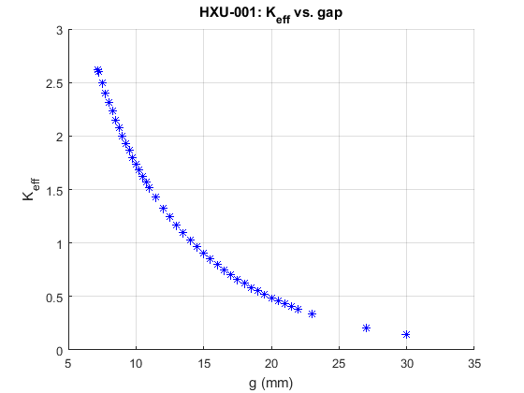

Evaluation of Hall Probe: Phase Shake vs. gap

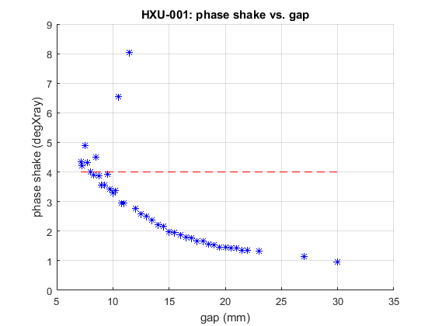

Evaluation of Hall Probe: K_{eff} vs x at Tuning Gap

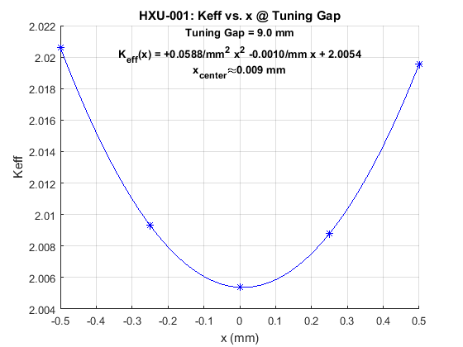

Evaluation of Hall Probe: K_{eff} vs y at Tuning Gap

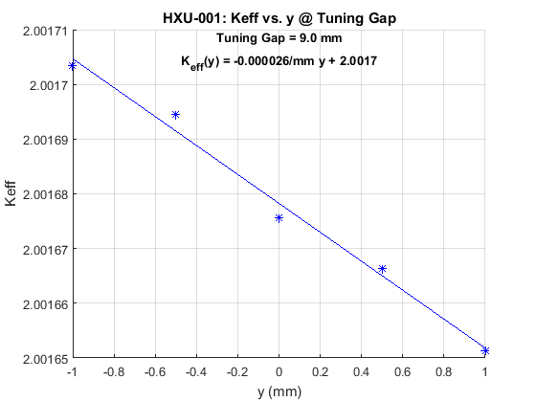

Long Coil Measurement of the On-Axis First Horizontal Field Integrals

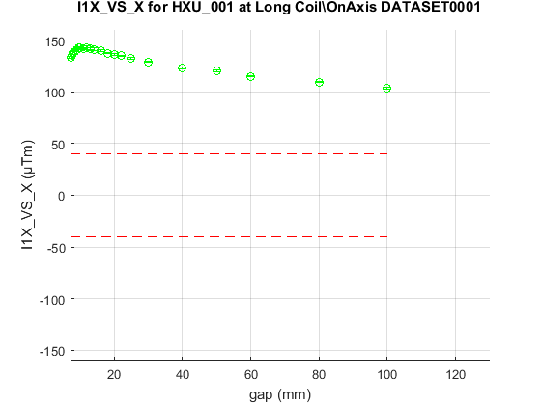

Long Coil Measurement of the On-Axis Second Horizontal Field Integrals

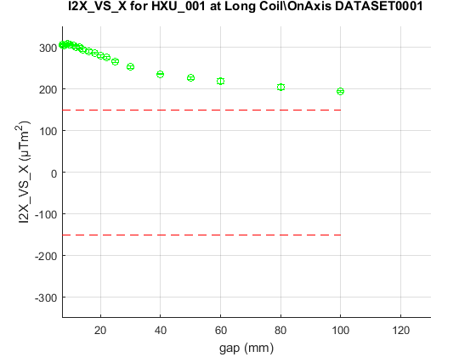

Long Coil Measurement of the On-Axis First Vertical Field Integrals

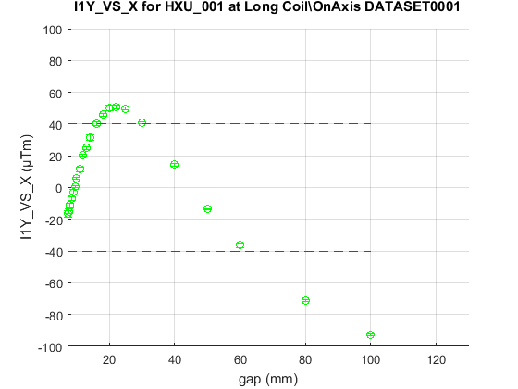

Long Coil Measurement of the On-Axis Second Vertical Field Integrals

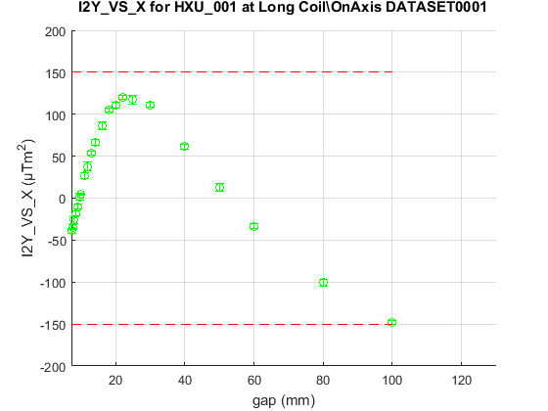

Capacitive Sensor Arrangement

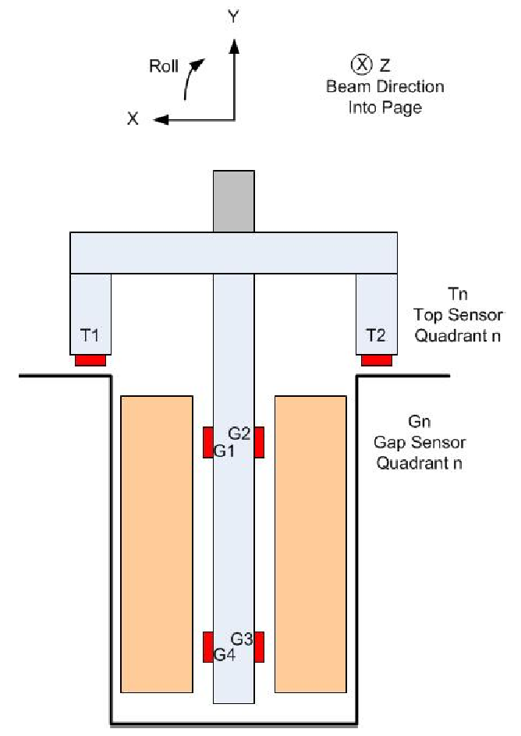

G1 Capacitive Sensor Readings

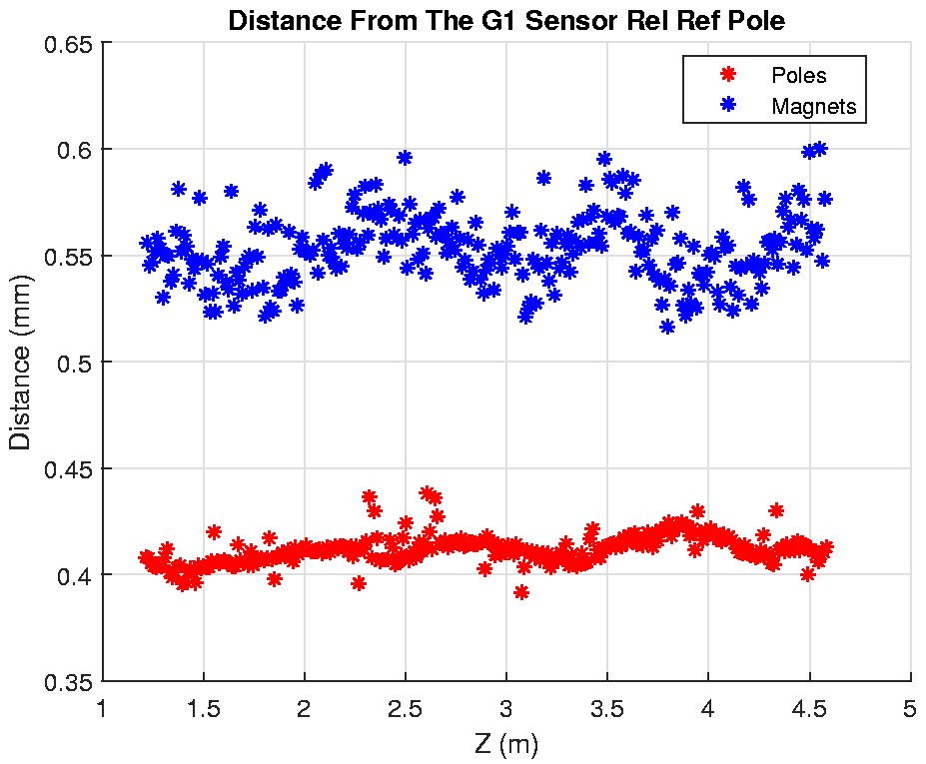

G2 Capacitive Sensor Readings

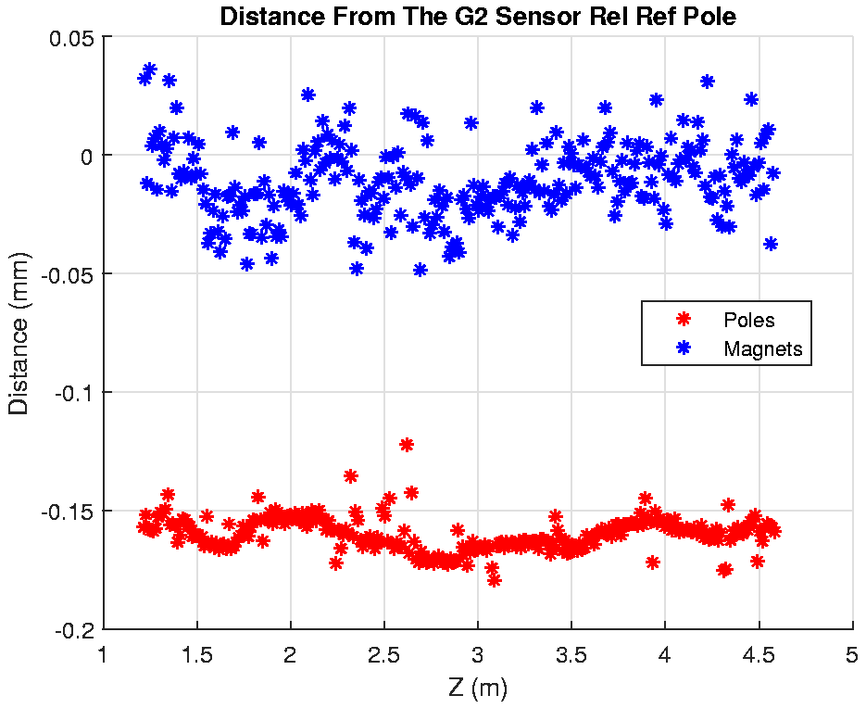

G3 Capacitive Sensor Readings

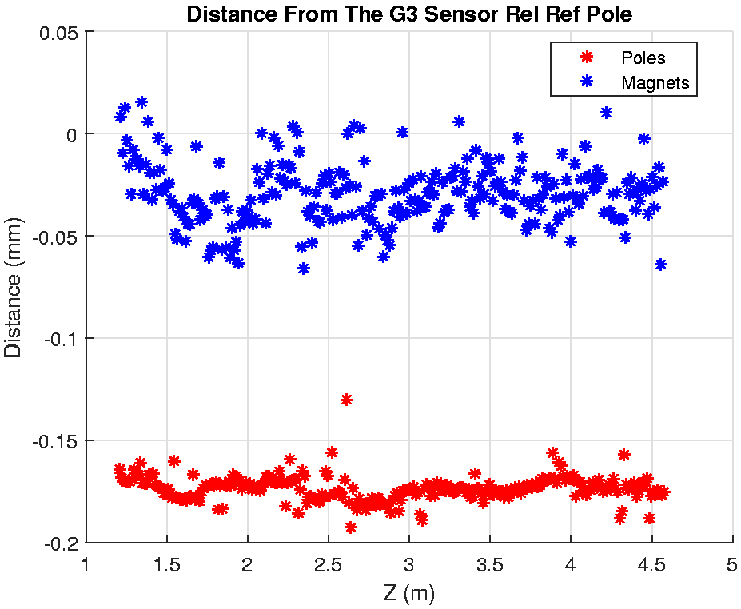

G4 Capacitive Sensor Readings

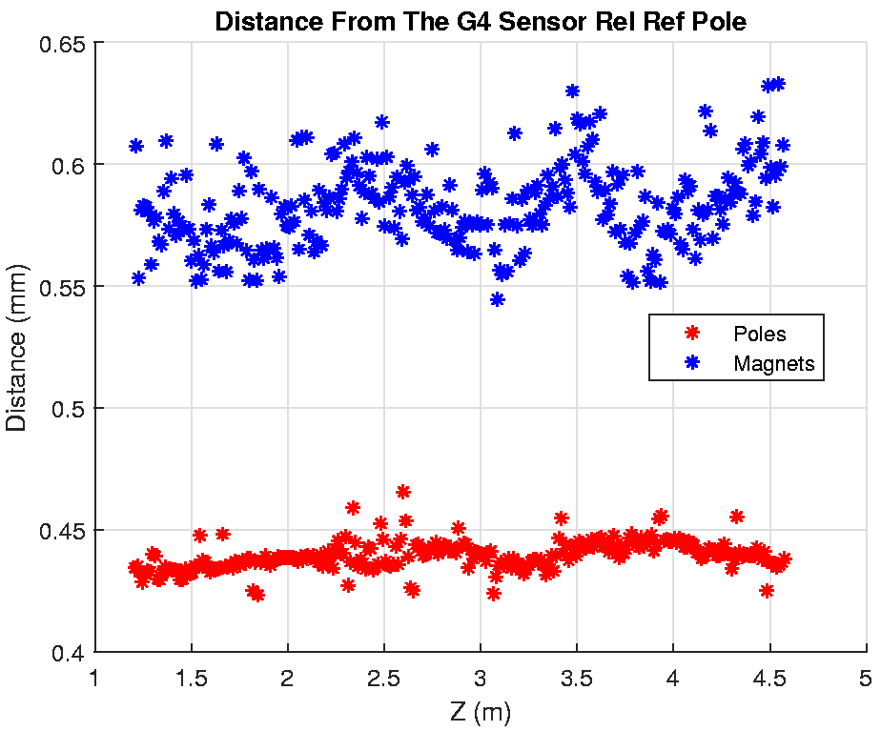

Phase advance from cell start (undulator center – 2.0296339 4.0127677/2 = 2.006384 m ) to center of physical pole 8.
Phase advance from physical pole 253 to cell end (undulator center + 2.0296339 2.006384 m ).

