SLAC Magnetic Measurement Plan and Traveller for LCLSII RF Gun Solenoid Type 2.90SO8.209, known as SOL1B, and its associated magnets, dated 9th August 2013
This magnetic measurement plan and traveler is for the LCLS-II gun solenoid magnet (SOL1B), its associated corrector dipoles (XC00B & YC00B), internal corrector quadrupoles (CQ01B, SQ01B), and the gun solenoid bucking coil (SOL1BKB). The quadrupole correctors are incorporated into the gun solenoid magnet. The X & Y dipole correctors are attached directly to the beampipe inside the solenoid magnet, and the bucking coil (also a solenoid) is attached to the rear flange of the photocathode gun when in the beamline. For the magnetic measurements a special jig will be provided to hold the bucking coil in place. All these magnets are exact replicas of the ones made for LCLS and it will be helpful to look back at the information kept from when they were measured in May-July 2006; this old magnetic measurement data can be found here;
http://www-group.slac.stanford.edu/met/MagMeas/MAGDATA/LCLS/Solenoid/SOL1/ .
The details of the solenoid design and analysis can be found in LCLS-TN-05-14.

The solenoid is about 8.3" long, 17.4 " tall and 17.4 wide, it weighs about 334 lb. When the special jig/spool piece carrying the bucking coil and X & Y correctors is added to the solenoid, the overall length will be about 14.6".

Receiving Information

Gun Solenoid
Received by (MMG initials)
Date received : (dd-mm-yyyy): | ____-____-2013
Look for Magnet Beamline Number and type it here.
Look for serial number on vendor plate and type it here
Enquire if Magnet Engineer has authorized MMG to do the magnetic measurements in this plan.
If solenoid does not have a barcode sticker then ask Magnet Engineer to add one and in any event write the 6 digit barcode number here:

Upon receipt of the magnet, the following information should be recorded:

Responsible measurement operator name (initials):

Verify that the magnet is complete and undamaged, including wiring and water cooling connections.

Incoming inspection OK (initials):

Bucking Coil and X and Y Correctors, on a special spool.
Will be delivered by Erik Jongewaard, who authorizes their measurement by their delivery to MMG
Received by (MMG initials)
Date received : (dd-mm-yyyy): | ____-____-2013
Look for bucking coil magnet beamline number and type it here.
Look for serial number on vendor plate and type it here
Look for X and Y correctors beamline numbers and type them here
The bucking coil will not have a barcode sticker. It is part of the solenoid assembly and shares the solenoid’s barcode.
The X&Y corrector assembly will not have a barcode sticker . They are part of the solenoid assembly and share the solenoid’s barcode.

Power Supplies Required and LCW Required

Power Supply for the solenoid SOL1B
A unipolar supply capable of producing 240 amps up to 30 volts will be needed. In the beamline the solenoid's PS will be controlled with a a EPSC controller with a cosine theta ramp. Please arrange for your PS to ramp this way.

Power Supply for the bucking coil SOL1BKB
A bipolar 6 amp MCOR supply will be needed to power the bucking coil.

Power Supplies for the internal quadrupole correctors, CQ01B and SQ01B
Two bipolar 12 amp MCOR supplies will be needed to power the quad correctors.

Power Supplies for the X and Y dipole correctors
Two bipolar 6 amp MCOR supplies will be needed to power the dipole correctors. In the beamline all these MCORs will be controlled on the "3-linear trim" mode. Please have your MMG MCORs mimic this way of ramping.

LCW Required
The solenoid has 8 parallel cooling water circuits and the LCW should be provided at a delta pressure of 100 psi, this should produce a total water flow of 4.8 gpm. All the other magnets have solid wire coils. ” Someone” needs to make the Synflex hoses for this solenoid; at this moment I don’t know if there is a manifold for all these hoses, MMG can probably provide their own hoses for their test set-up in Bld 26.

Magnets Orientations
A beam direction arrow is visible on the gun solenoid and the bucking coil and correctors will come to MMG already oriented on their special spool piece. If there is no beam direction arrow on the bucking coil then add a temporary one, it sits upstream of the solenoid.
Solenoid beam-direction arrow in place (initials):
Bucking coil beam-direction arrow in place (initials):

Name and URL of Magnetic Measurements Data Files
All the data files MMG generates should be placed in a subdirectory which has the beamline name of the gun solenoid as its identifier; the data files showing the effects of the bucking coil and various correctors will all be stored in the solenoids sub-directory. The major directory should include the name LCLS2.
Enter URL of on-line magnetic measurements data (please modify or correct if necessary):
http://www-group.slac.stanford.edu/met/MagMeas/MAGDATA/LCLS2/solenoid/SOL1B

Solenoid Fiducuialization and Set-up on Table in MMG Lab in Bld 26.
The solenoid will have been fiducialized on the CMM and with the Faro arm according to these instructions:

The solenoid magnet should be fiducialized by the Metrology Group using the CMM in building 25, using the same methodology as was used for the LCLS gun solenoids. This will require the installation of removable tooling balls, location of the geometric axis of the bore of the magnet, and location of tooling balls with respect to the X, Y and Z center of this geometric axis. Five tooling ball holes have been created in the upstream endplate of the solenoid magnets. The tooling ball holes in the flux return plates WILL ALSO BE USED.
The following measurements should be made:
- Precise location of the axis of the magnet, relative to the bores of the endplates (not to the inner bore of the magnet, which is only a carrier for the corrector coils).
- Measurement of the perpendicularity of the endplates with respect to the axis.
- Flatness of the endplates.
- Distance between the endplates.
- X and Y locations of the downstream bore relative to the upstream bore.
CMM technician (initials):
Date CMM performed (mmm-dd-yyyy):

URL of on-line CMM fiducialization data (please modify or correct URL if necessary):
\\web002\www-group\met\Quality\FIDUCIAL REPORTS\

Set up the solenoid on a flat, horizontal and stable and not-steel support table.
Hook up the LCW hoses and the power connections ( see next section for polarity definition).

Polarity of Solenoid and Bucking Coil
Hook up the power leads so the direction of the magnetic field along the beam direction is as shown in figure 1.

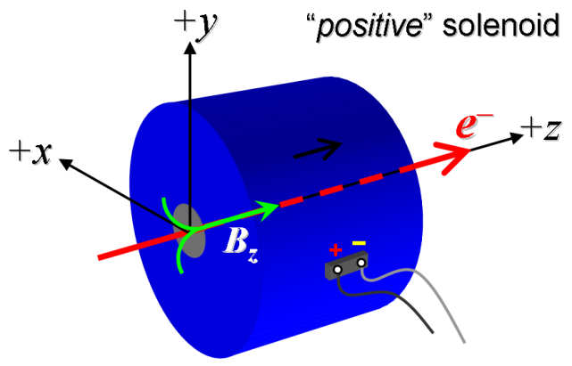

Figure 1. Polarity of solenoid field with positive power supply output current (‘normal’ polarity). The bucking coil should also produce this field orientation when in positive polarity.

Beam direction arrow applied (initials): | SDA
Magnet polarity (Fig. 1) has been marked (initials):
Name of photograph file in e-log:

Alignment of Solenoid and Hall Probe.
Set up a precise 3-axis Hall Probe so it sits in the bore of the solenoid, at the geometric center as best as one can tell by eye. Then the Alignment Crew will make sure the solenoid is sitting horizontal on the support table and will alter the position of the Hall Probe sensor so it is at the geometric center of the solenoid’s bore and it wll travel aong the geometric Z axis as it is moved on its arm. Later on, if it turns out the magnetic centerline is quite different from the geometric axis, then the Hall Probe will be re-aligned along the magnetic axis.

Solenoid sitting horizontal confirmed
Hall Probe aligned to move along z axis of solenoid

Test Sufficient Water Flow.
With 100 psi deltaP across the LCW manifold run the LCW through the 8 parallel LCW cooling circuits and measure how much the total water flwo is – should be 4.8 +/-0.2 gpm. If it is less than 4gpm at 100 psi then check for blocked hoses.

Standardization Procedure for the Solenoid.
Considering the capabilities of the power supply the solenoid will run off in the beamline and the solenoid’s resistance, the maximum standardization current will be 240 amps. The standardization cycle will go between 5 and 240 amps using a cosine theta approach to the end points of any ramp. The equivalent linar ramp rate during the standardization should be 15 amps per second. The equivalent linear ramp rate during ramping to an operating current should be 5 amps per second.
Pause times at 5 amps and 240 amps during the standardization procedure are to be 30 seconds. The pause time before a magnetic measurement should start, after an operating current has been reached, is 10 seconds.
The number of standardization cycles will be three, ending at 5amps.

Thermal test for main coils.

Run the solenoid at 240 amps for 2 hours and record the temperatures on at least one pancake coil and one mirror plate and the inner bore every 2 minutes; also the magnet’s resistance, and input and output LCW temperatures.

Ambient temperature (°C) at start of test: | 30.39°C
Ambient temperature (°C) at end of test: | 30.76 °C
Final LCW delta temperature (°C): | 1.65 °C

Inform the cognizant magnet engineer when this thermal test's data is available, it need to be checked before any further measurements are taken on the solenoid.

Initialization of the solenoid
In case this solenoid was run in its past in the opposite polarity to what is required, it must be taken through an initialization procedure, just once, before any magnetic measurements are taken:
Run the solenoid thorugh 5 standardization procedures, that is 5 times 3 = 15 cycles from 5 to 240 and back to 5 amps.

Initialization carried out by | Name of operator: SDA | Date 8/20/2013

Establish the nominal operating current of the solenoid so that current can be used to find the magnetic axis of the solenoid.
The nominal field value of this solenoid, at its center in X,Y and Z is 0.2422 T. From calculations and previous solenoid's measurements it is predicted the nominal operating current is around 170 amps. We need to find the magnetic axis at the nominal operating current, so we first need to establish what that current is. Follow this short procedure:
(a) Standardize the solenoid.
(b) Put the Hall Probe at the center of the solenoid, i.e.at X,Y and Z =0.
(c) Measure the B(z) component at 165, 170 and 175 amps
(d) From these three measurements calculate the current that produces a B(z) of 0.2422T .
B(z) measured at 3 currents | At 165A | At 170A | At 175A

Nominal operating current to produce 0.2422T | I _{nom} | Date and operator

Short rotating coil measurements to determine the magnetic axis:

Remove the X and Y correctors from the bore of the solenoid so the short rotating coil can be set up and used as described below.
- Standardize the magnet and set the current to I_{nom}.
- Align the short rotating coil so it travels in the z-direction, along the mechanical axis of the solenoid.
- Position the short rotating coil at the beam entrance to the solenoid with the coil longitudinally (z-axis) centered in the plane of the solenoid end plate. Adjust the rotating coil in the transverse direction (x and y) to minimize the dipole field. Record the coordinates relative to the mechanical axis (as known through the tooling balls ) below and in the data file.
- Position the short rotating coil at the beam exit of the solenoid with the coil longitudinally (z-axis) centered in the plane of the solenoid end plate. Adjust the rotating coil in the transverse direction (x and y) to minimize the dipole field. Record the coordinates relative to the mechanical axis (as known through the tooling balls) below and in the data file.
- Determine the line between the points found in 3 & 4 and move the rotating coil along this z-line for the next set of measurements. This establishes the magnetic axis of the solenoid.

Data filename:

 | x | y
Magnetic center at solenoid entrance (m)
Magnetic center at solenoid exit (m)
Magnet axis displacement error (m)
Magnet axis angle error (mrad)

REACHED HERE IN REVISING THIS SOLENOID PLAN, CHERRILL NEEDS TO CONSULT WITH SCOTT ON SOME DETAILS of the above section 13 procedure.

Short coil measurements of the skew and normal quadrupole corrector calibrations:

- Turn off the main solenoid power supply.
- With the short coil aligned along the magnetic axis, measure the field multipole spectrum, including ∫B_{x,y}dl, vs. z in steps of 1.25 cm with the skew quadrupole field corrector at 1 A.

Name of skew quad calibration data file:

- With the short coil aligned along the magnetic axis, measure the field multipole spectrum, including ∫B_{x,y}dl, vs. z in steps of 1.25 cm with the normal quadrupole field corrector at 1 A.

Name of normal quad calibration data file:

- Label the terminal polarities when field orientations are established as in Fig. 3, and photograph the terminals.

Polarity of norm. and skew labeled (initials):
Photograph file name:

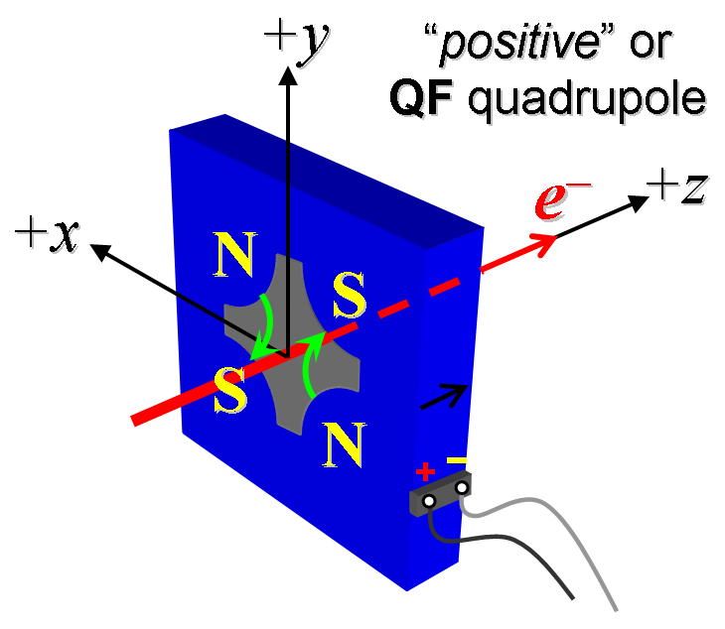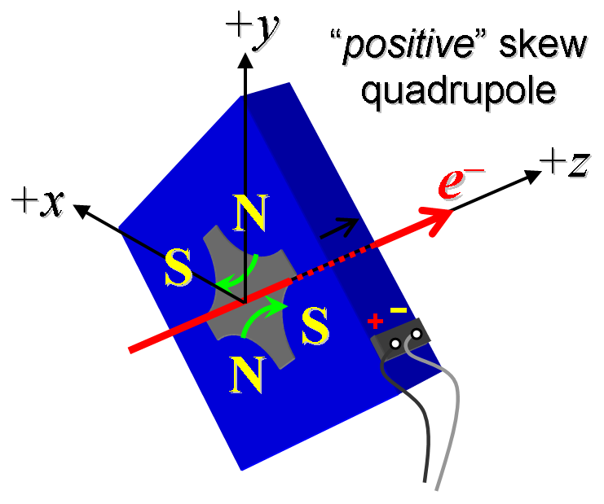
Figure 3. Normal and skew quadrupole coil polarities are set to arrange fields as shown above.

Hall probe measurements of the longitudinal field distribution and calibration of the bucking coil:

- Assemble the fixture holding the bucking coil and dipole corrector at their proper locations relative to the solenoid. Photograph configuration.

Photograph file name:

- Align the Hall probe travel axis along the magnetic centerline of the solenoid.
- Position the Hall probe at the cathode location.
- Standardize the solenoid and set the current to I_{nom}.
- Adjust the bucking coil current to cancel the solenoid field at the cathode location. Record bucking coil current required:
Bucking current to null solenoid field at I_{nom} | A

- Repeat Steps 4 & 5 for solenoid currents of 100, 125, 150, 175, 200, 225, 250, and 270 A.
Name of bucking coil measurements file:

- Standardize the solenoid and set the current to I_{nom}. Set the bucking coil to zero the field at the cathode.
- Measure the axial field vs. the z-distance along the magnetic centerline. The measurements should be done from z = −30 cm to +30 cm in 2-mm steps where z = 0 is the center of the solenoid.
Name of bucking coil measurements file:

- Standardize the solenoid and set the current to I_{nom} − 25 A. Set the bucking coil to zero the field at the cathode.
- Measure the axial field vs. the z-distance along the magnetic centerline. The measurements should be done from z = −30 cm to +30 cm in 2-mm steps where z = 0 is the center of the solenoid.
Name of bucking coil measurements file:

- Repeat 9 and 10 with solenoid set to I_{nom} + 25 A and bucking coil current set to zero field at cathode location.
- Turn off solenoid power supply and disconnect to assure zero current.
- Position hall probe at cathode location. Measure B_{z} vs. bucking coil current for I_{buck} = −20, −15, −10, −5, 0, 5, 10, 15, 20 A.
Name of bucking coil measurements file:

- With solenoid still off, measure B_{z} vs. z for I_{buck} = 10 A. The measurements should be done from z = −20 cm to +20 cm in 2-mm steps, where z = 0 is the bucking coil center.
Name of magnetic field measurements file:

- Label the bucking coil terminal polarities when field orientations are established as in Fig. 2. Take photographs of terminals showing polarity used for measurements.
Name of photograph file:

- Polarity check: Without bucking coil on; switch off power supply. Reverse magnet polarity. Switch on power supply. Standardize the solenoid and set the current to I_{nom}. Measure field at center of magnet. Repeat measurement for standard polarity.
Name of magnetic field measurements file:

Hall probe calibration of the dipole correctors:

- With the hall probe aligned along the magnetic axis, position it in the center (z = 0) of the solenoid.
- Set solenoid to zero current. (Disconnect from supply.) Measure the transverse magnetic field for each of the two dipole corrector coils at: −8, −6, −4, −2, 0, 2, 4, 6, 8
Name of XCOR field measurements file:
Name of YCOR field measurements file:

- Measure the transverse fields of each dipole coil vs. z at 4 A. The measurements should be done from z = −30 cm to +30 cm in 2-mm steps where z = 0 is the center of the solenoid.
Name of XCOR field measurements file:
Name of YCOR field measurements file:

- Label the terminal polarities when field orientations are established as in Fig. 4. Take photos of terminals to show polarity.

Polarity of X & YCOR labeled (initials):
Name of photograph file:

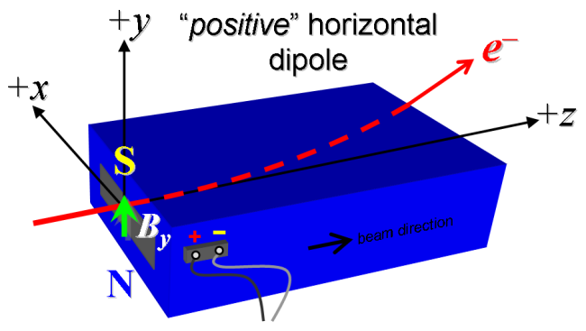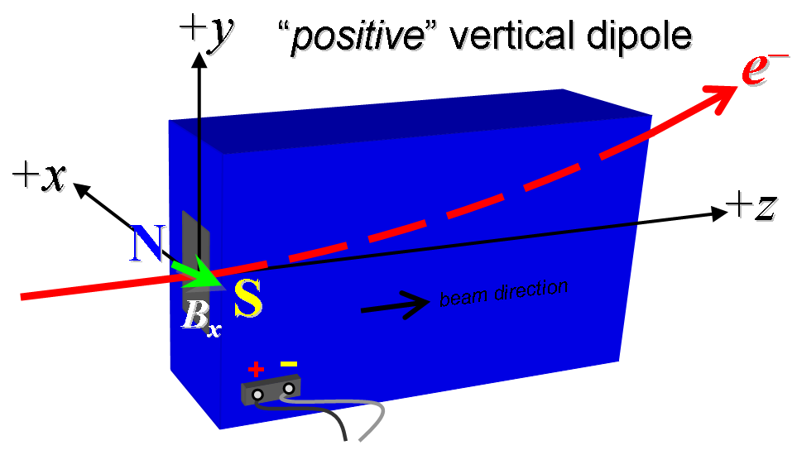
Figure 4. Horizontal and vertical dipole corrector coil polarities are set to arrange fields as shown here.
Long rotating coil measurements after calibrating: Measure multipoles from bucking coil and determine quad corrector currents to zero SOL1 integrated quadrupole fields.:

- Align the long rotating coil along the magnetic axis. Disconnect the normal and skew quad correctors from their power supplies.
- Standardize the solenoid and set the current to I_{nom}. Set the bucking coil to the current which zeros the cathode field. (See measurements above.)
- Use the long rotating coil to measure the integrated multipole field at the nominal solenoid setting.
Name of rotating coil data file:

- Standardize the solenoid to I_{nom} − 25 A and set bucking coil to the appropriate current to zero cathode field. Measure the integrated multipole field.

Name of rotating coil data file:

- Standardize the solenoid to I_{nom} + 25 A and set bucking coil to the appropriate current to zero cathode field. Measure the integrated multipole field.
Name of rotating coil data file:

Determine the normal and skew quad corrector currents which best cancel the integrated quadrupole field at I_{nom} and I_{nom} ± 25A.

- Connect the normal and skew quad correctors to their power supplies.
- Standardize the solenoid to I_{nom} and set the bucking coil to the current which zeros the cathode field.
- With the long rotating coil, measure the integrated quadrupole field.
- Adjust the current in the normal and skew quad correctors to zero the integrated quadrupole field.
- Log the normal and skew quad currents (and polarities).
- Standardize the solenoid to I_{nom} + 25 A and set the bucking coil to the current which zeros the cathode field.
- With the long rotating coil, measure the integrated quadrupole field.
- Adjust the current in the normal and skew quad correctors to zero the integrated quadrupole field.
- Log normal and skew quad currents (and polarities).
- Standardize the solenoid to I_{nom} − 25 A and set the bucking coil to the current which zeros the cathode field.
- With the long rotating coil, measure the integrated quadrupole field.
- Adjust the current in the normal and skew quad correctors to zero the integrated quadrupole field.
- Log normal and skew quad currents (and polarities).

I-solenoid | I-bucking coil | Normal quad | Skew quad
I_{nom} =
I_{nom} + 25 A =
I_{nom} − 25 A =

Upon completion of tests, send traveler to Dave Dowell, at mailstop 18.

Approval signatures:
Magnet accepted - Dave Dowell:
Magnet accepted - Cecile Limborg:

Upon completion, send traveler to Kathleen Ratcliff at mailstop 18.

SLAC approved electrical safety covers? (Y or N):
SLAC approved lifting eyes? (Y or N):
Shipping Damage? (Y or N):
Vendor tests passed on magnet label? (Y or N):

